Prepared By | Approved By | Effective Date
Baba Goud Gadiga |  | 04 July 2018

Subject: User Guide for SCM5821A Test Software

SCM5821A Test Software Application
User Guide

MAIN SECTIONS
Section | Description | Page
Table of Contents 3
1 Purpose 5
2 Applicable Documents 5
3 TEst Application 6
4 Architecture 6
5 Application GUI 8
6 Control Panel 18
8 Installation and Help 37

REVISION APPROVALS

REV | Revised By | Date | Approved  (Prog. Mgr.) | Date | Approved  (Design Engr.) | Date | Customer
01

NOTE: add new row here for each revision.

Table of Contents
Page

REVISION APPROVALS 2
Table of Contents 3
1 Purpose 5
2 Applicable Documents 5
3 TEst Application 6
3.1 Introduction 6
4 Architecture 6
7
5 Application GUI 8
5.1 Dockable Forms Interface 8
5.2 Open Dialog Box 8
5.3 Save Exposure Dialog box 9
5.4 Page Setup Dalog box 10
5.5 PRINT PREVIEW 11
5.6 PRINT Dialog Box 12
5.7 CLEAR HISTORY 13
5.8 EXIT 13
5.9 TCP SETTINGS 13
5.10 OPERATOR iNPUT 14
5.11 FIRMWARE LOGGER 15
5.12 TEST GRAPH PREFERENCES 16
5.13 INSTRUMENT dFAULTS 16
5.14 UPDATE CAMERA FIRMWARE 17
5.15 tEST LIMITS 18
5.16 tEST RESULTS 19
5.17 IMAGE DISPLAY PANEL 21
5.18 TEST APP THEMES 22
5.19 SEND EMAIL 23
6 cONTROL PANEL 23
6.1 USER MODE 24
6.2 TEMPERATURE/HUMIDITY DETAILS 25
6.3 CAMERA DETAILS 26
6.4 CHARACTERIZATION PRETEST 27
6.5 CHARACTERIZATION AUTOTEST/FINAL TEST 28
6.6 MANUAL CHARACTERIZATION TEST 31
6.7 STATUS BAR 33
7 Installation and Help 34

Table of Figures
Page

Figure 1. Test App Software Interface Architecture 7
Figure 2. CID821 System Overview 7
Figure 3. Top level User Interface 8
Figure 4. Open Dialog 8
Figure 5. Display File Dialog 8
Figure 6. Save As Dialog 9
Figure 7.Page Setup Dialog 11
Figure 8. Print Preview Dialog 12
Figure 9. Print Dialog 13
Figure 10.TCP Settings 14
Figure 11. Operator Input 14
Figure 12. Firmware Logger 15
Figure 13. Firmware Logger Window on Main Screen 16
Figure 14. Test Graph Preferences 16
Figure 15. Instrument Defaults 17
Figure 16. Downloaded Updated Firmware 18
Figure 17. Characterization Test Limits 19
Figure 18. Characterization Test Results 20
Figure 19. Characterization Test Results 20
Figure 20. Characterization Test Results 21
Figure 21. Image Test Window 21
Figure 22. Test App Theme Before Screen 22
Figure 23. Test App Theme After Screen 22
Figure 24. Send E-Mail 23
Figure 25. Control Panel 24
Figure 26. Control Panel User Mode 24
Figure 27. User Login Dialog 25
Figure 28. Control Panel Temperture/Humidity Details 25
Figure 29. Temperature/Humidity Details Graphical 26
Figure 30. Control Panel Camera Details 27
Figure 31. Control Panel PreTest 27
Figure 32. Pretest Dialog 28
Figure 33. Pretest Main Screen 28
Figure 34. Control Panel Auto Test 29
Figure 35. Operator Input 30
Figure 36. Auto Test Dialog 31
Figure 37. Auto Test Main Screen Tiled Window 31
Figure 38. Manual Test Main Screen Window 32
Figure 39. Manual Mean Variance Main Screen 33
Figure 40. Navigation/Manipulating Exposure Settings 33
Figure 41. Status Bar 33
Figure 42. Test App Setup Wizard 34

Purpose

This document describes the design, use, and installation of the Test Application software. This user guide will instruct the operator on how to setup and use this application to perform detector characterization, optoelectronic test, and measurement for the CID 821 camera.

Applicable Documents
2012746 SCM5821AX1 D&D_Specification.doc

SCM5821A Test Application

Introduction

This software is designed primarily to interface with the Scientific Cameras with a Charge Injection Device (CID) used for optical emission spectroscopy (OES). This software provides user defined methods for data acquisition, imager characterization, data logging, diagnostic processing, and visualization. It strives to support all future CID Cameras but will start with the CID821. This software program is implemented as a C# (sharp) desktop application that runs on a host 64-bit Windows 7 and later Operating Systems with .NET 4.5 libraries. It takes advantage of the National Instruments Measurement Studio, Infragistics Controls and is compiled and linked using Microsoft Visual Studio 2013 Integrated Development Environment (IDE).

This application provides the ability to execute Linearization, Mean Variance, NDRO, etc. on the host machine. This application allows provisions for logging internal messages for program debugging, camera diagnostics, and transparency of operation.
The application has dockable panels which give the operator a better way to view and customize their workspace and analyze multiple methods or exposures simultaneously for comparisons. Comments, in the form of tags, are embedded throughout the code. These tags can be processed by a third-party tool, such as Sandcastle, which generate the Application Programming Interface (API) in HTML to be viewed with any web browser.

Architecture

A general overview diagram of the system architecture is shown in the block diagram in Figure 1. The primary purpose of the Test App software is to provide a graphical user interface (GUI) for the testing the quality and performance of the CID scientific camera systems for manufacturing.

This application is a multithreaded program that runs on a standard Windows operating system host computer. The application provides the following general functionality:
- Provisions for graphing signal data as point plots for detector characterization.
- Ability to display bias settings and timing descriptor for each exposure.

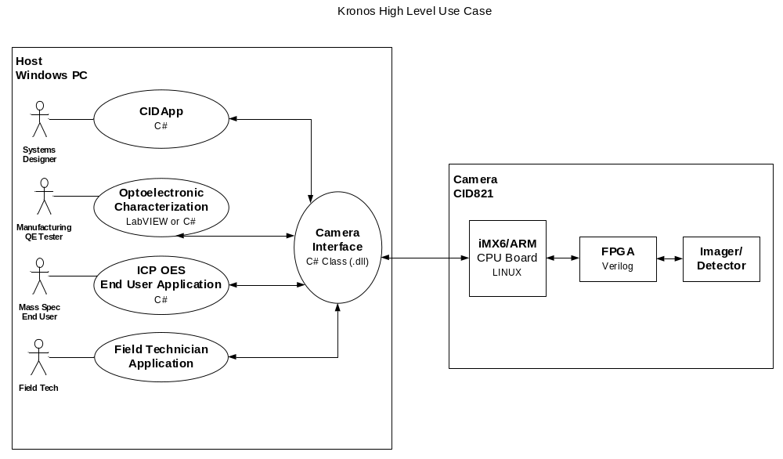Figure 1. Test App Software Interface Architecture

The software running on the host PC will interface with the camera firmware through a CAT5 Ethernet connection as seen in Figure 2

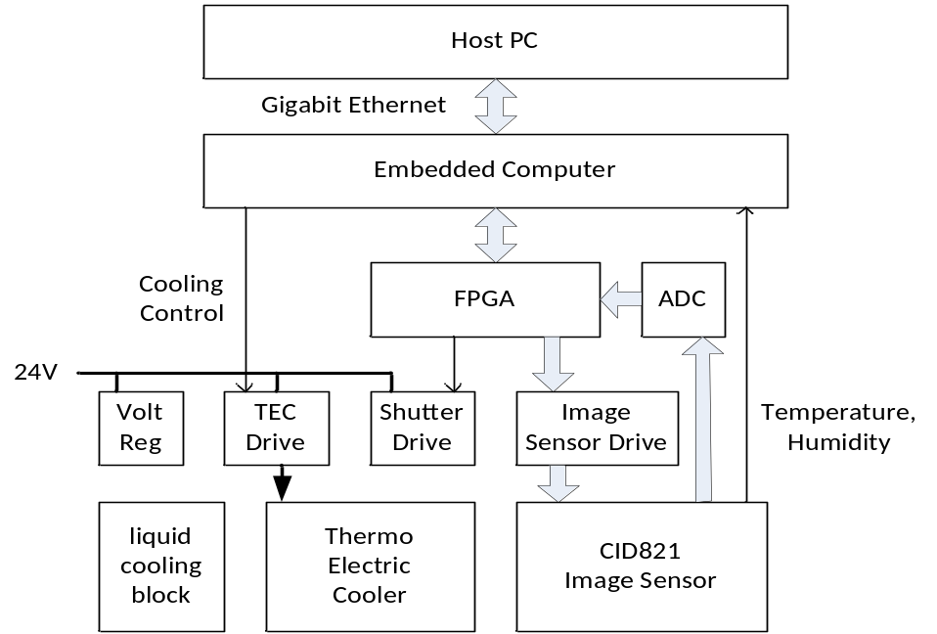
Figure 2. CID821 System Overview

Application GUI

The main user interface to the Test App software is the Graphical User Interface. The Test App screen is divided into three main sections as seen below in Figure 3.
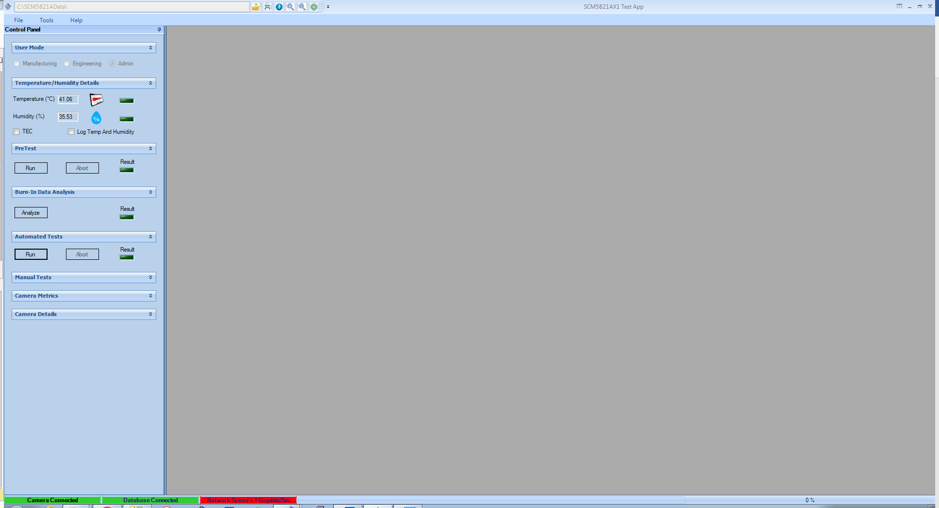

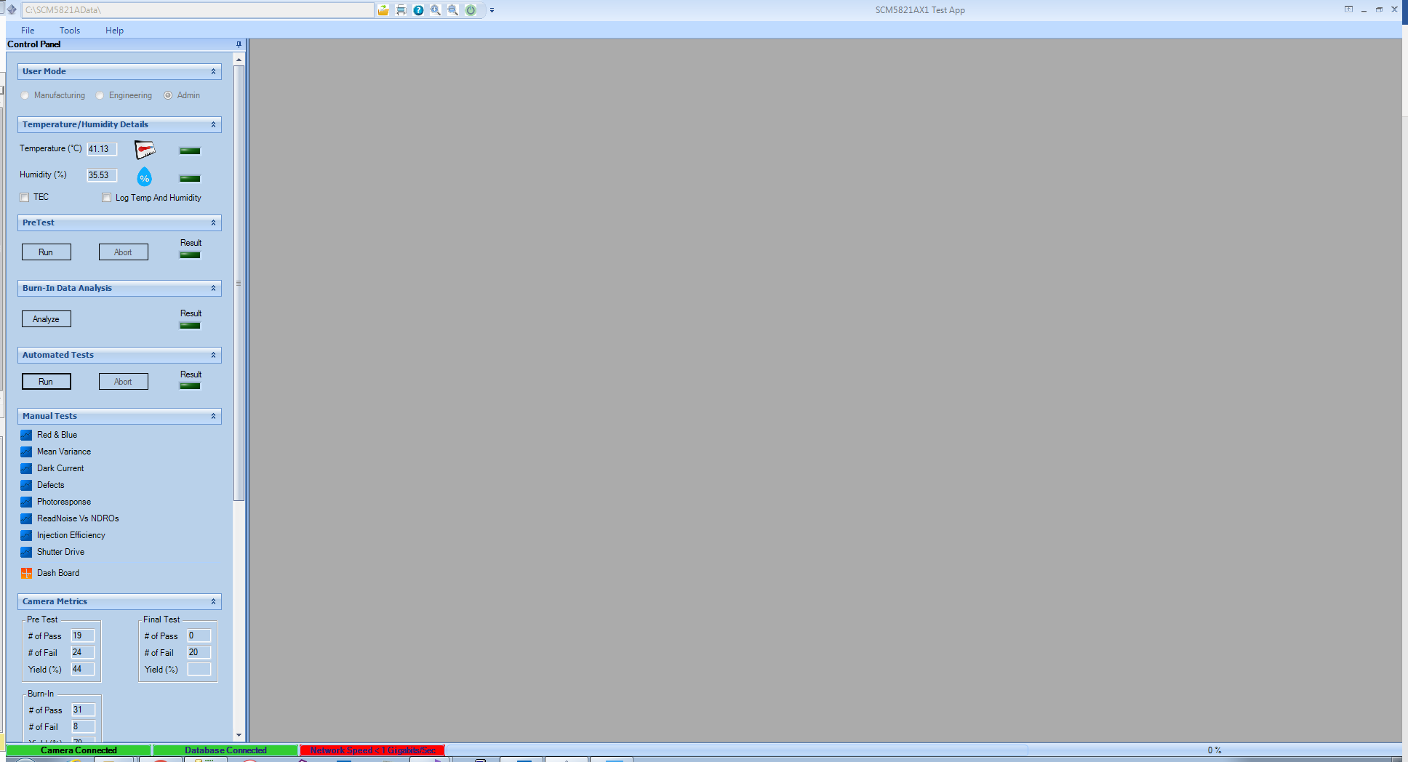
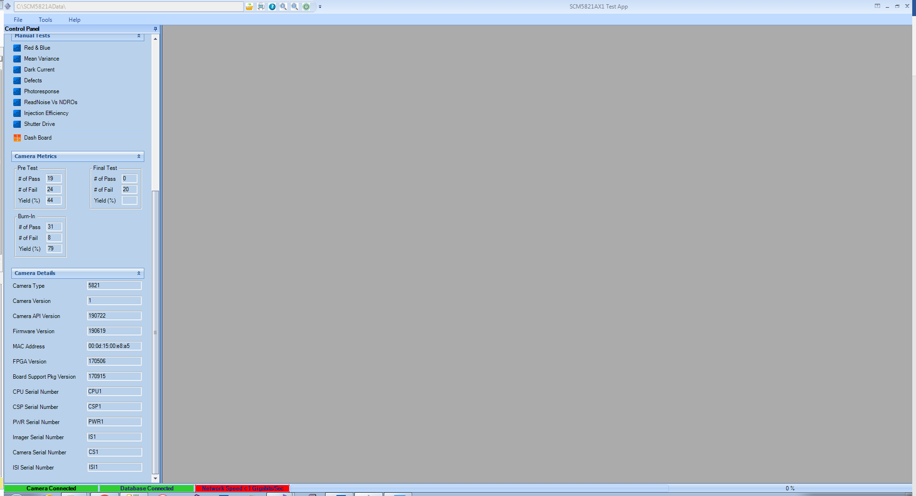

Figure 3. Top level User Interface

All menus and dialog boxes in the Test App module follow standard Microsoft® Windows© programming protocols. Several specific standards are followed.

Dockable Forms Interface
The Test App software has dockable forms which can be moved around within the main panel or moved off the panel as free forms to another monitor if desired. It is possible to re-size and re-position each form independently. This allows the operator to customize the screens most suitable for their workspace. This is done by left clicking the mouse on the title bar of the form and dragging it until the background of the form changes to a light blue shade. The forms background will remain shaded until it is dropped into another place.

Open Dialog Box
If the user selects File, Open menu item, then an Open file dialog box will be displayed as seen in Figure 4. The dialog box will appear similar to the Open dialog box from Microsoft® Word©. The dialog box will support full directory-file searching capabilities. Selection of the Open action button will open the selected Test App document in Display File Dialog as seen in Figure 5. The default Open file type shall be set as a *.jpg file. However, it shall be possible to open the Test App documents which are either in Bitmap, Tiff and XML file formats.
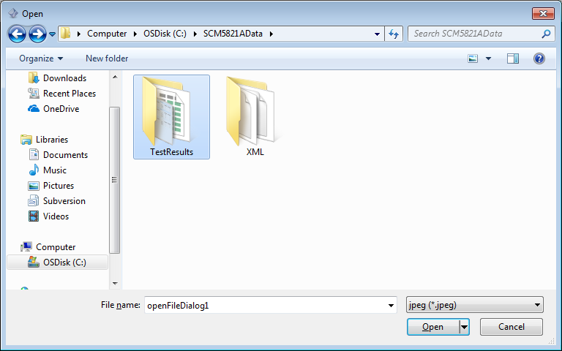
Figure 4. Open dialog

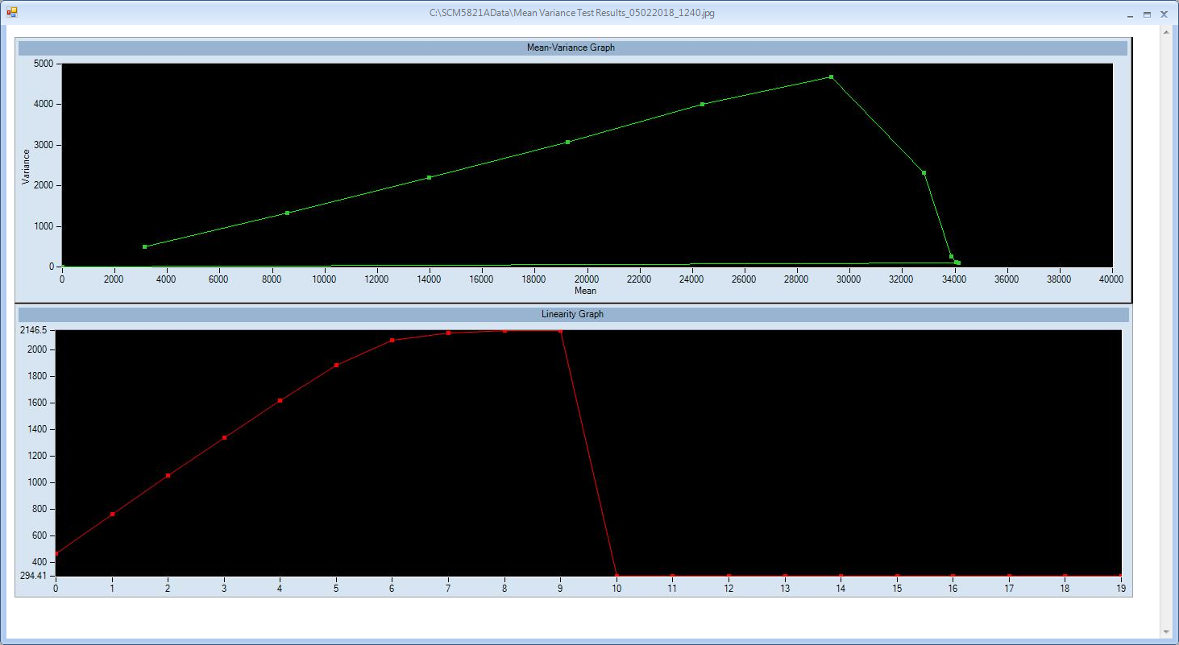
Figure 5. Display File Dialog

Save Exposure Dialog Box
If the user selects File, Save As Tiff, Save As Bitmap and Save As Jpeg menu items, then a Save data to a file dialog box will be displayed seen in Figure 6. The dialog box will appear similar to the Save As… dialog box from Microsoft® Word©. The dialog box will support full directory-file searching capabilities. Selection of the Save action button will save the selected Test App image or form.
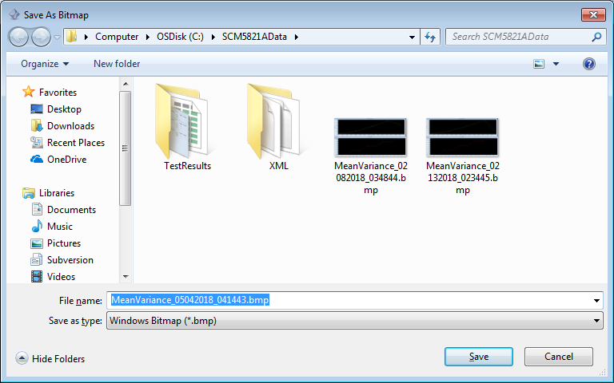
Figure 6. Save As Dialog

Page Setup Dialog Box
It is possible to print Test App data images, grids and various dialogs, and therefore, page setup functionality is required. If the user selects menu item File, Page Setup… then a Page Setup dialog box should be displayed as shown in Figure 7. The dialog box will appear like the Page Setup dialog box from Microsoft® Word©. The dialog box will support the Margins, Paper Size, and Paper Source tabs. However, it is not necessary to support the Layout tab.
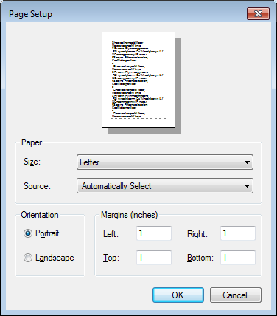
Figure 7. Page Setup Dialog

Print Preview Menu Item
It is possible to print Test App images, grids and characterization test forms, and therefore, print-previewing functionality is required. If the user selects menu item File, Print Preview… then a preview of the Test App document print shall be displayed as seen in Figure 8.
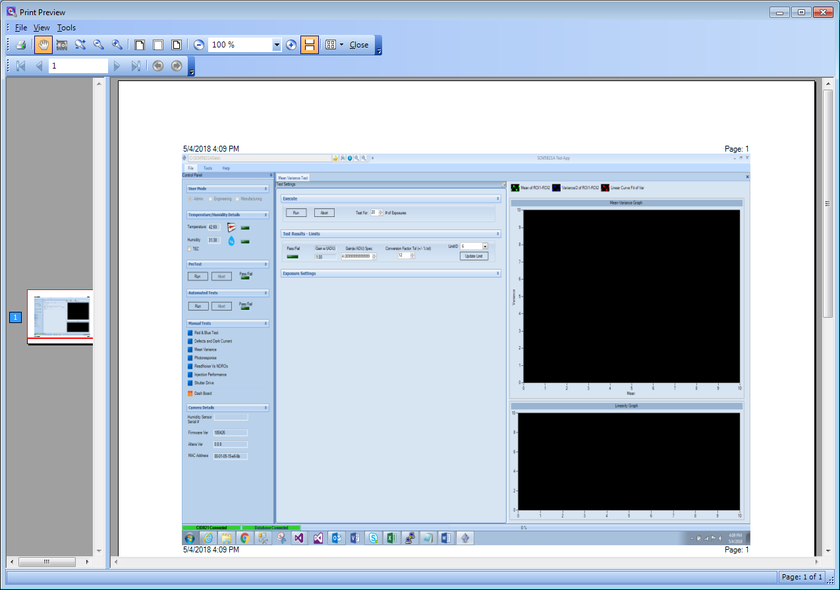
Figure 8. Print Preview Dialog

Print Dialog Box
If the user selects menu item File, Print… then a Print dialog box will be displayed as seen Figure 9. The dialog box should appear similar to the Print dialog box from Microsoft® Word©. The dialog box should support multiple Printers, Page Ranges, Copies, etc.
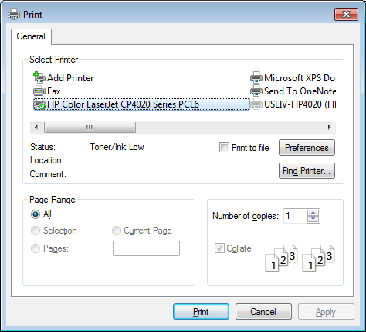
Figure 9. Print Dialog

Clear History
If the user selects menu item File, Clear History then plot data of characterization test form which is open in the main dialog will be cleared. The purpose of the option is to clear all the plots on the screen and start a fresh test run.

Exit

If the user selects menu item File, Exit then the application is shut down and closed.

TCP Settings
If the user selects Tools, TCP Settings menu he can configure the TCP/IP Settings connection to the camera. This can be configured for transfer of data to and from the imager device to the host software and can be seen below in Figure 40.

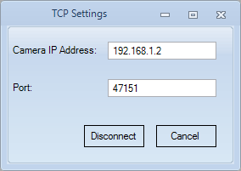
Figure 40. TCP Settings

Operator Input
If the user selects Tools, Operator Input menu item an Operator Input dialog is displayed as seen in Figure 11 which allows the user to input/check the Camera Model, Camera Serial Number, Imager Serial Number, Detector Type and Camera Control Serial numbers. This dialog is basically used by the operator to input the Camera that is under final test. Camera S/N, Imager S/N, CPU S/N, Power S/N and CSP S/N are mandatory fields and cannot be empty. User can scan the QR code by placing focus on the CPU text box and the values for the Power and CSP will be filled automatically. These values will be validated accordingly.

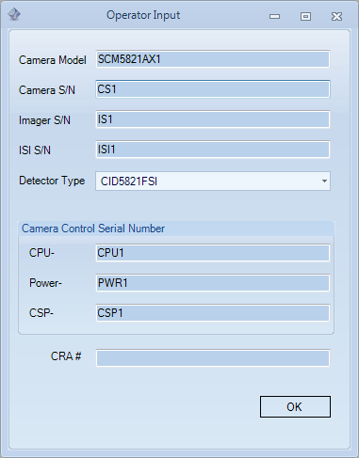
Figure 51. Operator Input Dialog

Firmware Logger
If the user selects Tools, Firmware Logger menu item a Firmware Logger Dialog will be displayed as seen in Figure 12. Using this dialog user can check the logs that is being sent by firmware to the Test App. User can select the location where the logs needs to be displayed.

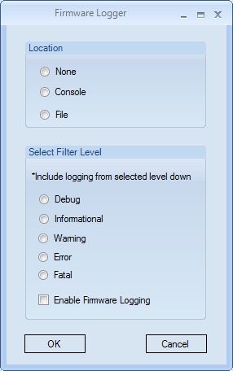
Figure 12. Firmware Logger

If the user selects Console option, then the user can see the logs in the main screen docked at the bottom of the screen as seen in Figure 13. User has the option to filter the logs based on the level of each log for example a log can be either Informational, Warning, Error, Fatal or Debug.

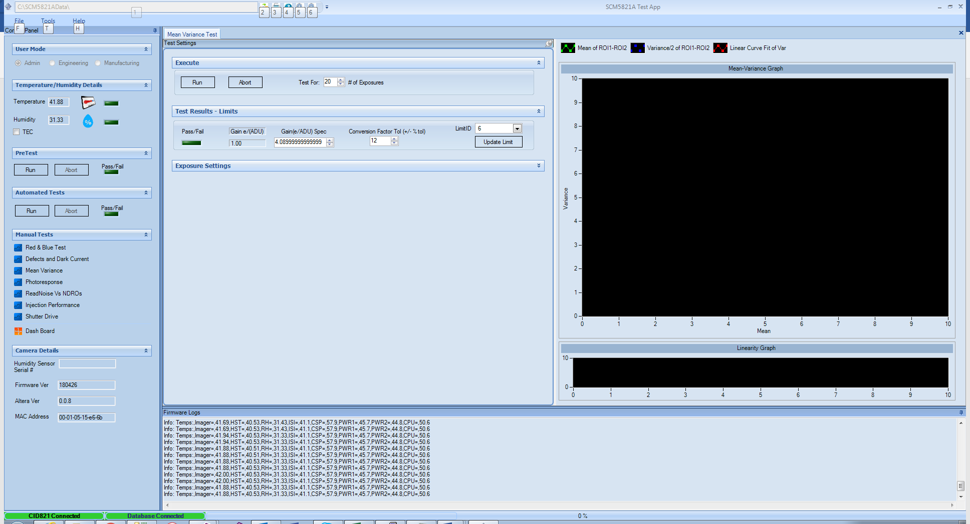
Figure 13. Firmware Logger Window on main screen

Test Graph Preferences
If the user selects Tools, Test Graph Preferences, a Test Graph Preference dialog is displayed as seen in Figure 14. Using the dialog, the user can set the Line width of the Plot and also set the background of the characterization test graphs to white background by selecting the Monochrome Graphs.

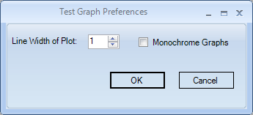
Figure 14. Test Graph Preferences

Instrument Defaults
When the Instrument Defaults menu is selected under tools the voltage settings dialog will allow the operator to set the cameras voltages as shown below in Error: Reference source not found15. This configuration should only be used by Admin users to adjust voltages for characterization. These adjustments can cause harm to the camera if not set properly. An admin user needs to click on the Update Database button to save the changes permanently.
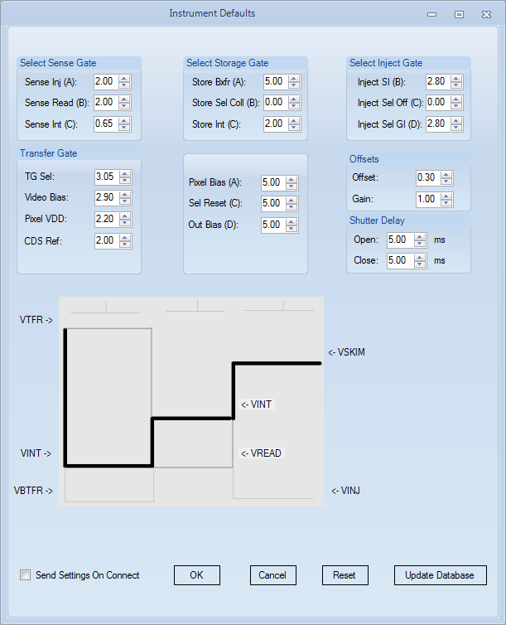
Figure 15. Instrument Defaults

Update Camera Firmware
Under the tools menu there is a menu item to upload a new firmware version to the camera. This can be configured for transfer of data to and from the iMX6/ARM board on the camera from the host software and can be seen below in the Figure 16.
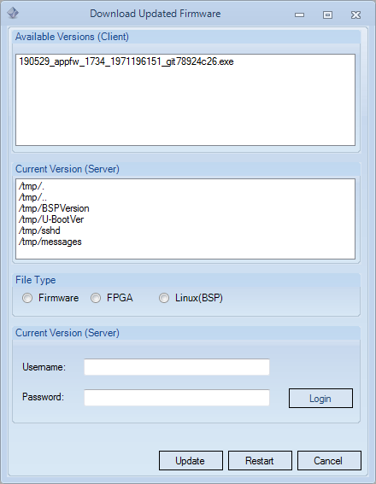

Figure 16. Download Updated Firmware

Test Limits
If the user selects Tools, Test Limits, Characterization Test Limits Dialog will be displayed as seen in Figure 17. User can view the limit/spec values of all the characterization tests. For example, in the Figure 17 we can see the Limits of the Mean Variance test. Only an Admin user can add new limit or remove an existing limit provided it has an ECO/ECN # associated with it. Tab ECO Details has a drop down which will list all the ECO/ECN numbers associated with limits. User can select a value from the drop down to display the limits associated with that ECO number. The Admin user can change the default limit to a specific limit by choosing the limit from the drop down and click on Apply Limit button. This limit will be applied for determining the test pass/fail condition.
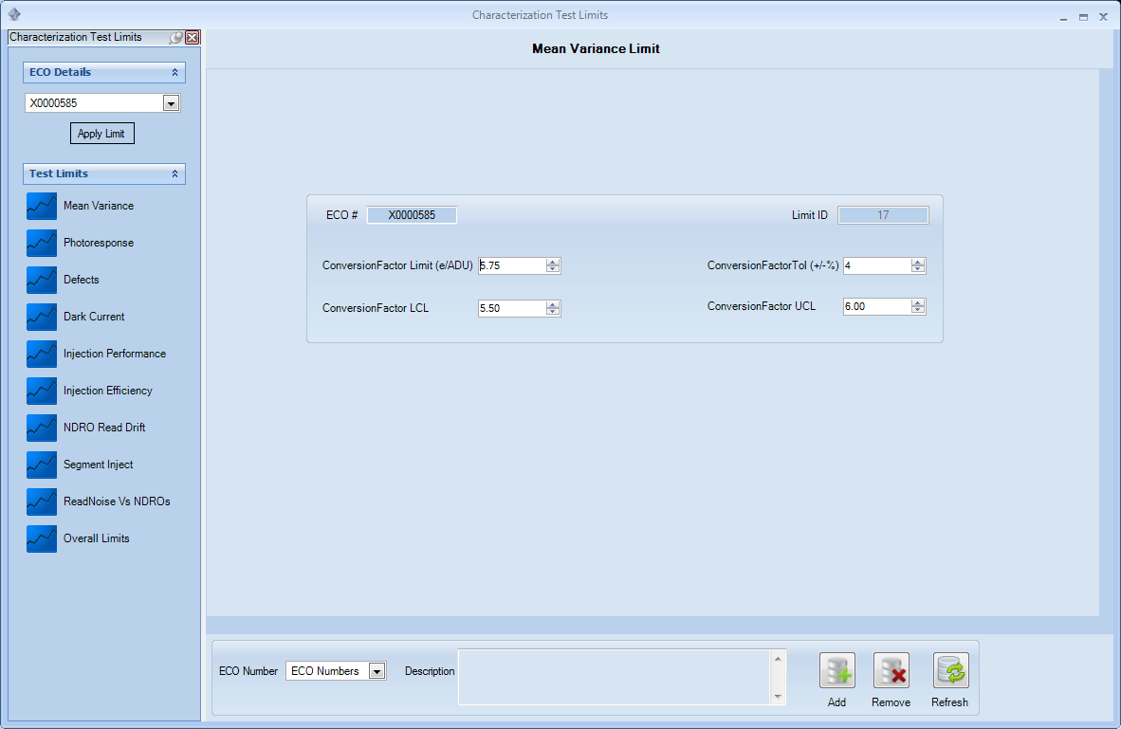
Figure 17. Characterization Test Limits

Test Results
If the user selects Tools, Test Results, Characterization Test Results dialog will be displayed as seen in Figure 18. By default, when the dialog is launched only 10 records will be displayed. This window has three sections. The section on the left side is an explorer bar which has two tabs Test Results and Filter Results. Filter Results tab has controls which can be used to filter the test results. There is a Camera Serial Number drop down which list the various Camera Serial Numbers which have been tested. The operator can also filter the results using From Date and To Date calendars and show Top 10, 20 etc., If nothing is entered in any of the controls all the test results will be displayed accordingly. From the Test Results tab a user can select a characterization test to see the test results associated with it. The results will be displayed in the right-hand section in a grid format as seen in Figure 18.
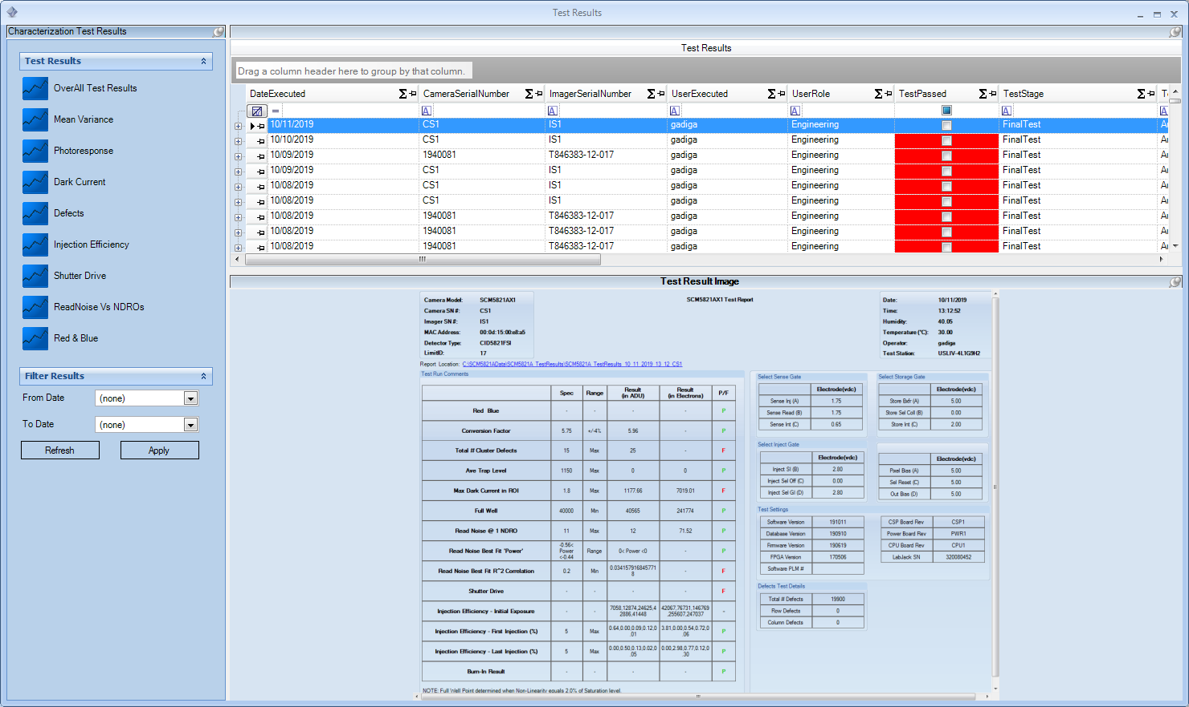
Figure 18. Characterization Test Results

The user has many options in this grid to filter the results accordingly. The operator can group the results based on Limits ID, ECO Number, Camera Serial Number etc., literally using any column from the grid for example below Figure 19 shows the results grouped by Camera Serial Number.

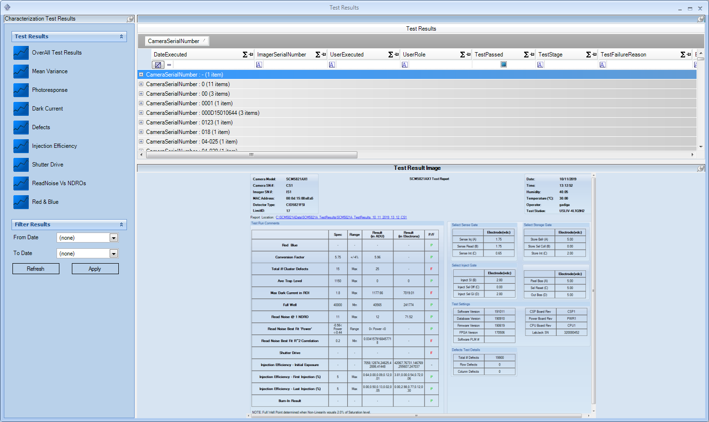
Figure 19. Test Results grouped by Serial Number

The operator can also the sort test results in the image format by selecting an image from the Result Image column in the grid which will display the test result image in the section below as seen in Figure 20.
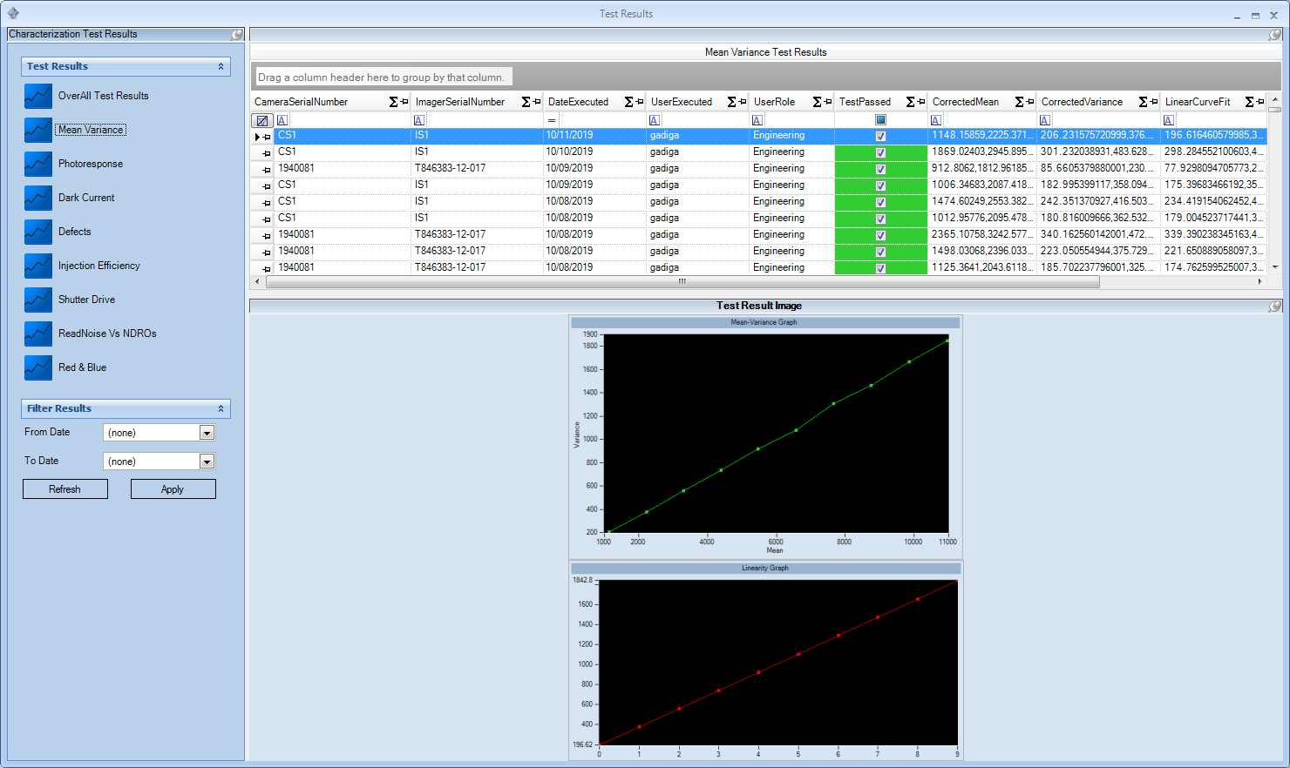
Figure 20. Image from Test Results

Image Display Test
When the user selects Tools, Image Display Test menu item, an Image Display Panel window will be displayed as seen in Figure 21. This window is basically used to perform Image test by the operator prior to any characterization test. The operator needs to drag the right mouse button and select the region of interest to proceed with the analysis. Once done the user needs to select the option Generate Subarray from the context menu, then click on the Run button on the Test Settings explorer bar. An Admin/Engineering user can make changes to the exposure settings as needed to test the image. User needs to hit on Reset Exposure button to reset the exposure settings to default.

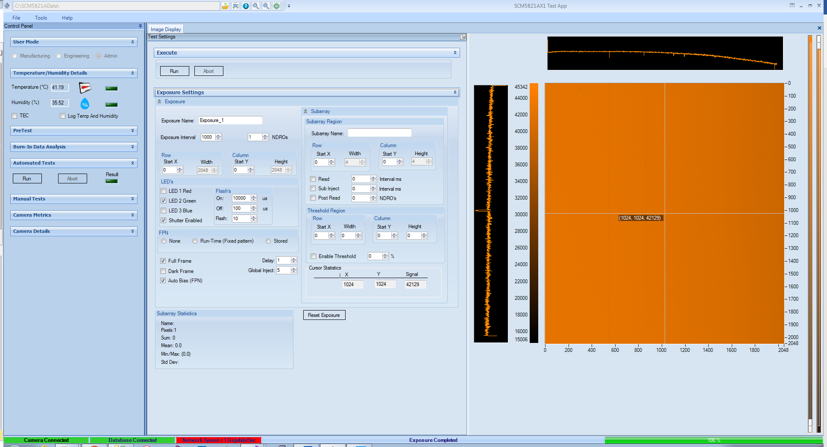
Figure 21. Image Test Window

Manage User Account

When an Admin user selects Tools, Manage User Account menu item, Manage User Account dialog will be displayed as seen below. Only an Admin user will be able to create a new user account, update an existing user’s user name, password, user role, Email Id or Subscribe for Test Failure Alerts and delete a user account.

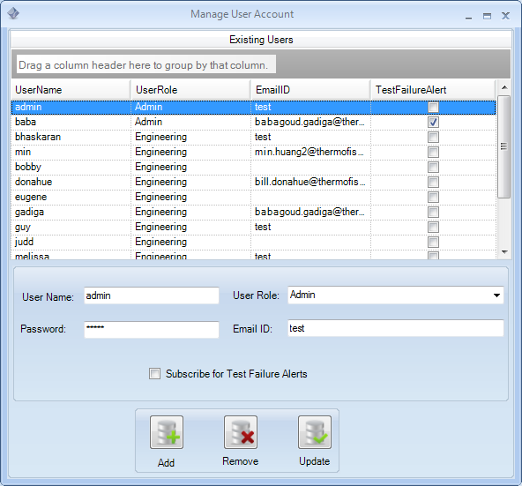

Test App Themes
When the user selects Tools, Metro, Aero, Trendy menu item or any option from More Styles menu item the test app theme will be changed accordingly. For example, before changing the theme the default window will be shown as in Figure 22.

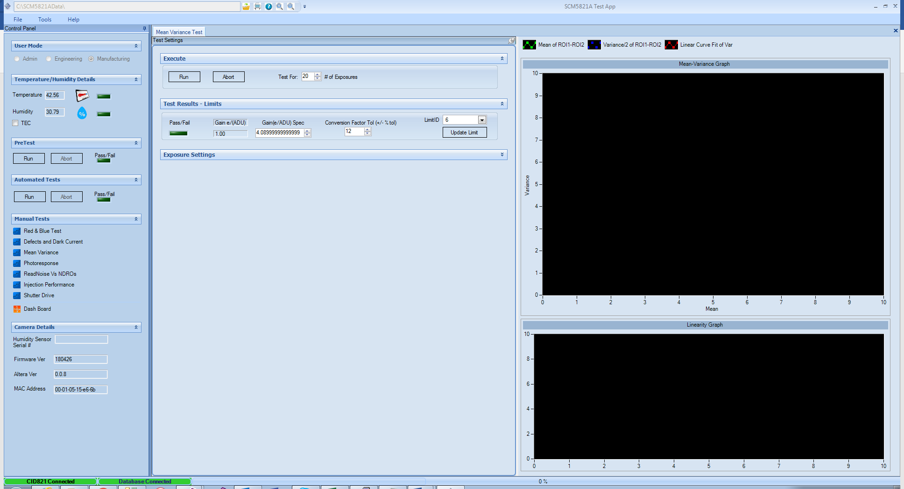
Figure 22. Test App Themes Screen Before

Later when the user selects any menu item as mentioned above, the theme will be changed as seen in Figure 23. For example, the default theme has been changed to Metro style

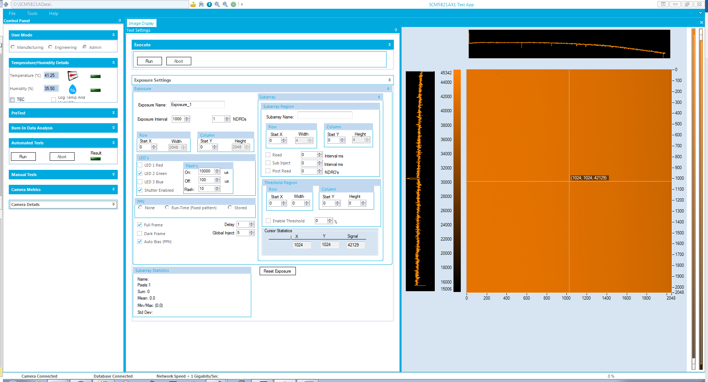
Figure 23. Test App Themes Screen After

Sending E-Mail
The Test App operator has the capability to send an email to share the test results or images with other colleagues. When the user selects File, Send Mail menu item, Send email dialog shows up as seen in Figure 24.

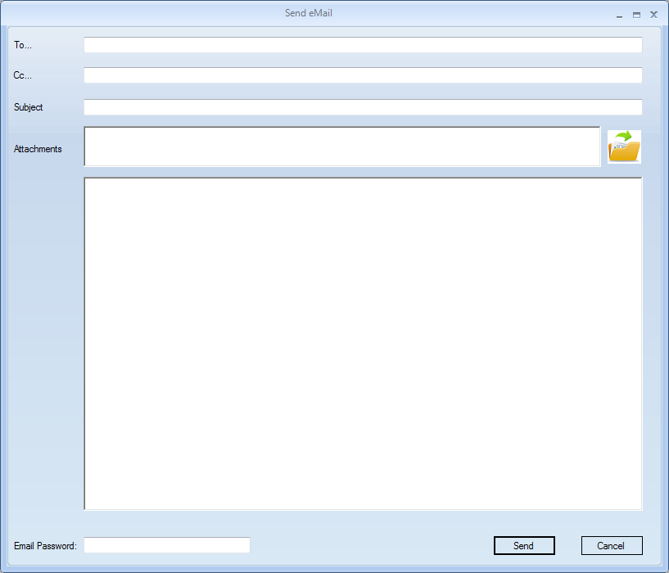
Figure 24. Send E-Mail Window

The user needs to provide their email password before sending an email.

Control Panel
The Control Panel is the main panel for the Test Application software. This panel is dockable and can be placed either on Top, Left, Right or Bottom of the screen by just dragging the Control Panel and placing it respectively. Any user can control or run characterization tests using this panel. The Control Panel is basically divided into six sections. User Mode, Temperature/Humidity Details, PreTest, Automated Tests, Manual Tests and Camera Details as seen in Figure 25.
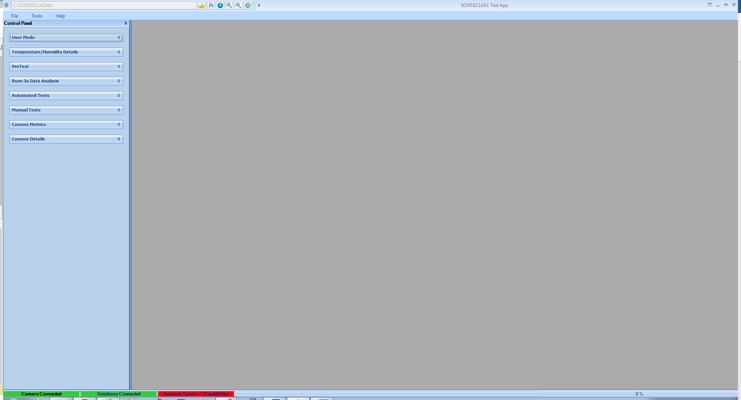
Figure 25. Control Panel

User Mode
User Mode section displays the operator level to run the test app. A user can run the test app either in Admin, Engineering or Manufacturing mode as seen in Figure 26.

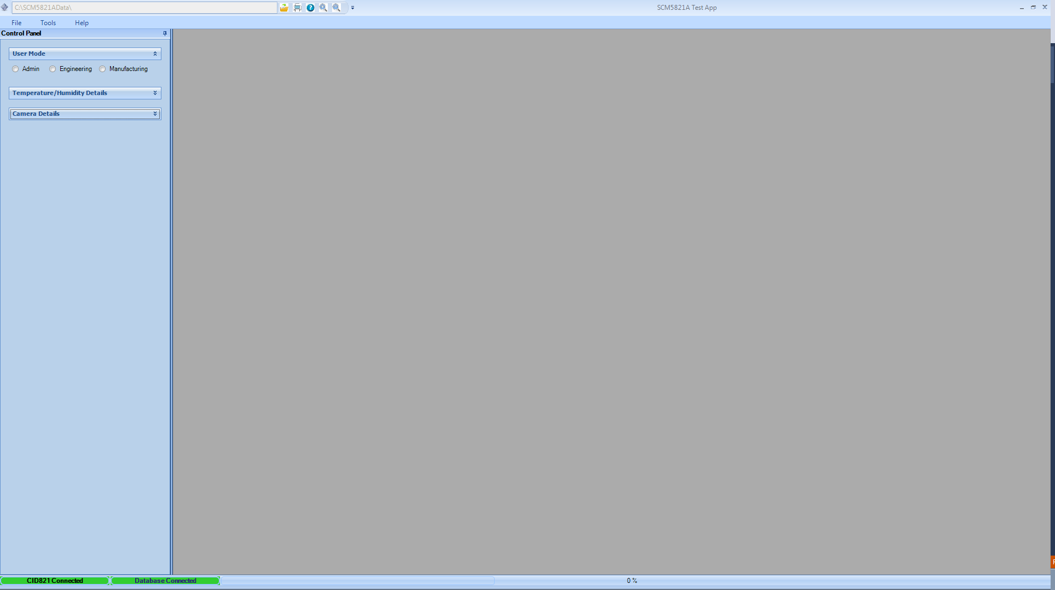
Figure 26. Control Panel User Mode

Each user mode has respective privileges to run the application. An Engineering user can only run the application and make changes to the data, but such changes will not be persisted to the Factory database. A Manufacturing user can run the application in basic mode meaning no changes can be done to any data parameters. When a user selects the Engineering or Admin option a Login dialog will be displayed as seen in Figure 27 based on the User Mode selected.
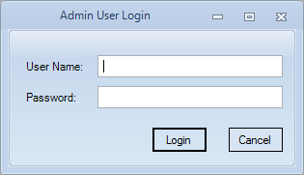

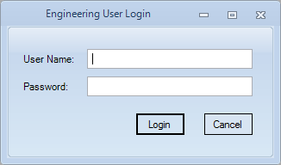
Figure 27. User Login Dialog

An Admin user will have the highest privileges to run the application. For example, this user can make changes to the Exposure Data, Change Limits Data, add other users etc. which will be persisted in the Factory Database.

Temperature/Humidity Details
This section displays the real time values of the Camera Temperature and Humidity levels as seen in Figure 28. Based on the target temperature and humidity values respective LED’s will set to green or red based on which the user can decide to run the Final test or in Manual test mode.
The TEC checkbox lets the user to run the test app under targeted values. For example, setting this option will send the enable TEC message to the Firmware to cool the camera temperature to targeted value -45.0 Celsius.

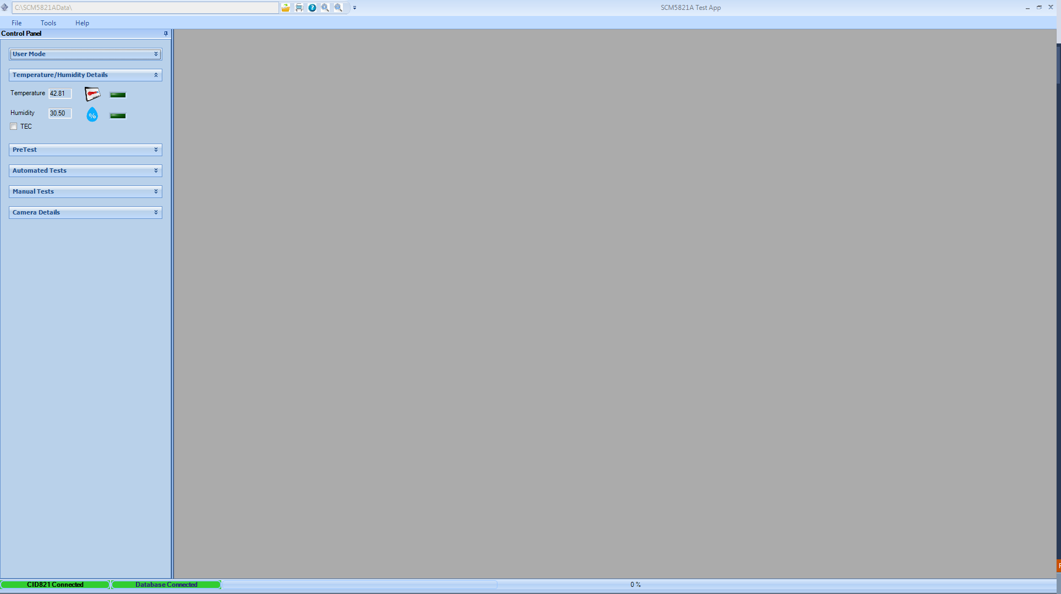
Figure 28. Control Panel Temperature/Humidity Details

Along with these values users can visualize the values in a graphical manner in a separate window by clicking on either the Temperature of Humidity icons as seen in Figure 29.

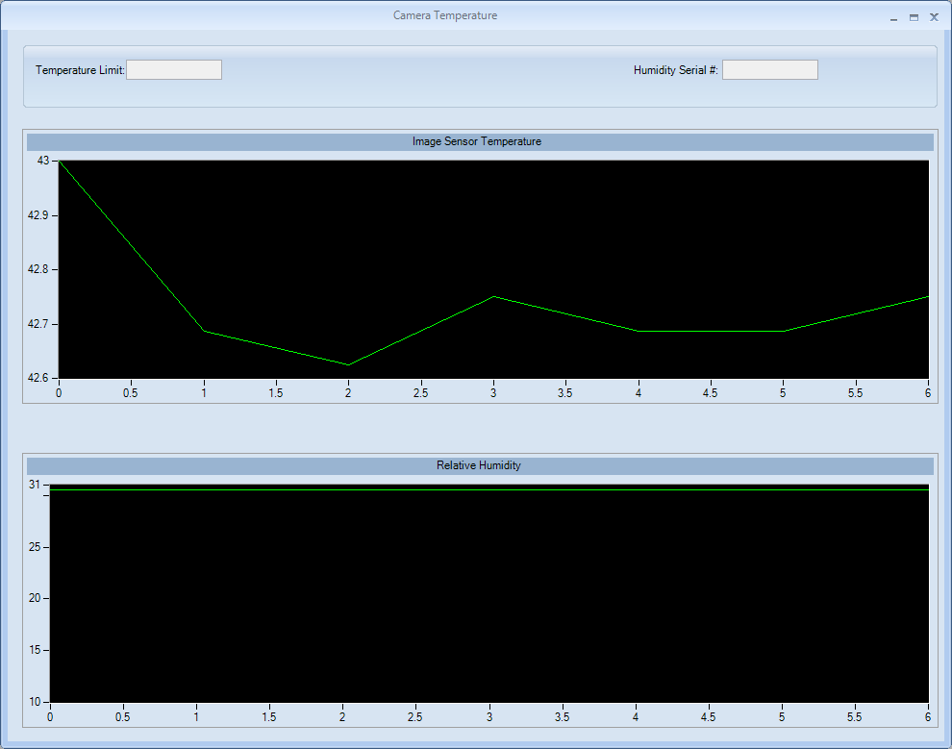
Figure 29. Temperature/Humidity Details Graphical

Camera Details
As seen in Figure 30 this section provides information related to the Firmware Version, Altera Version and MCA Address of the Camera.

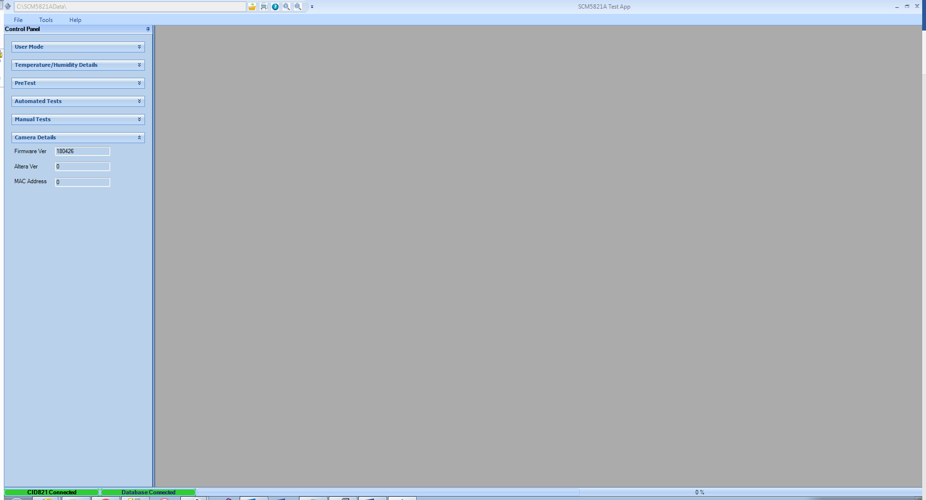
Figure 30. Control Panel Camera Details

Characterization Pretest
As seen in the Figure 31, this section, lets the user run the characterization test in a Pretest mode.

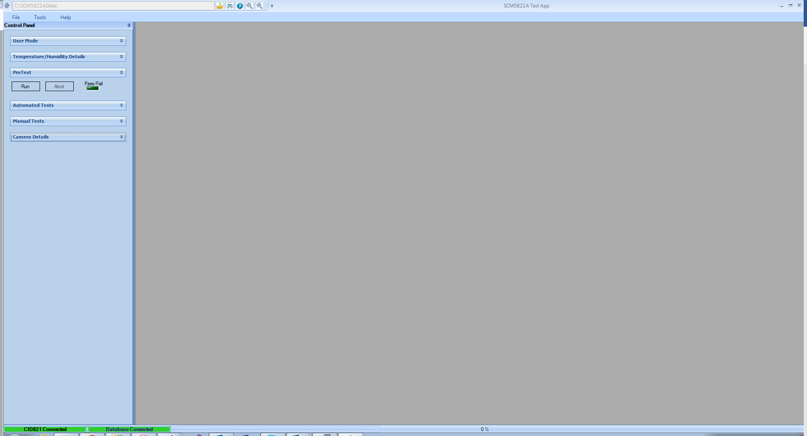
Figure 31. Control Panel Pretest

When the user clicks on the Run button, Operator Input dialog pops up for the user to enter the camera information as shown in the below figure.
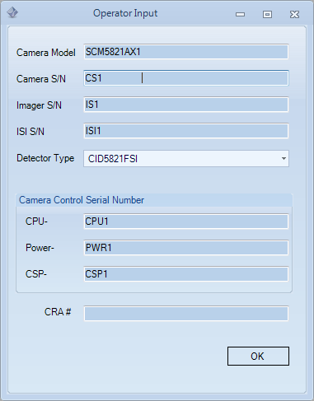

After the user enters the details in the above screen and hit on OK button a pop up dialog window will be shown as seen in Figure 32 where the user can select the tests to run as part of the Pretest.
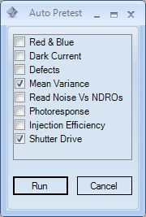
Figure 32. Pretest Dialog

Figure 33 below shows the Pretest main screen where the user has selected the respective tests to run in previous dialog.

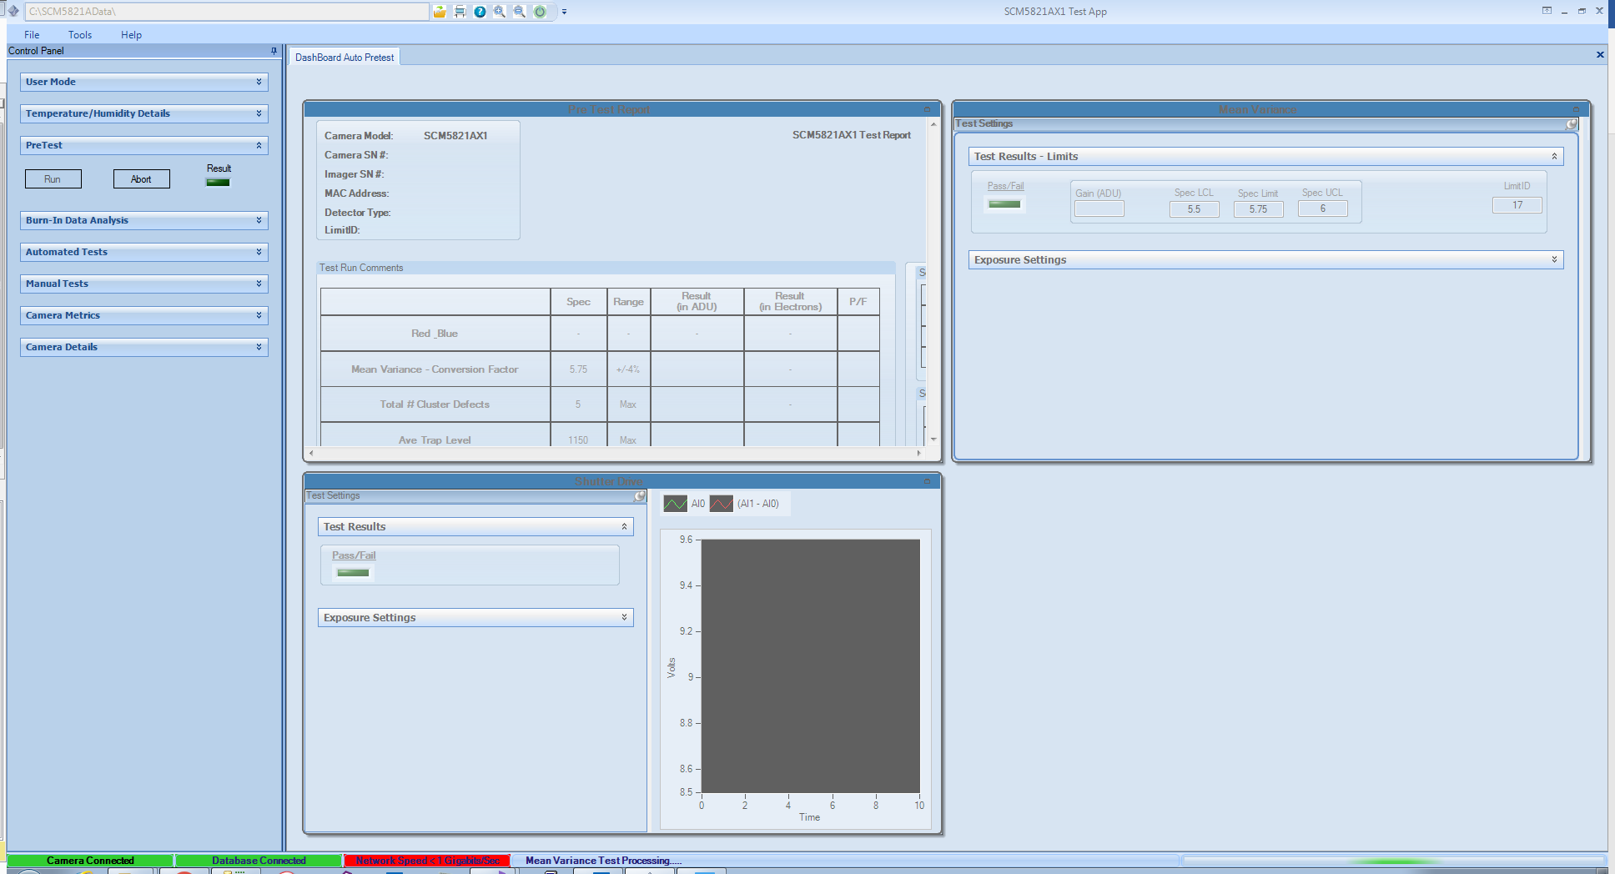
Figure 33. Pretest Main screen

Characterization Auto Test
As seen in Figure 34 below, this section lets the user to run the characterization tests in Auto Test / Final Test mode.
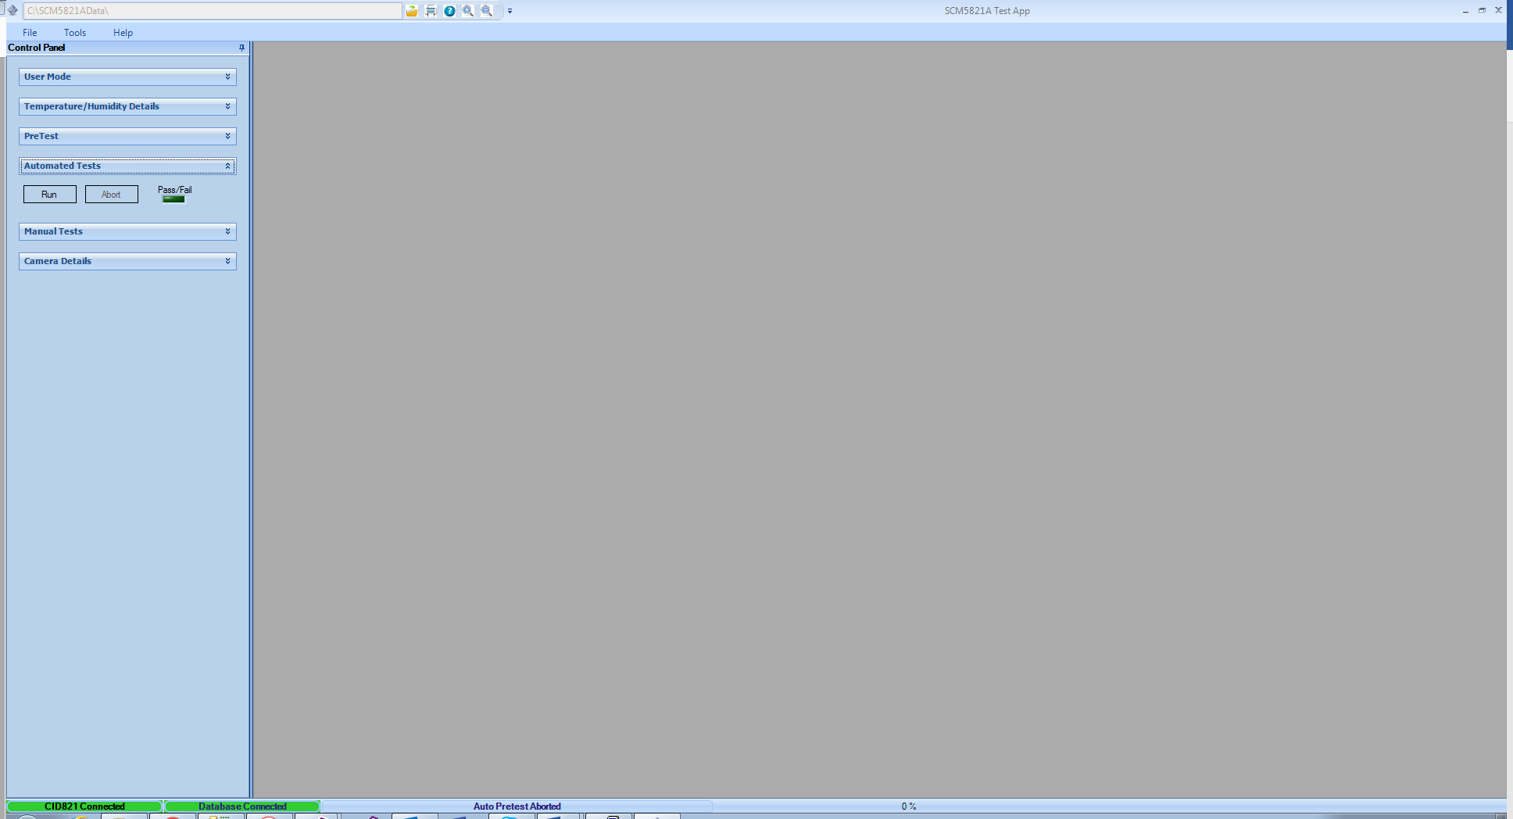
Figure 34. Control Panel Auto Test

When the user clicks on the Run button, an Operator Input dialog will be shown as seen in Figure 35 below. The operator needs to provide all the necessary information related to the Camera which is under Final test.
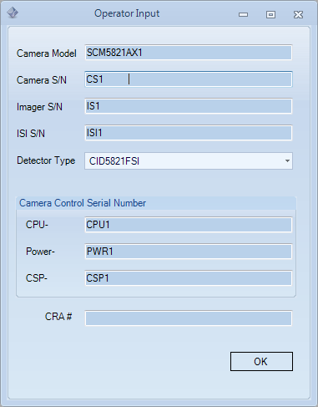
Figure 35. Operator Input

Once the user clicks on the OK button, an Auto Test dialog will be displayed as seen in Figure 36 where the user can select the Test Results path where he can store the results locally and also change the order of characterization tests. By checking the Abort Auto Test check box on the bottom on the dialog the user can abort the test if any of the characterization test fails. By default the auto test continues running all of the test even though a single test fails.
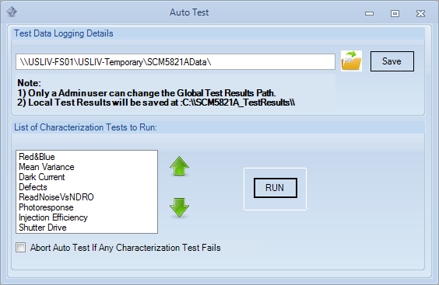
Figure 36. Auto Test Dialog

Once the user clicks on the Run button, the user can see the Auto Test main screen as seen in Figure 37, each characterization test will be under its respective tile windows. These tiles will be initially disabled when the test is run. Each tile will be enabled when that test is completed.

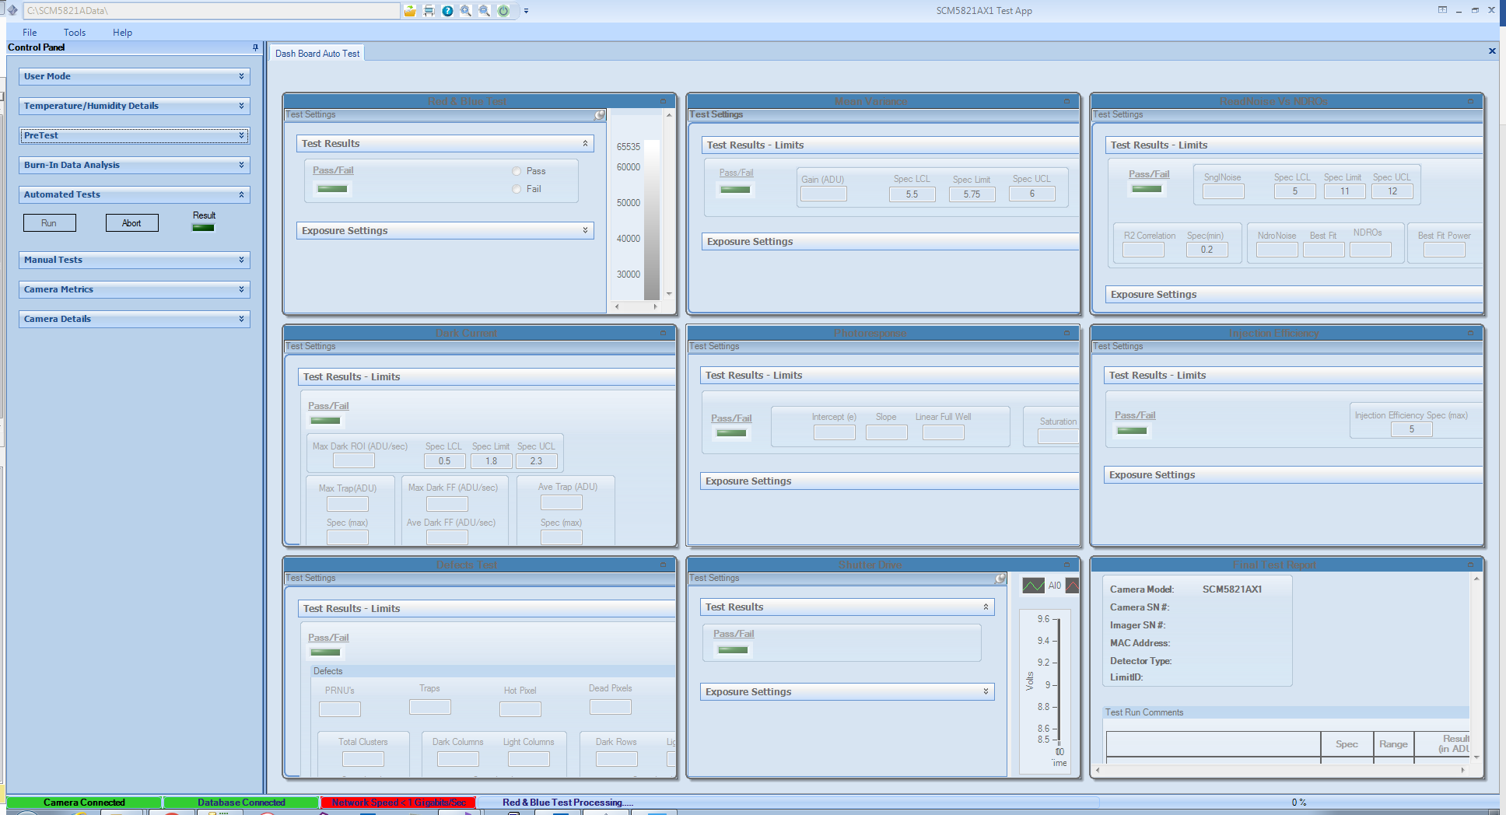
Figure 37. Auto Test Main Screen Tiled Window

At any point of time the user can click on the Abort button to abort the entire Final Test.

Manual Characterization Test

The Test Application performs the basic characterization routines of the CID821 imager and camera and displays the results using several plot waveform graphs. The Optoelectronics dialog under the tools menu is seen below. Mean-Variance determines the gain (electrons per count) and can be used to verify read noise. Linearity determines the full-well capacity, saturation, trap level (fat-zero), and deviance from true linearity. Read Noise versus NDROs noise should reduce as the square root of the number of NDROs. Dark Current noise in the overall signal measured at the specified CID operating temperature around -45 C. Charge Injection Efficiency determines mean-signal after the subarray injection.
Using this feature as seen in Figure 38 a user can run each characterization test manually making any changes to the exposure settings, limits/specs and see the test result in the test screen.

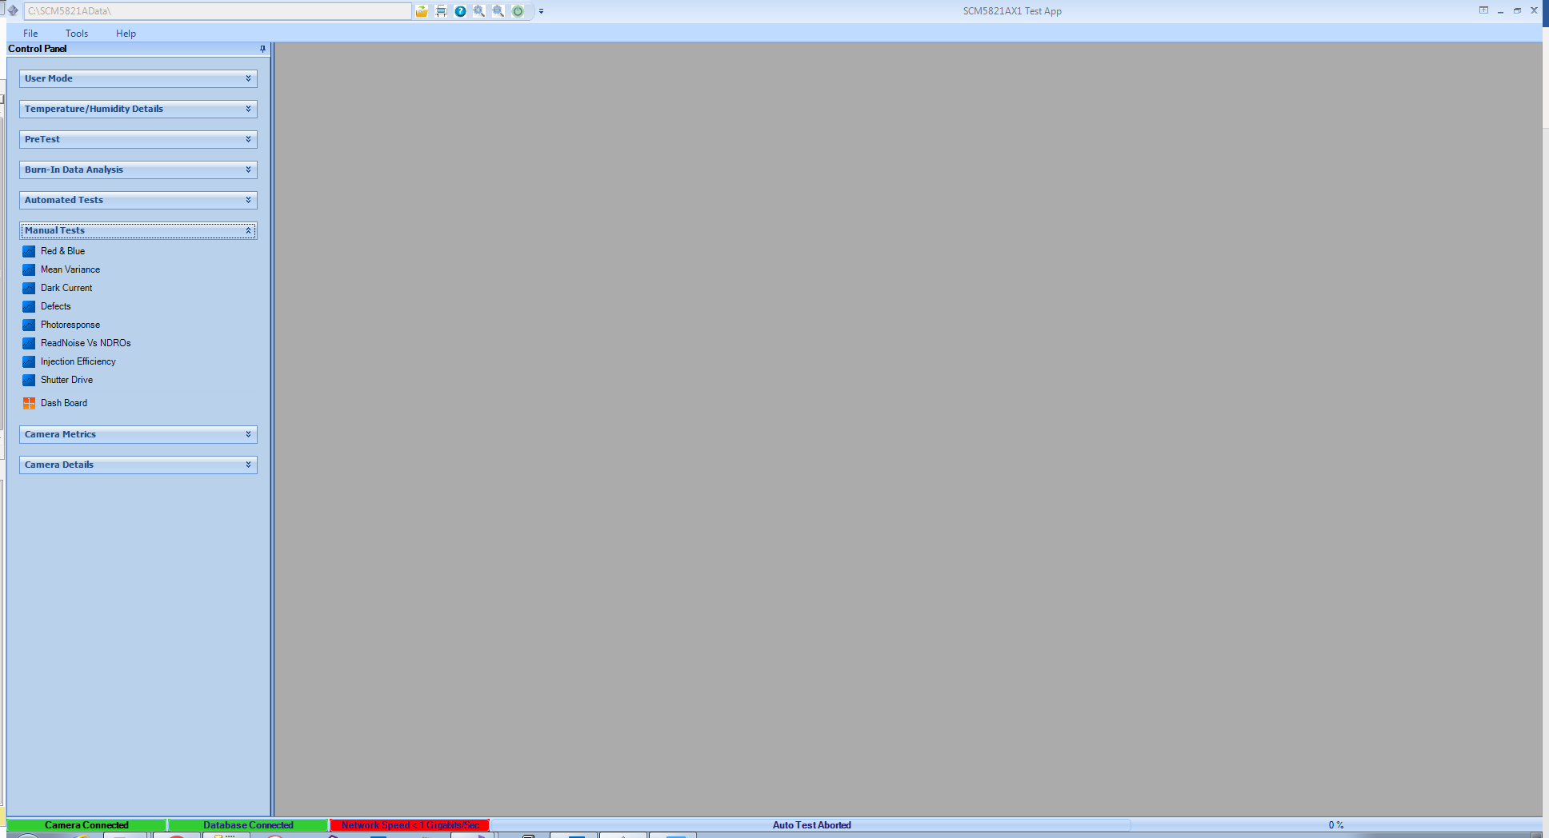
Figure 38. Manual Test Main Screen

For example, when the user selects the Mean Variance Test, a Mean Variance Test tab will be opened in the main screen as seen in Figure 39.

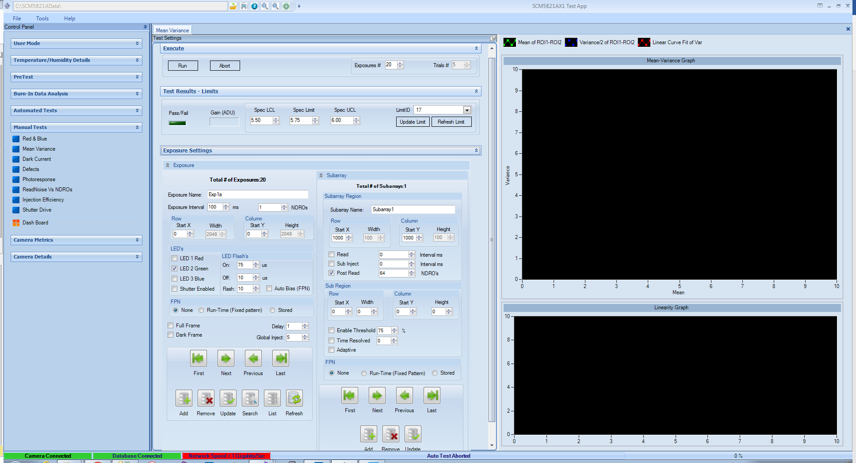
Figure 39. Mean Variance test Screen in manual mode

The operator can run the test by clicking the Run button from the Execute tab, abort the test by clicking on the Abort button. The user can also select the number of exposures they want the test to run.

In the Test Results – Limits section, the user can see the test results and various limits/specs associated with the test. Under the Exposure Settings tab, the user can make changes to each exposure, a user can add/remove/search or update an exposure setting. Only an Admin user can make the changes which will be persisted to the database. A Manufacturing/Engineering user can only make the changes which will be persisted to memory or until the application is not running. For trouble shooting a user can select the limit from the LimitID drop down and apply that limit by clicking on the Update Limit button for test pass/fail condition. If the user does not see any updated limits they can click on Refresh Limit to pull the updated data from database.
Using the buttons as shows in Figure 40 below the user can Add/Remove/Update/Search and navigate through the exposures that reside in the database. Clicking on Add/Remove/Update buttons enable the user to make changes to any one individual exposure that is displayed on the Exposure Settings section. If the user needs to view and make changes to multiple exposures at a time, then the user needs to hit on List button shown in the below image.

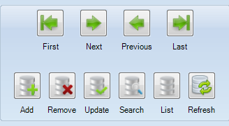
Figure 40. Navigation/Manipulating Exposure Settings
Once the user hits on the List button a separate window will show where the settings related to multiple exposures are shown in a grid format as shown below. If the user is logged in as a Engineering user, the user just needs to make changes as needed and close the window.

If the user is logged in a Admin user, he needs to hit on the Update button below to make changes permanent to the database.

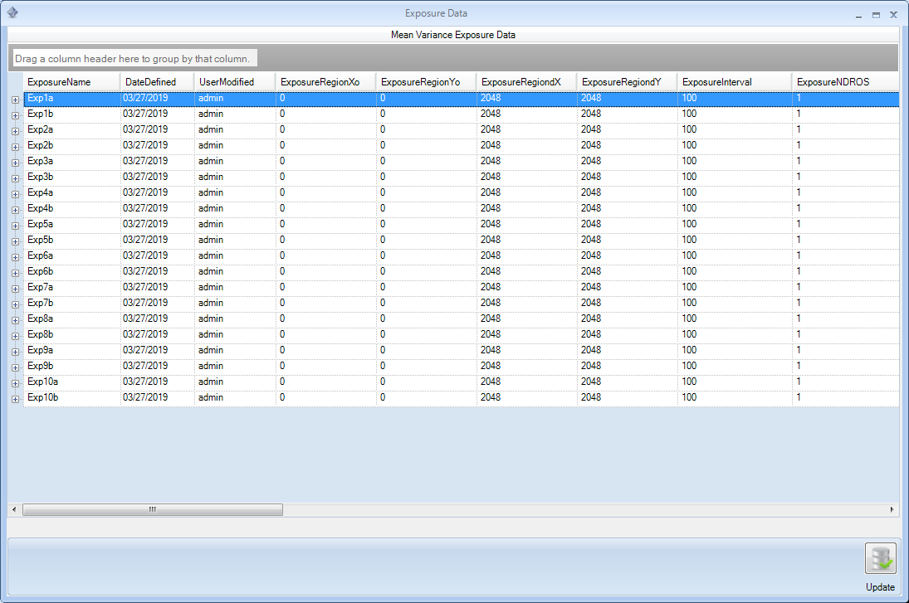

Status Bar
The Status Bar as shown in Figure 41 has 4 different sections. Section one shows the Camera Connection status, section two shows the Database connection status, section three shows the Network Speed of the ethernet/internet connection, section four shows the characterization test that is currently running and last section shows a progress bar which displays the progress status of each test.

Figure 41. Status Bar

Burn In Analysis

Using the Test app, user will now be able to perform Burn-In analysis. When the camera is connected and the test app is launched, the test app will look for the Burnin.sh file on the camera if the test app finds this file, the main screen shows the Burn-In Data Analysis section on the control panel of the main screen as shown below.

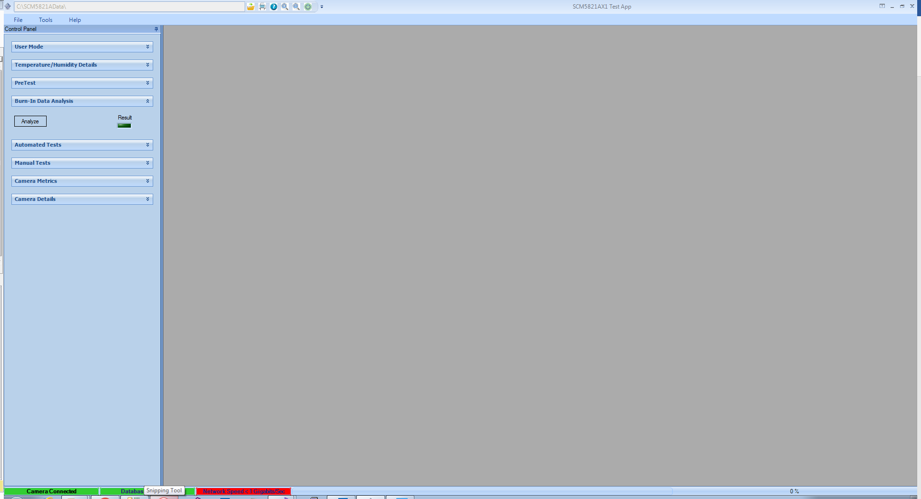

User needs to hit on the Analyze button to start analyzing the burnin files. Once the burnin analysis is completed a pop-up window opens up showing the results of the analysis as shown in the below figure. User has to select either Pass/Fail or Cancel radio buttons to save the results. The BurnIn files will be deleted from the camera when the user selects the Pass radio button. Selecting either Fail or Cancel button will enable the users to redo the analysis.

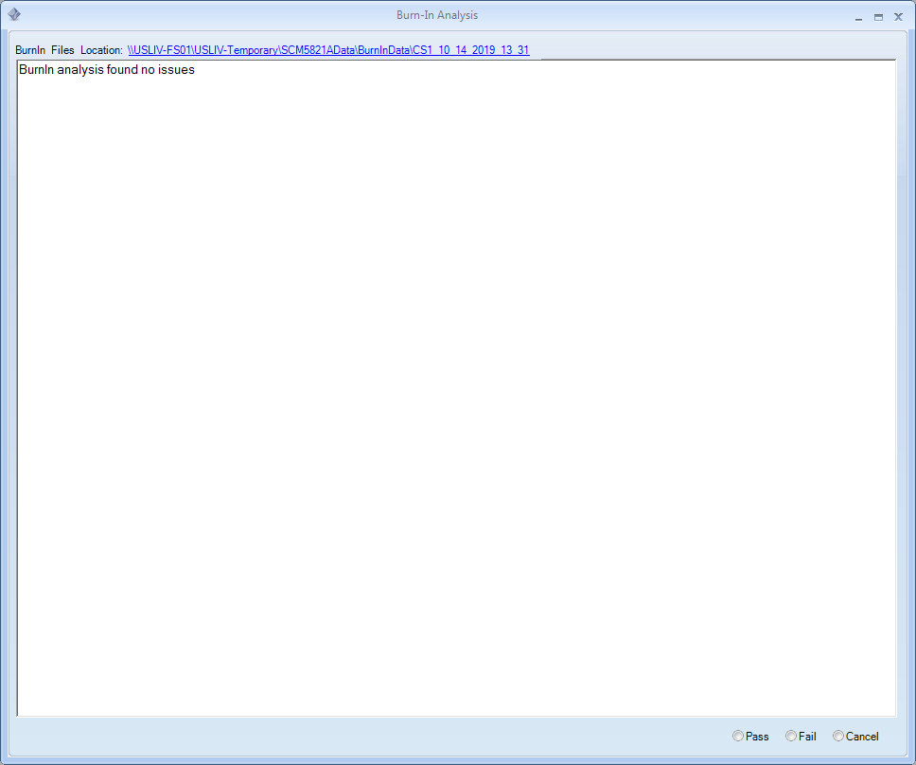

Once the Burn-In analysis is done, user can view the results of all the past burn-in analysis details by selecting menu option Tools-> Burnin Results. A separate window will be shown the burn-in results in a grid format as shown in the below figure.

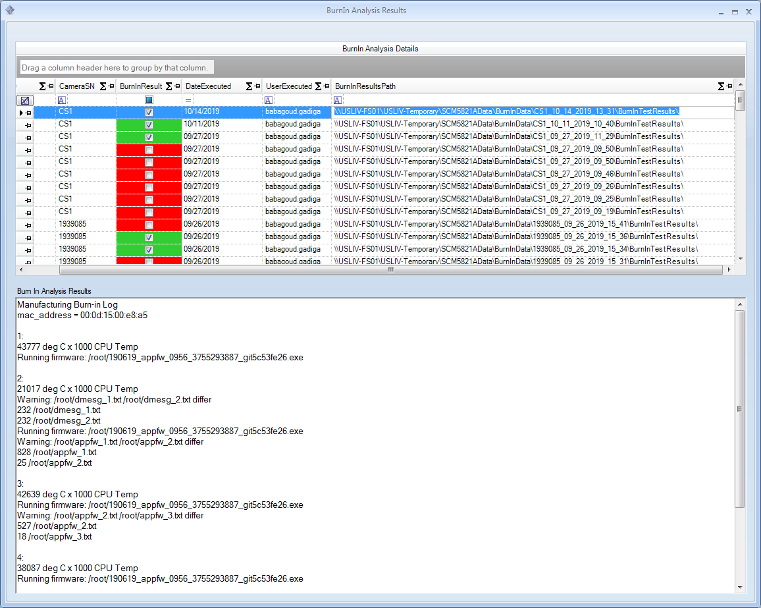

The Burn In Analysis results text box above shows the cotents of the Mfglog file stored on the camera.

Upload BurnIn Files
Using test app, user has the ability to upload the Burnin script files onto the camera. User needs to select menu option Tools->Upload Burnin Files. This functionality varies based on the type of user. If the user is logged in as a manufacturing user, test app will automatically upload the latest burin in files located on the shared drive onto the camera.

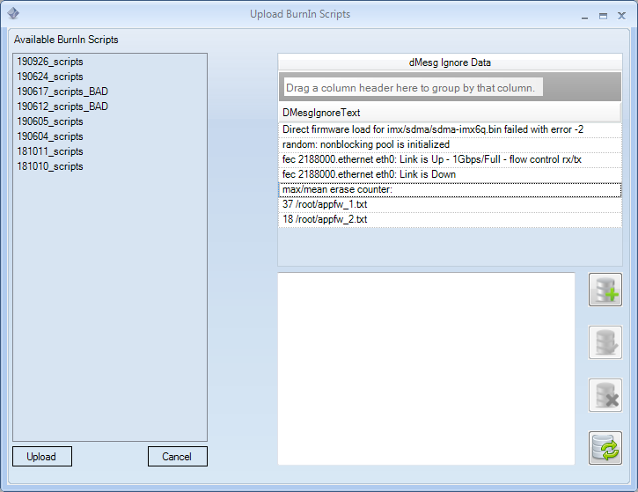

If the user is logged in as a Engineering or Admin user, test app will let the user to select the appropriate burn-in script files.

User can Add/Remove or update the DMesg Ignore contents that needs to be ignored while performing the burn-in analysis.

Camera Test Logs
Using test app, the user can look at the camera test metrics. The camera metrics window as shown in the below figure displays the Final and Pretest metrics of various cameras tested so far. All users has the ability to update the Failure Modes, Root Cause, Symptoms and Disposition details related to any camera that has failed testing. User has to select the Update button to make the changes persistent in database.

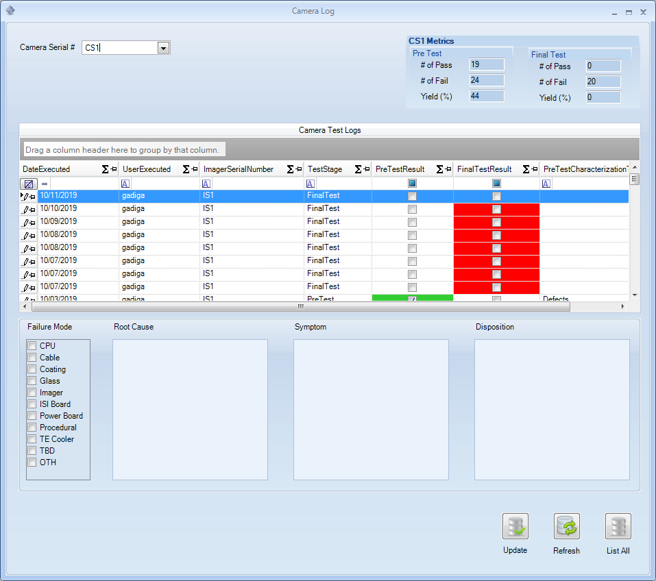

Report Application Issue
Test app enables the user to create new work items to be reported for any application bug or features. Select Help-> Report Application Issue from the menu bar. The below window will be displayed as shown below.

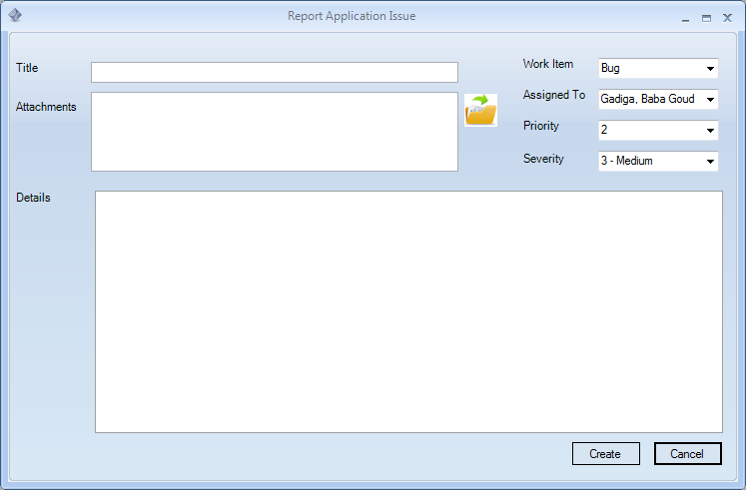

User can create a new bug or feature with or without attachments and assign to users which will eventually create the work item in the TFS server and an email notification will be sent to the development team accordingly.

Installation and Help

To install the application double, right click on the Setup.exe file and select the option Run as an administrator.
If there is a previous version already installed on the PC it will have to be uninstalled first. Once the application is installed, it can be run by clicking the windows Next button and going into C:\Program Files\Thermo Fisher Scientific\KronosTestApp\

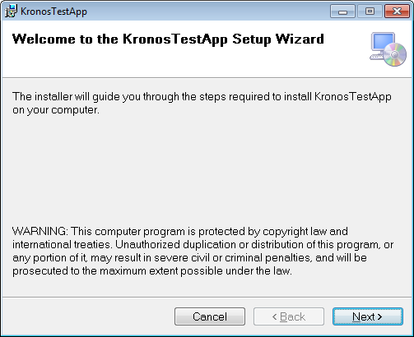
Figure 6. Test App Setup Wizard

Step through the wizard and select Next >
Accept the license agreement terms and select Next>
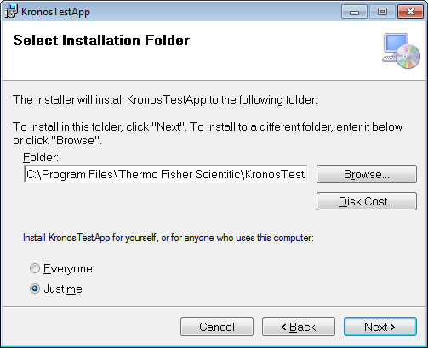

Select an installation folder where the application is to be installed on the PC and select Next >

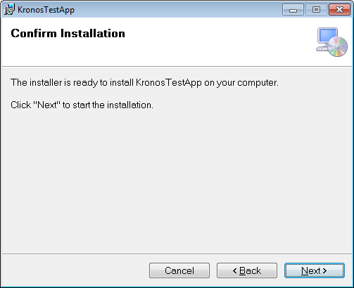

Select Close at the last install screen to complete the full installation of the Test App program. A short cut icon for the test app will be saved on the user’s desktop.
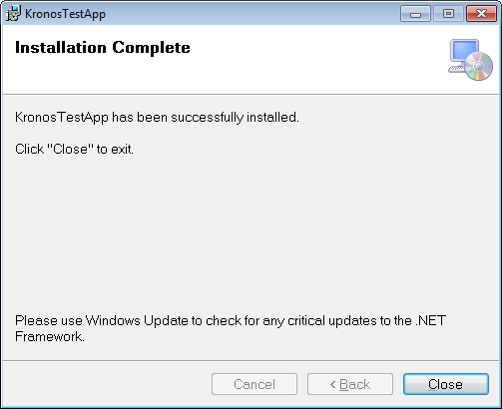

This User Guide can also be loaded from the Help, User Guide menu.
Structure definitions:

Region | y0 | The upper left row pixel number of rectangle region for a Subarray
 | x0 | The upper left column pixel number of the region for a Subarray
 | dy | The number of pixels, Rows, offset from y0, to create a Subarray (y0 + dy) < 2048
 | dx | The number of pixels, Columns, offset from x0, to create a Subarray (x0 + dx) < 2048

Subarray | Name |  |  |  | Unique name for this subarray (ROI). Name must not contain spaces.
 | Threshold active |  |  |  | Indicates whether the subarray processing should perform post-injection
based on ADU value in threshold.
See Region definition above.
 | Read enabled |  |  |  | Enable the read for this subarray
 | Read interval |  |  |  | The time in microseconds between non-destructive reads during the exposure.
 | Subinject enabled |  |  |  | Enable the Subinject to clear a subarray.
 | Subinject interval |  |  |  | Duration of time in microseconds to clear the subarray.
 | Postread enabled |  |  |  | Enable an optional read of subarray after the exposure ends.
 | Postread NDROs |  |  |  | Number of non-destructive reads during the post read.
 | Subarray FPN |  |  |  | Fixed Pattern Noise correction for the subarray (None, Fixed, Auto, or Stored).
 |  |  |  |  | See section 6. Method for FPN correction details.
 | Threshold enabled |  |  |  | Causes the subarray region to be cleared after a read if the mean exceeds threshold.
 | Threshold percent |  |  |  | Threshold value that has to be exceeded that causes the subarray to be cleared.
 | Threshold region |  |  |  | See Region definition above. Threshold region is a small region of interest inside
 |  |  |  |  | a subarray. This could be a single pixel of interest that the threshold is measured.
 | Time Resolved |  |  |  | Interval that will override the Read Interval. Allows fast changing image mean to
 |  |  |  |  | trigger more frequent reads.
 | Adaptive enabled |  |  |  | Adaptive attribute allows a scheduled read to be advanced to avoid crossing the
 |  |  |  |  | threshold.
 | Read interval |  |  |  | The time in microseconds between non-destructive reads during the exposure.

Exposure
 | Exposure Interval | The time in milliseconds the pixels are exposed to light.
 |  | Dark current is measured by an exposure without any light.
 | Exposure NDROs | Dark frame of Full frame may have a different number of NDRO’s than Subarrays.
 | Exposure region | See above for region definition. Exposure region can be a full frame.
 | Exposure FPN | Fixed Pattern Noise for the entire exposure.
 | LED Ontime | Indicates the duration the LED is on.
 | LED Offtime | Indicates the duration the LED is off.
 | LED Flashes | The number of LED flashes during the Ontime.
 | LED Enabled(1,2,3) | Indicates which LED will be on.
 | Shutter Enabled | Indicates if the shutter will open during an exposure.
 | Full Frame Enabled | Enable a full frame exposure for the exposure interval.
 | Dark Frame Enable | Capture a dark frame exposure for FPN correction.

