WINDOWS SECURITY MONITORING
& FAILED-LOGIN DETECTION USING SPLUNK
SOC Analyst Project Report

Prepared as a practical cybersecurity/SOC monitoring project

Prepared by: G.Vaishnavi
Program: B.Tech – Cybersecurity
Institution: SVIT
Academic Year: 2026–2027

1. Abstract
This project demonstrates a beginner Security Operations Center (SOC) monitoring workflow using Windows Security Event Logs and Splunk Enterprise. Windows logs were collected using Splunk Universal Forwarder and sent to Splunk Enterprise running on an Ubuntu virtual machine. Splunk Search Processing Language (SPL) was then used to analyze authentication events, investigate failed logins, configure a detection alert, and visualize the results in a security monitoring dashboard.

2. Objectives
- Collect Windows Security, System, and Application logs.
- Forward Windows logs to Splunk Enterprise on Ubuntu.
- Analyze Windows authentication events using SPL.
- Investigate successful and failed authentication events.
- Create a repeated-failed-login detection.
- Configure a scheduled Splunk alert.
- Create a Windows Security Monitoring dashboard.

3. Lab Architecture
Windows System → Splunk Universal Forwarder → Ubuntu VM → Splunk Enterprise → SPL → Detection → Alert → Dashboard
The Windows system acted as the monitored endpoint. Splunk Universal Forwarder collected Windows Event Logs and forwarded them to Splunk Enterprise running on Ubuntu. Splunk was configured to receive forwarded data on TCP port 9997. The collected Security events were stored in the main index with sourcetype WinEventLog:Security.

4. Log Collection Configuration
The Windows Universal Forwarder was configured to collect:
- Security
- System
- Application
[WinEventLog://Security]
disabled = 0
index = main
sourcetype = WinEventLog:Security
The Security log was the primary source used for authentication investigation.

5. Important Windows Event IDs
Event ID | Meaning | Project Use
4624 | Successful logon | Successful authentication analysis
4625 | Failed logon | Failed-login detection
4634 | Logoff | Session analysis
4648 | Explicit credential logon | Authentication investigation
4672 | Special privileges assigned | Privilege monitoring
4688 | New process created | Process monitoring

6. Security Event Analysis
index=main sourcetype=WinEventLog:Security
| stats count by EventCode
| sort - count
The investigation showed multiple Windows Security event types. The authentication-focused analysis concentrated on Event IDs 4624 and 4625.
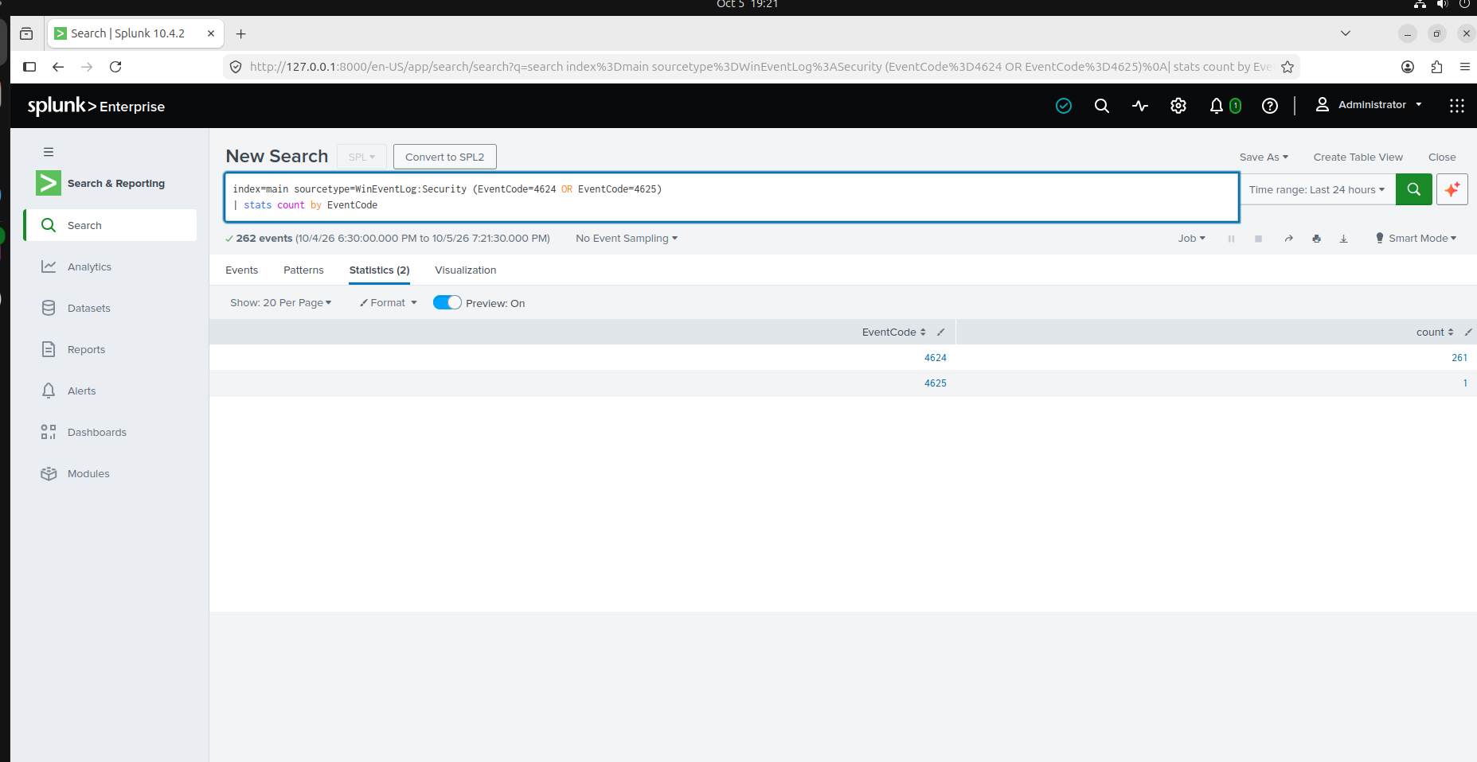
Figure 1: Successful and failed Windows authentication event counts.
In the displayed search, 261 successful logon events (4624) and 1 failed logon event (4625) were returned for the selected time range.

7. Successful Logon Analysis
index=main sourcetype=WinEventLog:Security EventCode=4624
| stats count by Logon_Type
| sort - count
Logon Type | Observed Count | Meaning
5 | 227 | Service
2 | 28 | Interactive
0 | 2 | System-related

8. Failed Login Investigation
index=main sourcetype=WinEventLog:Security EventCode=4625
| table _time, Account_Name, Logon_Type, Source_Network_Address, ComputerName, EventCode
| sort _time
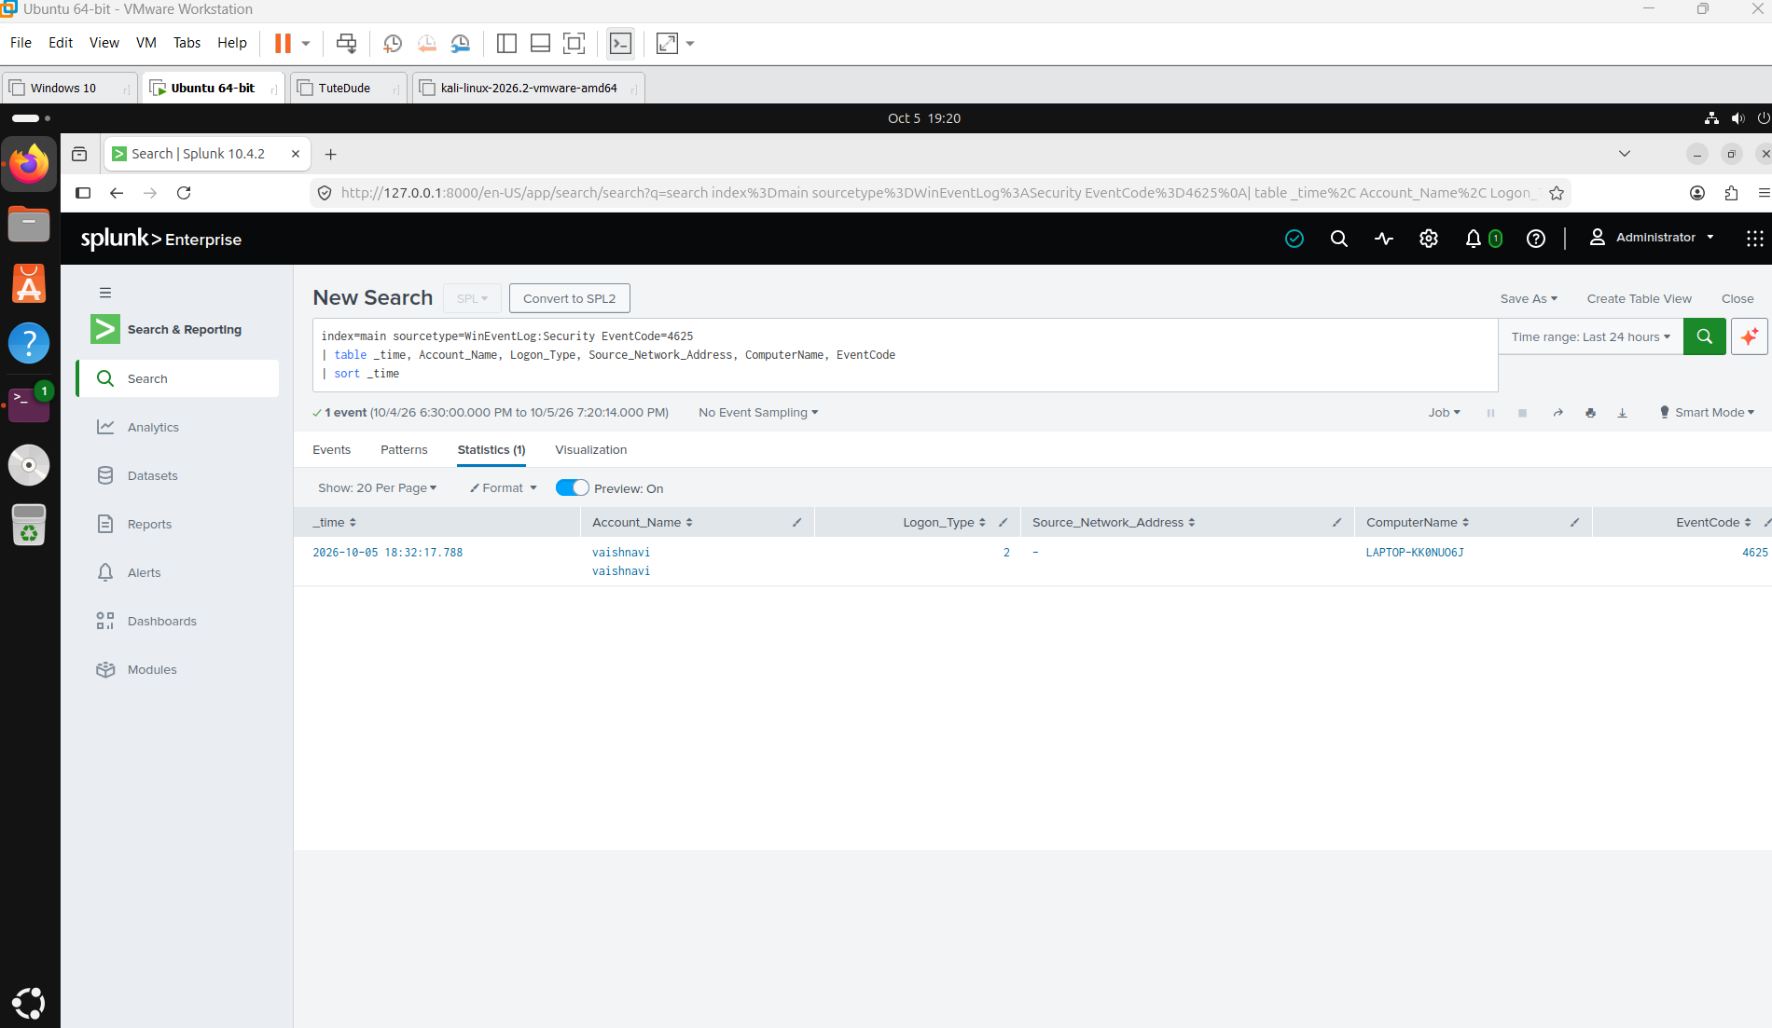
Figure 2: Detailed investigation of the Event ID 4625 failed-login event.
The investigated event occurred at 2026-10-05 18:32:17.788. The account shown was vaishnavi, the Logon Type was 2 (Interactive), the source network address field displayed '-', the computer was LAPTOP-KK0NUO6J, and the event code was 4625.
This confirms a failed authentication event. The available evidence does not, by itself, prove that the event was a brute-force attack.

9. Failed-Login Detection
index=main sourcetype=WinEventLog:Security EventCode=4625
| stats count by Account_Name
| where count >= 2
For the lab demonstration, a threshold of two failed logins was used. The dashboard later showed the vaishnavi account with a count of 2. This is a demonstration threshold and should not be interpreted as proof of malicious activity.

10. Splunk Alert Configuration
An alert named Multiple Failed Windows Logins was created and enabled. It was configured as a scheduled alert running hourly, at 0 minutes past the hour. The trigger condition was configured as Number of events is greater than 0, with Add to Triggered Alerts selected as the action.
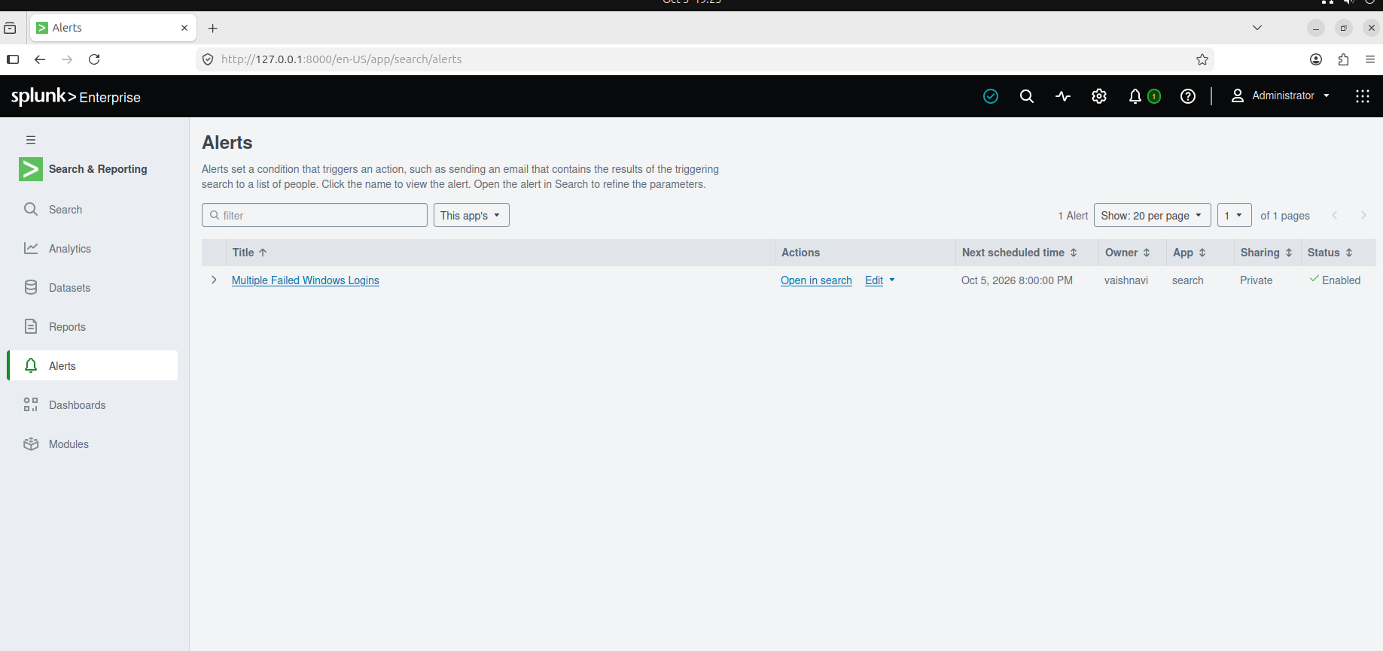
Figure 3: Multiple Failed Windows Logins alert in Splunk.
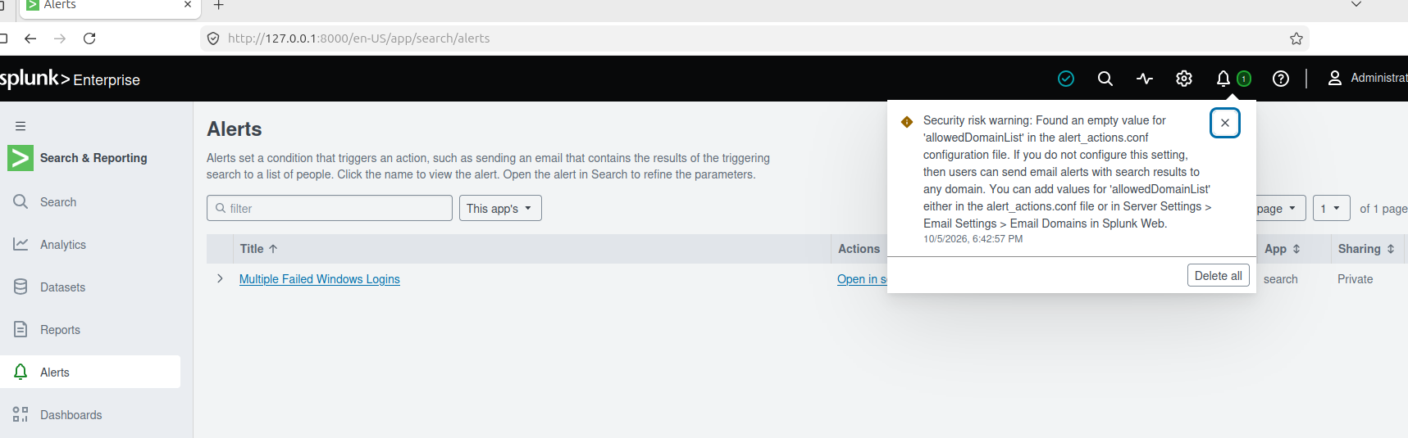
Figure 4: Scheduled alert and trigger configuration.
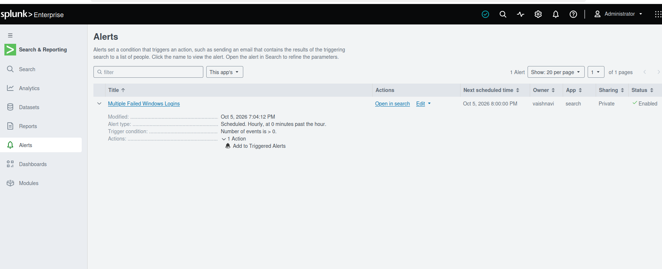
Figure 5: Enabled alert with Add to Triggered Alerts action.

11. SOC Dashboard
A Windows Security Monitoring dashboard was created to provide a visual overview of the authentication and security-event data. The dashboard contains panels for successful versus failed logins, failed logins by account, failed-login activity over time, successful logins by logon type, Windows Security Events, and potential repeated failed logins.
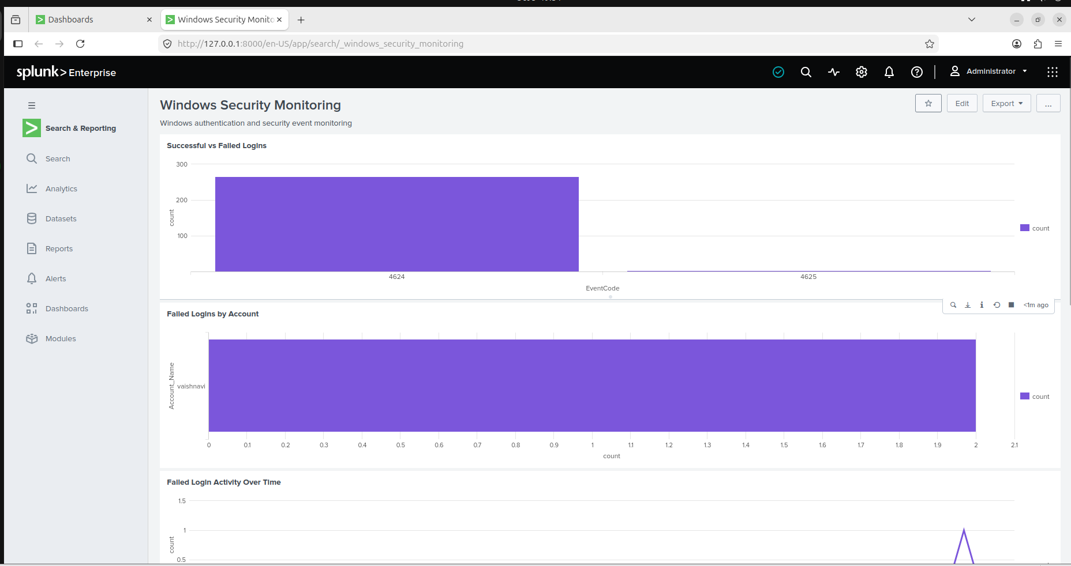
Figure 6: Windows Security Monitoring dashboard — authentication overview.
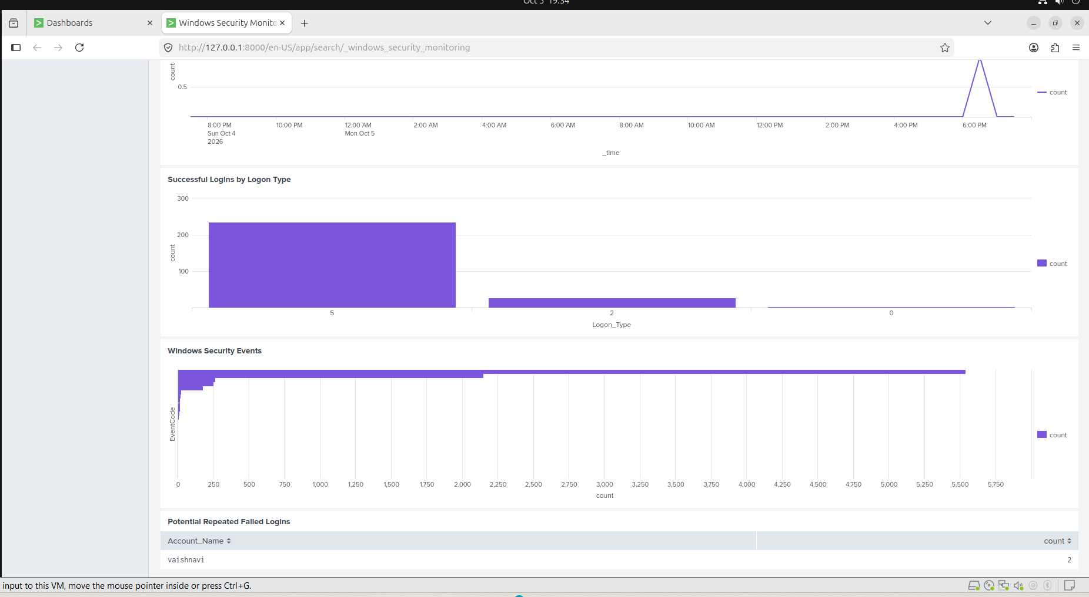
Figure 7: Windows Security Monitoring dashboard — detailed security panels.
The dashboard shows two failed-login events associated with the vaishnavi account in the panel used for repeated failed logins. It also shows the distribution of successful logons by logon type and the wider Windows Security Event activity.

12. Final SOC Investigation
The investigation identified failed Windows authentication activity associated with the vaishnavi account. The detailed Event ID 4625 event was an Interactive Logon Type 2 failure. The available source-address field was '-' in the investigated record.
The monitoring workflow successfully demonstrated how a SOC analyst can move from raw Windows security events to event classification, authentication investigation, detection logic, alerting, and dashboard visualization.
The evidence available in this lab is not sufficient to conclude that a brute-force attack occurred. A production SOC investigation would correlate failures over a defined time window and examine source address, account, host, logon type, surrounding events, and normal user behavior before classifying an incident.

13. Recommendations
- Monitor Event ID 4625 for repeated failed authentication.
- Correlate failed logins by account, source address, host, and time window.
- Investigate unusual authentication patterns and unexpected logon types.
- Tune alert thresholds using normal baseline activity to reduce false positives.
- Correlate authentication events with privilege and process events for deeper investigation.
- Continue using the dashboard for continuous Windows security monitoring.

14. Conclusion
This project provided practical experience with a basic SOC monitoring pipeline. Windows Security logs were collected and forwarded to Splunk Enterprise, analyzed using SPL, investigated for failed authentication, connected to an alert, and visualized through a security monitoring dashboard. The project demonstrates foundational skills in log collection, Windows Event ID analysis, SPL, security alerting, and SOC investigation.

15. Evidence Summary
Evidence | Screenshot | Purpose
4625 investigation | Figure 2 | Shows the failed authentication event
Authentication counts | Figure 1 | Shows 4624 and 4625 activity
Alert | Figures 3–5 | Shows detection and alert configuration
SOC dashboard | Figures 6–7 | Shows visual monitoring and repeated-failure analysis

Appendix — Key SPL Queries
1. Event ID counts
index=main sourcetype=WinEventLog:Security
| stats count by EventCode
| sort - count
2. Successful logon types
index=main sourcetype=WinEventLog:Security EventCode=4624
| stats count by Logon_Type
| sort - count
3. Failed-login investigation
index=main sourcetype=WinEventLog:Security EventCode=4625
| table _time, Account_Name, Logon_Type, Source_Network_Address, ComputerName, EventCode
| sort _time
4. Repeated failed-login detection
index=main sourcetype=WinEventLog:Security EventCode=4625
| stats count by Account_Name
| where count >= 2
5. Successful vs failed authentication
index=main sourcetype=WinEventLog:Security (EventCode=4624 OR EventCode=4625)
| stats count by EventCode

