EXAM OF Artificial Intelligence Exam
03-06-2025
PROF. MICHELA MILANO

Exercise 1
Consider the following graph, where A is the initial node and G the goal node. The number on each arc is the cost of the operator for the move, while the number in the square next to each node is the heuristic evaluation of the node itself, namely, its estimated distance from the goal.

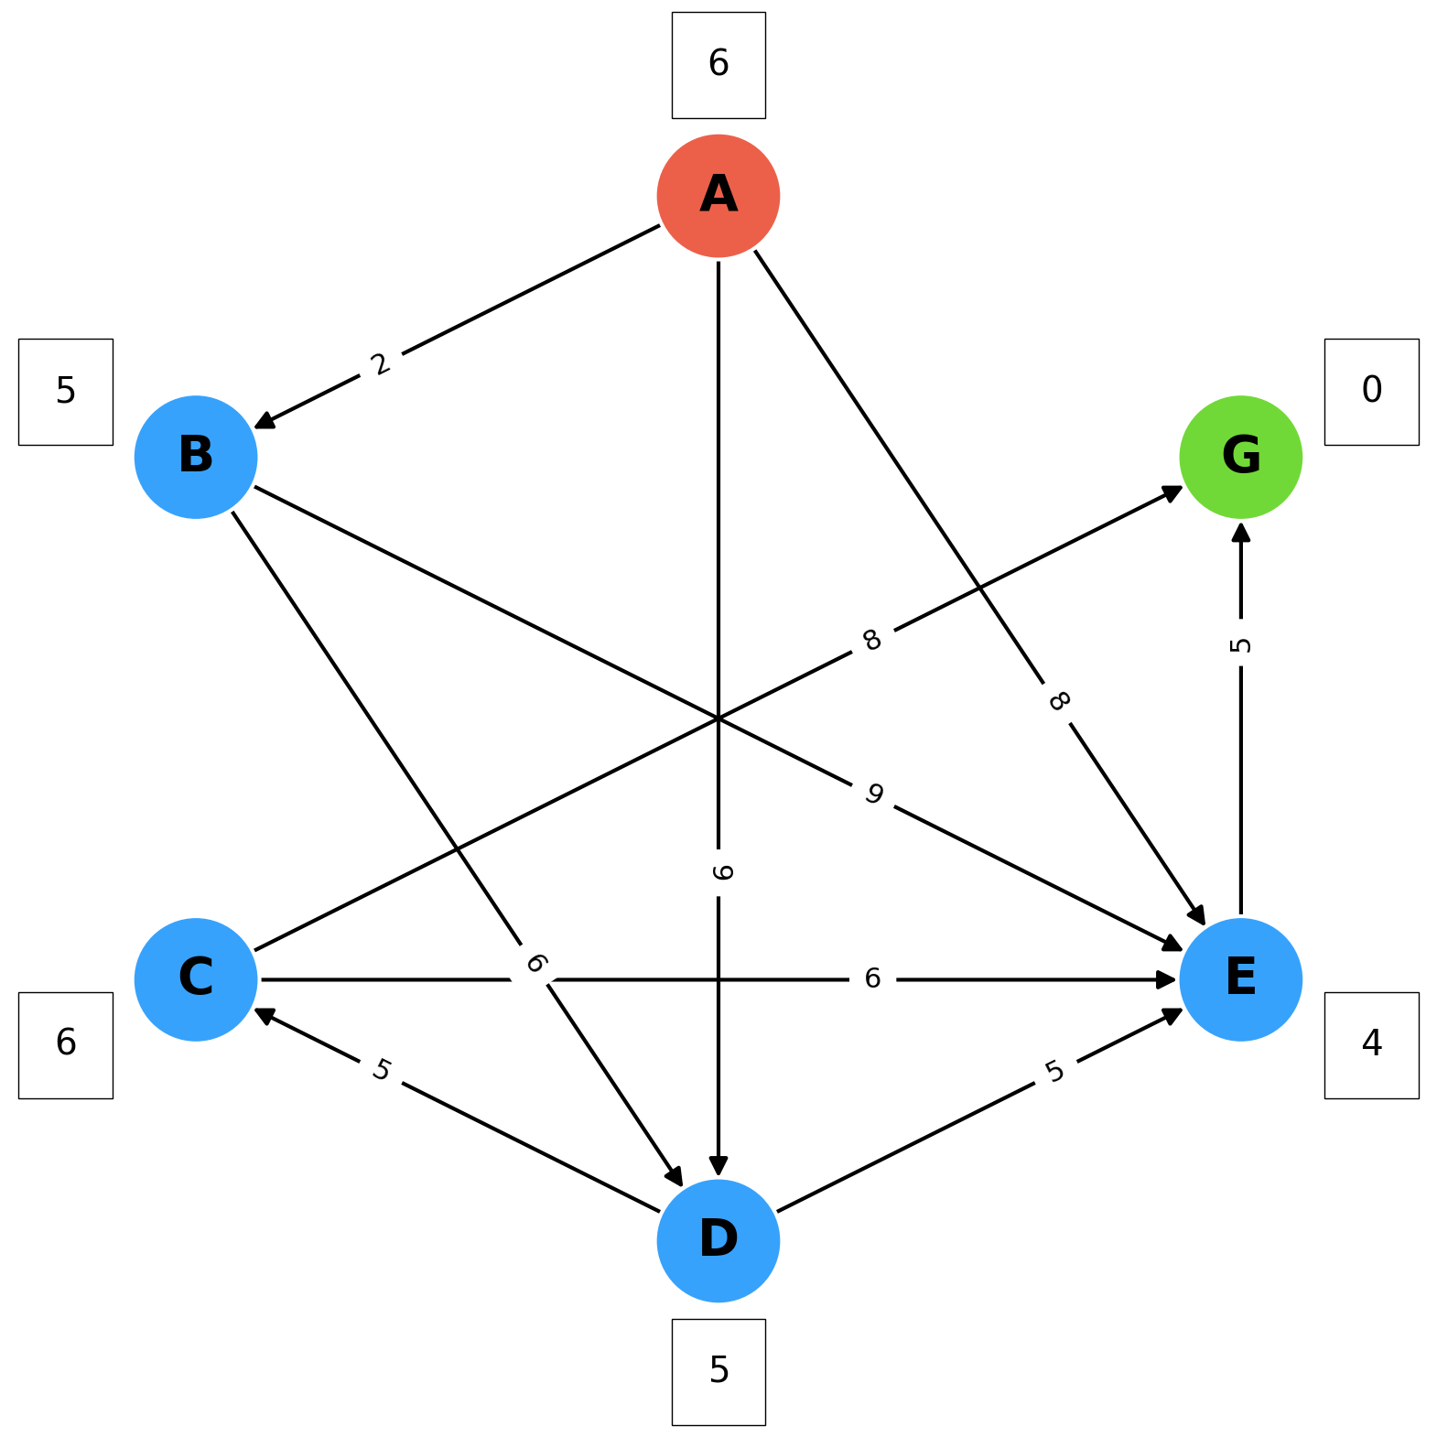

a) Apply the depth-first search (do not consider the costs of the nodes), and draw the developed search tree indicating the expansion order; in the case of non-determinism, choose the nodes to expand according to the alphabetical order. What is the produced solution and its cost?

b) Apply search A*, and draw the developed search tree indicating the expansion order and the value of the function f(n) for each node n. In the case of non-determinism, choose the nodes to expand according to the alphabetical order. Consider as heuristic h(n) the one indicated in the square next to each node in the figure. What is the produced solution and its cost?

SOLUTION

Exercise 1
a) Depth-first search

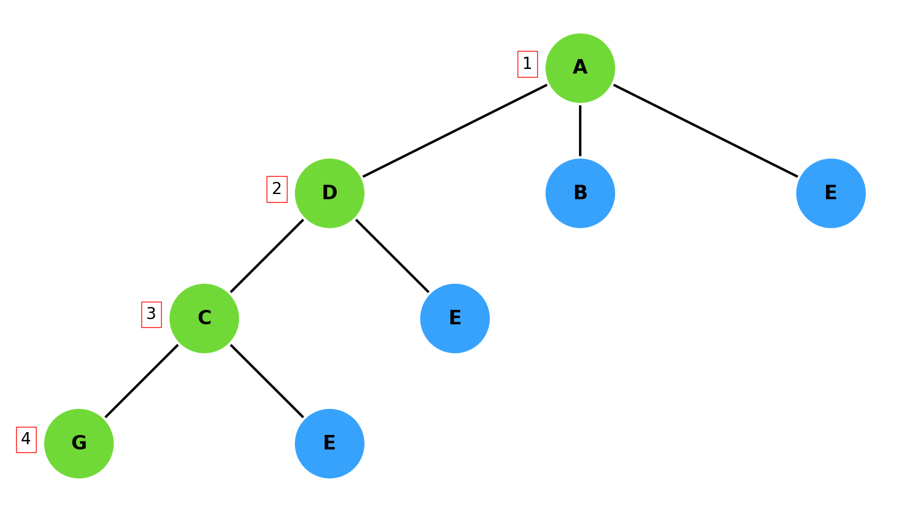

The produced solution is ADCG with cost 22

a) A*

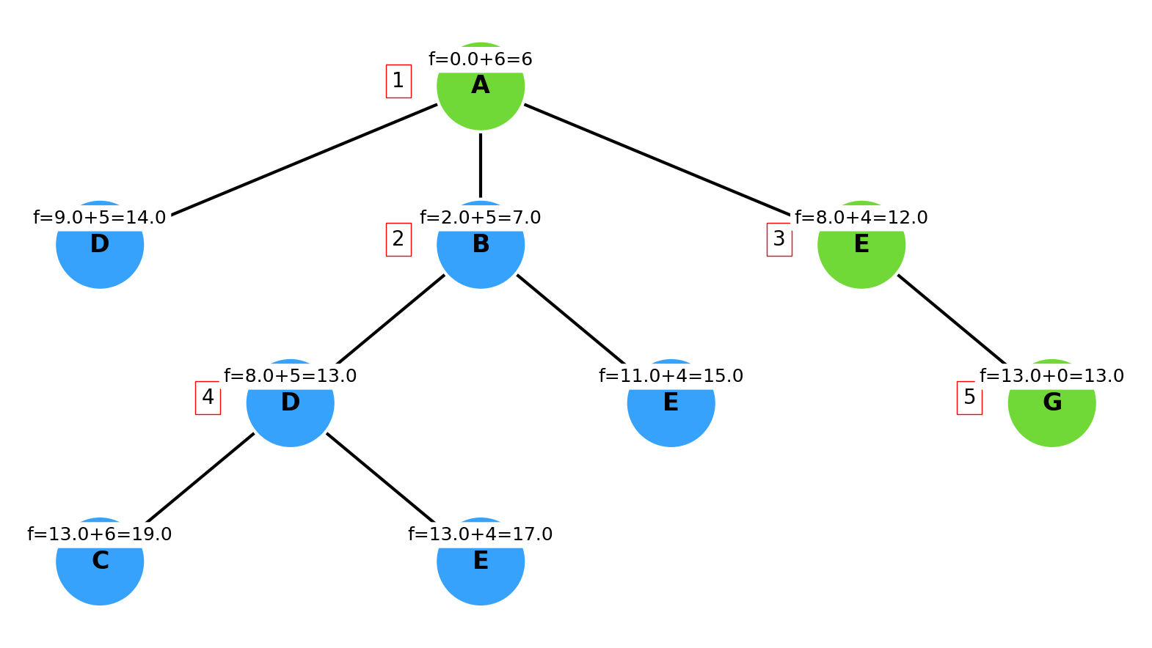

The produced solution is AEG with cost 13

