RQ: Is classmate’s sharing answers based on their gender impacted by the student’s major?

RQ: Are females more perceptive of gender bias than males?

RQ Does the existence of gender bias affect a student’s GPA?  
RQ: Do classmates of a particular race/ethnicity interact more with people of the same gender?

Hypothesis for RQ: There is a positive correlation between students of a particular major and if these students share information based on their gender. We predict that its influence will be *statistically insignificant.*

One-sample t test

Ho: 2.5 = u (u is the mean of the singular major’s response)

Ha: 2.5 ≠ u

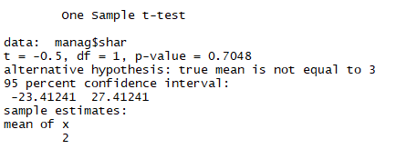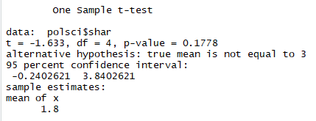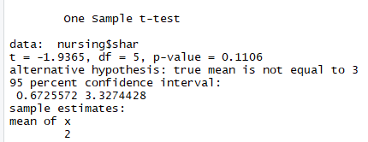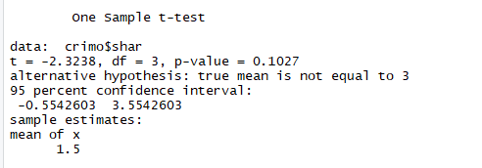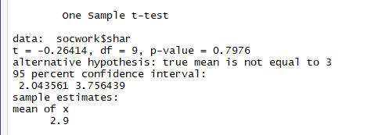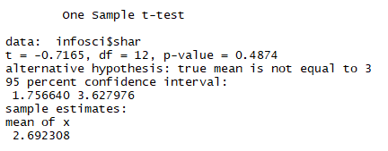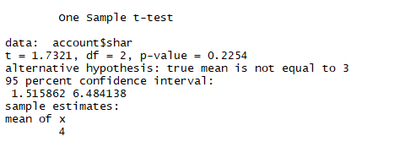

No significance.

Hypothesis for RQ: There is a negative correlation between females and whether or not they are aware gender bias exists. We predict that its influence will be *statistically significant.*

One-proportion z test

Ho: p = p1 (p is number of guys who think that gender bias exists, p1 is girls who do)

Ha: p ≠ p1

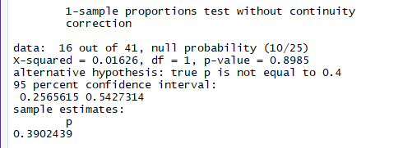

Not significant

Hypothesis for RQ: There is a negative correlation between if a student believes that gender bias exists at USG and a student’s GPA. We predict that its influence will be *statistically significant.*

One-sample t test

Ho: u = u1

Ha: u > u1

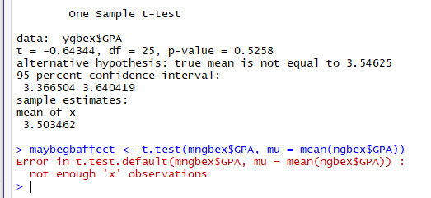

Not significant for “yes”, not enough samples for “not sure”

Hypothesis for RQ: There is a positive correlation between a particular race/ethnicity and if they interact most with people of the same gender. We predict that its influence will be *statistically insignificant.*

One-sample t test

Ho: u = 3

Ha: u ≠ 3

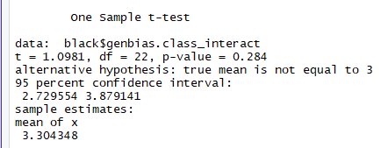

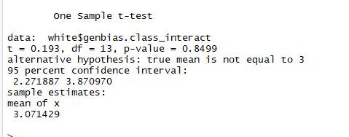

Models for both research question

