#### **Revised Project Overview:**

#### **TeleTot**

Our mission: Helping new parents adjust to parenthood one *resource* at a time.

##### **Introduction to the iPhone app:**

Raising children nowadays can be very difficult for parents. We have created an application called, TeleTot is which is designed for new parents of the millennial generation. Our application will allow for parents to connect with other parents in their communities. As society increases their dependency on cell phones, as a team we designed a platform where parents can be able to turn for dependable advice on day to day bumps they might face while raising their beloved tots.

Features of this app:

To enhance our application we decided to incorporate different features to assist parents. Some of the features are *a medical advice, events calendar, chat forum, a live chat, videos, trade in, frequently asked questions* *and coupons.* Our *Medical advice* feature will expose parents to certified professionals in their community and provide advice to better serve their children. While keeping this feature in mind we will have a disclaimer on our app notifying parents to take the advice at their own risk. This medical advice feature will allow users to find doctors near them and also allow them to schedule an appointment if they would like. Once the user selects a doctor of their choice they will be able to view the doctor’s avatar, age, sex, availability, and their address along with other bio information. We have also included a review feature which gives the user the access to view the professionals ratings as well as rate them themselves. TeleTot will also have a special feature called trade in, where parents can purchase cost effective goods which are highly recommended. We also have a calendar event that will which will display events that are happening throughout the community, such as toy drives, fundraising for children, play events, library events, and community gatherings. We will have a section set up for advertisements and coupons. This gives parents savings on essentials needed to support their children. TeleTot Will have a live chat where parents and other community members can collectively come together and discuss and share information needed to help one another in being a successful parent. Lastly, we will include a general advice session open to anyone that would like to provide advice on raising a child.

**Stakeholders:**

Our application will be available in the Apple store and the Google Play store. In order to download the application on a smartphone or a tablet, parents will download the application “TeleTot” , which will be free. We decided to have a free application because it will get more users.

We plan on generating income through the advertisements, coupons, and videos sponsored by different organizations. After our stakeholder analysis, profit is expected to generate in less than a month because it does not take much funding to create this app.

##### **Scope and scale:**

*Developing the app:*

**There are multiple step when it comes to designing an application. Here are the steps: [1]**

* **Step 1:** You must firstdownload XCode or android studio on your handheld device. XCode is a development platform for iPhones which is available at no cost from the Apple store and android studio can be downloaded from the Google Play.
* **Step 2:** Install a text editor. You can either download TextMate or JEdit.
* **Step 3:** The next step is to install a vector graphics program in order to create art and designs for our application. We will also need to download a vector programs. Some vector programs include CorelDraw, Adobe Illustrator, and Inkscape.
* **Step 4:** Getting yourself familiarize with Objective-C. This program handles data and object manipulation.

Organizations for TeleTot[2]

* The National Parenting Education Network (educating newer families through networking)
* National Diaper Bank Network (providing diapers)
* Program for Early Parent Support (connecting newer parents to peers)

Causes for TeleTot

* Child welfare
* Financial stability in families

Events for TeleTot

* MommyCon & DaddyCon [3]
* Baby Expo
* Toy drive
* Community gatherings

Organizations not included in TeleTot App

* Parent Teacher Association (PTA)
* The Children’s Aid Society (helping children develop)

**Stated rationale (Scope and Scale):**

**T**he organizations that will be included in the app directly reflect our mission and our audience (the users). According to PewResearch.org, “1.2 million millennial women gave birth for the first time in 2016” .[4] Knowing our target users, organizations like The Program for Early Parent Support (PEPS), will connect parents in the same peer group. They specifically target first-time parents and match them with a community of their peers through special programs. Also, the National Diaper Bank Network (NDBN) is extremely important since new mothers use about 165 diapers per month.[5] Diapers can be expensive, so letting our new parents know of the resources out their that could reduce cost is extremely crucial to our success. Moreover, the National Parenting Education Network (NPEN) will provide a network for new parents looking to learn about the development and well-being of their kids. Adding this to our app will ensure that our users are well-equipped with meeting the demands of parenthood.

Looking at different causes, our app wants to promote and bring awareness to child welfare and financial stability in families. We recognize that making sure a new child is being provided for is the main concern with new parents. New parents worry if they are caring for their child correctly or if they can support them financially. As we expand, TeleTot wants to ease the mind of new parents by being well-informed and aware on the issues of their environment.

With regards to events mentioned in our app, Baby Expo and the parent conventions (MommyCon and DaddyCon) will allow new parents to meet organizations and programs willing to aid them in their new lifestyle.

Since we want to provide the best experience for new families, any organizations (PTA), events, and/or causes that do not directly relate to

TeleTot’s mission should will not be included in our app. We are solely focused on making sure new parents adjust.

##### **About the Users:**

Our main audience for this application are parents with young children between the ages of 12 to 36 months in the United States. We hope to expand to other parts of the world in the near future. We expect parents to refer to our application for references when seeking parental advice.The parent will be able to communicate with other parents and community members. Having easy access to TeleTot makes for a likeable information resource for millenials and the world’s busiest parents trying to balance it all.

##### **Metadata Lifespan:**

Our app will have different varieties of resources that will help guide parents in raising their children. If a individual is a first time parent, it tends to be overwhelming for them. Children who are between the age of 12 to 36 months can not communicate via words with their parents. One of our resources will have a toddler behavior selection where a list of feelings and actions that toddlers go through during the age of 12-36 months. Our applications will provide links to videos to help parents ease up on the situation that they are struggling with because every child is different. It takes patience and time to work with young children.

**Relationship with other information systems:**

TeleTot app is working closely to other information systems such as:

* Pediatrician network
* Bank system for app purchase
* Online retails for baby products purchase
* Links to access digital media
* Calendar app which tracks baby growing process
* Advertisements

### TeleTot Draft 2 Revised: Project Screen Mockups

#### **Getting Started**:

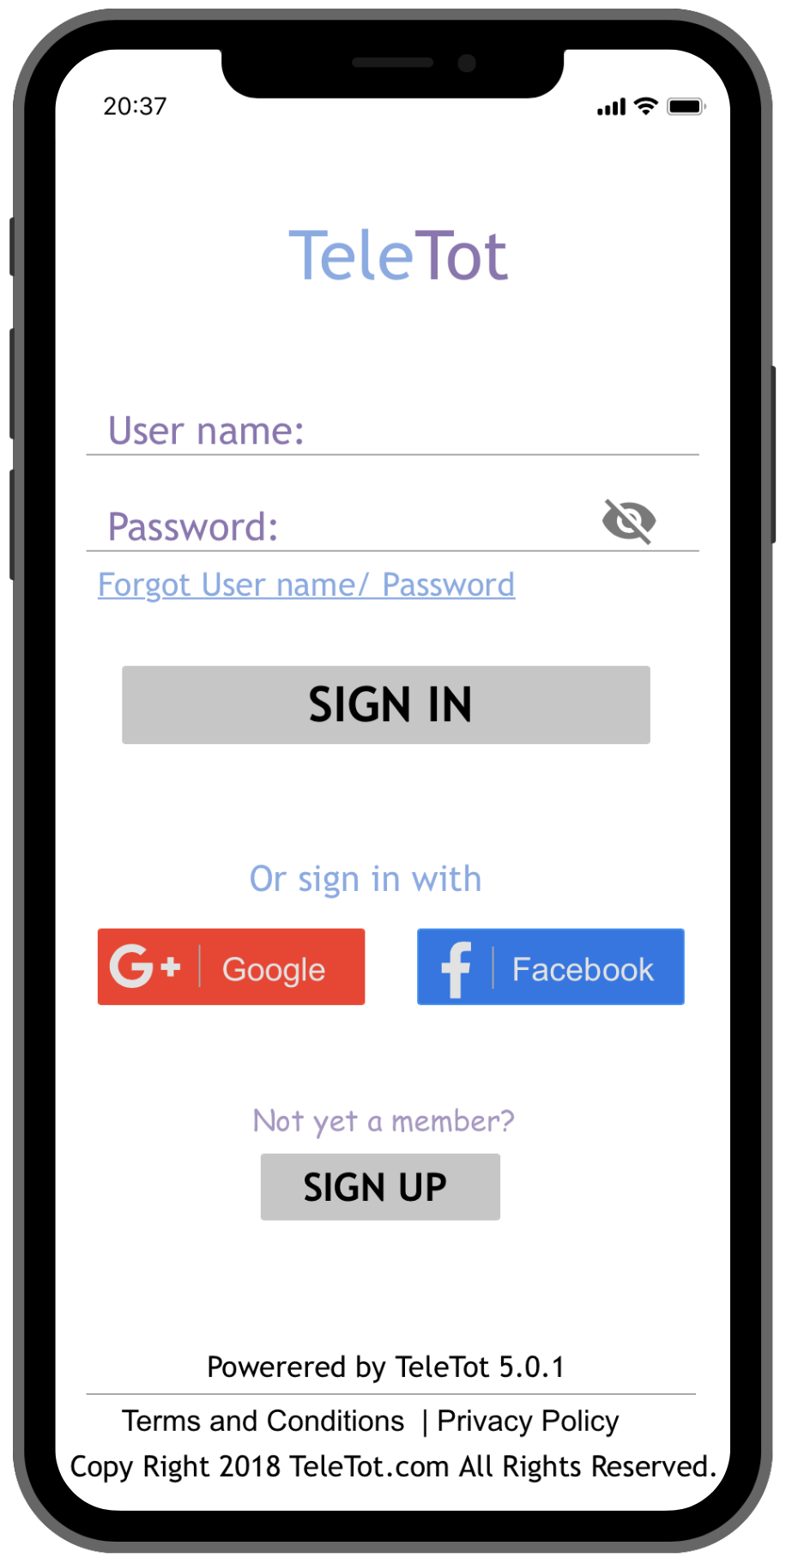 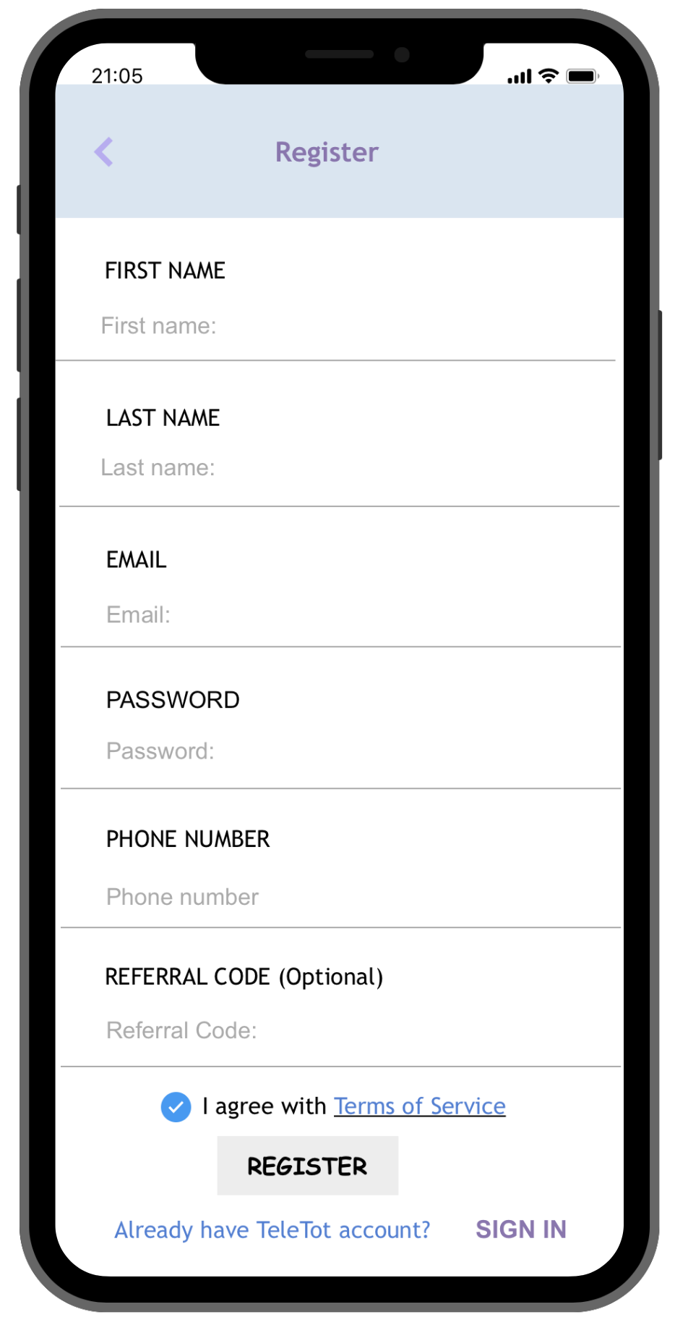

Figure GS-1 Figure GS-2

When users first download the application, they will be asked to sign in. They can enter their username and password, then click the “sign in” button. The eye icon to the right of the password entry box is it users want to hide or show their passwords. In order to streamline for sign-up/sign-up process by signing in with their Google plus or Facebook accounts. For their convenience, users can reset their passwords by clicking on the “Forgot Username/Password” button. If they are not yet a member they can click the “Sign up” button under “Not yet a Member?” *See Figure GS- 1 & 2*

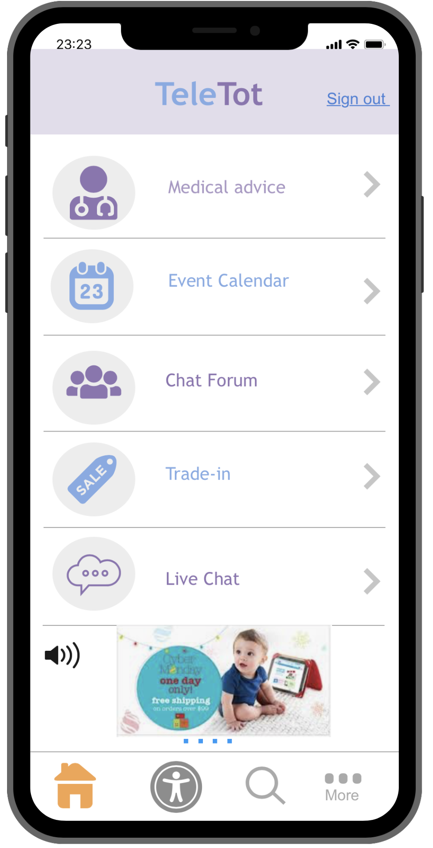

Figure GS-3

Once the user is signed it, they are given a few categories to choose from. These categories/modules include medical advice, events calendar, chat forum, live chat, and trade-in. All of these modules are accompanied by an icon that will help users make an instant distinction from one category to another. There is also an advertisement (option to play sound with the icon) at the bottom of the home screen from one of partner organizations. Ads will be displayed throughout the app since we want our users to enjoy a free experience. The ‘signout’ button is placed conveniently at the top so that users can instantly log out without all of the hassle. At the bottom of the screen are four distinct icons which are the home, user, search, and … (more information). These icons will be located on various modules throughout the app to ensure that users can find what they are looking for seamlessly. *See figure GS-3.*

#### Searching, Browsing, Filtering & Sorting:

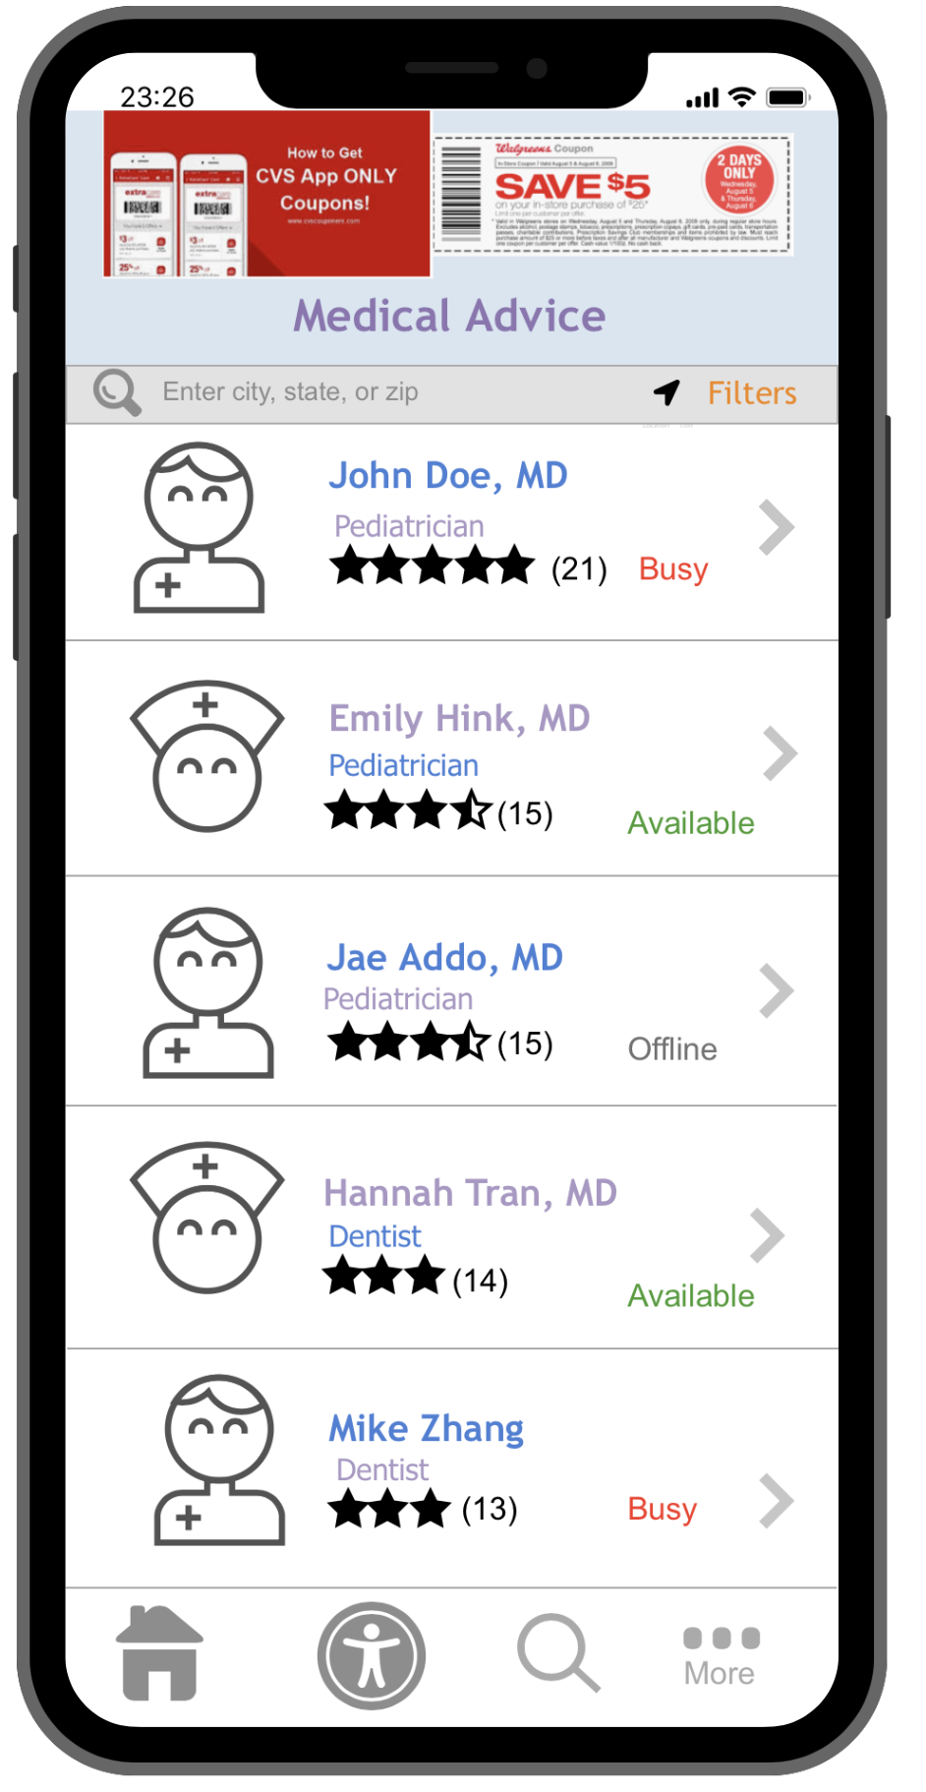 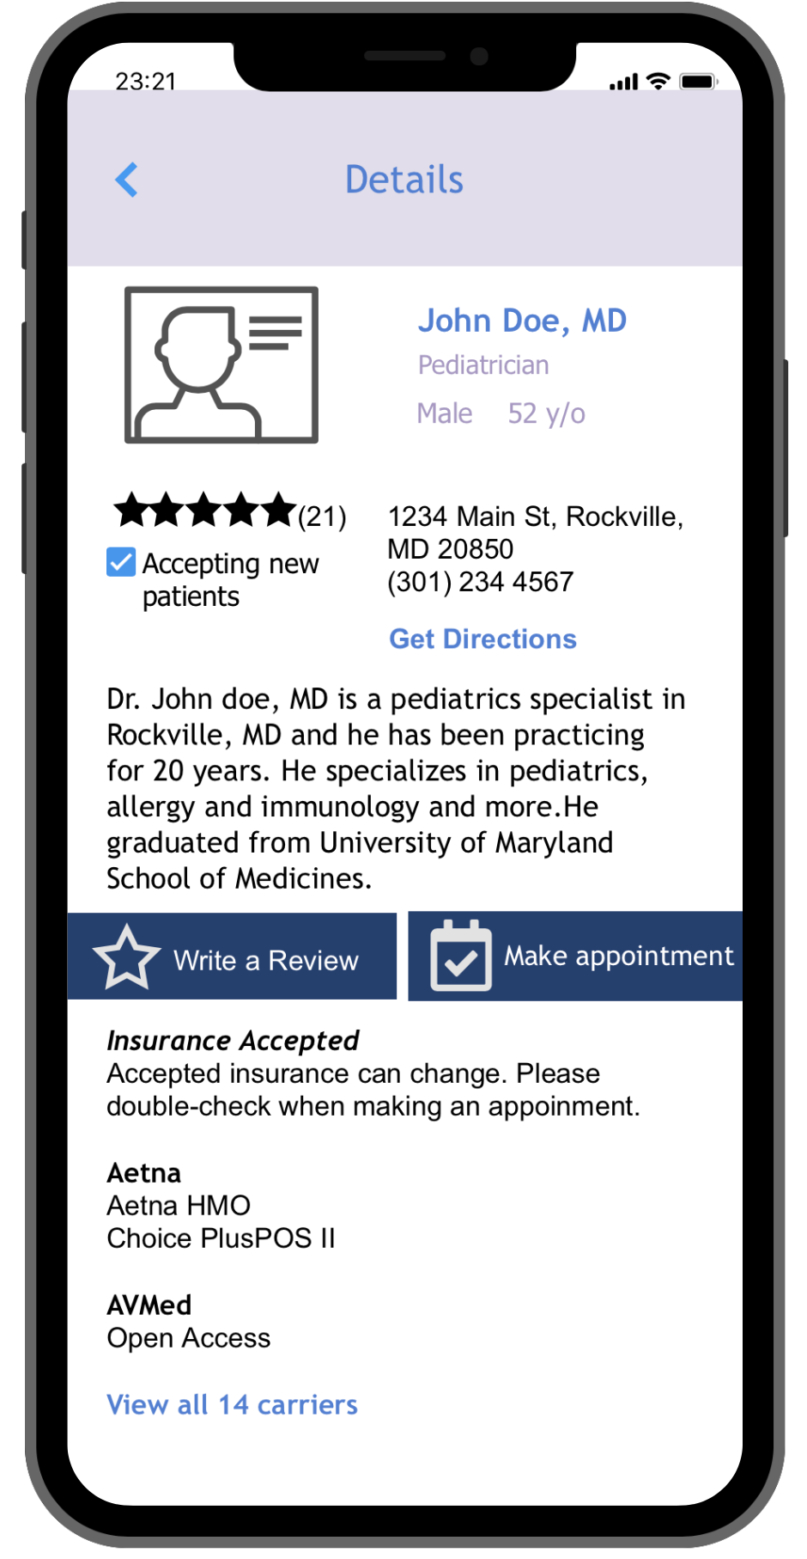

Figure: SBFS-1 Figure: SBFS-2

Some of the searching, browsing, filtering, and sorting features on our app are the search bar, filter icon, maps icon, and search icon at the bottom of the app. Under “medical advice” module, users can search a provider’s name, and other things as well (type of doctor). The filter tool lets users sort by names, type of doctors, ratings, and miles from user. The maps icon allows users to find doctors near them if they would like to schedule an appointment. When a user clicks on a specific doctor (see John DOe example above), their full profile displayed and gives the user the option write a review or make an appointment. Users can quickly make a decision based on doctor’s location, bio, rating, insurance accepted, and the type of doctor they are.

Lastly, the search icon at the bottom of the app is to search the entire app. *See ‘Search Results” section for more information on searching the app in its entirety.* When using our application users will be able to search up products and services through the search engine. The application will be able to read key words and sort the information. When a user is looking for a medical advisor the application uses the users location and locates the nearest medical advisor in their area. It also gives the user ratings on the advisor. Once you select the advisor the application opens up another section where the user is then able to have a live chat and get the questions answered along with viewing their personal information. *See figures SBFS-1 and SBFS-2.*

#### Search Results:

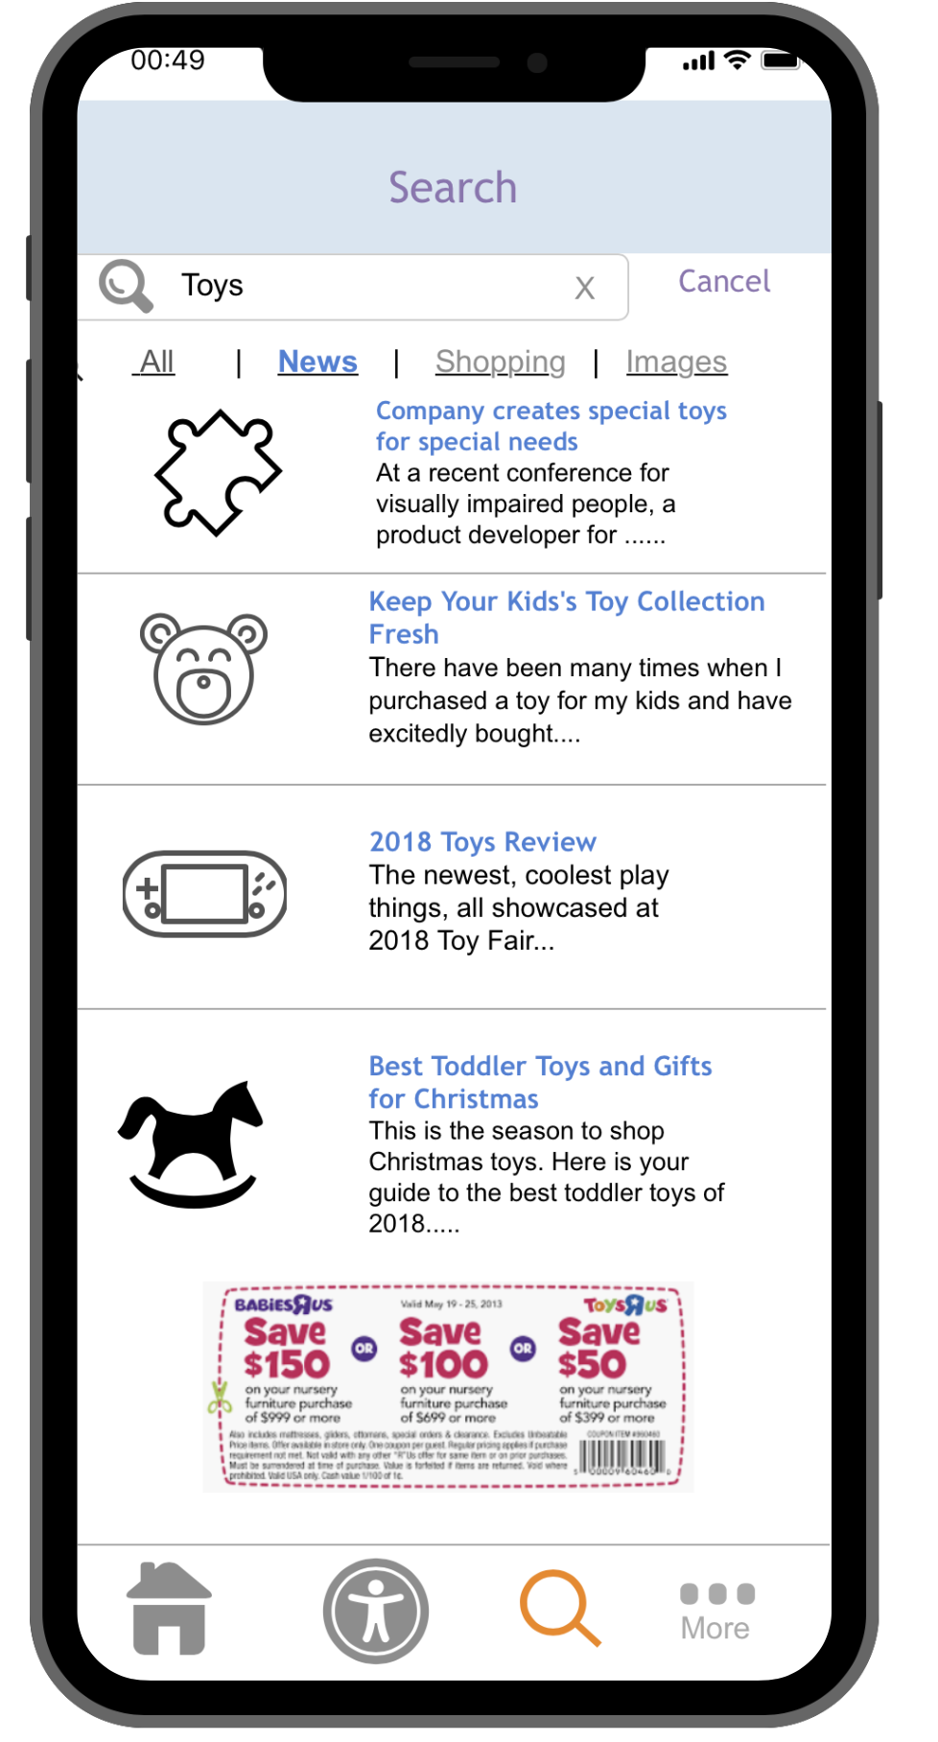

Figure: SR-1

When clicking on the search icon at the bottom of the screen, it will direct users to the search page where users can type their questions. The search result will give the users list of results related to keywords. For instance, we searched ‘Toys,’ once the user clicks search in the keyboard, it will display all of the results from our app entirely. Only trusted and partnered news outlets like Parenting.com or The Parenting Junkie will populate results. This decision was made in order to increase relevance of search results. Also, users are given the option to filter results by ‘All’, ‘News’, ‘Shopping’, and/or ‘Images’. Images serves as a way for users to get a better understanding of their search. When looking up the right toys to buy. Some images will most likely come from partnered news outlets. For instance, since the ‘News’ filter option was selected, all articles and reviews related to Toys show up as results. Structuring the results vertically, allows users to scroll through results to pick out which one is relevant to their search. Also, adding more filter options help users find what they need quickly. *See figures SR-1.*

#### Detailed Item Information:

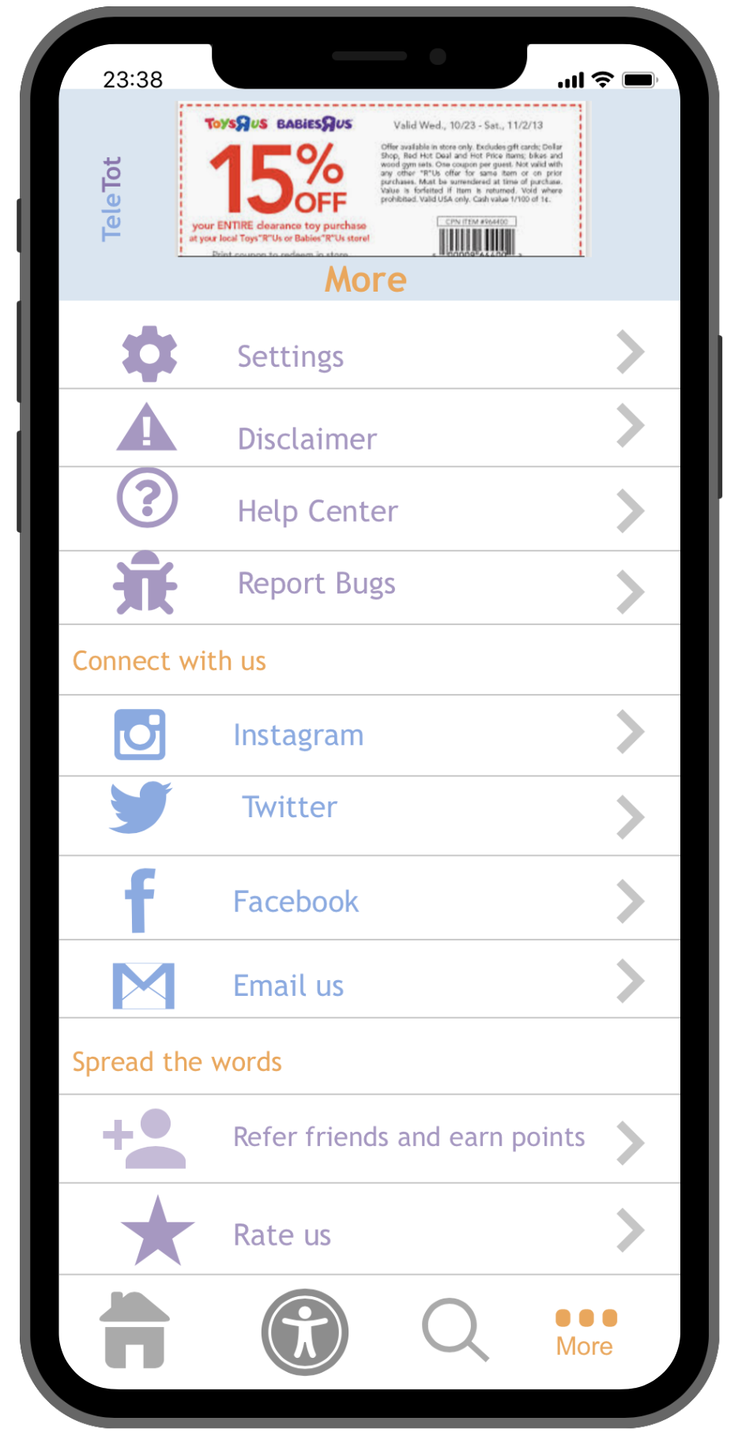

Figure: DI-1

From the home screen, users click the “... more” button at the bottom of the app. It allows them to view more information about our disclaimer, help center, reporting bugs on our app, connecting with us on social media, and spreading the word through referral and/or rating us. When users select click on the “disclaimer” word or arrow, the terms of use and privacy policy will show (also linked when users are getting started at the bottom of GS-1), disclaimer about medical content, like chatting with medical professionals, how information is collected (how we come across or get access to resources), and how we are committed to ensure all of users’ data is protected. Some things that may be included in the Disclaimer is that we will keep all patient data for five years from discharge, last treatment, last appointment, and/or death. If users would like their information deleted from our app completely before then, they should connect with us (email us or use social medias provided above) and we would be happy to delete it. The metadata on the disclaimer module helps users gain insight into how TeleTot works! *See figures DI-1.*

**Draft 3: Revised Metadata Schema Worksheet**

|  |  |  |  |  |
| --- | --- | --- | --- | --- |
| **Name of Element** | **Description of Element, including why it would be useful to users or to app functionality** | **Expected Data Type. If controlled vocabulary, include the entire vocabulary as a bulleted list. Vocabularies of more than 10 terms should be in an appendix and referenced in this column.** | **Mandatory Element? (yes/no)** | **Searchable Element? (yes/no)** |
| **User name/user information** | **Keeps a record of the user and personalizes their experience** | * **Names** * **Email** * **Phone number** * **Password** * **Referral code (optional)** | **Yes (cannot participate in app without logging in)** | **No (Users can edit their data, but cannot search for other users)** |
| Ratings for app and also Medical Professionals | Ratings are useful to our app because it allows for positive impressions on users. It will also help users get advice from the best medical professionals near them. | * Ratings out of five stars (1,2,3,4,5 and anywhere in between) | Yes (App creators want to improve the app and make sure users are receiving medical advice) | Yes (Users can sort through medical professionals based on ratings and find sort through overall app ratings) |
| Urls | Help users navigate to relevant YouTube videos, articles, discounts, and more. | * Link * Copy * Paste | Yes (Increases usability since users can instantly find information on how to burp a baby, for example) | Yes (Users can search for these Urls in the app by clicking on search icon) |

|  |  |  |  |  |
| --- | --- | --- | --- | --- |
| Event Calendars | Allows the user to navigate and look up events happening near their area | * Upcoming * Time * Month * Day * Year * Location * Distance from user * Kind of event * Icons for different events * Event name | Yes (We want our users to have access to all events and resources near them, events are generally things like meetups or seminars) | Yes, users can search for a specific event by looking through the calendar. |
| Location | Allows users to navigate to the doctors and/or medical professionals in the area | * By zip code * By distance (miles or kilometers, in decimals) * By City, State, Country * Getting directions from user | Yes (it allows users to find their preferable location, either through GPS or the user can input it themselves) | Yes (Users can sort and filter based on location of doctors and medical professionals) |
| Disclaimer/user Agreement | Lowers the user’s expectations. | * Legal jargon that voids us of responsibility for the user’s actions. * Requires user to hit “I agree” | Yes (This is just a precaution.) | No (it’s a legally binding contract between the user and us, to ensure misuse on the user’s part does not end in us being sued. This will pop up whenever the app is opened, and that’s it.) |
| Search Refining | Find specific things with relation to what they search | * Images * News * All * Shopping | Yes, because it makes it easier to find things with relation to searches. | Both yes and no. It serves as a way of filtering, but people can find the search icon at the bottom and search a phrase. |

1. *https://www.wikihow.com/Make-an-iPhone-App*
2. https://www.babygaga.com/top-15-organizations-that-help-new-parents/
3. https://mommycon.com/
4. http://www.pewresearch.org/fact-tank/2018/05/04/more-than-a-million-millennials-are-becoming-moms-each-year/
5. https://www.personalcreations.com/blog/new-mother-statistics