Spud

Was on vacation across the country, had to travel vast distances to get back to his home city?

Reserved a grave next to ancestors/family/friends? (motivation)

Reserved top-quality grave using his connections in the post-life business?

Removal of Limbs?

Clothing: Hawaiian shirt and shorts.The sleeves of the shirt have been torn off with time.

Noticeable traits:

How he moves with one leg?

How he moves with no legs?

One liners? Braaains.

Motives: Need for peace

Annoyances:

Occupation: Environmental Scientist

Spud was part of an environmental group trying to find a compound that would deteriorate trash in a non-harmful way...his job was to use it on potatoes that had gone bad in order to test the strength of it. (hence his name). But one of the scientists had another plan in mind. He knew this new concoction would only postpone the inevitable of the world being destroyed by humans, and decided to take the plan a step further...He altered the formula so that when people dumped the chemical on the trash, it would emit a poison gas that would kill anyone within its radius. Or so he thought..

Spud: a 35 year old male while Human, now a 20 year undead zombie. Has a weird obsession with hawaiian shirts and groaning (braaaains).

He is bald on the top with some hair on the side of his head. (see image1) He has a smaller build, with brown eyes and perfect teeth (zombie dental...don’t ask).

Motivation:

1. Get to grave (underground lab) where he can finally “rot in peace” is actually the name of the serum that has the cure to being a zombie?
2. Forced to “live” with the guilt that he was partially responsible for the zombie outbreak, after years of having to kill and run, Spud is tired of it all and only wishes to find a grave and rot away.
3. Zombie grave advertisement has been showing up as signs throughout the city, and in light of the humans taking the earth back, a nice dirt nap with a view doesn’t sound too bad to Spud.

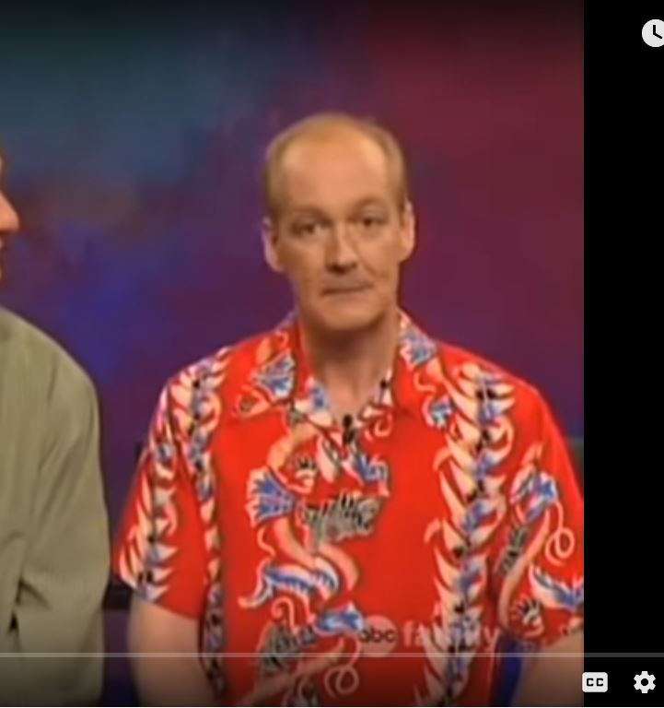

#### Looked like this as a human. Or similar.

Spud was one of the OG zombies that Zombinc created. After graduating college with a PHD in Underwater Basket Weaving. Unable to find a job in his field, he is forced to move back in with his parent's basement. When he came across an ad from Zombinc offering a full-time position with “benefits” such as housing provided and healthcare. He jumped on the opportunity for a job that would get him out of his parent's basement.

Spud was one of the OG zombies that Zombinc had used to start their grand conquest of creating the best AR game in history.

Spud was an unemployed 35 year old man with a degree in environmental soil sciences. Unable to find a job close to home, he decided to move back with his parents. On one particular day when his parents were scolding him and telling him to stop sitting around playing games all day and get a job. Spud got fed up and left the house, wandering into the inner city at 2am, and was routed by a strange man in a business suit. The man threw a small brain at him that had an address scribbled on the side of it. The man said “You look like you could use the money. Go to this address, and my employers will give you $5000 cash. Further details will be given

when you arrive.” Then he disappeared into the night.

Spud was an unemployed 35 year old man with a degree in environmental soil sciences. Unable to find a job close to home, he decided to move back with his parents. On one particular day when his parents were scolding him and telling him to stop sitting around playing games all day and get a job. Spud got fed up and left the house, wandering into the inner city at 2am, and was routed by a strange man in a business suit.

The man threw a small brain at him that had an address scribbled on the side of it. The man said “Hello, Spud. We have been watching your progress in our game ‘Being a Zombie’, (or some game with zombies) and the higher ups are impressed by your skill. They'd like to meet you and talk about offering you a job as one of our testers for a new game we are developing. Further details will be given when you arrive.” Then he disappeared into the night.

Spud was an unemployed 35 year old man with a degree in environmental soil sciences. Unable to find a job close to home, he decided to move back with his parents. On one particular day when his parents were scolding him and telling him to stop sitting around playing games all day and get a job. Spud got fed up and left the house, wandering into the inner city at 2am, and was blocked by a strange man in a business suit. The man asked if he had $10 to spare, to which Spud replied “I would, but I don’t even have a job”. This seemed to peak the man’s interest. He then whispered something and a black van raced next to them and Spud had a bag thrown over his head, was shoved inside and taken.

MOTIVATION for wanting to get to a grave: Last of zombie sick and tired of this kill or be killed world,