Test plan:

We should donate at least two hours a week after a new build has been finished, for testing purposes. If more time is needed for testing we will allocate more time. Testers will be found in the tc during game nights, and we will test for an hour there..

How do we attract testers?

The current plan to attract playtesters is to entice them with cookies.

What is our current preferred player demographic?

The current player demographic is people ages 17 to 26.

~~Requests for testing: We would like for testers to find bugs and describe what they did to cause them to happen. Testing should be fairy quick in the beginning depending on how many bugs pop up.~~

Does the current design allow the player to explore the core essential experience? If not, how can we fix it?

Current core experience: Experiencing exigency while controlling a zombie trying to traverse through an exaggerated world in order to find the perfect grave.

Questions

What did you enjoy about the zombie’s movement?

Is there anything you would like changed about it?

Was there anything that you think should be changed about the camera?

What did you enjoy about the level?

If there was a least favorite part of our game, what was it and why?

Which door did you leave through to to get out of toms bar, left or right? Why?

Build release schedule

The current release schedule for builds is by-weekly in-line with the sprint report.

Testingschedule

The new testing schedule for Brains: Graveyard bound is : (needs to be discussed with the team.)

Tests to be completed-

Focus testing-

1. Does the game match the core essential experience?
2. What would make the city feel more desolate?
3. Were the enemies too easy? Too Hard? (f)
4. In one word describe how the enemies made you feel. (f)
5. After making it to your grave, how did you feel?
6. Describe your overall experience in one sentence.

Usability testing-

1. How does the mapping of the controls feel?
2. ?

Technical testing-

1. Do the menus work as intended?
2. When playing dead does your character hit the ground as intended? Or does he pass through the floor?
3. When playing the game do any bugs crop up? Is it repeatable? What caused it?

Testing feedback

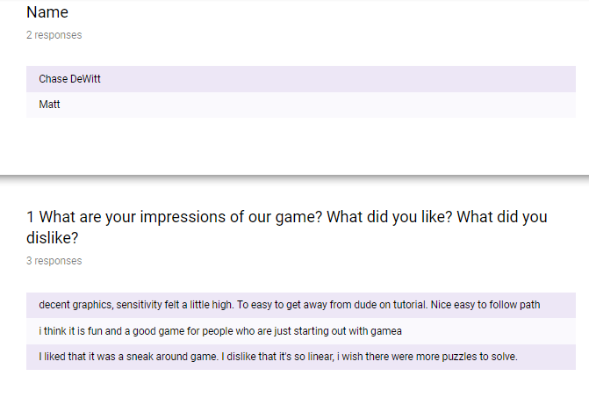

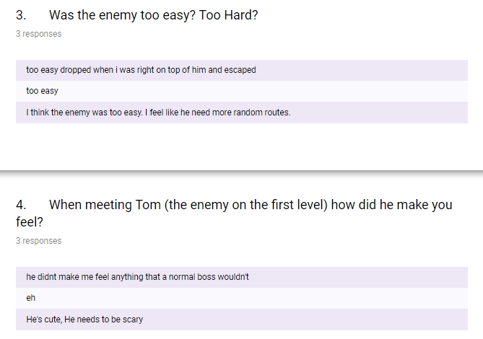

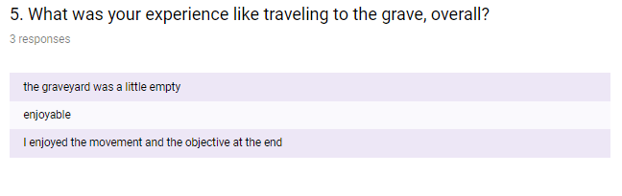

From the feedback we got, Tom is to cute, he should be scary if he is an enemy. The game is enjoyable and the testers seemed to enjoy it for the most part.

New Bugs Found

If you spam space while game is paused, you can charge jumps (fixed)

If you ragdoll between street and sidewalk, you fall through the floor. (couldn’t replicate for testing)

Ragdolling can cause spud to fly

Bugs Still being tracked

Bug #16

Both levels are VERY laggy on some machines; high-polygon models need to be optimized

Bug #17

Spud moves inconsistently on slopes (Fixed)

Bug #18

Misplaced occlusion portals on fences

Bug #19

Spud ragdoll may throw you into the void

Bug #22

Sidewalks are artifacting

Bug #23

Enemy Toms attack doesn’t always trigger on time