Current Systems and how to use them.

ScriptableAudio

ScriptableAudio:

Where to save instances:

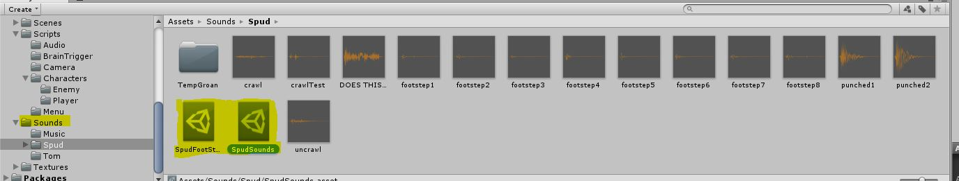

How to Create:

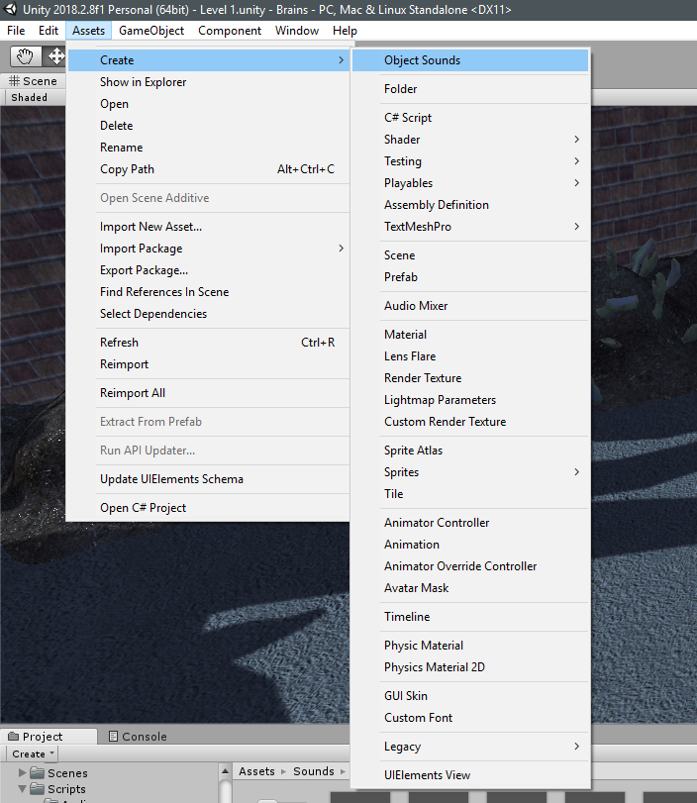

Navigate to the Assets Panel then hover over create then click on Object Sounds

Assets -> Create -> Object Sounds

Or…

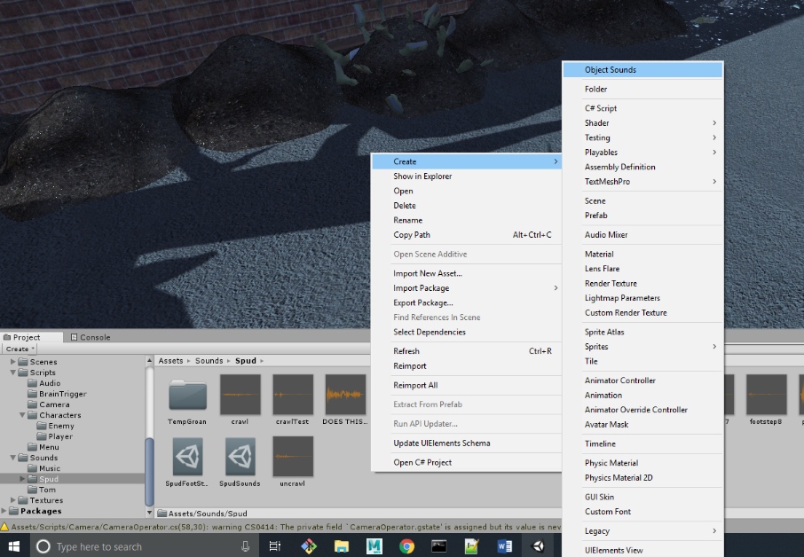

Right click in the project window then hover over create then click Object Sounds

Project Window -> Right Click -> Create -> Object Sounds

Layout of ScriptableSounds:

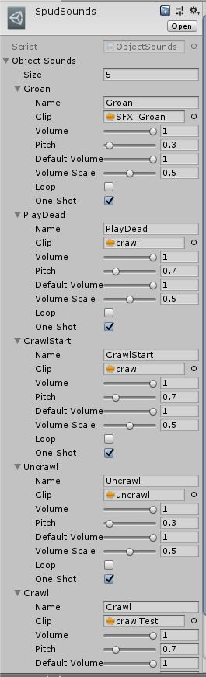 Size: The number of sounds in the list

Name: The name you want the sound to be identified as

Clip: The Audio clip of the sound

Volume: The adjusted volume

Pitch: The adjusted pitch of sound

Default Volume: The beginning volume

Volume Scale: The total volume scale of the sound

Loop: Does the sound Loop?

One Shot: Does the sound fire only once?

\*note: the name also changes the displayed name of the item