Current Systems and how to use them.

AI Pathing Tool

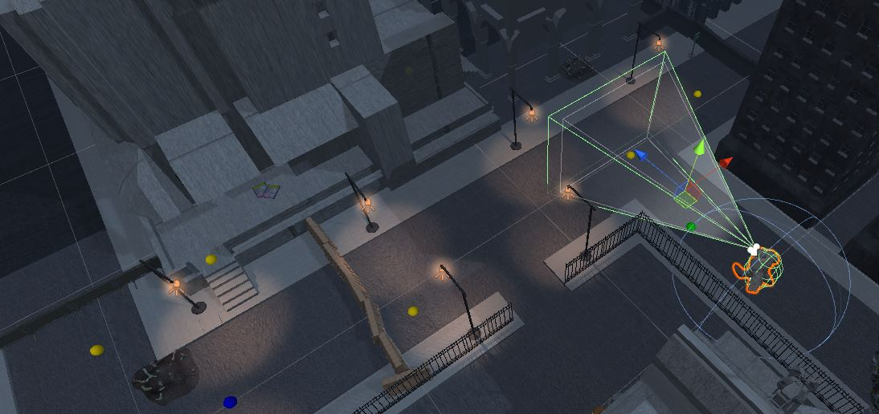

\*note: missing line connector

Green spheres: Pass points - the AI will pass through this point uninterrupted

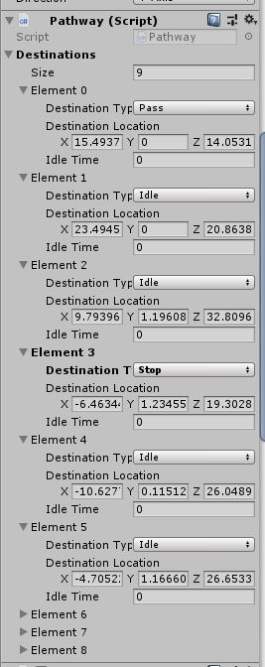Yellow spheres: Idle points – the AI will idle at this point then continue the path

Blue spheres: Stop points – the AI will no longer move after hitting this point.

\*note: Stop points are not currently implemented.

Size: The total size of the path

Element: Position in the path

Destination Type: Pass, Idle, Stop

Destination Location: The location in virtual space

Idle Time: if the type is idle then idle time determines how long in seconds the idle is.