Spud

Spud was an unemployed 35 year old man with a degree in environmental soil sciences. Unable to find a job close to home, he decided to move back with his parents. On one particular day when his parents were scolding him and telling him to stop sitting around playing games all day and get a job. Spud got fed up and left the house, wandering into the inner city at 2am, and was blocked by a strange man in a business suit. The man asked if he had $10 to spare, to which Spud replied “I would, but I don’t even have a job”. This seemed to peak the man’s interest. He then whispered something and a black van raced next to them and Spud had a bag thrown over his head, was shoved inside and taken.

He was later injected with nanites and became one of the OG zombies.

Spud: a 35 year old male while Human, now a 20 year undead zombie. Has a weird obsession with hawaiian shirts and groaning (braaaains).

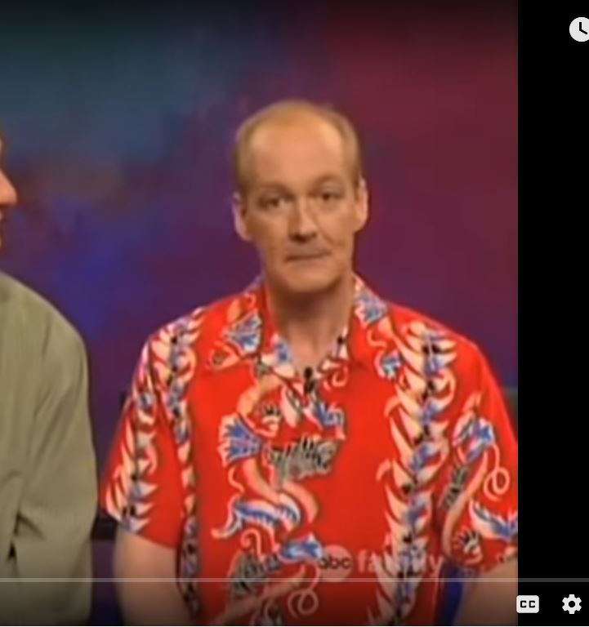He is bald on the top with some hair on the side of his head. (see [image1](https://docs.google.com/document/d/1lJ0OcyTrWXbgpnf_GyZ_IPqighRTAW1dnmO3pR4BNm8/edit#heading=h.gfrt85ctpby3)) He has a smaller build, with brown eyes and perfect teeth (zombie dental...don’t ask).

MOTIVATION for wanting to get to a grave: Last of zombie sick and tired of this kill or be killed world.

ENEMIES

1: Having years of being without glasses, since his prescription ran out years ago, he has developed a higher hearing radius allowing him to detect zombies from further away when they groan. However, will have the lowest chance of detecting the zombie hiding.

This enemy is a bit stockier in size. He is around 55 now and used to be a business man, so he is still wearing his suit, even in the apocalypse. His suit is that kind of lighter colored. Maybe make the suit and character look something like Dave Bautista? His eyes are a tad squinty at most times due to his lack of being able to see properly.  Primary weapon: rebar wrapped around his fists (Doom reference, anyone?)

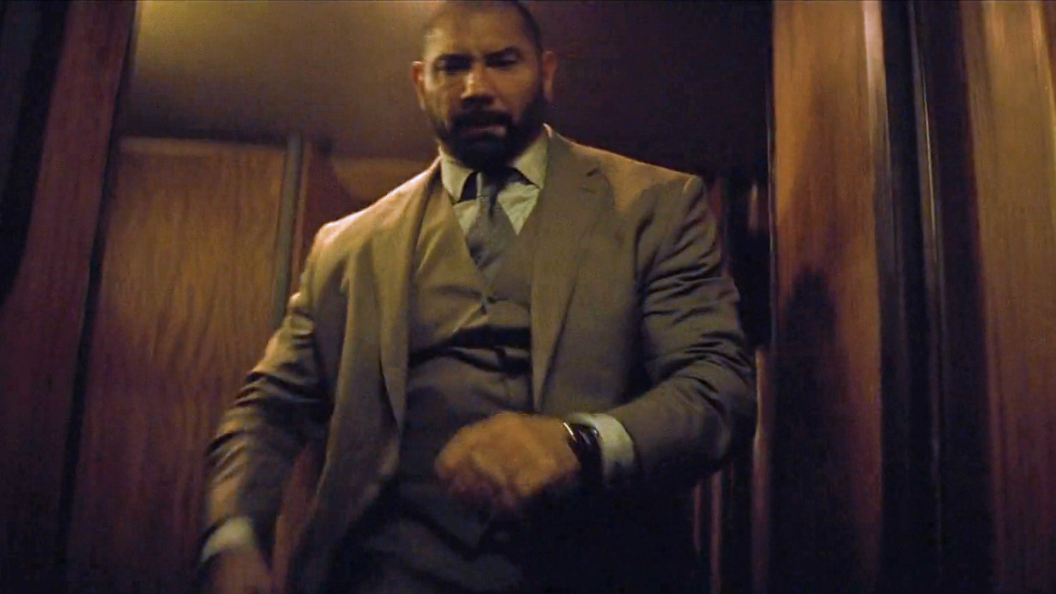

2: Born into the zombie apocalypse, his family has always taught him to never engage zombies, always run and get someone stronger. At a young age he somehow found a working mp3 player and has managed to keep it running throughout the years. He has headphones in at all times, drowning out most of his ability to hear (it helps him, because he is terrified of zombies). But he makes up for it by being able to spot a “non-dead” zombie in a pile of bodies easier (so if you see him running away from you, you had better start creeping/crawling away). Primary weapon: carries a flashlight and typically travels with another human.

This enemy is on the scrawny side and is wearing shorts and a heavy metal t-shirt in 45-degree weather, because he doesn’t own any jackets. If alone he won’t attack the zombie. They will run to find another human to finish the job.

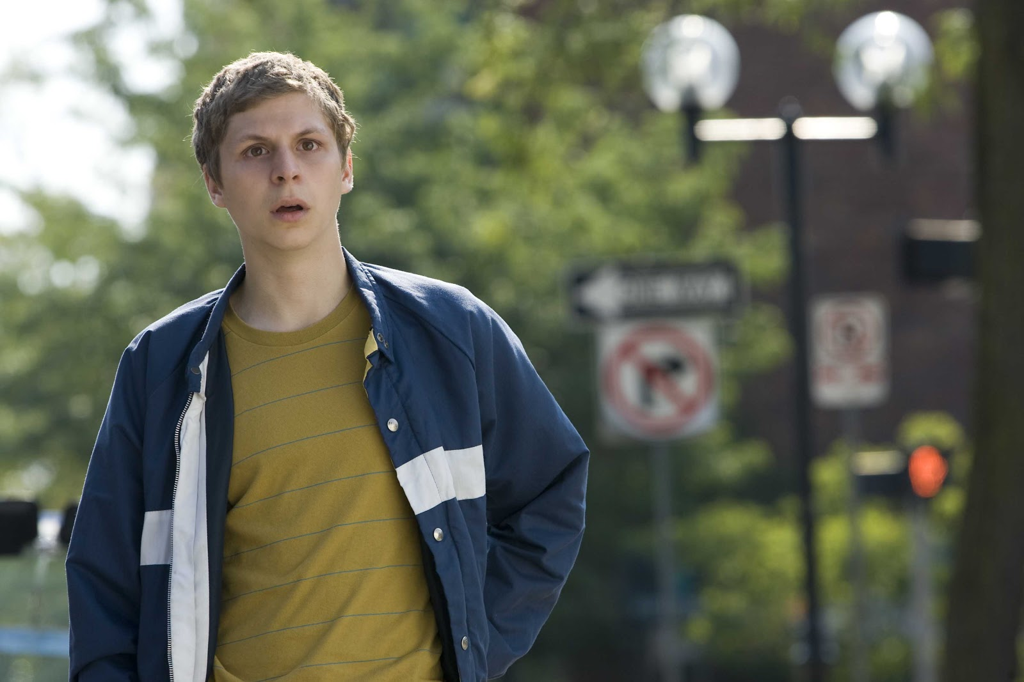

3: She was a gym fanatic before the apocalypse began, and it hasn’t slowed her down, yet. She doesn’t know when to give up, so once she loses sight of a zombie, she will stick around longer in search of it.

She is a 40-year-old woman with long brown hair, usually in a ponytail, and a relatively toned physique. Usually in her fall workout attire

