# Summary:

Nanocon was an interesting experience for everyone involved. As opposed to last year, the get up and go on testing our games was very slow. However, it was a ton of fun to watch people play our game and give feedback.

We learned once again that our premise is a fun one, and that people enjoy the idea of this game. Our execution, so far, hampers this experience. We plan to add many more gifts, which should be expedited now that we have a uniform way of adding these items in place. This should increase the length and variety of the experience.

It was a pleasant surprise to see that everyone thought the UI was easily navigable. This means if we keep the UI as simple and fluid as it currently is, then northing should change.

When asked to describe the experience of our game, most people said exactly what we wanted to hear! A simple game that is fun to play with friends. Which is exactly what we’re aiming for. With the feedback as a new banner to represent our goals, we can continue to flesh out the game while maintaining the experience!

Many of the complaints about our game came from the volume levels. The music and vibration relative to the sound of the gifts was far too loud. To fix these we will lower the base volume of the music, and raise the base volume of our gifts.

For the future, we look to have many more gifts added, a player name creation screen, and an achievable goal. Among those we also look to have a more fluid work environment. We look forward to another semester of hard works and seeing how the game unfolds.

# Questionnaire Answers:

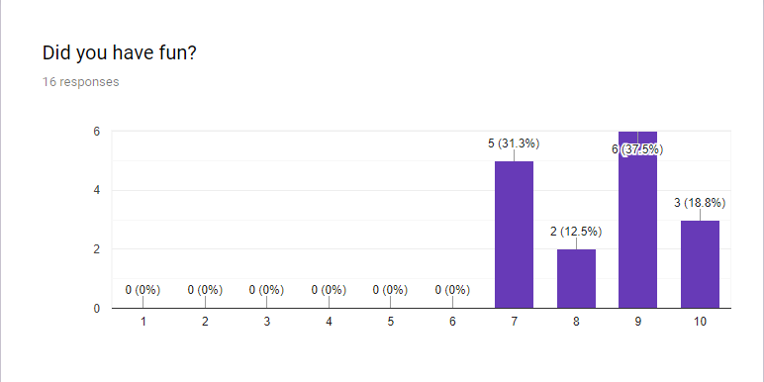

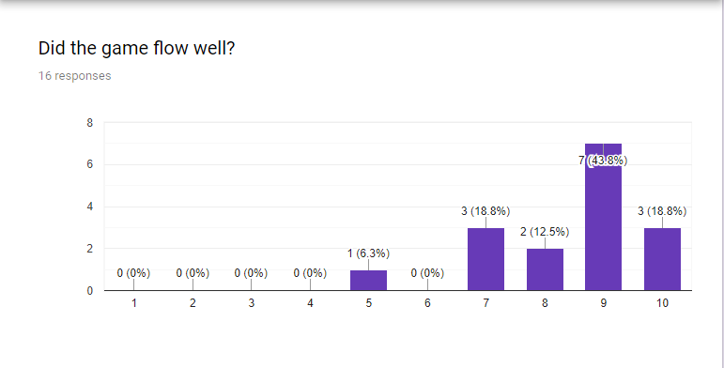

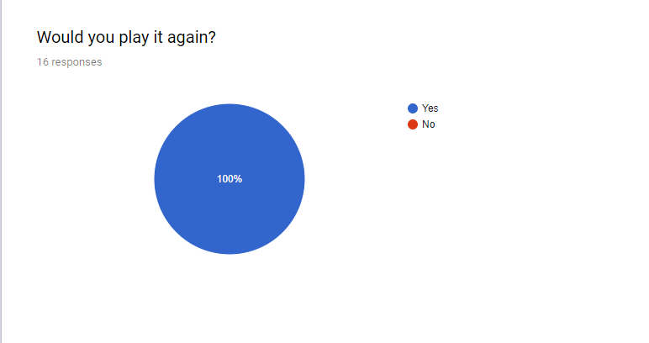

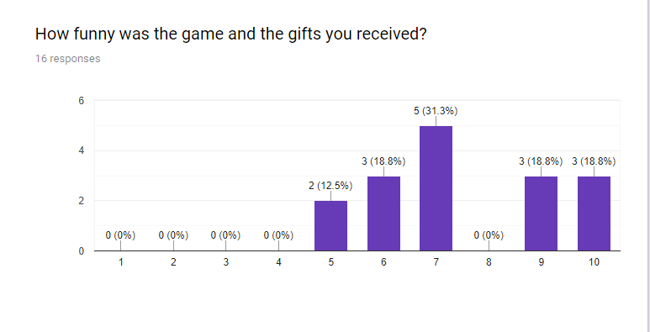

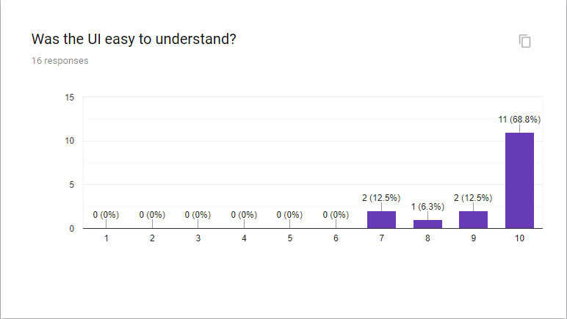

How Would you Describe the experience you had?

Easy

Light-hearted casual fun without much goal or strategy so far.

Gameplay seemed fine, but slightly bland in it's current state.

It's a cute, fun, mobile experience. Needs a bit more development, but seems to be in a good early stage.

Socks!

It was fun and i enjoyed playing.

enjoyment per being able to actually shake a gift instead of getting in trouble

It was a whole bunch of random fun!

It was very random FUN

it was a fun game for friends!

just like christmas back home!

Enjoyed the idea of deciding whether or not to keep the present

It was a very fun experience. Something that I'd probably get a group of friends for every now and again.

It was fun, if a bit clunky

confusing but fun nonetheless

cool

Please state at least one thing you enjoyed about our game:

Ease of presents

It was funny to open silly gifts, especially bad ones (bomb, dead fish)

The gifts were exciting.

The tension of "is this good" is well done. Sounds effects are decent. Visuals are simple but effective (though I find the "coal" graphic hard to "read")

Socks!

That there was different sounds for each thing.

the joy of guessing what it could be

The gifts were beautiful

The Spongebob reference

The pickup lines I'm keeping

getting RNG screwed

Getting the Healing potion round one

I like how quick it goes, makes for easy replay-ability.

I liked the mystery of the game and I like how there are going to be point values for competition

i enjoyed obtaining healing crystals

the whole shake to hear the present idea

Please state at least one thing you disliked about our game:

Water balloon drawing

It felt unfair to learn the gift associated with a sound and then have that same sound associated with an opposite gift (e.g. dead fish sounds like water balloon).

Most noises sounded very similar, wasn't a lot of distinction.

Still needs more variety. Ideally a bit more distinct funny sounds. Maybe some other mechanics on why I'd want to NOT open a bad gift, gain from opening a good gift. Plus some kind of pressure to keep me from handing off all gifts.

Diamonds

Some of the sounds were hard to hear or didn't happen

some of the sounds were hard to hear on the game and also in the boxes

I wasn't sure if the candy cane was good or bad

the dead fish i got:(

Gabe lol

lack of item variety

The single tone for vibration

I don't like that some sounds aren't very accurate. Those are some really crusty socks if they're making that sound when not in a package.

It's kind of purposeless at the moment

not too intuitive

i got the fish lol

What gifts would you add if you could?

Train, Robot, coal

An electronic copy of the Gift Game. Limburger cheese. Somebody's soul

Bottle of Wine

Glass object that breaks if shaken too hard. Some kind of "White Elephant." Bad toilet gift (bedpan?). Possibly a live pet (puppy = good, vs. gremlin = bad) if you can present it in a way that people don't shake it too hard.

box in a box

not sure, maybe rocks

gift cards, packing peanuts,

The gift of ramen

Toto vinyl

bouncy balls

possibly different "rarities" of items - like maybe a wooden horse a glass horse and a jewel encrusted horse, each worth x points with one being a negative

More sweaters

An I.O.U.

More funny gifts, some niche ones implying pop culture references, maybe

nug of weed, one billion dollars, jet ski

maybe a phone or toy car idk

What is the best/weirdest/most memorable gift you’ve ever received?

Money

animatronic t rex

The bomb wrapped in a neat little bow :)

Weird little voodoo doll.

soap

Beauty and the Beast Rose

art supplies

A "Show Me Your Moves" t-shirt

the "Cheeks" disc

my guitar

Sweaters. I only received Sweaters. I want a reinbursement

The Dev merch

A candy cane. Short and sweet.

A diamond

underwear that was too small

fish