Project Documentation
Project Title: Empowering India: Analysing the Evolution of Union Budget Allocations for Sustainable Growth
Program: SmartInterz APSCHE Internship
Student Name: Sunitha Gadula
Course/Tool Used: Excel , Tableau
Submission Date: __________________

1. Introduction
The Union Budget is the Government of India’s annual financial statement that outlines revenue and expenditure priorities. Over the years, budget allocations have played a crucial role in promoting economic development, social welfare, infrastructure growth, and environmental sustainability. This project analyzes how Union Budget allocations have evolved across different sectors and how these changes contribute to sustainable growth and national development.

2. Objectives
- To study the evolution of Union Budget allocations over the years
- To analyze sector-wise funding trends such as Education, Health, Infrastructure, and Rural Development
- To understand how budget policies support sustainable and inclusive growth
- To create visual dashboards for better data interpretation

3. Problem Statement
India aims for sustainable economic growth while ensuring social equity and environmental protection. However, analyzing how budget allocations have shifted over time is necessary to understand policy priorities and development strategies. This project evaluates the trends in Union Budget allocations and their role in empowering India’s long-term sustainable growth.

4. Tools & Technologies Used
- Microsoft Excel / Tableau / Power BI
- Union Budget Allocation Dataset
- Data Visualization Techniques
- Charts and Dashboards

5. Methodology (Step-by-Step Development)
- Data Collection: Collected Union Budget allocation data for multiple years from reliable sources.
- Data Cleaning: Removed missing values and formatted the dataset using Excel or chosen tool.
- Data Analysis: Analyzed sector-wise allocation trends such as Infrastructure, Education, Health, Rural Development, and Renewable Energy.
- Visualization: Created charts and dashboards to visualize allocation changes over time.
- Interpretation: Identified patterns showing government focus on inclusive growth, social welfare, and sustainability.

6. Key Insights / Analysis
- Infrastructure spending has increased significantly to support economic growth.
- Investments in renewable energy and green initiatives reflect sustainability goals.
- Higher allocations to education and healthcare indicate focus on human development.
- Rural development funding shows commitment to inclusive growth.

7. Results / Output
The project resulted in interactive dashboards and charts that clearly show year-wise and sector-wise budget allocation trends. (Insert dashboard screenshots here)
Dashboard 1:
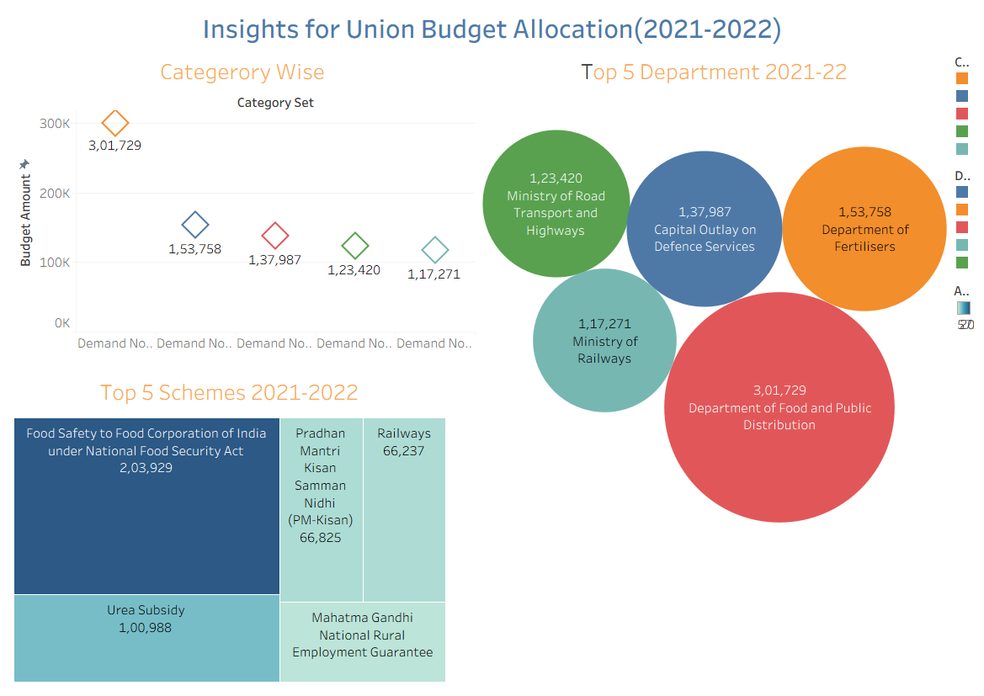
Dashboard 2:
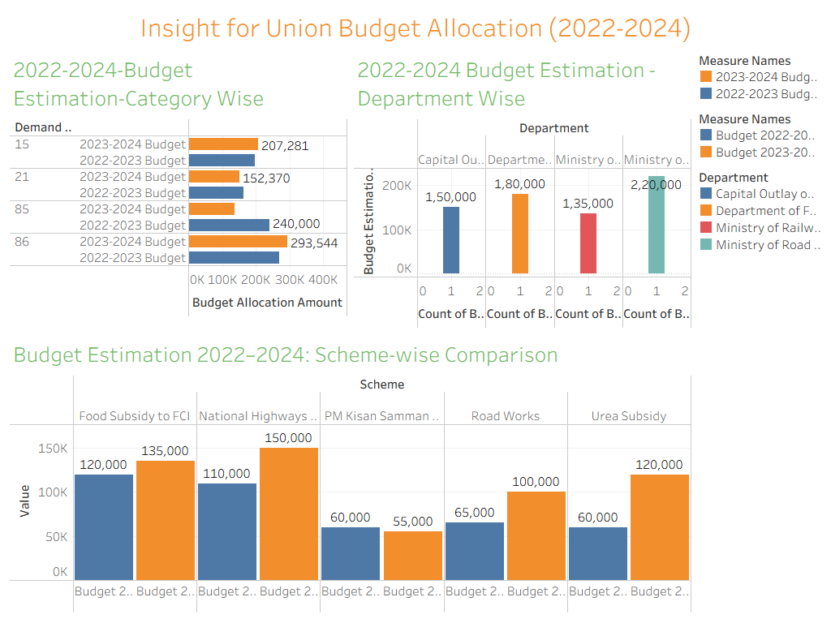

8. Conclusion
The analysis of Union Budget allocations reveals that India is steadily prioritizing sustainable growth by increasing investments in infrastructure, human capital, and renewable energy sectors. These trends demonstrate the government’s commitment to long-term economic stability, inclusive development, and environmental sustainability.

9. Future Enhancements
- Include real-time and latest Union Budget datasets
- Apply predictive analytics for future budget forecasting
- Compare India’s budget allocation with other countries for deeper insights

