**Add a Shared Calendar Microsoft Outlook Windows**

Open Microsoft Outlook

At the bottom left-hand side of the screen click on the calendar icon

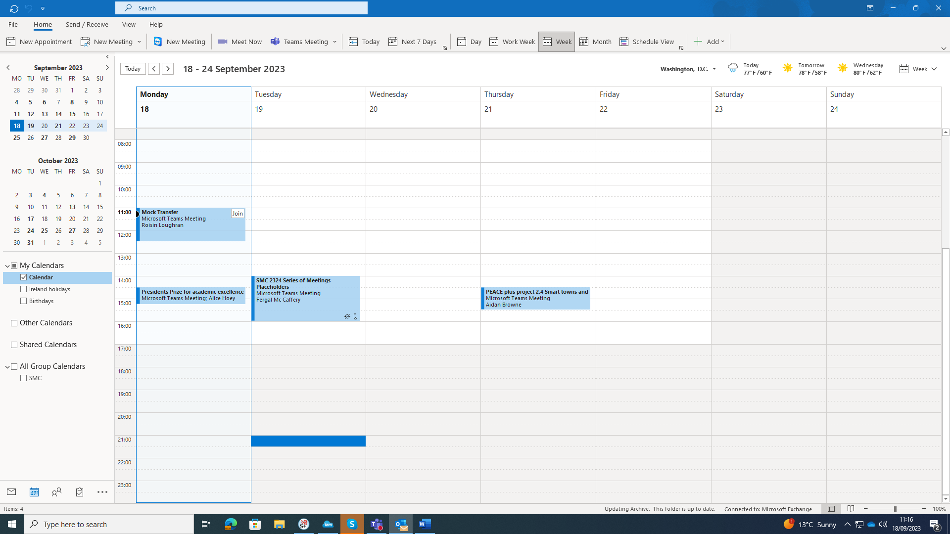

Once you are in the Calendar Section, right click on “Shared Calendars”

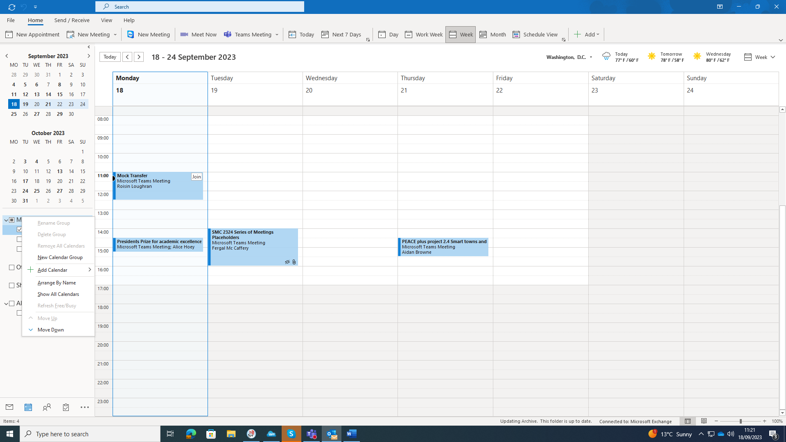

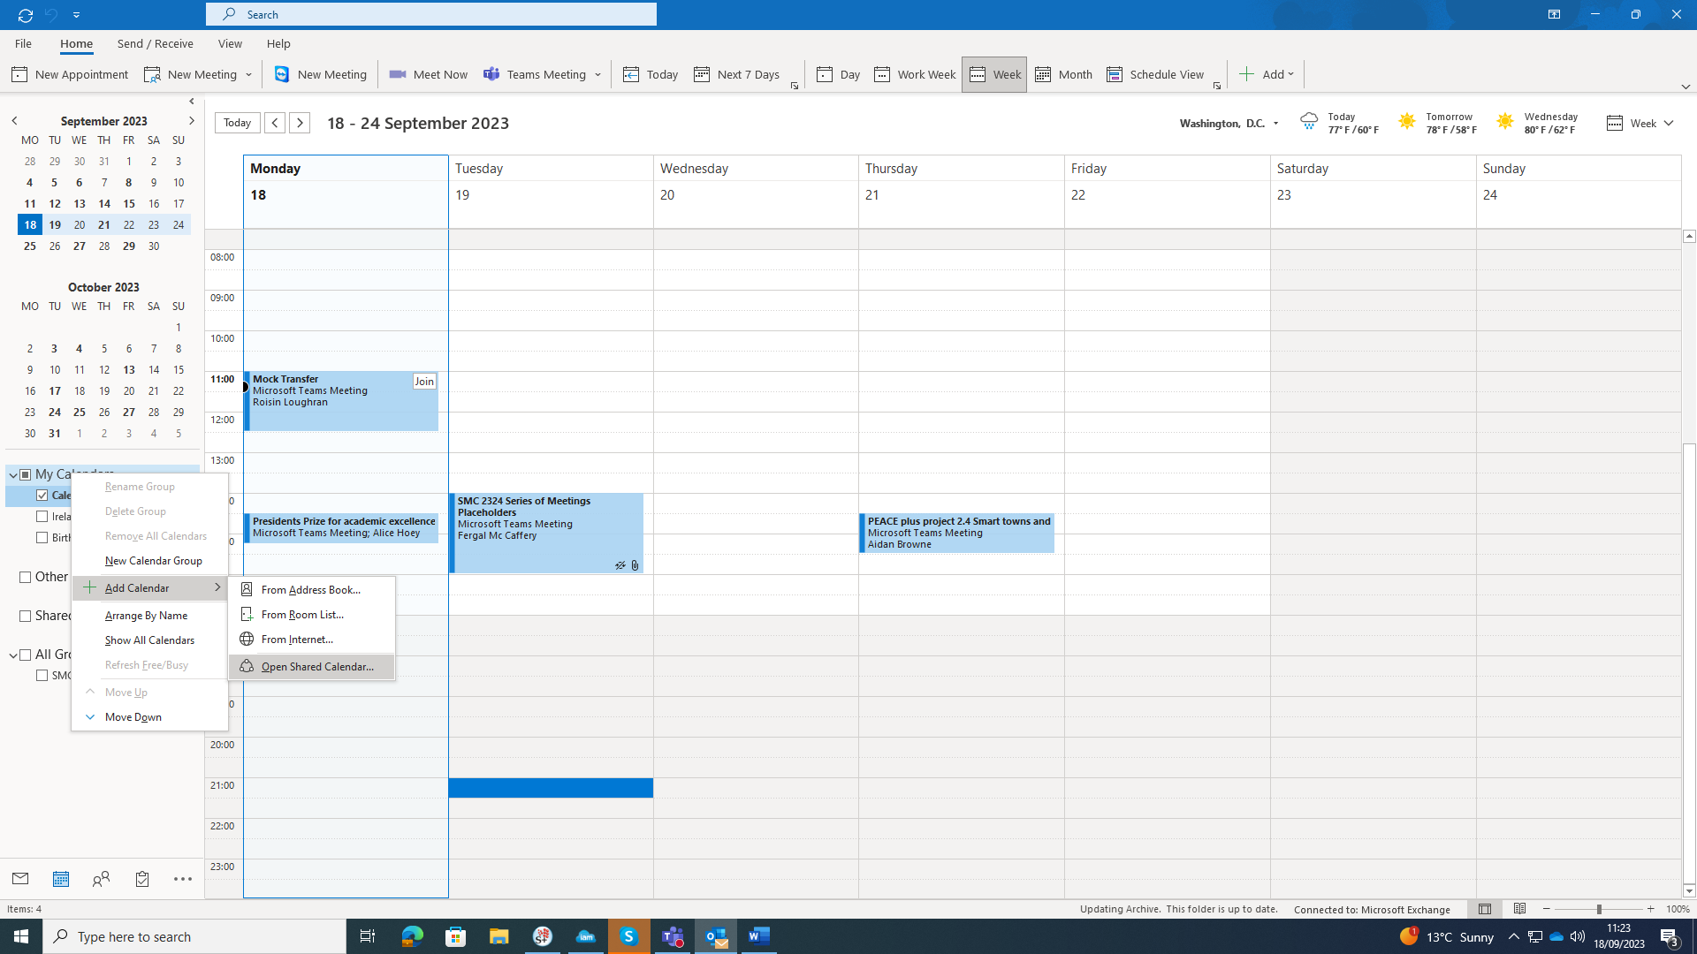Now click on “Add Calendar” and then click on “Open Shared Calendar”

In the dialog box that appears enter the address for the shared school calendar ([i.staff.admin@dkit.ie](mailto:i.staff.admin@dkit.ie)) and click OK

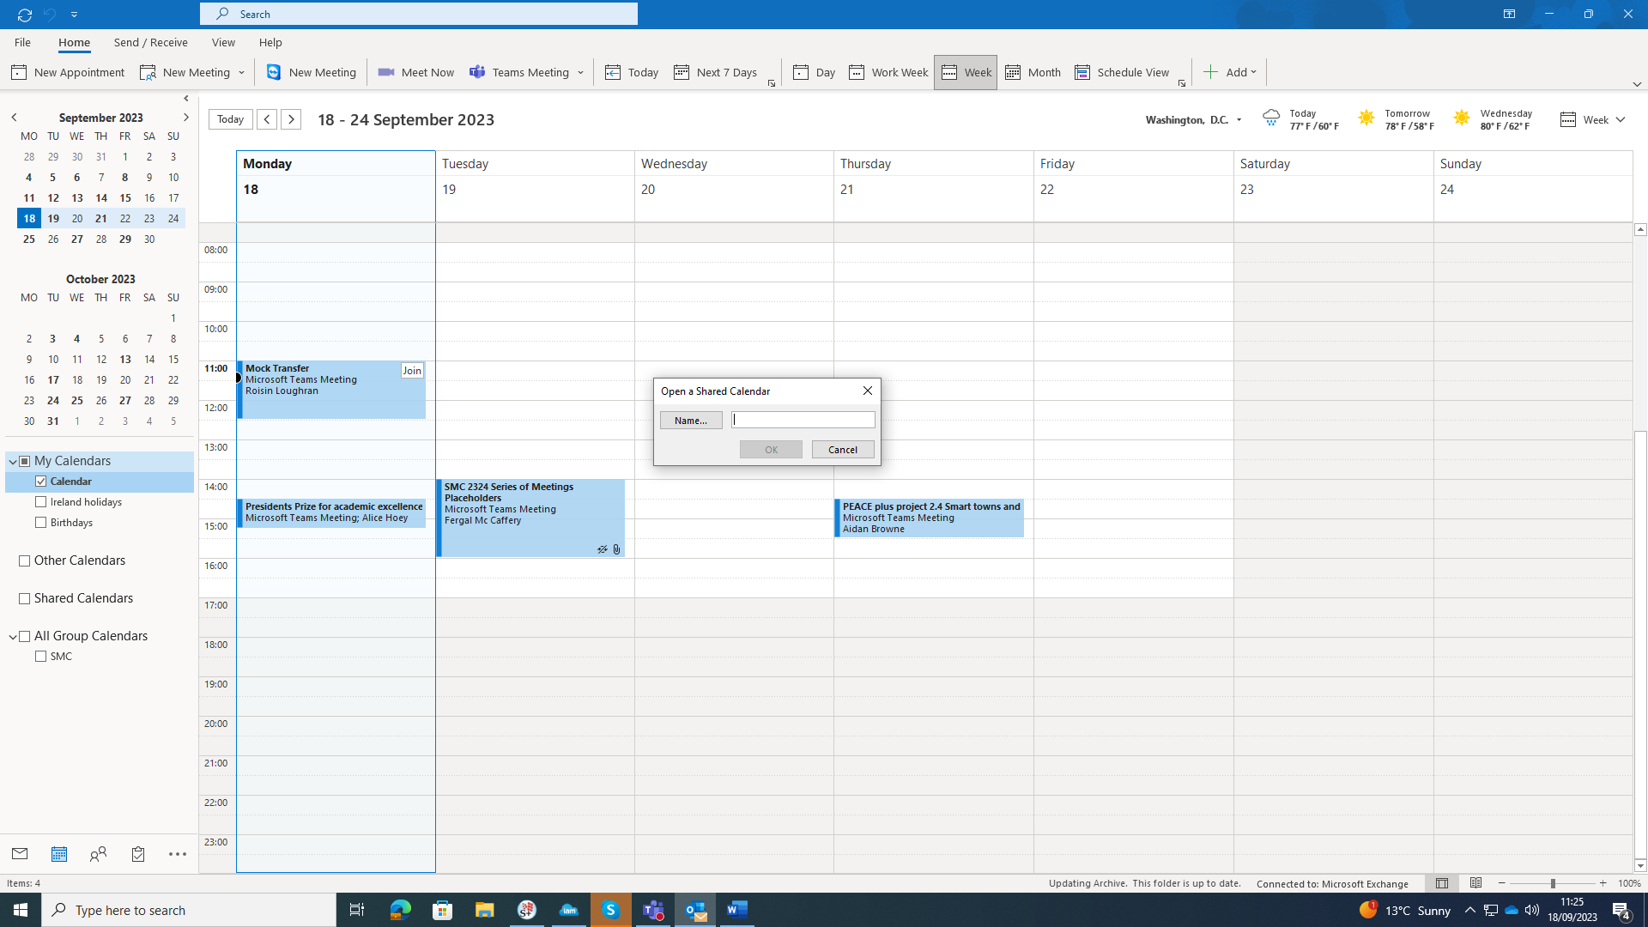

The shared calendar should now be visible under “Shared Calendars” and can be seen in the main calendar window on the right-hand side of your screen

