Creating NFI Phase 2 sample location with SFC

2024-02-26

# Context

This technical report covers the establishment of field sample locations for the Improved “National Forest Inventory Plan for Indonesia Forest”. The main document proposes a two-phases systematic stratified design with target sampling sizes for seven strata of dryland forest and one strata of mangrove forest.

Three annexes to the main report describe: 1. Optimal sampling grids for the NFI phase 1 visual interpretation. 1. Results of the NFI Phase 1 visual interpretation. 1. Distribution of the NFI Phase 2 field sample location (this report).

# Method

Given a final dataset of NFI phase 1 visually interpreted samples, the general approach to selecting the NFI phase 2 samples was as follows:

1. determine the distance of each sample along a space filling curve (Hilbert’s distance, computed with Python dask-geopandas [library](https://dask-geopandas.readthedocs.io/en/stable/docs/reference/api/dask_geopandas.GeoSeries.hilbert_distance.html))

## R Markdown

This is an R Markdown document. Markdown is a simple formatting syntax for authoring HTML, PDF, and MS Word documents. For more details on using R Markdown see <http://rmarkdown.rstudio.com>.

When you click the **Knit** button a document will be generated that includes both content as well as the output of any embedded R code chunks within the document. You can embed an R code chunk like this:

summary(cars)

## speed dist   
## Min. : 4.0 Min. : 2.00   
## 1st Qu.:12.0 1st Qu.: 26.00   
## Median :15.0 Median : 36.00   
## Mean :15.4 Mean : 42.98   
## 3rd Qu.:19.0 3rd Qu.: 56.00   
## Max. :25.0 Max. :120.00

## Including Plots

You can also embed plots, for example:

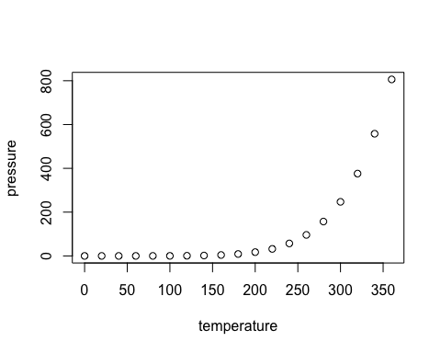

Note that the echo = FALSE parameter was added to the code chunk to prevent printing of the R code that generated the plot.