สวัสดี

สวัสดี

25/08/2021

# สวัสดี

## สวัสดี

สวัสดี

**สวัสดี**

*สวัสดี*

df <- data.frame(a = paste0("สวัสดี ", letters[1:5]), b = 1:5)  
  
ggplot(df, aes(x = a, y = b)) +  
 geom_point() +  
 geom_text(aes(y = b + 0.2, label = a), family = "Sarabun") +  
 labs(  
 title = "สวัสดี",  
 caption = "สวัสดี") +  
 theme_bw() +  
 theme(text = element_text(family = "Sarabun"))

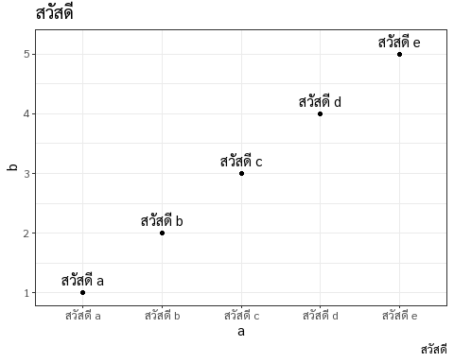

สวัสดี

col_names <- c("สวัสดี", "Value")  
  
knitr::kable(df, col.names = col_names, caption = "สวัสดี")

สวัสดี

|  |  |
| --- | --- |
| สวัสดี | Value |
| สวัสดี a | 1 |
| สวัสดี b | 2 |
| สวัสดี c | 3 |
| สวัสดี d | 4 |
| สวัสดี e | 5 |

## R Markdown

This is an R Markdown document. Markdown is a simple formatting syntax for authoring HTML, PDF, and MS Word documents. For more details on using R Markdown see <http://rmarkdown.rstudio.com>.

When you click the **Knit** button a document will be generated that includes both content as well as the output of any embedded R code chunks within the document. You can embed an R code chunk like this:

summary(cars)

## speed dist   
## Min. : 4.0 Min. : 2.00   
## 1st Qu.:12.0 1st Qu.: 26.00   
## Median :15.0 Median : 36.00   
## Mean :15.4 Mean : 42.98   
## 3rd Qu.:19.0 3rd Qu.: 56.00   
## Max. :25.0 Max. :120.00

## Including Plots

You can also embed plots, for example:

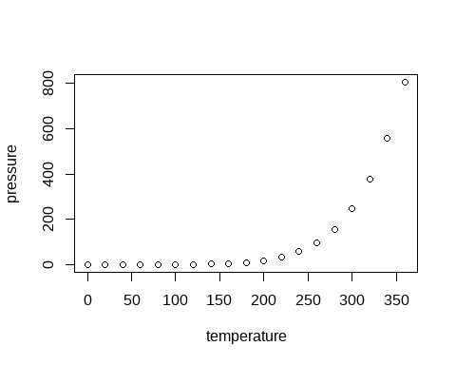

Note that the echo = FALSE parameter was added to the code chunk to prevent printing of the R code that generated the plot.