Write the complete specification of the user application (client-server integration, protocol registration,...)
Write the complete specification of the mesh-router (for broadcast discover query)
Implement a client application
Create a lab mesh network
Make the modifications to the routing system
Testing it : benchmark, reliability,...

- Introduction

VoiP is complex and powerful name for everything could provide Voice over IP Network. But in a context of oppression, some limits tend to be create over the IP network : China, Arabic Spring, ACTA,... and VoiP services, by his central registrar server can be easily control or shut down if someone or some power want to limit this service.
The P2PSIP workgroup try to create a decentralised version of the sip registrar : Like we can see here the main idea consist of a good number of registrar “nodes” who get only a part of the database registration table, with a lot of redundancy (Distributed Hash Table, DHT)
The P2PSIP protocol is now in process to define his standard, but now we can see that this methods require a management of the differents “main” nodes. It's get the same weakness than classical VoiP solutions : with a little less of stress because the servers can be easilly distributed all over the world.
Skype, use a P2P based communication between the users, but need a centralised system to authentificate the users between each other.
In mobile ad-hoc network (MANET) the system is design to be totally standalone, and work properly without any form of centralized system. If a node or many nodes fails, the whole system is able to create the new routing table and find himself new roads to get
This paper will describe and discuss about a way to get a standalone VoiP service over a MANETs network.

    - MANETs network – routing - OLSR
A MANET network infrastructure is made with several devices (call “nodes”) able to connect to others nodes and create a complete and autonomous networking system. Contrary to classical ad-hoc network, the communication between nodes are multi-hop : On Fig. 1 each node can communicate to another node using multiples hops.
If a node have a sub network, resource to share (for example an Internet connection) he can be used as a gateway.
Fig. 1 : a simple MANET topology with a gateway to Internet.

Many routing protocols exists, with two big kind of algorithms :
- Pro-active : Each node maintain a routing table of every reach-able address.
- Reactive : Try to find a route when you try to reach an unknown destination.

With these properties, MANETs networks are very usefull in cheap network or in unofficial infrastructures : In such kind of network, without any form of centralised or decentralized services, IP addressing is a veritable challenge. A lot of work already exists about this subject to get a reliable dynamic addressing in MANETs network. However, when a MANET network is build for a static use (with wireless router for example), we prefer call it “mesh”. Mesh problematic are more simple about IP addressing, but also are more used for home internet deliver, for instance in Africa : cheap, easy to deploy and robust are good pros of mesh network. A lot of howto exists to build a mesh network, and a lot of usage already exists : uncontrollable internet access during Arab Spring, ISP end user connexion

    - SIP over MANETs network

MANETs network, by his pro and usages become a very bad place for classical VoiP network : It become difficult and less efficient to create a centralized registration, and also stupid because you never really now if the network will be reachable.
Most part of MANET routing protocols implements Service Localisation Protocol (SLP) . SLP is use usually in LAN networks to provide discovery other devices.
In SIPHoc and SIPMON projects, two projects about implementation of SIP registrar over MANET network, they implement a SIP proxy in each node.
They use this layer to run a fully distributed and autonomous system. SIPMON use a DHT distributed table, like most of P2PSIP implementation, but SIPHoc use a very interesting different way (Fig. 2) :
The client A connect to his local SIP proxy (1). Each node should have his own. This proxy send the message to the whole MANET network through the SLP layer (2).
By this way, every SIP proxy in the network will get the registration (3). At this point, client B can now join client A with usual SIP protocol usage. If A want to call B but have no clue of the localization of B, when the local SIP proxy will receive a SIP INVITE request (5) for B, he use the SLP layout (6) to discover the localization of B. after what, he can initiate the session with B (7) as usual. 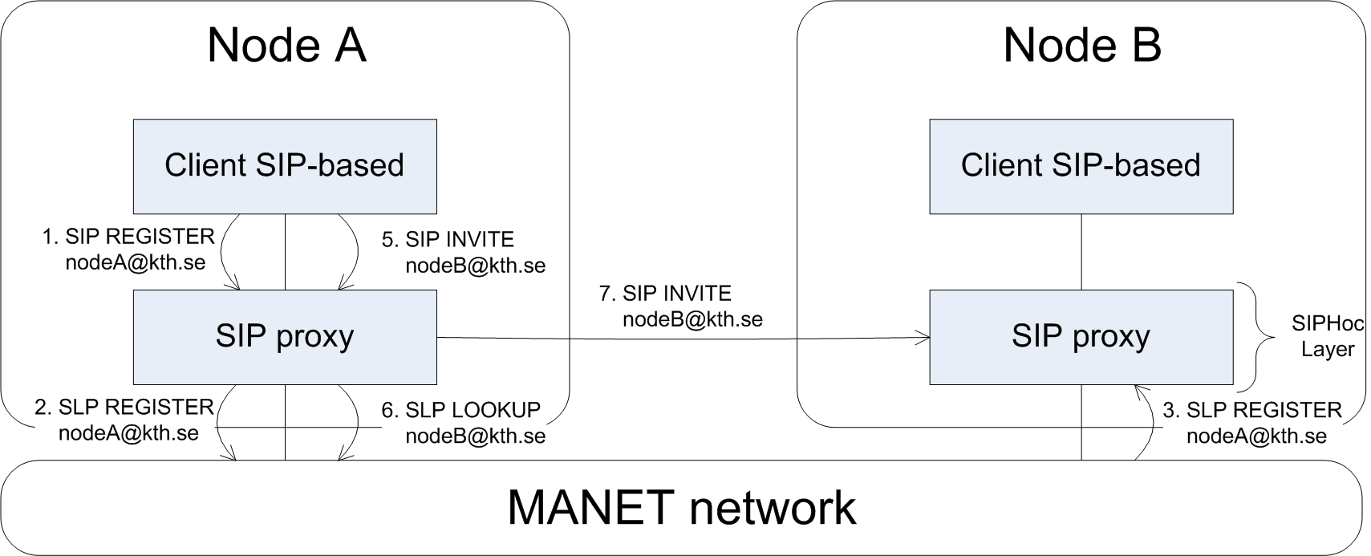
Fig2. SIPHoc Proxy system

This methods is very well adapted in MANETs topology where a lot of moving devices are involved : the lookup system permit to resolve efficiently URI.
Some problems occurs on Mesh of this system is the security: you tell to everybody your name and localization. Also, it could be a good idea to reduce the number of SLP messages on the network.
Another important point to be able to get a good VoiP system is the quality. After pass the problem of the registration, we have to get a good quality of the calls, and it’s depending mostly on the routing protocol. By their construction, routing protocols in MANETs usually consume a lot of bandwidth, and can slow down the traffic, a very important point for audio quality. In this paper we can observe that it’s possible to get a good audio quality with OLSR routing.
Finally, the mechanism introduce by SIPHoc permit a completely autonomous system based on discovery request (SLP). This system is efficient in different scenarios where we have to discover the network a lot, the usual use of MANET network.
Meanwhile, in mesh network, the IP addressing is usually static to get a good routing performance. (example in Fig. 5) On this topology, the specific routers can be used as registar nodes with DHT table as suggested in P2PSIP’s works. Some “all in one” firmware exists for mesh routers and could be adapted to create a decentralized SIP registration service.

Fig. 5 : mesh topology example (from Building a Rural Wireless Mesh Network, CC license )
Once again, the system can work, but need a lot of configuration and will not be able to recover if a big part of the network crash. Meanwhile, on mesh significant networks ( > 20 nodes ) it’s become very powerful with the scalability of DHT. SIPHoc could be also a good idea, but risk to increase the traffic and slow down the network by spamming SLP messages.
SIPHoc should be a great system on MANETs networks, but not very efficient on significant mesh networks. P2PSIP is possible but complicated to establish safely.
Now, we will focus on mesh network to find a good registration protocol.

    - Mesh – specific registrar implementation

Another approach based on SIPHoc architecture is to register directly to every people who you care about : each client have to maintain a list of contact he could call (like your buddy-list in Skype for example).
Because we have a static IP addressing, the probability for an user to change his localization is low. By this way, if only one contact change his localization it become impossible to lose the localization of your friend list : two users A and B are register to each other, and A change his localization. He register to his local proxy, and after that register directly to all his contacts, include B who get’s the new localization. If he is not able to communicate with B, maybe B have change his localization, so A use a SLP LOOKUP to find B again. In Fig. 3, you can find the state machine of this registration protocol. In anycase, if you change your localization, you have to do your best to find again your buddy and give to him your new localization, even if he has changed his localization.

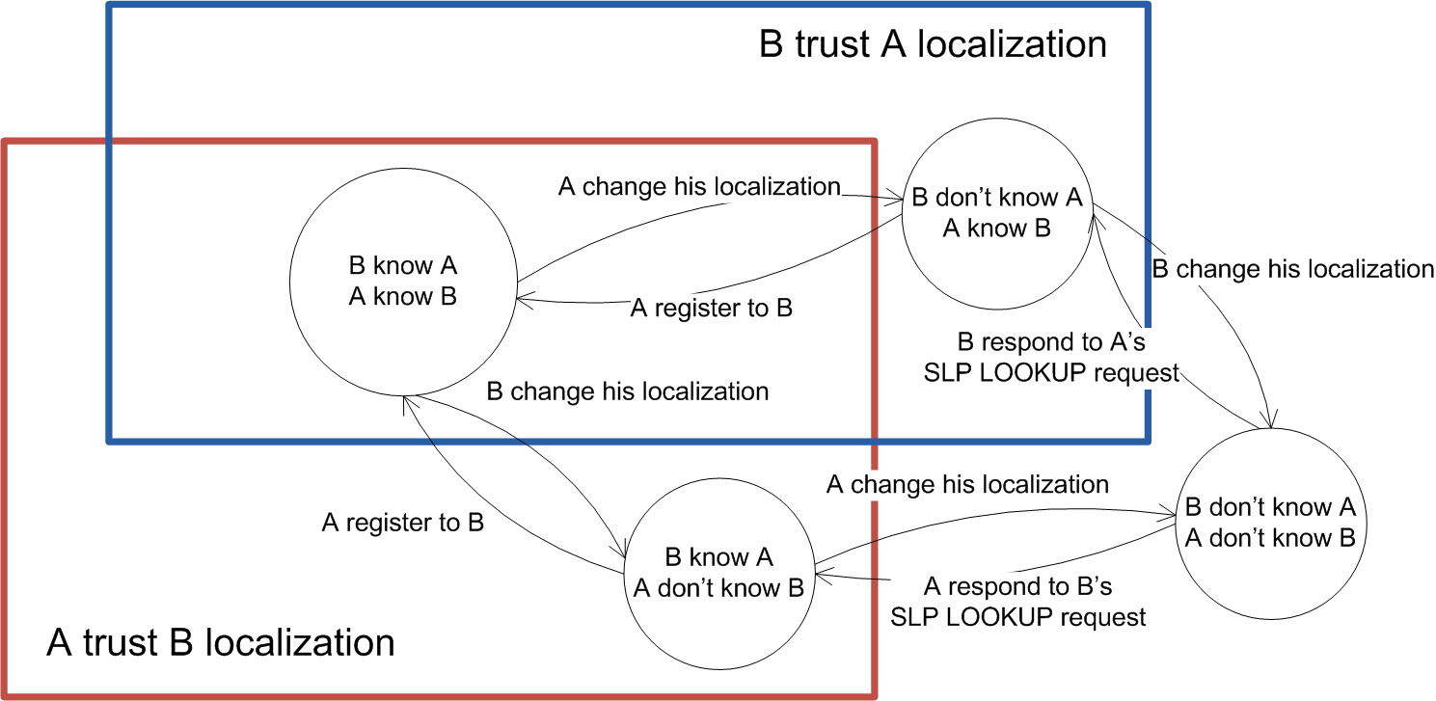
Fig. 3 :Registration state machine between two nodes.

In the case where A and B manage to change their localization at the same time, or they where unable to access to each other to exchange their new localization, they could use common friends to get the new URI : Introduce a new common client C. A,B,C knew each others. The topology is in Fig. 4.
The client A change is localization (1), and try to register to B and C (2, 5). C get the message and update his URI table (3, 4), but B never get the new location of A.
A want to know if he has miss the new localization of B, he ask his common contact C the localization address of B and his link-status with a SIP MESSAGE (6,7). A with help of C is sure that B should be able to join C even if B change his address. So he assumes B is offline.
After that, B becomes online again with a new localization. He want to register (8) and try contact A and C (9,12). C get his new localization (10), but B fail his registration with A. He ask C the status of A (13,14), get the new localization of A (15) and can now register A with success : A get the new location of B and vice versa.
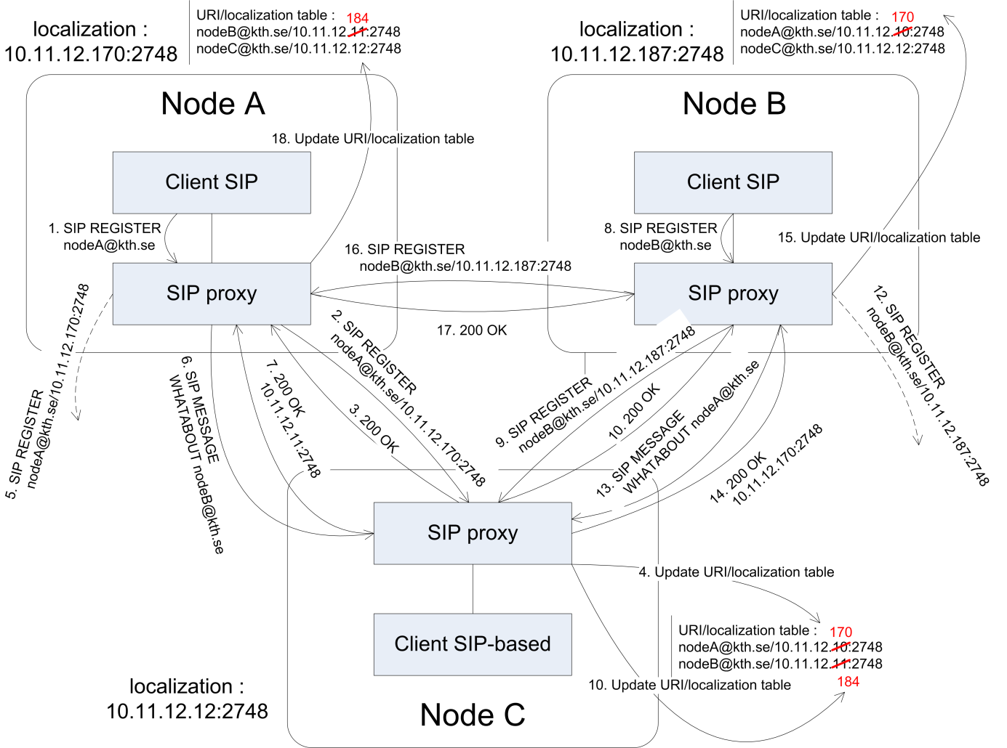
Fig. 4 : Registration with a third node

In Fig. 5 you can see the complete algorithm of the registration. It should be executed each time the client ask explicitly to register and also regularly for rescue offline buddies.
This algorithm concept is an improvement of SIPHoc methods : instead of using SLP layer, we use directly SIP registration protocol to give each potential dialer our new localization or status.
To be able to implement this protocol, we can re-use the SIPHoc middleware, but we have to develop a specific client software. It should be easy to tweak an existing sip client like QuteCom who is already based on a potential buddy list and support video traffic.

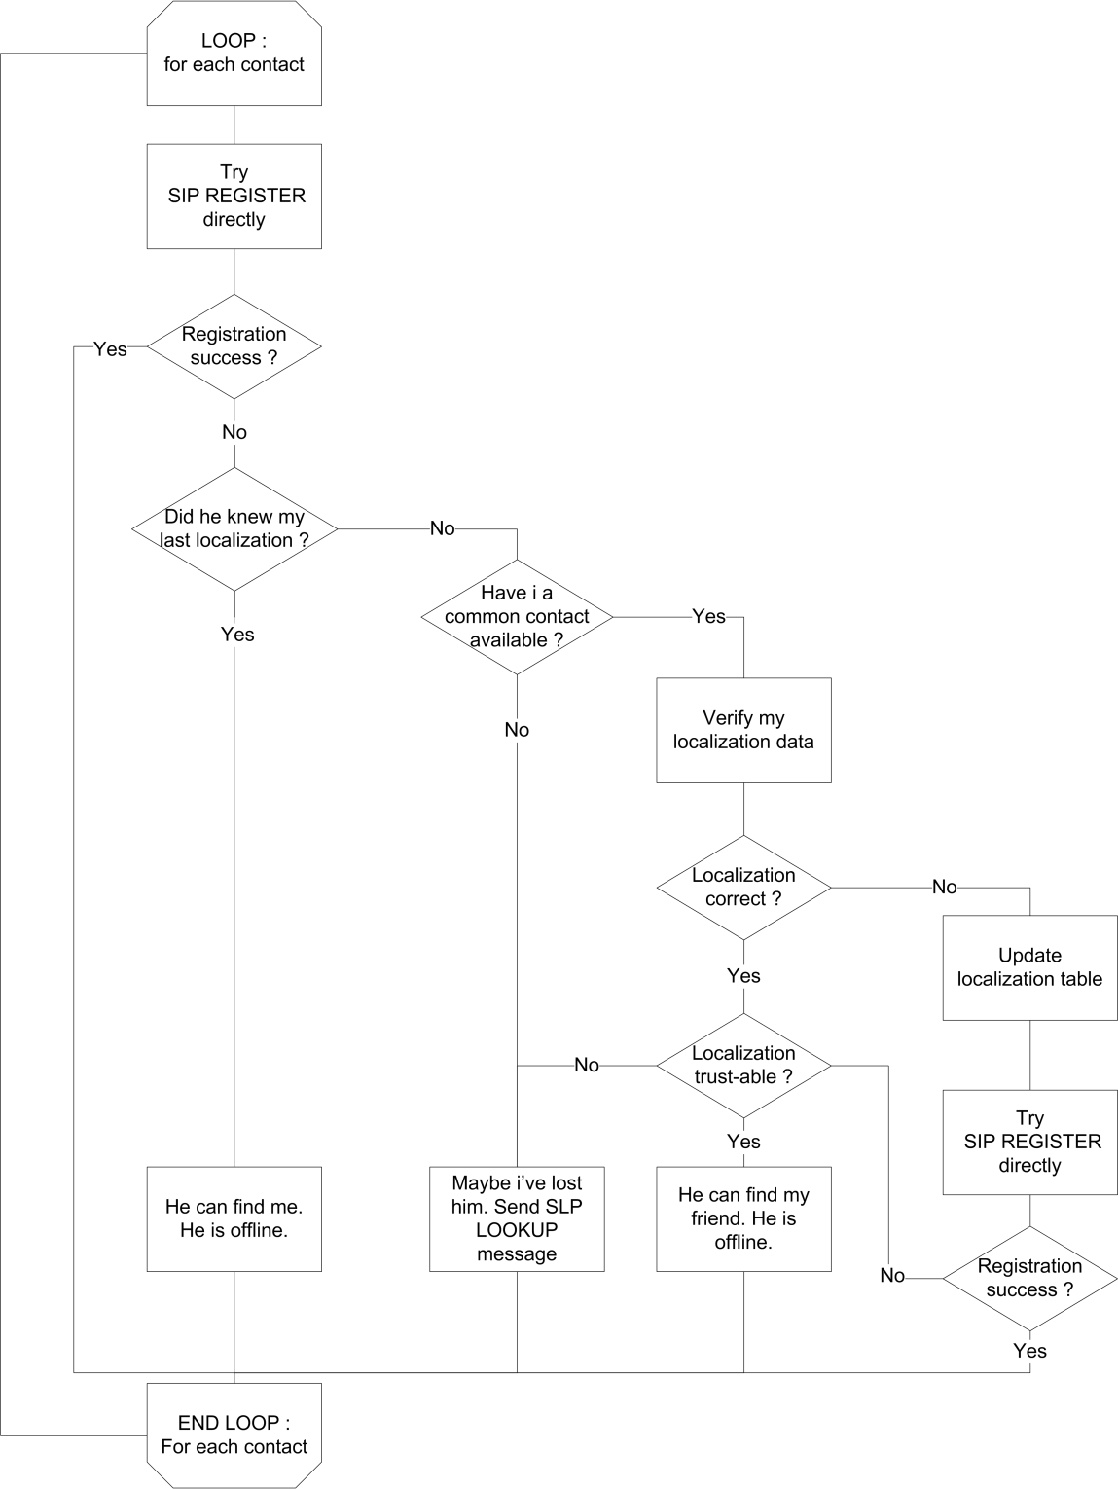
Fig. 5 : SIP Proxy registration algorithm

    - Integration in AIO solutions – mobility usages
    - Parallels with traditional IP network.
    - Conclusion

To avoid the problems of the security and performance
* Adding one user protocol
* Registration policy
* Find third user
* Return to the basics of SIPHoc after

Certificate based

    - News problems
      - Availability
    - Security
    - Integration
    - Limits of the idea : the mesh topo
    - CCL
- Limited to MANET networks

The SIPMON
For instance, each user
Secontly, for the User-URI affectation we can use 3 propriety of real life common users : Two users don't change their URI many time, and in a second time if you lose the URI of one of your contact, maybe you can ask a third person to give you his new address.
In the worst case, when you have
As we can see in Mesh or MANETs network, the whole system is based on actives nodes who can equally try to participate to the network.

Matuszewski, M., et E. Kokkonen. « Mobile P2PSIP - Peer-to-Peer SIP Communication in Mobile Communities ». In 5th IEEE Consumer Communications and Networking Conference, 2008. CCNC 2008, 1159 -1165, 2008.
Mohsin, M., et R. Prakash. « IP address assignment in a mobile ad hoc network ». In MILCOM 2002. Proceedings, 2:856 - 861 vol.2, 2002.
« Mesh Networking ». Wikipedia, the Free Encyclopedia, octobre 11, 2012. http://en.wikipedia.org/wiki/Mesh_networking
SolarMesh technology in Mannweiler, C., C. Lottermann, A. Klein, J. Schneider, et H. D. Schotten. « Cyber-physical networking for wireless mesh infrastructures ». Adv. Radio Sci. 10 (septembre 18, 2012): 113-118.
One Laptop Per Child (OLPC) Project, Low cost computer for http://wiki.laptop.org/go/Mesh_Network_Details#Design_goals
Johnson, D., K. Matthee, D. Sokoya, L. Mboweni, A. Makan, et H. Kotze. Building a Rural Wireless Mesh Network, 2007. http://mirror.omadata.com/onno/library-ref-eng/WirelessU- materials/Building_a_Rural_Wireless_Mesh_Network_-_A_DIY_Guide_v0.7_65.pdf .
Building a Subversive Grassroots Network, IEEE Spectrum, Article, 21 July 2011, http://spectrum.ieee.org/telecom/internet/building-a-subversive-grassroots-network
Pépin, Guénaël. « Haut débit en zones blanches : entre avancées technologiques et réalités économiques ». ZDNet, s. d. http://www.zdnet.fr/actualites/haut-debit-en-zones-blanches-entre-avancees-technologiques-et-realites-economiques-39753628.htm .
Standard define in RFC2608 and RFC3224, IETF
SIPHoc: Efficient SIP Middleware for Ad Hoc Networks, Patrick Stuedi, Marcel Bihr, Alain Remund and Gustavo Alonso, report, Zurich, ETH, Department of Computer Science,
Wongsaardsakul, Thirapon. « P2P SIP over mobile ad hoc networks ». Institut National des Télécommunications, 2010. http://tel.archives-ouvertes.fr/tel-00712171.
« Mesh Networking ». Wikipedia, the Free Encyclopedia, octobre 11, 2012. http://en.wikipedia.org/wiki/Mesh_networking
Performance Analysis of Ad hoc Routing Protocols for Voice Communication Support over Hybrid MANETs, Manpreet Singh and Rajneesh Kumar Gujral, article, International Journal of Computer Applications (0975 – 8887), Volume 22– No.3, May 2011
« Freifunk presentation ». Wiki - Freifunk, s. d. http://wiki.freifunk.net/Kategorie:English.
QuteCom, s. d. http://www.qutecom.org/

