VoIP over MANETs networks: a centered approach on users
Master student Gaëtan Trivino
School of Information and Communication Technology (ICT)
Royal Institute of Technology (KTH)
October 2012

Introduction
VoIP is complex and powerful name for everything could provide Voice over IP Network. But in a context of oppression, some limitations tend to be creating over the IP network: China, Arabic Spring, ACTA... and VoIP services, by his central registrar server can be easily control or shut down if someone or some power wants to limit this service.

The P2PSIP workgroup try to create a decentralized version of the sip registrar: Like we can see here the main idea consist of a good number of registrar “nodes” who get only a part of the database registration table, with a lot of redundancy (Distributed Hash Table, DHT).
The P2PSIP protocol is now in process to define his standard, but now we can see that this methods require a management of the different “main” nodes. It's get the same weakness than classical VoIP solutions, with a little less of stress because the servers can be easily distributed all over the world.
In mobile ad-hoc network (MANET) the system is design to provide IP networking service and work properly without any form of centralized system : each node is equal as is neighbor by construction.

This paper will describe and discuss about a way to get a scalable and autonomous VoIP service over MANETs networks: routing, protocols of registration and user integration.

MANETs network – routing – OLSR
A MANET network infrastructure is made with several devices (call “nodes”) able to connect to others nodes and create a complete and autonomous networking system. Contrary to classical ad-hoc network, the communication between nodes is multi-hop: On Fig. 1 each node can communicate to another node using multiples hops.
If a node have a sub network, resource to share (for example an Internet connection) he can be used as a gateway.
  - Fig. 1: a simple MANET topology with a gateway to Internet.
Many routing protocols exist, with two big kinds of algorithms:
- Pro-active: Each node maintains a routing table of every reach-able address.
- Reactive: Try to find a route when you try to reach an unknown destination.

With these properties, MANETs networks are very useful in cheap network or in unofficial infrastructures: In such kind of network, without any form of centralized or decentralized services, IP addressing is a veritable challenge. A lot of work already exists about this subject to get a reliable dynamic addressing in MANETs network. However, when a MANET network is build for a static use (with wireless router for example); we prefer call it “mesh”. Mesh problematic are more simple about IP addressing, but also are more used for home internet deliver, for instance in Africa,: cheap, easy to deploy and robust are good pros of mesh network. A lot of howto exists to build a mesh network, and a lot of usage already exists: uncontrollable internet access during Arab Spring, ISP end user connection

SIP over MANETs network: existing work
MANETs network, by his pro and usages become a very bad place for classical VoIP network: It becomes difficult and less efficient to create a centralized registration, and also stupid because you never really now if the network will be reachable.
Most part of MANET routing protocols implements Service Localization Protocol (SLP). SLP is use usually in LAN networks to provide discovery other devices.

In SIPHoc and SIPMON projects, two projects about implementation of SIP registrar over MANET network, they implement a SIP proxy in each node. They use this layer to run a fully distributed and autonomous system. SIPMON use a DHT distributed table, like most of P2PSIP implementation, but SIPHoc use a very interesting different way (Fig. 2):
The client A connects to his local SIP proxy (1). Each node should have one locally. This proxy sends the message to the whole MANET network through the SLP layer (2).
By this way, every SIP proxy in the network will get the registration (3). At this point, client B can now join client A with usual SIP protocol usage. If A want to call B but have no clue of the localization of B, when the local SIP proxy will receive a SIP INVITE request (5) for B, he use the SLP layout (6) to discover the localization of B. after what, he can initiate the session with B (7) as usual. 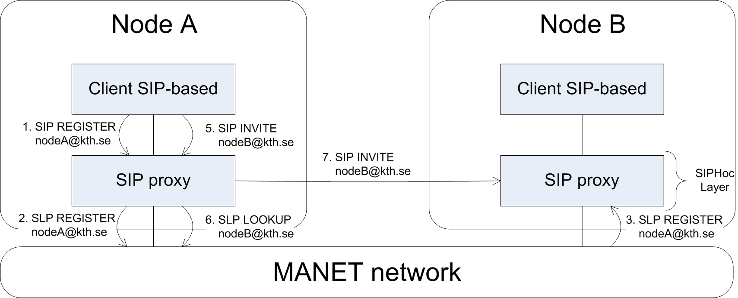
  - Fig2. SIPHoc Proxy system
This method is very well adapted in MANETs topology where a lot of moving devices are involved: the lookup system permit to resolve efficiently URI. It resolve also the DNS resolution problem: as every centralized service in MANETs networks, it’s very difficult to have a trust-able DNS service : the network don’t always give you a DNS service resolution, and you cannot know if you can trust the DNS service you get. By this method, you ask directly the URI name, and wait for someone who recognize his name on the network.
Some problems occur on Mesh of this system is the security: you tell to everybody your name and localization. Also, it could be a good idea to reduce the number of SLP messages on the network.
Another important point to be able to get a good VoIP system is the quality. After pass the problem of the registration, we have to get a good quality of the calls, and it’s depending mostly on the routing protocol. By their construction, routing protocols in MANETs usually consume a lot of bandwidth, and can slow down the traffic, a very important point for audio quality. In this paper we can observe that it’s possible to get a good audio quality with OLSR routing.
OLSR is a proactive routing protocol for MANETs networks. Each node send periodically in broadcast his identity and the routes he can route locally outside the mesh network: usually his own IP pool sub network, a gateway to Internet or nothing if he is alone. If the network contain too many nodes, it become impossible for the routing protocol to manage the broadcast messaging flow, and the network crash. In this interesting paper, with an optimization of OLSR routing protocol they estimate the limit of OLSR protocol to 25 000 nodes. The number isn’t very important, but the main point is, contrary to P2PSIP who is design to manage 2 or 2 millions of users with the same system, a VoIP service on a MANET network make no sense after this theoretical limit.
Finally, the mechanism introduce by SIPHoc permit a completely autonomous system based on discovery request (SLP). This system is efficient in different scenarios where we have to discover the network a lot, the usual use of MANET network.
Meanwhile, in mesh network, the IP addressing is usually static to get a good routing performance. (Example in Fig. 3) On this topology, the specific routers can be used as registrar nodes with DHT table as suggested in P2PSIP’s works. Some all in one firmware exists for mesh routers and could be adapted to create a decentralized SIP registration service.

Fig. 3: mesh topology example (from Building a Rural Wireless Mesh Network, CC license)
Once again, the system can work, but need a lot of configuration and will not be able to recover if a big part of the network crash. Meanwhile, on mesh significant networks (> 10 nodes) it’s become very powerful with the scalability of DHT. SIPHoc could be also a good idea, but risk to increase the traffic and slow down the network by spamming SLP messages.
SIPHoc should be a great system on MANETs networks, but not very efficient on significant mesh networks. P2PSIP is possible but complicated to establish safely.
Now, we will focus on mesh network to find a good registration protocol, adapted to the problematic of mesh network: the routing protocol already consume a lot of broadcast bandwith, the service should work event if there is only 2 nodes online.

Mesh – specific registrar implementation

Global routine
Another approach based on SIPHoc architecture is to register directly to every people who you care about: each client has to maintain a list of contact he could call (like your buddy-list in Skype for example).
Because we have a static IP addressing, the probability for a user to change his localization is low. If only one contact change his localization it’s become impossible to lose the localization of your buddy list: two users A and B are register know their registration each other. A change his localization. He registers to his local proxy, and after his proxy register directly to all his contacts, include B who gets the new localization. If he is not able to communicate with B, maybe B has change his localization, so A use a SLP LOOKUP to find B again, like describe in SIPHoc specifications. If B doesn’t answer, A assumes B is offline.
In Fig. 4, you can find the state machine of this registration protocol. In any case, if you change your localization, you have to do your best to find again your buddy and give to him your new localization, even if he has changed his localization.

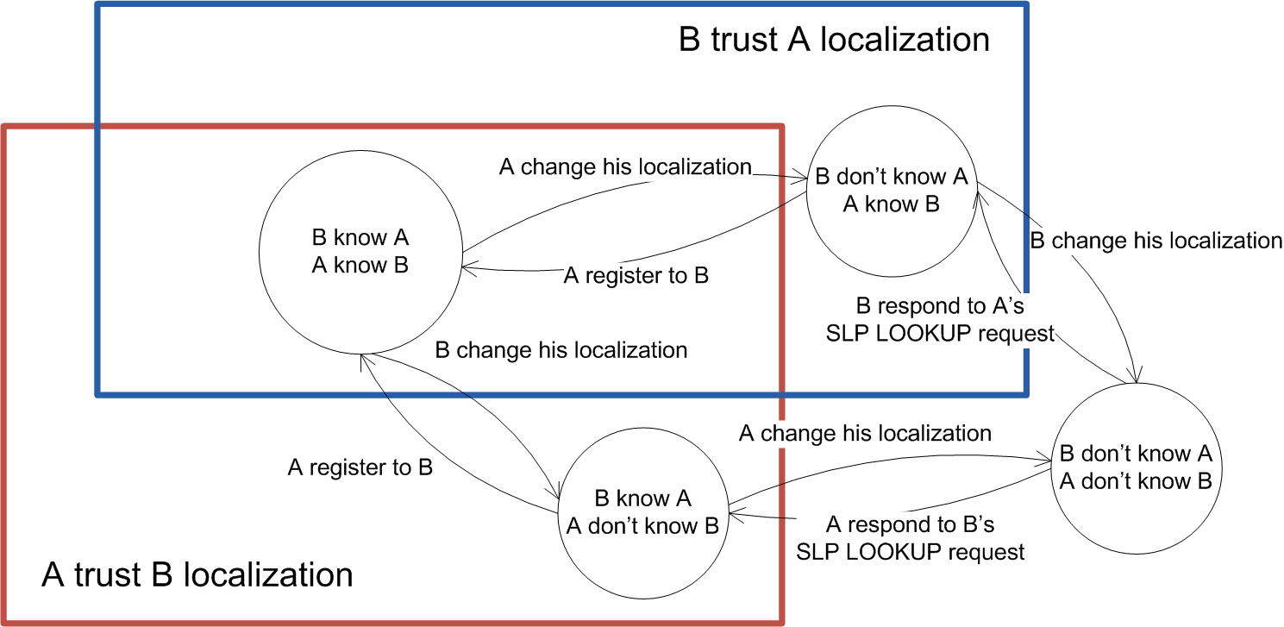
  - Fig. 4: Registration state machine between two nodes.
In the case of A and B change their localization at the same time, or they were unable to access to each other to exchange their new localization, they could use common friends to get the new URI: Introduce a new common client C. A, B and C knew each others. The topology is in Fig. 5.
The client A change is localization (1), and tries to register to B and C (2, 5). C get the message and update his URI table (3, 4), but B never get the new location of A.
A want to know if he has miss the new localization of B, he ask his common contact C the localization address of B and his link-status with a SIP MESSAGE (6,7). A with help of C is sure that B should be able to join C even if B change his address. So he assumes B is offline.
After that, B becomes online again with a new localization. He wants to register (8) and try contact A and C (9, 12). C gets his new localization (10), but B fails his registration with A. He asks C the status of A (13, 14), get the new localization of A (15) and can now register A with success: A get the new location of B and vice versa.

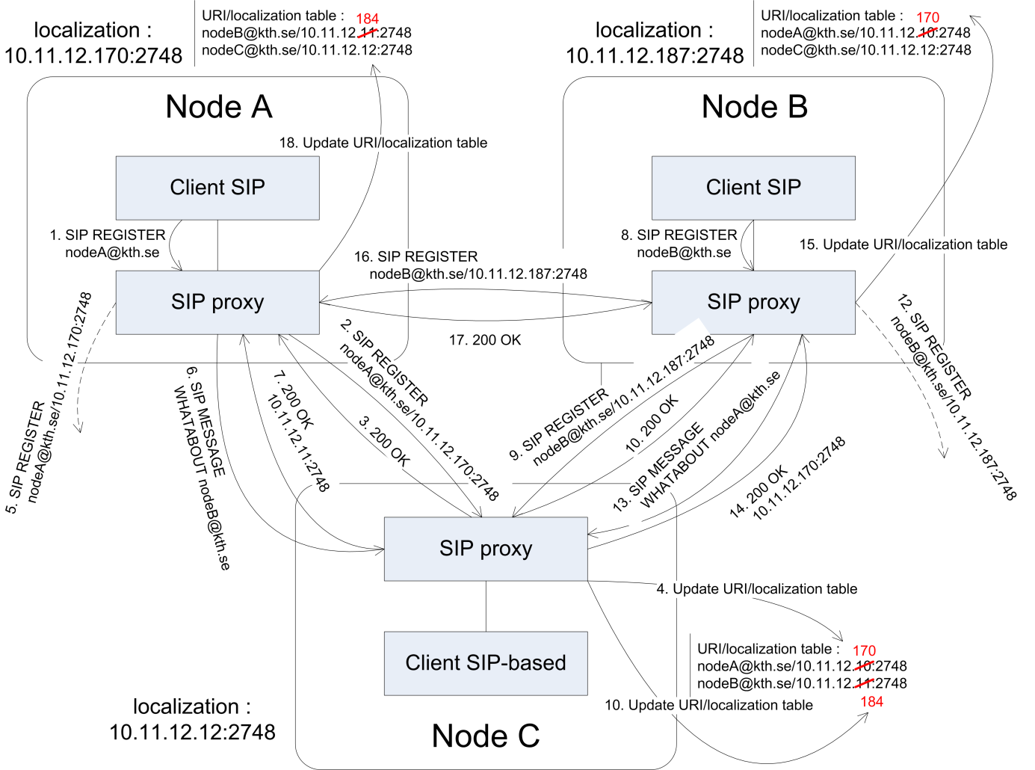
  - Fig. 5: Registration with a third node
In Fig. 6 you can see the complete algorithm of the registration. It should be executed each time the client ask explicitly to register and also regularly for rescue offline buddies.
This algorithm concept is an improvement of SIPHoc methods: instead of using SLP layer, we use directly SIP registration protocol to give each potential dialer our new localization or status.
To be able to implement this protocol, we can re-use the SIPHoc middleware, but we have to develop specific client software. It should be easy to tweak an existing sip client like QuteCom who is already based on a potential buddy list and support video application.

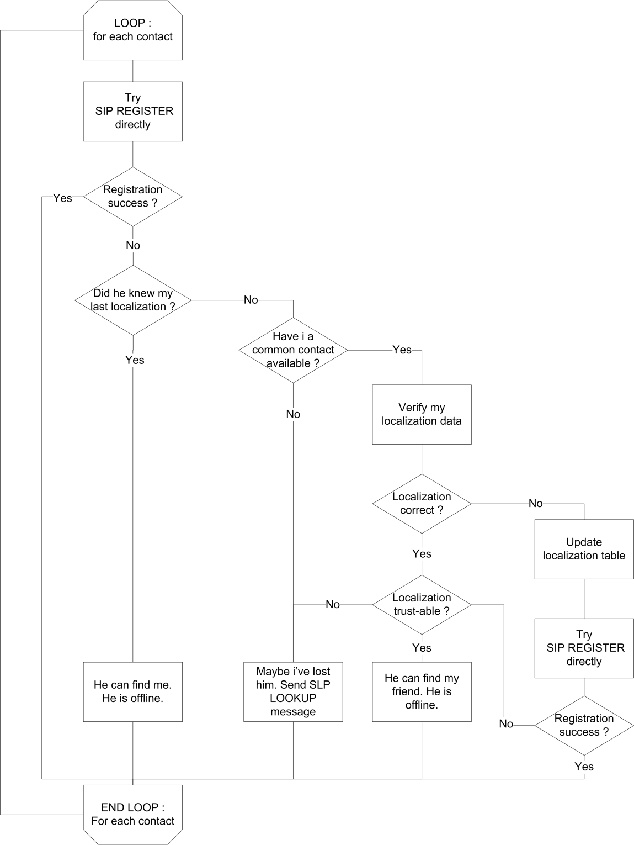
  - Fig. 6: SIP Proxy registration algorithm

Adding buddy
To permit two users to share permanently their localization, we have to initiate the connection. To be sure that the two users are agree and limit security problem, we want to use an acceptation request system like describe in Fig. 7:
First, A want to add B to his buddy list. He send a SIP MESSAGE to B (1,2,4) by using his proxy(1). If nodeB isn’t already known, we use the SLP protocol (2) as before. B receive the message and accept the request of A and inform his own proxy (5). Then, the SIP proxy of B execute a SIP SUBSCRIBE with A (6) and vice-versa(7). A and B will exchange their SIP registration start from this point.
For temporary use, we can reuse the timeout value in SIP SUBSCRIBE request. We should notice this isn’t a standard use of SUBSCRIBE request: we send register query and not NOTIFY commands.

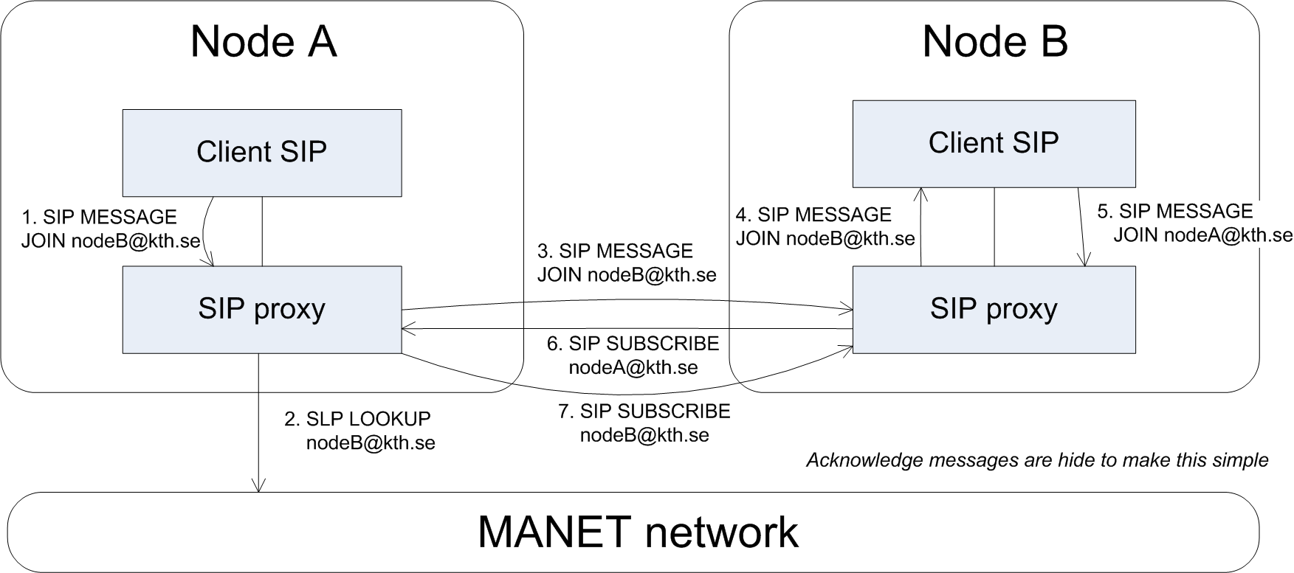
  - Fig. 7 : Add a new URI to buddy-list

Security
In every network, security is very important topic. Without central registration service, it’s become harder to manage duplicate URI and authentication. The P2PSIP working group have done a good analysis and in this blog we can find also a good overview : Man in the middle, attack in the overlay network, … At this point, there is a lot of questions with no response, and SIPHoc or our adaptation to mesh network have the same problems as P2PSIP.
In the mean time, mesh infrastructures are used in situation where it’s difficult to have a classical IP network, and construct by people who already know each other : users own the network and differ our ability to trust the network and use unsecure protocols.

Integration in all in one solution – mobility usages - experimentation
Nowadays, two types of devices are massively connected on IP networks : computers (laptop or desktop) and smartphones.
The OLSRd project already implements an OLSR routing system for computer and they are working on smartphone integration. Some applications are available, but not really released yet.

Conclusion

Matuszewski, M., et E. Kokkonen. « Mobile P2PSIP - Peer-to-Peer SIP Communication in Mobile Communities ». In 5th IEEE Consumer Communications and Networking Conference, 2008. CCNC 2008, 1159 -1165, 2008.
« Distributed Hash Table ». Wikipedia, the Free Encyclopedia, octobre 11, 2012. http://en.wikipedia.org/wiki/Distributed_hash_table
Mohsin, M., et R. Prakash. « IP address assignment in a mobile ad hoc network ». In MILCOM 2002. Proceedings, 2:856 - 861 vol.2, 2002.
« Mesh Networking ». Wikipedia, the Free Encyclopedia, octobre 11, 2012. http://en.wikipedia.org/wiki/Mesh_networking
SolarMesh technology in Mannweiler, C., C. Lottermann, A. Klein, J. Schneider, et H. D. Schotten. « Cyber-physical networking for wireless mesh infrastructures ». Adv. Radio Sci. 10 (septembre 18, 2012): 113-118.
One Laptop Per Child (OLPC) Project, Low cost computer for http://wiki.laptop.org/go/Mesh_Network_Details#Design_goals
Johnson, D., K. Matthee, D. Sokoya, L. Mboweni, A. Makan, et H. Kotze. Building a Rural Wireless Mesh Network, 2007. http://mirror.omadata.com/onno/library-ref-eng/WirelessU- materials/Building_a_Rural_Wireless_Mesh_Network_-_A_DIY_Guide_v0.7_65.pdf .
Building a Subversive Grassroots Network, IEEE Spectrum, Article, 21 July 2011, http://spectrum.ieee.org/telecom/internet/building-a-subversive-grassroots-network
Pépin, Guénaël. « Haut débit en zones blanches : entre avancées technologiques et réalités économiques ». ZDNet, s. d. http://www.zdnet.fr/actualites/haut-debit-en-zones-blanches-entre-avancees-technologiques-et-realites-economiques-39753628.htm .
Standard define in RFC2608 and RFC3224, IETF
SIPHoc: Efficient SIP Middleware for Ad Hoc Networks, Patrick Stuedi, Marcel Bihr, Alain Remund and Gustavo Alonso, report, Zurich, ETH, Department of Computer Science,
Wongsaardsakul, Thirapon. « P2P SIP over mobile ad hoc networks ». Institut National des Télécommunications, 2010. http://tel.archives-ouvertes.fr/tel-00712171
« Mesh Networking ». Wikipedia, the Free Encyclopedia, octobre 11, 2012. http://en.wikipedia.org/wiki/Mesh_networking
Performance Analysis of Ad hoc Routing Protocols for Voice Communication Support over Hybrid MANETs, Manpreet Singh and Rajneesh Kumar Gujral, article, International Journal of Computer Applications (0975 – 8887), Volume 22– No.3, May 2011
Philippe, Jacquet. « RFC3626 : Optimized Link State Routing Protocol (OLSR) », s. d. http://tools.ietf.org/html/rfc3626
Adjih, Cédric, Emmanuel Baccelli, Thomas Heide Clausen, Philippe Jacquet, et Georgios Rodolakis. « Fish Eye OLSR Scaling Properties ». Journal of Communications and Networks 6, nº. 4 (décembre 2004): 352-361.
« Freifunk presentation ». Wiki - Freifunk, s. d. http://wiki.freifunk.net/Kategorie:English
QuteCom, s. d. http://www.qutecom.org/
Matuszewski, Marcin, Song Yongchao, et Dan York. « P2PSIP Security Overview and Risk Analysis », s. d. http://tools.ietf.org/html/draft-matuszewski-p2psip-security-requirements-06
Singh, Kundan. « P2P-SIP: Security in P2P-SIP ». P2P-SIP / Peer-to-peer Internet telephony using SIP, s. d. http://p2p-sip.blogspot.se/2009/10/security-in-p2p-sip.html
OLSRd, s. d. http://www.olsr.org/

