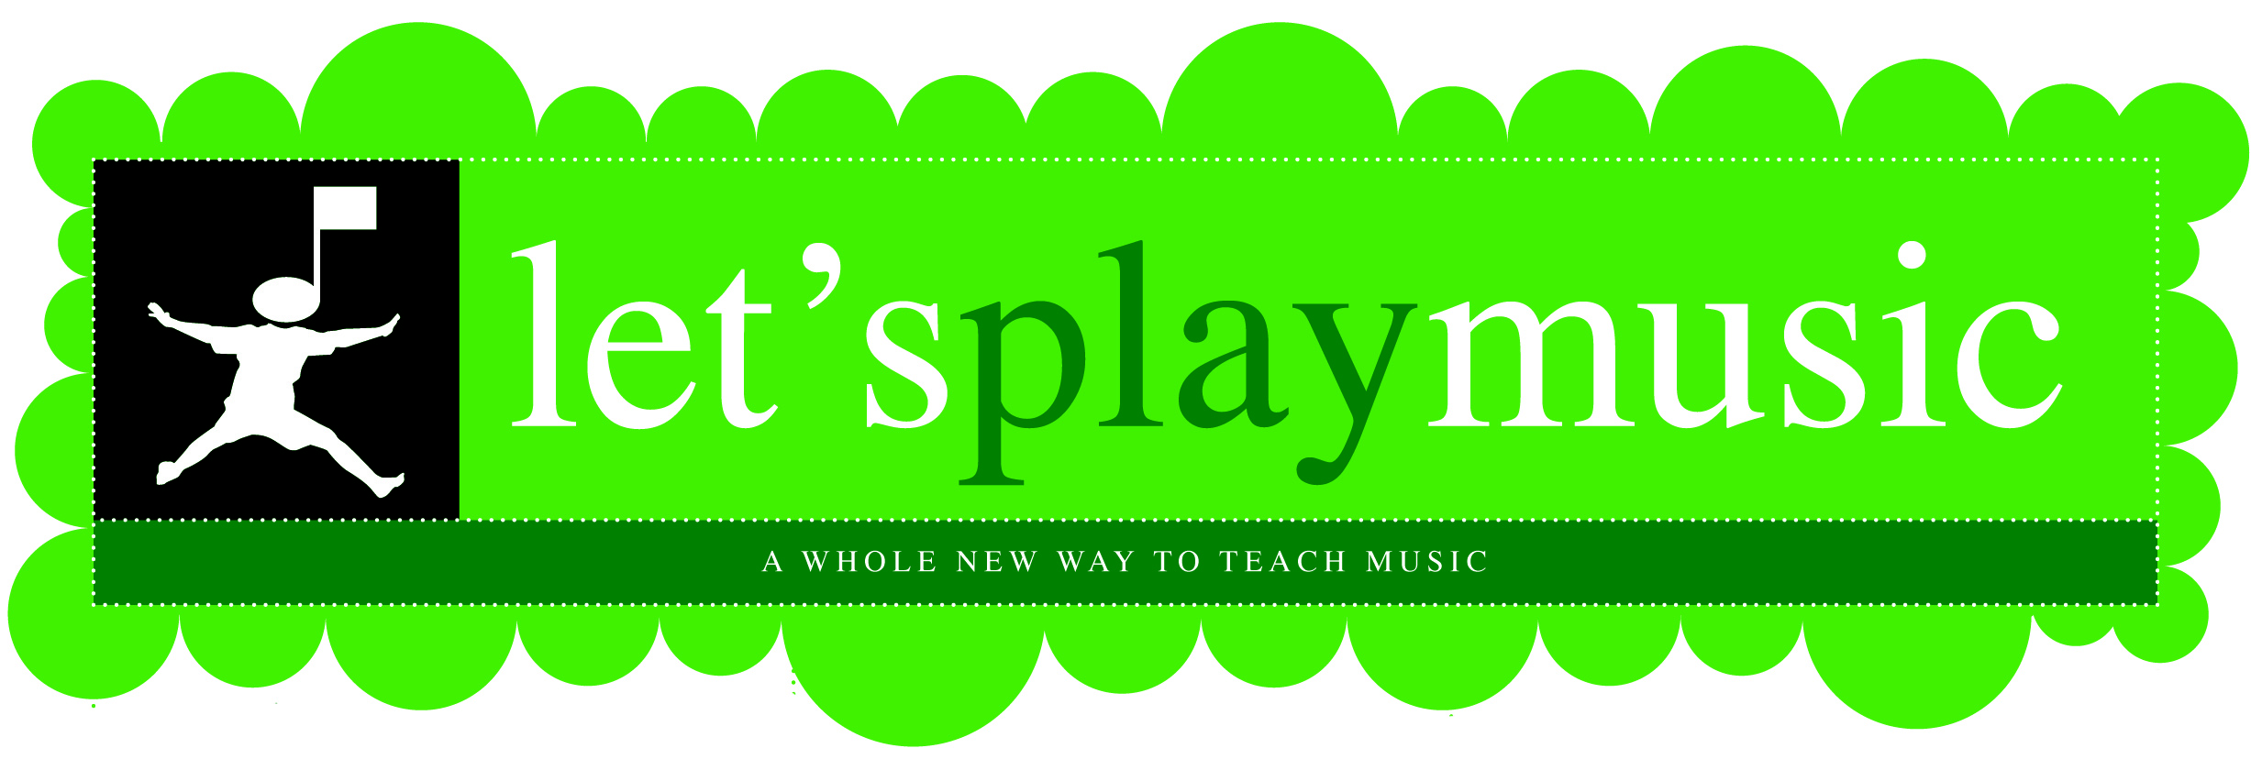

Let’s Play Music Registration
Registration for the 1st year in the Let’s PLAY Music program.
I’m so excited to begin classes next fall! To secure your place in class, please fill out this form and return it along with your deposit. When selecting your class time, remember that 1st year parents attend with the children twice a month. I will do my best to accommodate your first choice of class time, but will go back to who turned in their registration first if there is a conflict, so don’t delay! (Especially if you have a sticky schedule next year!) Please call me if you have any questions.
Student’s Name: | _________________________________________________ |  |  | Birthday: | _______________________
Address: | _____________________________________________________________________________________
Home Phone: | _________________________________ | Cell Phone: | ____________________________________
Parent’s Names: | _____________________________________________________________________________________
Email Address: | _____________________________________________________________________________________
Please indicate your 1st and 2nd choices (or indicate impossible) class times.
Tuesday 10:30 AM
Tuesday 1:00 PM
Materials Fees: | $83 for entire year (includes set of Tone Bells, Home Study Notebook, Tote bag and two Home Study CDs). *For additional siblings, fee is $23 materials plus the $15 registration fee. ($38 total)
Deposit: | $98 ($83 materials fee and a $15 registration fee) *sibling $38
Tuition: | $360 per year or 8 monthly payments of $45
Please read and initial the following items below
stating that you have read and are aware of the upcoming dates and policies.
 | The deposit holds a spot for your child in fall classes.
 | Once materials are purchased, they can’t be refunded. However, if there is a problem contact the teacher for options.
 | There is a mandatory orientation meeting for the parents approximately one week before class starts.
 | You will receive your student’s materials at the orientation meeting.
 | At the beginning of August, you will receive a Welcome Email confirming class times.
 | The information on this form will be used to register my child with corporate Let’s Play Music.
 | It is anticipated that your child will continue in my studio throughout the three year Let’s Play Music curriculum.
Signature: | _________________________________________________ |  |  | Date: |  | _____________________
