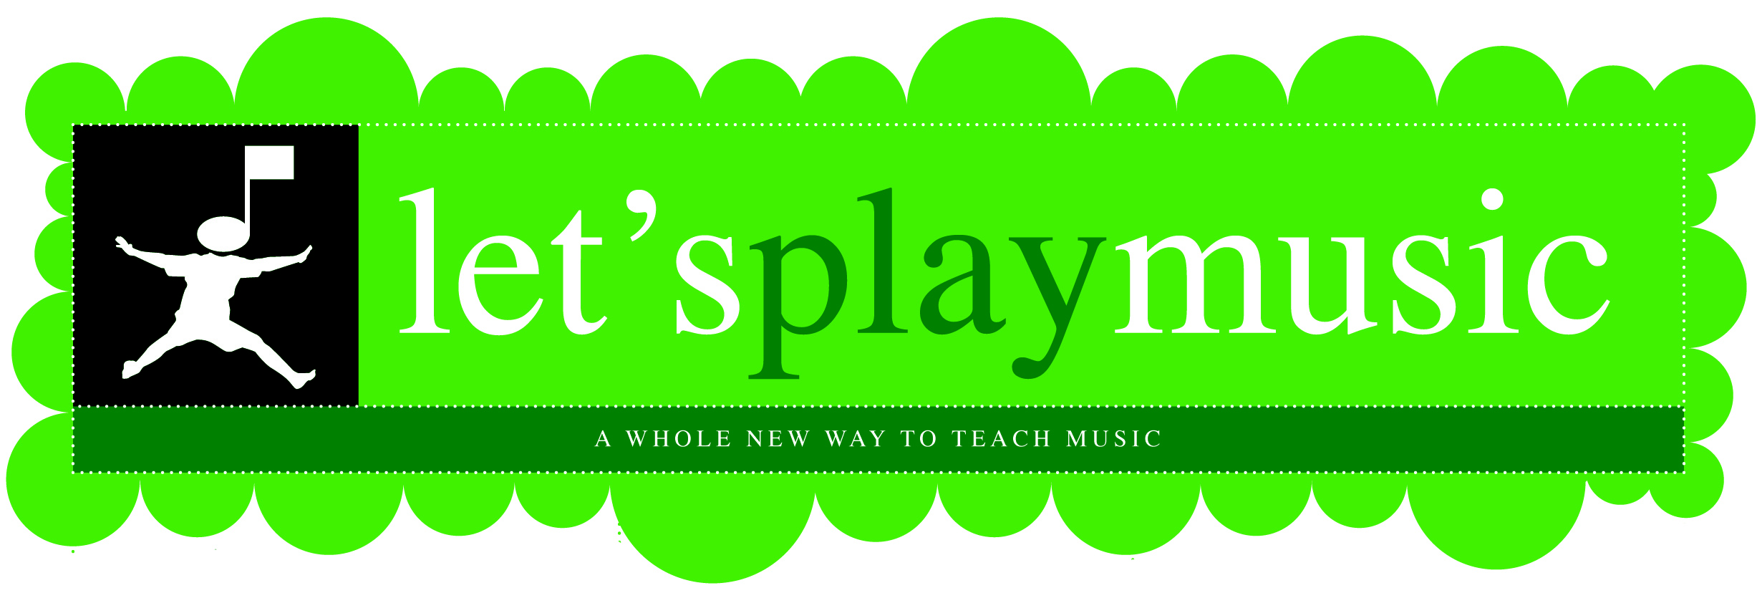

Let’s Play Music Registration
Registration for the 2nd year of the Let’s PLAY Music program.
I’m so excited for classes to begin next fall! We will be working on keyboards in class, so you will need a piano or a keyboard with full size keys at home. Remember, parents will now attend classes once a month and classes are 50 minutes long. Please fill out this form and return it along with your deposit. I will try to accommodate everybody’s first choice, but will go back to who turned in their registration first if there is a conflict, so don’t delay, especially if you have a sticky schedule next year!
Student’s Name: | _________________________________________________ |  |  | Birthday: | _______________________
Address: | _____________________________________________________________________________________
Home Phone: | _________________________________ | Cell Phone: | ____________________________________
Parent’s Names: | _____________________________________________________________________________________
Email Address: | _____________________________________________________________________________________
Please indicate your 1st and 2nd choices (or indicate impossible) class times.
Wednesday 10:30 AM
Wednesday 3:30 PM
Materials Fees: | $63 for entire year (includes two each of the following: Home Study CDs, Piano Songbooks, Lesson Guides, and “Bubble Hands” *For additional siblings, fee is $38 + $15 registration fee.
Deposit: | $78 ($63 materials fee and a $15 registration fee) *$53 for additional sibling.
Tuition: | $440 per year or 8 monthly payments of $55.
Please read and initial the following items below
stating that you have read and are aware of the upcoming dates and policies.
 | The deposit holds a spot for your child in fall classes.
 | There is a mandatory orientation meeting for the parents approximately one week before class starts.
 | You will receive your student’s materials at the orientation meeting.
 | Once materials are purchased, they can’t be refunded. However, if there is a problem contact the teacher for options.
 | A week before the orientation meeting you will receive a Welcome Email reminding you of the upcoming dates.
 | The information on this form will be used to register my child with corporate Let’s Play Music.
 | It is anticipated that your child will continue in my studio throughout the three year Let’s Play Music curriculum.
Signature: | _________________________________________________ |  |  | Date: |  | _____________________


