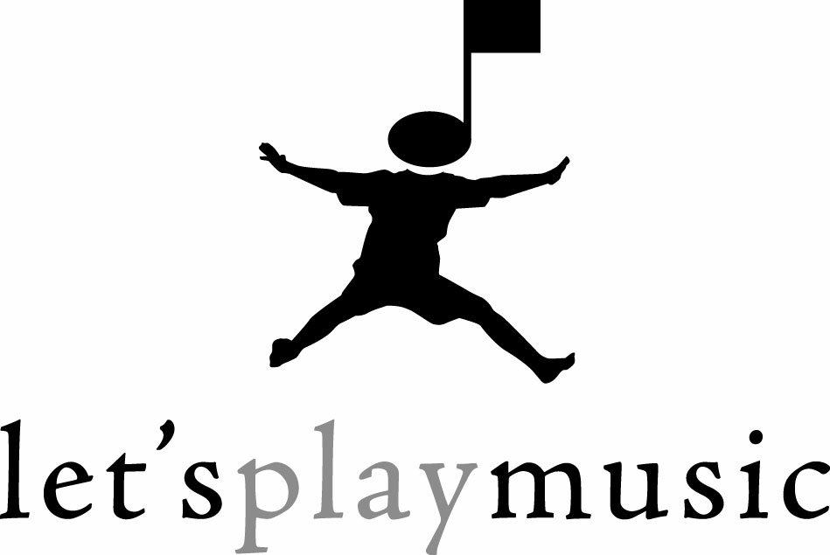
www.letsplaymusicsite.com
YOUR ADDRESS
Mesa, AZ 85203

Dear Friend,

As a music educator, I am constantly bombarded with questions such as: When should I start my child in piano lessons? Are group or private lessons better? Is ear-training or note-reading more important? When is vocal training appropriate? The list goes on and on. Unfortunately, I have been unable to suggest a curriculum that is completely based upon music education facts and findings pertaining to the young child. Until now……...

I am excited to introduce you to Let’s Play Music!, an exciting, new music curriculum which teaches advanced musical skills to young children using age-appropriate methods. Music educators have long taught that the young child learns best through play, experience and discovery. Let’s Play Music! uses play as the medium through which difficult concepts and skills are learned.

This exciting curriculum will lead your child from very basic music introduction using singing, and rudimentary instruments through a three year program. By graduation time, students will be playing piano at an intermediate level, transposing music, composing their own music, sight-reading music, and prepared to excel in any further piano instruction.

Because this is such a new and innovative curriculum, I am anxious to give you and your child (age 4-5) an inside look into what you can expect from each and every class period. I would like to invite you to attend a special sneak preview Sample Class. There you can observe your child participate in class and ask any questions you may have. I am positive that your experience will be enlightening, refreshing and FUN! Please visit our website at www.letsplaymusicsite.com and watch the online video at www.letsplaymusicsite.com/video for lots of great information!

I will begin enrolling for the 2010-2011 session on YOUR DATE. Please call me at YOUR NUMBER or e-mail at youre-mail@music.net to register for a Sample Class and discover the fascinating world of Let’s Play Music!

Sincerely,

YOU

