Let’s Play Music 3rd Year Training
Finale Tutorial

Product Line: http://www.finalemusic.com/
- Finale 2010 - $600. does everything. Orchestral scoring,
- Finale Allegro - $199. slightly less technical, but does everything I’ve ever heard of
- Finale Print Music – $99.95. Includes SmartScore Lite, ability to scan and convert to an XML document.
- Finale Songwriter - $49.95. MIDI capability, click in notes.
- Finale Notepad - $9.95. click in notes. Limited capability to edit in expressions, directions, staff size and layouts.

You can upgrade to the next level for a lesser fee. They make it very easy to start simple and buy more when you’re ready!

Print MusicTutorial: This has screen shots, step by step examples, and is very easy to follow! http://www.finalemusic.com/UserManuals/PrintMusic2009Win/PrintMusic.htm

If you don’t get the “Document Set-up Wizard” box during your launch, you can get there by clicking in the upper left corner “File – New – Document with set-up Wizard” and follow the instructions given here.

Getting Started:
        - Launch Finale (click on the icon)
        - If you get a “Quick Start” prompt, click “not yet”
        - Next, you’ll get the “Document Set-up Wizard”
          - Click “Next” to default the title and composer
          - “Choose Parts” menu: Select “keyboard” from the left column, then, moving right “piano”, “add” and “next.
          - Click “Next” to default through the key signature and time signature box.
          - Click “Finish” to default through the final settings box.

Your new document now looks like this:
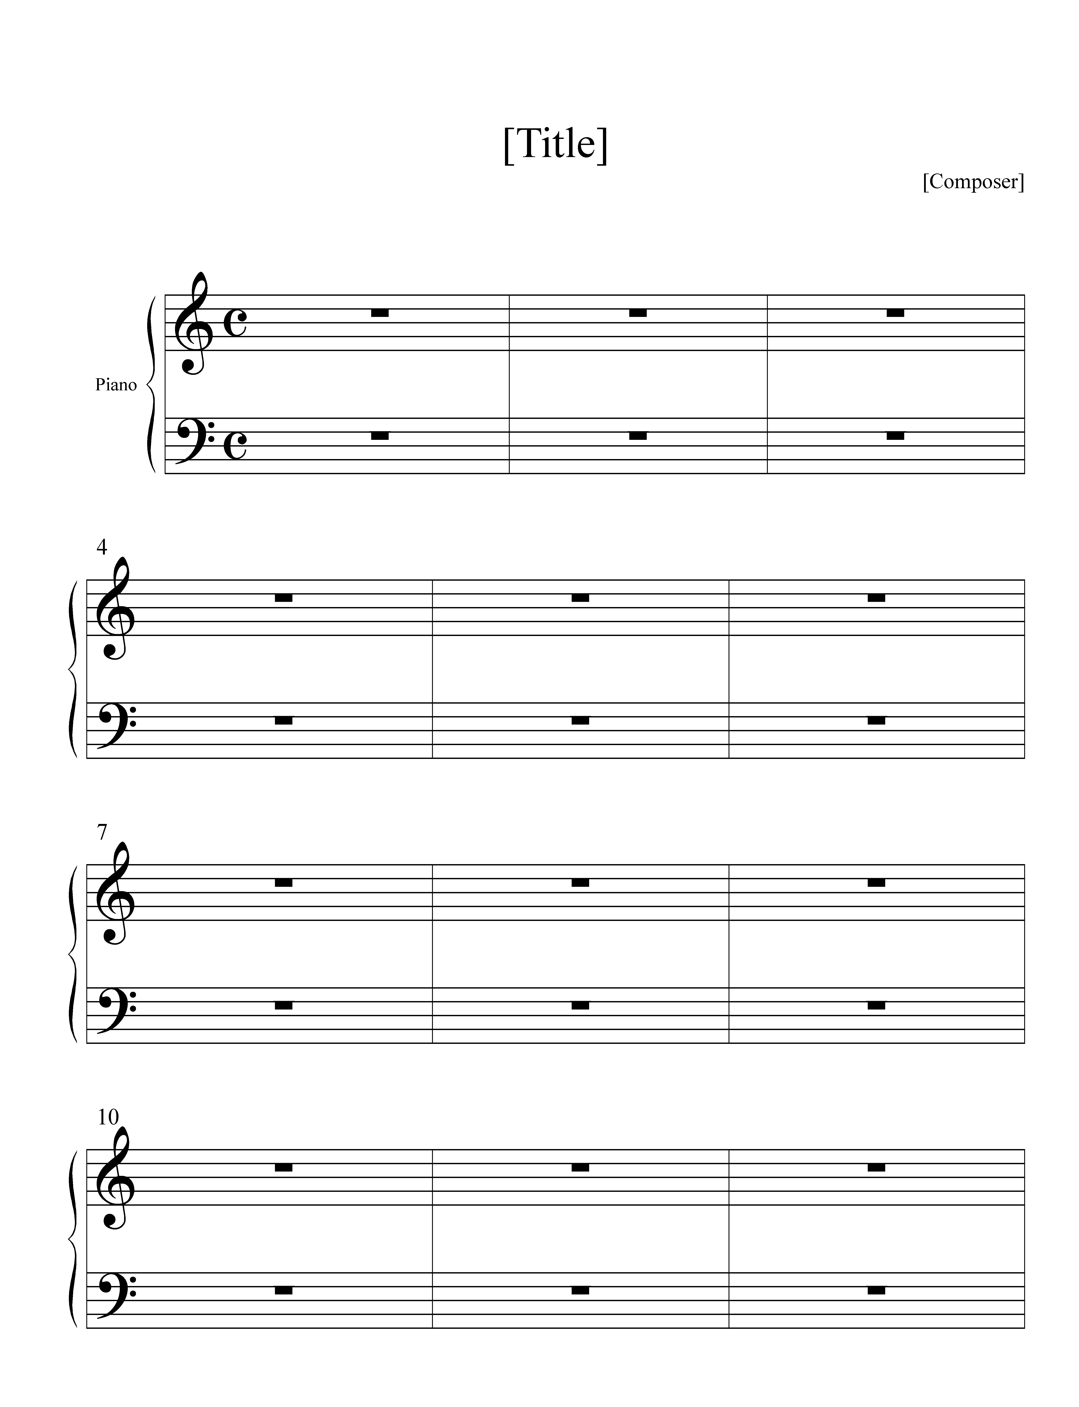
Creating a Template
The easiest way to create many student compositions with the same format is to create a template with all the necessary elements of a Lesson 6 composition.
If you do not see a tools palette or a page layout tool, go into the “Tools” tab at the top and select from there.
- Select the page layout tool from the tools palette.
- “Handlebars” will appear in the form of squares connected by dotted lines.
Click and drag on the square in the top left that controls the top stanza and
drag it to the left so that it lines up with the other stanzas on the page:
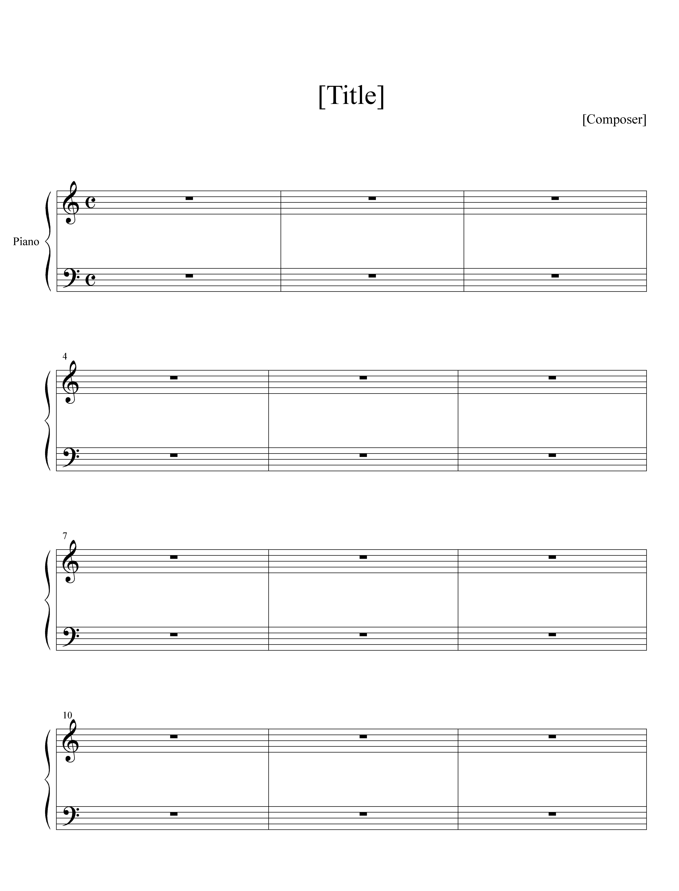
- Select the resizing tool from the tools palette.
- Click anywhere on the treble line of the first stanza and a dialogue box appears. Enter 150% into the box and click OK. Then click the bass line, and put 150% in the box.
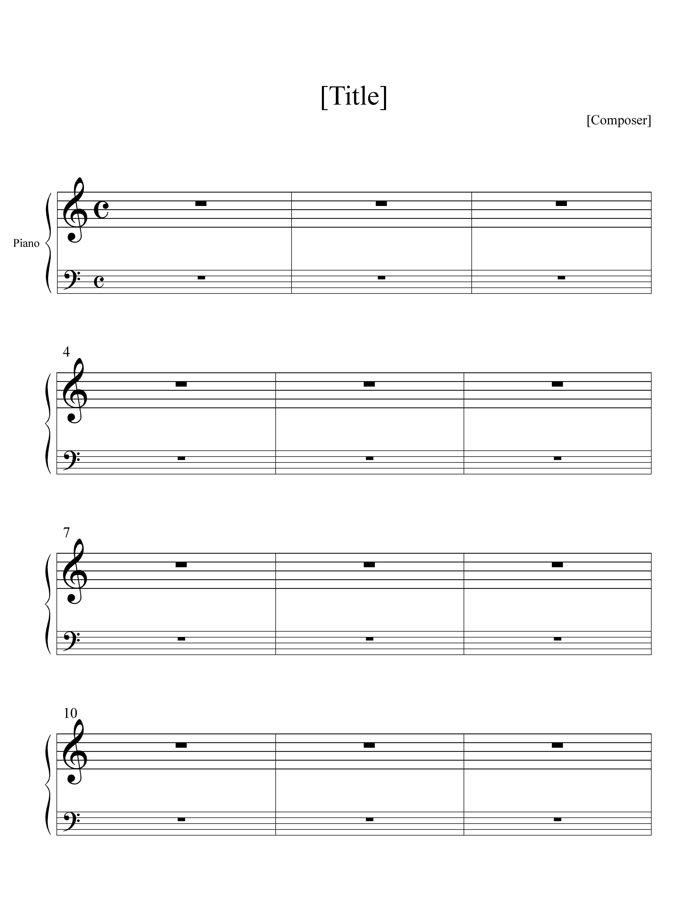
treble line resized treble and bass lines resized

5. I like to put 4 measures per line into my template. Seems most of the children are composing 4 to 8 measures of melody. It makes a nice, well rounded form. To do this, select the MassEdit/Selection Tool, go into MassEdit/ Utilities menu and choose "Fit Music/Measures". In the Fit Music/Measures window, enter 4 to lock the layout with 4 measures per system.
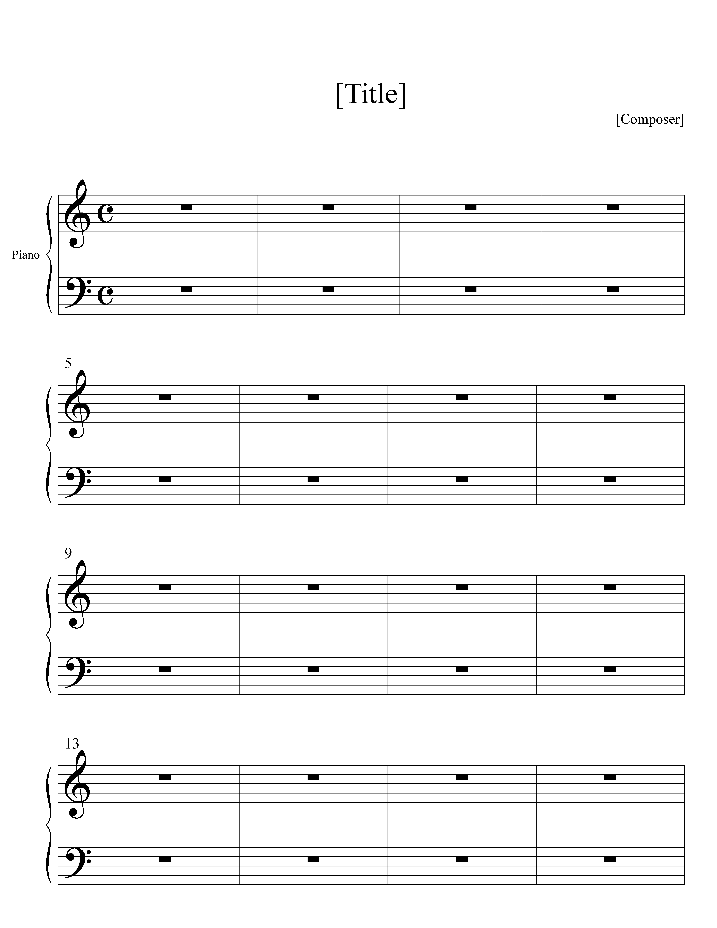

- Now we want to change the C to 4/4, since that’s what the students have learned. Just click the time signature tool then double click the first measure. The dialogue box will appear. Toward the bottom of that box you’ll see “Use a Different Time Signature for Display”. Check this box. (If you don’t see that box, click “Options” in the upper right corner of the dialogue box and it will appear.) Then make sure the box that says “Abbreviate” is unchecked. Click OK, and you’ll have good ol’ 4/4!

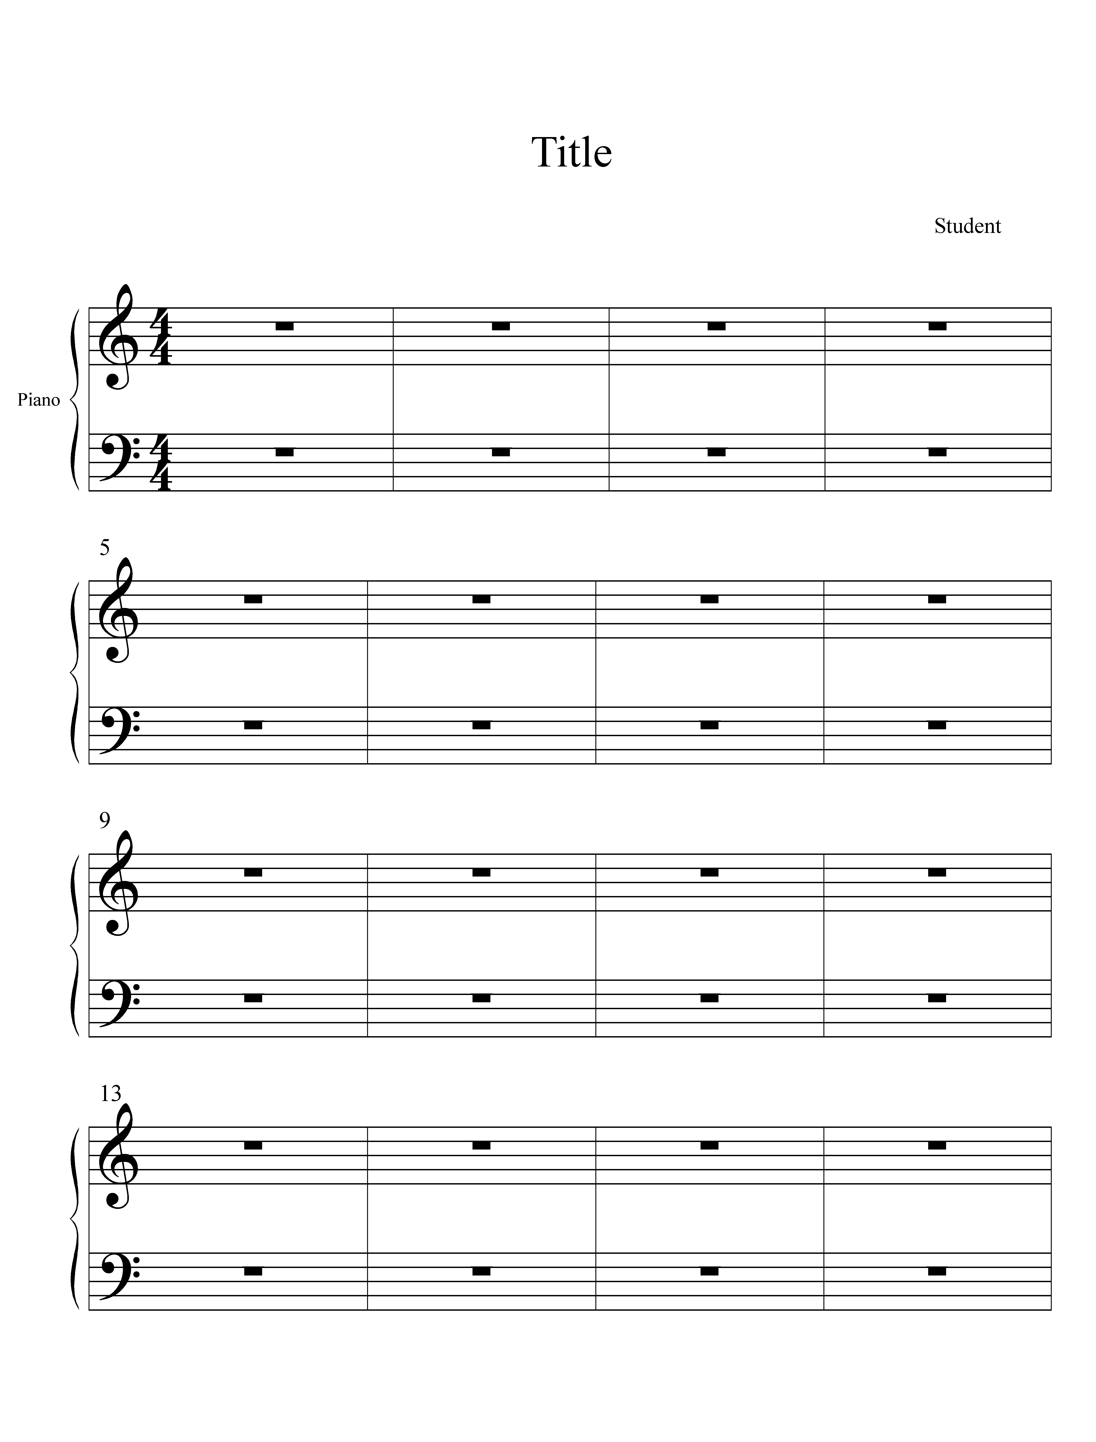
- Now, let’s add some text. Just click the text tool. and double click anywhere on the page. You can start typing! As soon as you click the text tool, square handles will appear on all text already in the document. Clicking on the square selects that text for dragging or deleting. Double click the square and a cursor will appear to let you edit that text. On lesson 6, I like to have:
This is a great start! Play it and play around with it and more ideas will come. Also, be thinking of a title. What does it sound like? What does it make you think of? Keep this in your bag with your songbook. We'll be practicing it soon.

Viola! Your template is complete! All you have to do is save it, calling it your Student Template.

Lesson 6
To be totally ready for Lesson 6, type each student’s name into where it says “Student” (the composer spot) and select “Save As” from the File menu. Save it as the student’s name. You’ll now have a blank song saved for each of your students. Open them up in the opposite order that they’re coming for their lesson (open the last student’s blank composition first, then the next to last on top of that, etc.) Your first student will be on top. (Say it’s Ashley) When she arrives, you’ll spend about 5 minutes talking it through, listening to what she has prepared, or asking her questions to help her come up with something, and making any changes to the time and key signatures. Enter the notes into the document, print it and close it. Finale will ask you if you want to save the changes to “Ashley” click yes, and the next student’s blank song is sitting there ready to go! You check Ashley’s songbook, she grabs a treat from the prize basket, and grabs her song off the printer, and you’re ready for the next student! 15 minutes…. WHIZ BANG!

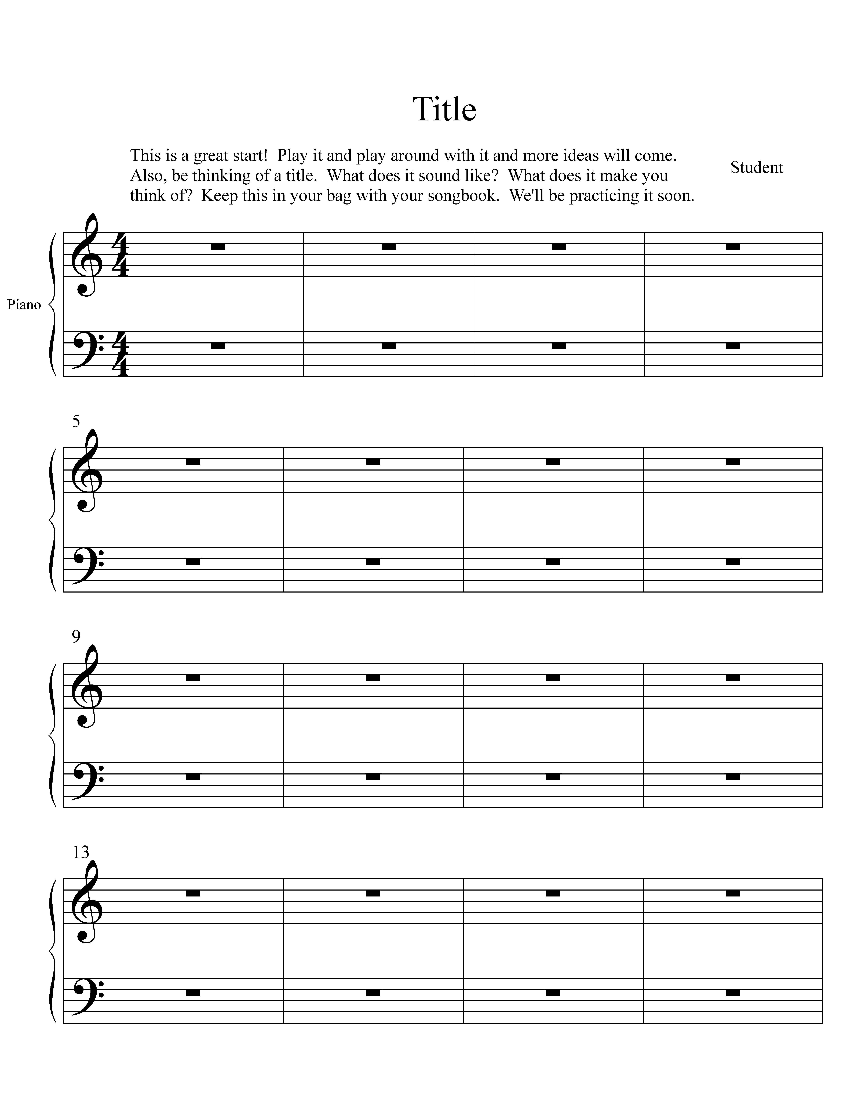

Putting notes into the document
There are 3 ways to get the notes in:
- MIDI (Musical Instrument Digital Interface) connection to your music keyboard. You need a MIDI keyboard and connectors for this.
- Simple note entry, using your mouse to point and click
- Speedy note entry, using your computer keyboard and a chart showing what key represents what note.

The compositions you’ll be inputting are quite simple. It doesn’t take long to enter using the simple note entry method. It’s by far the easiest to learn.

Key Signature Changes
Just click the key signature tool then double click the first measure you want to alter. The dialogue box will appear and you can select the number of flats or sharps you need, also, giving an option for major or minor.

Time Signature Changes
Just click the time signature tool then double click the first measure you want to alter. The dialogue box will appear and you can select the number of beats per measure, along with the note that gets the beat.

This information given thus far will probably get you through Lesson 6. More technical tools may be needed for Lesson 11, where you’ll add much more music and detail. Again, to prepare for Lesson 11, open each child’s song in the opposite order that they will arrive, leaving the first student’s song on top and ready to be edited.

Special Markings
- Repeats, double bar lines, etc. Use the measure tool to access these. Just click the measure you want to alter and you’ll get a dialogue box with all the options.
- Staccatos, accents and others are created using the articulation tool. Double click the note you want to alter and you’ll get a box full of markings to select from.
- Slurs, octave markings use the smart shape tool. Just double click the note you want to add the shape to and it will appear with handle bars that you can drag to alter the lenth and arc of the slur, or 8va marking.

From this point forward, the tutorials online are far more helpful than anything I can replicate here. For more advanced markings and movements, use the online tutorial I referenced in the beginning.

Enjoy this creative, educational process with each student! It is an amazing accomplishment to compose!

