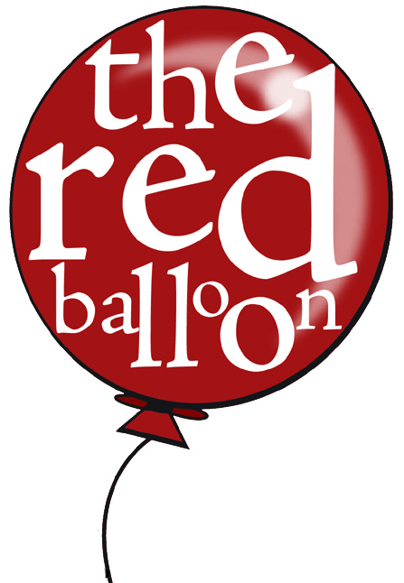
Red Balloons
Class Calendar-2010

August 19 *Lesson 1
August 26 Lesson 2
September 2 Lesson 3
September 9 Lesson 4
September 16 *Lesson 5
September 23 Lesson 6
September 30 Lesson 7
October 7 Lesson 8
October 14 *Lesson 9
October 21 Lesson 10
October 28 Lesson 11
November 4 Lesson 12
November 11 NO CLASS
November 18 *Lesson 13
November 25 Lesson 14
December 2 Lesson 15

Classes will resume January 6 – Blue Bugs!

Reminders:
Parents attend on all odd-numbered lessons (in bold)
*Tuition is due on lessons 1, 5, 9, & 13 and is $45
Make checks payable to (YOUR NAME/COMPANY)
Classes are 45 min. long

Please call or e-mail if you have any questions that aren’t on this sheet! (Your name, number and/or e-mail@email.com )
Red Balloons
Class Calendar-2010

August 19 *Lesson 1
August 26 Lesson 2
September 2 Lesson 3
September 9 Lesson 4
September 16 *Lesson 5
September 23 Lesson 6
September 30 Lesson 7
October 7 Lesson 8
October 14 *Lesson 9
October 21 Lesson 10
October 28 Lesson 11
November 4 Lesson 12
November 11 NO CLASS
November 18 *Lesson 13
November 25 Lesson 14
December 2 Lesson 15

Classes will resume January 6 – Blue Bugs!

Reminders:
Parents attend on all odd-numbered lessons (in bold)
*Tuition is due on lessons 1, 5, 9, & 13 and is $45
Make checks payable to (YOUR NAME/COMPANY)
Classes are 45 min. long

Please call or e-mail if you have any questions that aren’t on this sheet! (Your name, number and/or e-mail@email.com )

