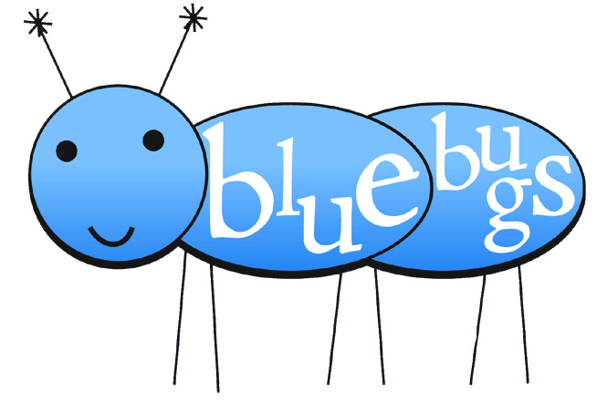
Blue Bugs
Class Calendar 2011

January 4 Lesson 1
January 11 Lesson 2
January 18 Lesson 3
January 25 Lesson 4
February 1 Lesson 5
February 8 Lesson 6
February 15 Lesson 7
February 22 Lesson 8
March 1 Lesson 9
March 8 Lesson 10
March 15 spring break NO CLASS
March 22 Lesson 11
March 29 Lesson 12
April 5 Lesson 13
April 12 Lesson 14
April 19 Lesson 15
April 27 Recital! 6:30 pm

Reminders:
Parents attend all odd lessons
Tuition is due on lessons 1, 5, 9, & 13 and is $45
Make checks payable to YOUR NAME/COMPANY
Classes are Tuesdays from 3:45 – 4:30

Please call or e-mail if you have any questions that aren’t on this sheet! YOUR NAME – PHONE – EMAIL
Blue Bugs
Class Calendar 2011

January 4 Lesson 1
January 11 Lesson 2
January 18 Lesson 3
January 25 Lesson 4
February 1 Lesson 5
February 8 Lesson 6
February 15 Lesson 7
February 22 Lesson 8
March 1 Lesson 9
March 8 Lesson 10
March 15 spring break NO CLASS
March 22 Lesson 11
March 29 Lesson 12
April 5 Lesson 13
April 12 Lesson 14
April 19 Lesson 15
April 27 Recital! 6:30 pm

Reminders:
Parents attend all odd lessons
Tuition is due on lessons 1, 5, 9, & 13 and is $45
Make checks payable to YOUR NAME/COMPANY
Classes are Tuesdays from 3:45 – 4:30

Please call or e-mail if you have any questions that aren’t on this sheet! YOUR NAME – PHONE – EMAIL

