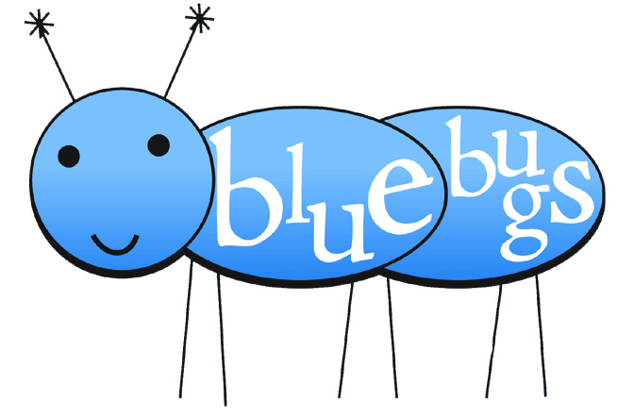
year end recital 5.11.2010

Wednesday, April 28, 2010

Year I: Blue Bugs
Directors: Debbie Huish, Cindy Read & Janalee Marriott
Let’s Play Music!

How to Skip
Reading notes from the staff is an important skill. This song reminds us that notes “from a line to the next line” or “from a space to the next space” are skips!

Primary Chords Song
Three chords make up over 90% of the music we listen to. We’ve learned all about the red (I), blue (IV), and yellow (V) chords this year!

Three Blind Mice Bells: Miss Debbie’s Class
Are You Sleeping? Bells: Miss Jana’s Class
We’ve learned that when you sing (or play) different things at the same time and they sound good together, it’s called harmony! Listen to us create harmony with our bells & voices!

BINGO
Performing rhythms can be fun! We are clapping a rhythmic pattern with our hands, then just hearing it in our heads! This skill is called audiation and it is the beginning of all great musicians!

Can’t Bug Me
Who knew that learning rhythmic notation could be so fun?! We can read rhythms because of these very musical bugs!

Magical Lamp – ‘Aragonnaise’ from Carmen by Georges Bizet
Puppet shows are our favorite! While we play, we’re listening intelligently to classical music, learning about form, recognizing themes and the moods of themes, and distinguishing various instruments.

* FINALE – Do, Re, Mi Bells: Miss Cindy‘s Class
We will be performing a special finale number with the 2nd year students after they perform their songs. Stay seated….you’re going to love it!

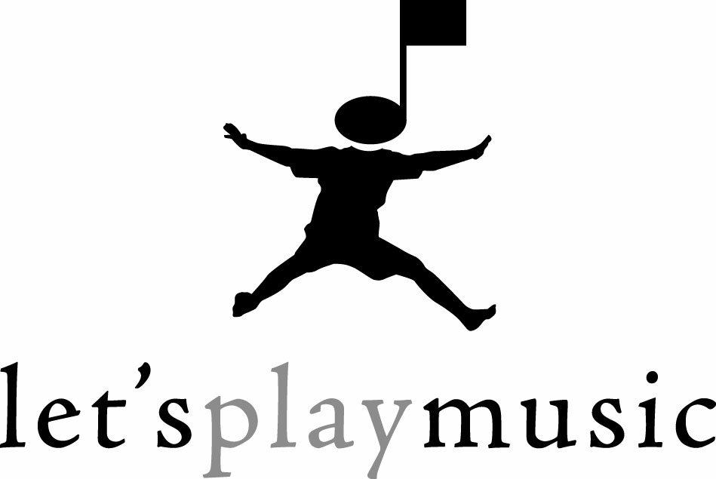

In the 1st year of Let’s Play Music we use engaging games and songs and incorporate tone bells to teach staff awareness and rhythm reading skills. Students are introduced to the 5 lines and 4 spaces of the staff, sing the major scale on solfeggio syllables with hand signs, learn to keep a steady beat, match pitch using a minor 3rd, play melodies and ostinati on tone bells, and learn the three primary chords on the autoharp. Students learn to divide and subdivide beats, read rhythmic notation patterns, distinguish major and minor tonalities, play steps and skips from the staff onto tone bells and much more!
Miss Cindy’s Blue Bugs:

Tyler Davis Jacob Fillmore Gavin Goodman Chloe Carmona Ella Goodman Calvin Hughes Zachary Loiselle

Miss Debbie’s Blue Bugs:
Case Felstead Kazzlyn Huish
Danielle Hulet Michael LanRachel Larson, Ashlyn Lenhart Maya Watkins
Emma Wolfe

Miss Jana’s Blue Bugs:

Emma Hanson Knox Pothier
Emeri Arnett Mikenna Kunz
Matix Arnett Janey Belnap
Karli Cook

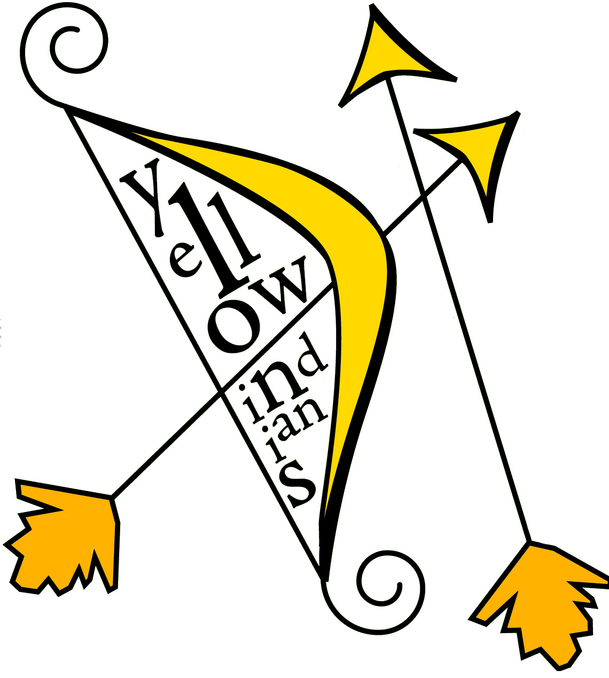
Year II: Yellow Indians
Directors: Cindy Read, Janalee Marriott & Shelle Soelberg

Music Alphabet
This year, the students have learned all the names of the white keys on the piano! We are well on our way to becoming fine pianists! Listen and you’ll see how smart they’ll get as they sing their music alphabet.

Turtle Shells Keyboards: Miss Jana ’s Class
An important skill of reading music is the ability to quickly see the relationship between two notes. This relationship is called an interval, but we like to call our intervals TURTLE SHELLS! Listen to how well we know – and can play – our intervals!

How to Skip Keyboards: Miss Shelle’s Class
Reading notes from the staff is an important skill, begun in the 1st Year and carried on to the 2nd Year. Watch us play this song full of skips!

I’m an Indian Keyboards: Miss Jana’s Class
Playing rhythms correctly can be difficult. We have learned to do this correctly by first feeling the rhythm through full body involvement. Listen for the dotted quarter & eighth note rhythm on the keyboards as the singers “shoot their arrows and pull their bows.”

Practice Every Day Keyboards: Miss Cindy’s Class
This song involves both hands playing together. We have learned about the grand staff, the treble and bass clefs, and we’ve also learned that “if we practice every day, lots of songs we’ll learn to play!”

Don’t Put Your Trash in My Backyard
Total musicianship is much more than just playing the piano. True musicians can hear music in their heads, even several different parts at a time. This song exhibits the children’s developing talent of singing in harmony.

Pirate Ship – Hungarian Dance #5 by Johannes Brahams
Intelligently listening to classical music is both a skill and an art! By guiding the children’s ear to hear the individual themes in the music, and the recurrence of the themes in a balanced form, we are teaching them to love classical music because they understand it.

FINALE: Do, Re, Mi
This song has it all! Watch as the children sing a major scale up and down, play it on the bells and on the keyboards, use their solfeggio hand signs, and sing harmony!

In the 2nd year of Let’s Play Music, we transfer the skills learned in 1st year to playing the piano, where we also learn chord notation, intervals, and harmonic improvisation. Students are introduced to the keyboard, learn C position, middle C, identify and play intervals of 2nd, 3rd, 4th and 5th, play primary cadences on keyboard, and accompany them selves on the keyboard. Students play keyboard in contrary motion, learn the major scale, sing in harmony, learn more complex rhythmic notations, learn more note names on the staff, and learn the names of the white keys on the keyboard.

Miss Cindy’s Yellow Indians:
Ceci Carbone Brekyn Goodman Sabrina Stewart Adele Schreiber Warren Schreiber
Miss Jana’s Yellow Indians:
Rebekah Marriott Katie Shoemaker
Samuel Frost Kali Shoemaker
Jerrymiah Frost Krishelle Soelberg
Rachel Brinkerhoff Ayden Hickey
Joshua Larson Morgan Campbell
Hannah Larson Taylor Robinson

Miss Shelle’s Yellow Indians:

Haylee Bingham Annalise Decker
Nathaniel Nesbit Grace Soelberg
Hailee Smith Sadie Soelberg

