Percepció 3

Initially the camera has been calibrated. The obtained values have been copied at the file ‘head_camera.yaml’. The Figure 1 shows these values:

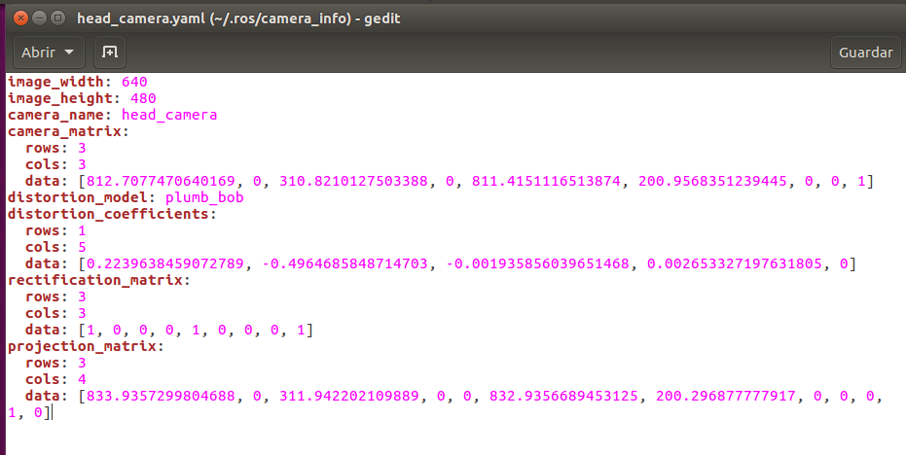
Figure 1: calibrated values

The second part of this exercise consist of detectind a ball and calculate the ray direction between the ball and the camera.

In order to detect the ball the code used before for detecting circles has been used. Then we know the center of the ball we have detected with which are able to calculate the ray direction. These values have been calculated using the inverted K matrix and multiplied by the center point obtained.
Afterwards, the direction is shown using the geometry_msgs “PoseStamped”. With it we can show the position and the orientation. The Figure 2 shows the structure of the geometry_msgs.
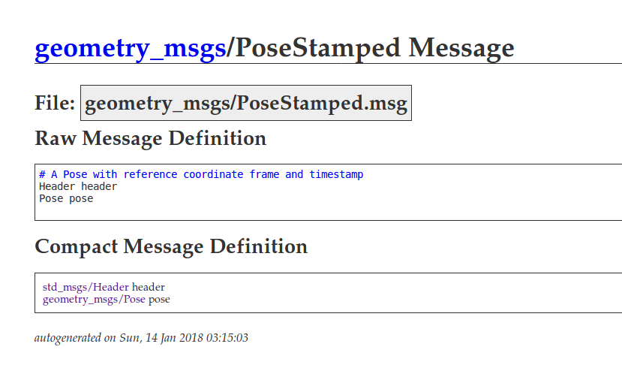
Figure 2: PoseStamped message

The Figure 3 shows the ray direction of the camera.

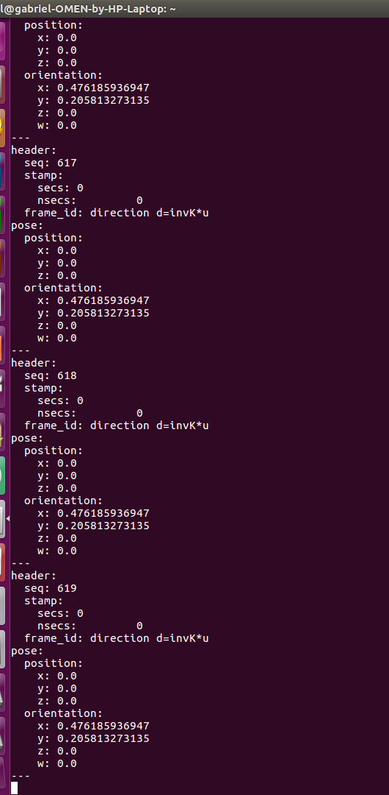
Figure 3: ray direction values

