
UNITED INTERNATIONAL UNIVERSITY (UIU)
Dept. of Computer Science & Engineering
Assignment 2
Course No: CSE 3521 Course Title: Database Management Systems
Marks: 20

- a) Consider a schema R(A,B,C,D,E) with the following set of functional dependencies
A → E
BC→ A
DE → B
i. Prove whether or not R is in BCNF. (1)
ii. Consider the decomposition of R into two schemas R1(A,E),
R2(A,B,C,D). Determine whether this decomposition is both
both lossless and dependency preserving. (2)
b) A company maintains a database to track employees working on various projects. The schema for this database is: EmployeeProjects(A, B, C, D, E)
The following functional dependencies hold in the system:
AB → CD
A → B
B → C
C → E
BD → A
BD → C
i. Help them choose a primary key by determining all the possible
candidates. (1)
ii. Compute the minimum cover of the set of FDs. (1)
- a) When should we prefer indexing and why? (2)
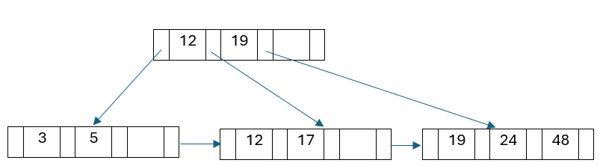
b) Determine the order of the B+ tree. Insert the following keys sequentially in the above B+ tree. Keys: 10, 15, 22, 50, 32, and 16. Show all the necessary steps while inserting. (3)
- a) Suppose we have a relation named R, having attributes as A, B, C, D, E, F.
The relation R is having the following functional dependencies,
A → C
B → DF
AB → E
D → F
Considering the relation with functional dependencies, find if CD→E and
AB → CE is valid or not using Armstrong's axioms. [mention the axim’s rule applied in each state] (2)
b) Consider the functional dependencies of the relation,
R(P, Q, R, S, T, U)
FD:
P → SQR
Q → T
R → U
PR → U
S → Q
i) Find out all the candidate keys. (1)
ii) Find out the minimal cover. (1)
iii) Explain in which normal form the relation is with proper justification. (1)
c) Consider a relation R(L, M, N, O, P, R) with the following functional
dependencies,
L → NR
M → OP
LM → P
If we decompose the relation in R1(L, N, R, M) and R2( M, O, P, L), state the
validity of this decomposition in terms of lossless and dependency preserving
concepts. (2)
- a) Differentiate the pros and cons of using indexing with proper justification. (1)
b) Draw a B+ tree of order 4 for the given key values below, (2)
23, 9, 3, 10, 7, 15, 30, 2, 19, 8, 25, 21, 6, 22, 4

