PROJECT TITLE IN CAPITAL LETTERS
A DBMS Capstone Project Report submitted in partial fulfillment of the requirements for the award of the degree of
BACHELOR OF TECHNOLOGY
in
ARTIFICIAL INTELLIGENCE AND MACHINE LEARNING

Submitted By
M. Gafoor Khan – 25B11AI752
S. Hima Naga Sudheshna – 25B11AIA77
G. Eesanth – 25B11AI373
G. Narendra– 25B11AI826

Under the esteemed guidance of
Mr. T.Srinivasulu M.Tech, (Ph.D.)
Assistant Professor



DEPARTMENT OF ARTIFICIAL INTELLIGENCE AND MACHINE LEARNING
ADITYA UNIVERSITY
(Formerly Aditya Engineering College (A))
Aditya Nagar, ADB Road, Surampalem, Andhra Pradesh, India
2026 – 2027

Aditya Nagar, ADB Road, Surampalem, Andhra Pradesh, India
DEPARTMENT OF ARTIFICIAL INTELLIGENCE AND MACHINE LEARNING
CERTIFICATE
This is to certify that the DBMS Capstone Project report entitled Software Management System” is being submitted by M. Gafoor khan (Roll No. 25B11AI752), S. Hima Naga Sudheshna (Roll No. 25B11AIA77), G. Eesanth (Roll No. 25B11AI373) and G. Narendra (Roll No. 25B11AI826) in partial fulfillment of the requirements for the award of the B.Tech. degree in Artificial Intelligence and Machine Learning. The work documented in this report was carried out as part of the Capstone Project for the course Database Management Systems (2501IT05) during the academic year 2026–2027, and records the database design, implementation, and documentation undertaken by the team.

Project Guide Head of the Department
Mr. T. Srinivasulu, M. Tech, (Ph.D.) Dr. K. Naga Bhargavi, M. Tech, Ph.D. Assistant professor Associate Professor & HOD

External Examiner

DECLARATION
We hereby declare that the DBMS Capstone Project entitled “ Software Management System ” is a genuine work carried out by us. The database design, SQL implementation, queries and documentation presented in this report are our own work, completed under the guidance of T. Srinivasulu, Department of Artificial Intelligence, Aditya University, Surampalem . We further declare that this work has not been submitted, in full or in part, for the award of any degree of this or any other educational institution.

Project Associates
M. Gafoor Khan (25B11AI752)
S. Hima Naga Sudheshna (25B11AIA77)
G. Eesanth (25B11AI373)
G. Narendra (25B11AI826)

Date: 5-10-2026
Place: Surampalem

ACKNOWLEDGEMENT
It is with immense pleasure that we express our indebted gratitude to our project guide T. Srinivasulu , Department of Artificial Intelligence, who guided us throughout the capstone project. We are thankful for the constant encouragement and valuable suggestions received at every review stage.
We are grateful to Dr. K. Naga Bhargavi, Head of the Department, for inspiring us and for arranging the facilities and resources needed for this project.
We extend our sincere thanks to the Management, Dr. M. Sreenivasa Reddy, Deputy Pro-Chancellor, Dr. M. B. Srinivas, Vice-Chancellor, and Dr. A. Ramesh, Pro Vice-Chancellor (Engineering & Sciences), for providing an excellent academic environment.
Not to forget, we thank the Teaching and Non-Teaching Staff, our parents and our friends, who have directly or indirectly supported us in completing this project on time.

Project Associates
S M. Gafoor Khan (25B11AI752)
S. Hima Naga Sudheshna (25B11AIA77)
G. Eesanth (25B11AI373)
G. Narendra (25B11AI826)

TABLE OF CONTENTS
- Cover Page
- Certificate
- Acknowledgement
- Table of Contents
- Abstract
- Introduction
- System Analysis
- Database Design
- ER Diagram
- Relational Schema
- Table Design
- Normalization
- SQL Implementation
- SQL Queries & Screenshots
- Conclusion & Future Enhancements
- References

a
ABSTRACT
The Software Management System is a database-driven application designed to simplify and organize the management of software products, users, licenses, developers, projects, and maintenance activities. The main objective of this system is to replace manual record-keeping with a centralized and secure database that improves accuracy, efficiency, and accessibility. Using a Relational Database Management System (RDBMS), the application stores and manages essential information such as software details, version history, customer records, license information, bug reports, and maintenance schedules. The system supports operations such as adding, updating, deleting, and retrieving records while maintaining data integrity through primary keys, foreign keys, and relational constraints. It also enables quick report generation and efficient data retrieval using SQL queries, reducing redundancy and minimizing errors. The database schema is designed following normalization principles to ensure consistency and optimize storage. This project demonstrates the practical implementation of DBMS concepts, including entity-relationship modelling , relational schema design, key constraints, and SQL operations. Overall, the Software Management System provides an effective, scalable, and user-friendly solution for managing software-related information, making it suitable for organizations seeking improved productivity and reliable data management.

LIST OF FIGURES
Figure 1. ER Diagram of Software Management System Database
Figure 2. Display All Projects
Figure 3. Display All Employees
Figure 4. Display All Teams
Figure 5. Display All Sprints
Figure 6. Display All Tasks
Figure 7. Display All Bugs
Figure 8. Display Active Projects
Figure 9. Display Completed Projects
Figure 10. Display High Priority Tasks
Figure 11. Display Open Bugs
Figure 12. Employees Sorted by Employee ID
Figure 13. Projects Sorted by Start Date
Figure 14. Display Task Title and Status
Figure 15. Projects with Their Teams
Figure 16. Tasks Assigned to Employees
Figure 17. Bugs with Corresponding Projects
Figure 18. Sprints with Their Projects
Figure 19. Number of Employees in Each Team
Figure 20. Number of Tasks in Each Project
Figure 21. Number of Bugs in Each Project
Figure 22. Total Number of Employees
Figure 23. Average Employee Salary
Figure 24. Employees with More Than Five Years of Experience
Figure 25. Project Manager Details
Figure 26. Count of Tasks by Status
Figure 27. Teams Having More Than One Employee
Figure 28. Display Completed Tasks
Figure 29. Employees Whose First Name Starts with 'A'
Figure 30. Search Projects by Keyword
Figure 31. Bugs Assigned to Employees

LIST OF TABLES
Table 1. Functional Requirements
Table 2. Requirements Specification
Table 3. Major Entities
Table 4. Relationships
Table 5. Relational Schema
Table 6. Project Table Design
Table 7. Employee Table Design
Table 8. Team Table Design
Table 9. Sprint Table Design
Table 10. Task Table Design
Table 11. Bug Table Design
Table 12. Keys and Constraints
Table 13. Normalization Summary (3NF)

ACRONYMS
- DBMS – Database Management System
- ER – Entity Relationship
- SQL – Structured Query Language
- DDL – Data Definition Language
- DML – Data Manipulation Language
- DQL – Data Query Language
- DCL – Data Control Language
- TCL – Transaction Control Language
- PK – Primary Key
- FK – Foreign Key
- 1NF – First Normal Form
- 2NF – Second Normal Form
- 3NF – Third Normal Form
- CRUD – Create, Read, Update, Delete
- UI – User Interface
- API – Application Programming Interface
- RDBMS – Relational Database Management System
- IDE – Integrated Development Environment
- OS – Operating System
- SDLC – Software Development Life Cycle
- UML – Unified Modeling Language
- SRS – Software Requirements Specification
- DB – Database
- INT – Integer Data Type
- VARCHAR – Variable Character Data Type
- AUTO_INCREMENT – Automatic Increment of Numeric Values
- AI – Artificial Intelligence
- IT – Information Technology
- CI/CD – Continuous Integration / Continuous Deployment
1. INTRODUCTION

1.1 Brief Information about the Project
The Software Management System is a database application designed to manage software development activities in an organized and efficient manner. It stores information related to projects, employees, teams, sprints, tasks, and bugs in a centralized database. The system uses a relational database to maintain data accuracy, reduce redundancy, and establish relationships between different entities using primary and foreign keys. It also supports SQL operations for efficient data storage, retrieval, and management, making software project management more reliable and effective.

1.2 Motivation and Contribution of Project
Motivation
Many organizations still manage software project information using spreadsheets or manual records, which can lead to data duplication, inconsistency, and difficulty in tracking project progress. A centralized database is needed to organize software development information efficiently and improve data management.
Contribution
The Software Management System provides a structured database for managing projects, employees, teams, sprints, tasks, and bugs. It demonstrates key DBMS concepts such as ER modelling , normalization, relational schema design, constraints, and SQL queries. The system improves data consistency, reduces redundancy, and enables faster retrieval of information, making software management more efficient and reliable.
These sections are written specifically for your Software Management System project and are appropriate for a DBMS project report.

1.3 Objectives of the Project
- Objective 1: Store software-related information in a centralized and organized database.
- Objective 2: Reduce data redundancy and maintain data accuracy and consistency.
- Objective 3: Enable quick insertion, updating, deletion, and retrieval of records using SQL
- Objective 4: Manage software projects, developers, customers, licenses, and maintenance details efficiently
- Objective 5: Improve data security and support efficient report generation for better decision-making

1.4 Scope of the Project
The Software Management System is designed to manage software development information in a centralized database. It covers the management of projects, employees, teams, sprints, tasks, and bugs, ensuring accurate and organized data storage. The system supports essential database operations such as adding, updating, deleting, and retrieving records while maintaining data integrity through primary and foreign keys. It can be further enhanced by integrating a web-based user interface, role-based authentication, reporting features, and cloud support to meet the needs of larger organizations.
2. SYSTEM ANALYSIS

2.1 Existing System
- Manual maintenance of software project records.
- Multiple Excel sheets or separate files for project and employee data.
- Duplicate records and inconsistent information.
- Time-consuming search and retrieval of project details.
- Difficulty in tracking tasks, bugs, and project progress.
- Higher possibility of data-entry errors.

2.2 Proposed System
The proposed Software Management System uses a centralized relational database to organize software development information into related tables. It uses Primary Keys, Foreign Keys, UNIQUE, NOT NULL, and CHECK constraints to maintain data integrity and consistency. The system supports efficient management of projects, employees, teams, sprints, tasks, and bugs.
- Centralized database
- Project management
- Employee management
- Team management
- Sprint management
- Task management
- Bug management
- SQL-based reporting
- Referential integrity

2.3 Functional Requirements
Module | Functional Requirement
Project Management | Add, update, search, and manage project details.
Employee Management | Store employee information and assign project
Team Management | Create teams, assign team leads, and manage team members
Sprint Management | Create sprints and track sprint goals and status.
Task Management | Assign tasks to employees and monitor task progress.
Bug Management | Report, assign, and track software bugs until resolution.
Search & Reporting | Retrieve project, employee, sprint, task, and bug information using SQL queries

2.4 Non-Functional Requirements
- Performance – Queries should retrieve project and task information efficiently.
- Integrity – Primary and Foreign Keys should prevent duplicate and invalid records.
- Security – Only authorized users should access and modify the database.
- Usability – The database should be easy to understand and maintain.
- Reliability – Data consistency should be maintained during all database operations.
- Scalability – The database should support future growth in projects, teams, employees, tasks, and bugs.

2.5 Requirements Specification
Category | Suggested Requirement
Hardware
  Intel i3 or above, 4 GB RAM minimum, 20 GB free storage, keyboard, mouse, and monitor.
Operating System | Windows 10/11 or Linux.
Database
  MySQL Database Server.
Query / Admin Tool
  MySQL Workbench.
Programming Language
  SQL
Version Control
  GitHub (Optional)

3. DATABASE DESIGN

3.1 Major Entities
Entity | Description
Project
  Stores information about software projects, such as project name, start date, and status.
Employee
  Contains details of employees working on different software projects.
Team
  Represents project teams and the employees assigned to each team.
Sprint | Stores information about development sprints, including duration and progress
Task
  Maintains records of tasks assigned to employees within a project or sprint.
Bug
  Stores details of software bugs, including severity, status, and assigned employee.
Team member | Stores the association between employees and teams by recording team membership. It links employees to their respective teams.

3.2 ER Model
The Entity-Relationship (ER) Model represents the major entities and their relationships in the Software Management System. The database consists of the entities Project, Employee, Team, Team Member, Sprint, Task, and Bug. The relationships include Project–Employee (Manages), Project–Team, Team–Team Member, Sprint–Task, Employee–Task (Assigns), Employee–Bug (Reports), and Task–Bug. The ER diagram also includes important attributes such as project id, employee id, team id, sprint id, task id, bug id, project name, task title, status, priority, severity, start date, end date, and reported date. Primary Keys and Foreign Keys are used to maintain referential integrity and establish relationships among the entities.

3.3 Relationships
Relationship | Description
Project → Employee | One employee (manager) can manage many projects.
Project → Team | One project can have multiple teams.
Project → Sprint | One project can contain multiple sprints.
Team → Team Member | One team can have multiple team members.
Team Member → Employee
  An employee can belong to one or more teams through the Team Member table.
Sprint → Task | One sprint can contain multiple tasks.
Employee → Task | One employee can be assigned multiple tasks.
Task → Bug | One task can have multiple bugs.
Employee → Bug | One employee can report multiple bugs.

4. ER DIAGRAM
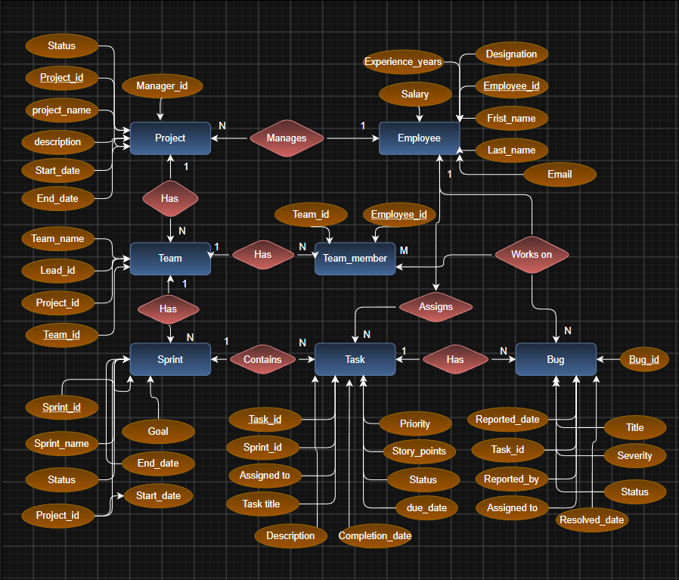

Figure 1: ER Diagram of Software Management System Database
The ER diagram illustrates the database structure of the Software Management System. It shows the main entities Project, Employee, Team, Team Member, Sprint, Task, and Bug, along with their attributes and relationships. The diagram defines the cardinalities between entities using Primary Keys (PK) and Foreign Keys (FK) to maintain referential integrity. It provides a clear representation of how project management, team assignments, sprint planning, task tracking, and bug management are organized within the database.
5. RELATIONAL SCHEMA
Relation | Relational Schema
PROJECT
  Project ID (PK), Project Name, Description, Start Date, End Date, Status, Duration Days, Manager ID (FK)
EMPLOYEE
  Employee ID (PK), First Name, Last Name, Designation, Email, Skills, Experience Years, Salary
TEAM | Team ID (PK), Team Name, Project ID (FK), Lead ID (FK), Team Size
TEAM_MEMBER
  Team ID (PK, FK), Employee ID (PK, FK)
SPRINT | velocity
  Sprint ID (PK), Sprint Name, Project ID (FK), Start Date, End Date, Goal, Status,
TASK
  Task ID (PK), Sprint ID (FK), Assigned To (FK), Task Title, Description, Priority, Status, Due Date, Completion Date, Days Taken
BUG
  Bug ID (PK), Task ID (FK), Reported By (FK), Assigned To (FK), Title, Severity, Status, Reported Date, Resolved Date, Resolution Time

The relational schema follows the structure of the Software Management System database. The Project relation references Employee through Manager ID. Team references both Project and Employee (Lead ID). Team Member establishes the many-to-many relationship between Team and Employee using a composite primary key. Sprint references Project, Task references Sprint and Employee, and Bug references Task and Employee. Primary Keys and Foreign Keys maintain referential integrity and ensure consistent relationships among all entities.
This version matches your ER diagram exactly, including the Team Member table and all PK/FK relationships.

6. TABLE DESIGN

6.1 Project Table
Attribute | Data Type | Constraint | Description
Project id | INT | PK | Project identifier
Project name | VARCHAR(150) | NOT NULL | Project name
Description | TEXT |  | Project description
Start date | DATE |  | Start date
End date | DATE |  | Planned end date
Status | VARCHAR(30) |  | Planning/Active/Completed
Duration days | INT | Derived | end_date − start_date
Manager id | INT | FK → Employee | Project manager
Technologies | TEXT | Multi-valued | Project_Tech table

6.2 Employee Table
Attribute | Data Type | Constraint | Description
Employee id | INT | PK | Employee identifier
First name | VARCHAR (50) |  | First name
Last name | VARCHAR (50) |  | Last name
Designation | VARCHAR (50) |  | Developer/QA/Manager/Architect
Email | VARCHAR (100) | UNIQUE NOT NULL | Work email
Skills | TEXT | Multi-valued | Employee_Skills table
Experience years | INT |  | Years of experience
Salary | DECIMAL (10,2) |  | Monthly salary

6.3 Team Table
Attribute | Data Type | Constraint | Description
Team id | INT | PK | Team identifier
Team name | VARCHAR (100) | NOT NULL | Team name
Project id | INT | FK → Project | Assigned project
Lead id | INT | FK → Employee | Team lead
Team size | INT | Derived | Count of members

6.4 Sprint Table
Attribute | Data Type | Constraint | Description
Sprint id | INT | PK | Sprint identifier
Sprint name | VARCHAR(100) |  | e.g. Sprint 1
Project id | INT | FK → Project | Parent project
Start date | DATE |  | Sprint start
End date | DATE |  | Sprint end
Goal | TEXT |  | Sprint goal description
Status | VARCHAR(20) |  | Planned/Active/Completed
Velocity | INT | Derived | Story points completed

6.5 Task Table
Attribute | Data Type | Constraint | Description
Task id | INT | PK | Task identifier
Sprint id | INT | FK → Sprint | Sprint assigned to
Assigned to | INT | FK → Employee | Assigned employee
Task title | VARCHAR(200) | NOT NULL | Task name
Description | TEXT |  | Task details
Priority | VARCHAR(20) |  | Low/Medium/High/Critical
Story points | INT |  | Effort estimate
Status | VARCHAR(20) |  | Todo/In Progress/Done
Due date | DATE |  | Task deadline
Completion date | DATE |  | Actual finish date
Days taken | INT | Derived | completion − due

6.6 Bug Table
Attribute | Data Type | Constraint | Description
Bug id | INT | PK | Bug identifier
Task id | INT | FK → Task | Linked task
Reported by | INT | FK → Employee | Reporter employee
Assigned to | INT | FK → Employee | Fixing employee
Title | VARCHAR(200) | NOT NULL | Bug title
Severity | VARCHAR(20) |  | Low/Medium/High/Critical
Status | VARCHAR(20) |  | Open/In Progress/Resolved/Closed
Reported date | DATE |  | Date reported
Resolved date | DATE |  | Date resolved
Resolution time | INT | Derived | resolved − reported (days)

6.7 Keys and Constraints
Constraint Type | Applied To / Purpose
Primary Key
  Project ID, Employee ID, Team ID, Sprint ID, Task ID, Bug ID, and composite key (Team ID, Employee ID) in Team Member.
Foreign Key
  Project. Manager ID → Employee .Employee ID; Team. Project ID → Project. Project ID; Team. Lead ID → Employee. Employee ID; Team Member. Team ID → Team. Team ID; Team Member. Employee ID → Employee .Employee ID; Sprint. Project ID → Project. Project ID; Task. Sprint ID → Sprint. Sprint ID; Task .Assigned To → Employee. Employee ID; Bug. Task ID → Task. Task ID; Bug. Reported By → Employee. Employee ID; Bug. Assigned To → Employee. Employee ID.
NOT NULL
  Required fields such as Project Name, Team Name, Sprint Name, Task Title, Bug title, and Employee. Email.
UNIQUE
  Employee. Email to ensure each employee has a unique email address.
CHECK
  Restrict valid values for Status (Planning, Active, Completed), Priority (Low, Medium, High, Critical), and Severity (Low, Medium, High, Critical).
DEFAULT
  Default values can be assigned to Project, Sprint, Task, and Bug status (e.g., 'Planning', 'To Do', 'Open') when no value is provided.

7. NORMALIZATION
Normalization organizes data into related tables to reduce redundancy, improve data consistency, and eliminate insertion, update, and deletion anomalies. The Software Management System database is normalized up to Third Normal Form (3NF).

7.1 Unnormalized Form (UNF)
A single project record may contain project details, manager information, team members, sprint details, tasks, and bugs in one table. Repeating groups such as multiple team members, tasks, and bugs create redundancy and make updates difficult.

7.2 First Normal Form (1NF)
In 1NF, repeating groups are removed and each attribute contains atomic values. Separate records are maintained for projects, employees, teams, sprints, tasks, and bugs, with each row representing a single entity.

7.3 Second Normal Form (2NF)
In 2NF, partial dependencies are removed by separating data into related tables. Project, Employee, Team, Sprint, Task, and Bug each store information specific to their primary key. The Team Member table uses a composite key (Team ID, Employee ID) to represent team membership.

7.4 Third Normal Form (3NF)
In 3NF, transitive dependencies are eliminated. Project, employee, sprint, task, and bug information are stored in separate tables and linked using Primary Keys and Foreign Keys. Derived values such as Duration Days, Team Size, Velocity, Days Taken, and Resolution time are calculated instead of being stored, reducing redundancy and maintaining data integrity.
Relation | Reason for Separation
Project
  Stores project-specific information.
Employee
  Stores employee details independently.
Team
  Stores team information and links to projects.
Team Member
  Represents the many-to-many relationship between teams and employees.
Sprint
  Stores sprint details for each project.
Task
  Stores task information and links to sprints and employees.
Bug
  Stores bug details and links to tasks and employees.

8. SQL IMPLEMENTATION

8.1 DDL – Data Definition Language
The following DDL is a documentation-ready implementation aligned with the supplied relational schema. Data types may be adjusted to the specific DBMS used by the employee team.
CREATE TABLE Employee (
employee_id INT PRIMARY KEY AUTO_INCREMENT,
first_name VARCHAR(50) NOT NULL,
last_name VARCHAR(50) NOT NULL,
designation VARCHAR(50),
email VARCHAR(100) UNIQUE NOT NULL,
experience_years INT CHECK (experience_years >= 0),
salary DECIMAL(10,2)
);

CREATE TABLE Project (
project_id INT PRIMARY KEY AUTO_INCREMENT,
project_name VARCHAR(150) NOT NULL,
description TEXT,
start_date DATE,
end_date DATE,
status VARCHAR(30) DEFAULT "Planning",
manager_id INT,
FOREIGN KEY (manager_id) REFERENCES Employee(employee_id)
);

CREATE TABLE Team (
team_id INT PRIMARY KEY AUTO_INCREMENT,
team_name VARCHAR(100) NOT NULL,
project_id INT NOT NULL,
lead_id INT,
FOREIGN KEY (project_id) REFERENCES Project(project_id),
FOREIGN KEY (lead_id) REFERENCES Employee(employee_id)
);

CREATE TABLE Team_Member (
team_id INT NOT NULL,
employee_id INT NOT NULL,
joined_date DATE,
PRIMARY KEY (team_id, employee_id),
FOREIGN KEY (team_id) REFERENCES Team(team_id),
FOREIGN KEY (employee_id) REFERENCES Employee(employee_id)
);

CREATE TABLE Sprint (
sprint_id INT PRIMARY KEY AUTO_INCREMENT,
sprint_name VARCHAR(100),
project_id INT NOT NULL,
start_date DATE,
end_date DATE,
goal TEXT,
status VARCHAR(20) DEFAULT "Planned",
FOREIGN KEY (project_id) REFERENCES Project(project_id)
);

CREATE TABLE Task (
task_id INT PRIMARY KEY AUTO_INCREMENT,
sprint_id INT,
assigned_to INT,
task_title VARCHAR(200) NOT NULL,
description TEXT,
priority VARCHAR(20) DEFAULT "Medium",
story_points INT,
status VARCHAR(20) DEFAULT "Todo",
due_date DATE,
completion_date DATE,
FOREIGN KEY (sprint_id) REFERENCES Sprint(sprint_id),
FOREIGN KEY (assigned_to) REFERENCES Employee(employee_id)
);

CREATE TABLE Bug (
bug_id INT PRIMARY KEY AUTO_INCREMENT,
task_id INT,
reported_by INT NOT NULL,
assigned_to INT,
title VARCHAR(200) NOT NULL,
severity VARCHAR(20),
status VARCHAR(20) DEFAULT "Open",
reported_date DATE DEFAULT (CURRENT_DATE),
resolved_date DATE,
FOREIGN KEY (task_id) REFERENCES Task(task_id),
FOREIGN KEY (reported_by) REFERENCES Employee(employee_id),
FOREIGN KEY (assigned_to) REFERENCES Employee(employee_id)
);

8.2 DML – Data Manipulation Language

INSERT INTO Employee (first_name,last_name,designation,email,experience_years,salary) VALUES

('Aarav','Sharma','Manager','aarav@company.com',10,90000.00),

('Bhavya','Reddy','Developer','bhavya@company.com',5,55000.00),

('Charan','Kumar','Developer','charan@company.com',4,50000.00),

('Divya','Patel','Tester','divya@company.com',3,42000.00),

('Esha','Verma','UI Designer','esha@company.com',6,60000.00),

('Farhan','Ali','Developer','farhan@company.com',2,40000.00),

('Gokul','Rao','Tester','gokul@company.com',5,47000.00),

('Harsha','Naidu','Developer','harsha@company.com',7,70000.00),

('Ishita','Singh','Manager','ishita@company.com',12,100000.00),

('John','David','Developer','john@company.com',3,45000.00),

('Karan','Mehta','Tester','karan@company.com',6,52000.00),

('Lavanya','Sai','Developer','lavanya@company.com',4,48000.00),

('Manoj','Kumar','Developer','manoj@company.com',8,78000.00),

('Neha','Reddy','UI Designer','neha@company.com',5,62000.00),

('Om','Prakash','Developer','om@company.com',2,39000.00),

('Priya','Sharma','Tester','priya@company.com',4,46000.00),

('Rahul','Yadav','Developer','rahul@company.com',9,85000.00),

('Sneha','Patel','Developer','sneha@company.com',3,43000.00),

('Tarun','Varma','Tester','tarun@company.com',7,65000.00),

('Vaishnavi','Rao','Developer','vaishnavi@company.com',5,56000.00);

INSERT INTO Project (project_name,description,start_date,end_date,status,manager_id) VALUES

('EduTrack LMS','Learning Management System','2026-01-01','2026-06-30','Active',1),

('HealthBot AI','Healthcare Chatbot','2026-01-15','2026-07-30','Planning',9),

('FinancePro ERP','Finance ERP','2026-02-01','2026-09-30','Active',17),

('Smart Library','Library Automation','2026-02-10','2026-08-15','Completed',1),

('AgriConnect','Agriculture Portal','2026-03-01','2026-09-01','Planning',9),

('Travel Buddy','Travel Booking','2026-03-05','2026-10-05','Active',17),

('Food Express','Food Delivery','2026-03-20','2026-09-20','Planning',1),

('Job Portal','Recruitment System','2026-04-01','2026-11-01','Active',9),

('HotelEase','Hotel Management','2026-04-10','2026-10-10','Completed',17),

('MediCare','Hospital Management','2026-04-20','2026-11-30','Planning',1),

('ShopEasy','E-Commerce Website','2026-05-01','2026-12-31','Active',9),

('BankSecure','Banking Software','2026-05-15','2026-12-15','Planning',17),

('Scholar Access','Scholarship Portal','2026-06-01','2027-01-30','Active',1),

('Exam Portal','Online Examination','2026-06-15','2027-02-15','Completed',9),

('CRM System','Customer Management','2026-07-01','2027-03-01','Planning',17),

('Payroll System','Payroll Software','2026-07-10','2027-03-20','Active',1),

('Fleet Tracker','Vehicle Tracking','2026-08-01','2027-04-01','Planning',9),

('Attendance System','Attendance Management','2026-08-10','2027-04-10','Completed',17),

('Inventory Pro','Inventory Management','2026-09-01','2027-05-01','Active',1),

('Sales Analytics','Sales Dashboard','2026-09-10','2027-05-15','Planning',9);

INSERT INTO Team (team_name, project_id, lead_id) VALUES

('Alpha Team',1,2),

('Beta Team',2,3),

('Gamma Team',3,4),

('Delta Team',4,5),

('Epsilon Team',5,6),

('Zeta Team',6,7),

('Eta Team',7,8),

('Theta Team',8,9),

('Iota Team',9,10),

('Kappa Team',10,11),

('Lambda Team',11,12),

('Mu Team',12,13),

('Nu Team',13,14),

('Xi Team',14,15),

('Omicron Team',15,16),

('Pi Team',16,17),

('Rho Team',17,18),

('Sigma Team',18,19),

('Tau Team',19,20),

('Omega Team',20,1);

INSERT INTO Team_Member (team_id, employee_id, joined_date) VALUES

(1,2,'2026-01-05'),

(2,3,'2026-01-10'),

(3,4,'2026-01-15'),

(4,5,'2026-01-20'),

(5,6,'2026-02-01'),

(6,7,'2026-02-05'),

(7,8,'2026-02-10'),

(8,9,'2026-02-15'),

(9,10,'2026-03-01'),

(10,11,'2026-03-05'),

(11,12,'2026-03-10'),

(12,13,'2026-03-15'),

(13,14,'2026-04-01'),

(14,15,'2026-04-05'),

(15,16,'2026-04-10'),

(16,17,'2026-04-15'),

(17,18,'2026-05-01'),

(18,19,'2026-05-05'),

(19,20,'2026-05-10'),

(20,1,'2026-05-15');

INSERT INTO Sprint

(sprint_name,project_id,start_date,end_date,goal,status)

VALUES

('Sprint 1',1,'2026-01-01','2026-01-15','Login Module','Completed'),

('Sprint 2',2,'2026-01-16','2026-01-30','Dashboard','Completed'),

('Sprint 3',3,'2026-02-01','2026-02-15','Reports','Active'),

('Sprint 4',4,'2026-02-16','2026-02-28','Authentication','Completed'),

('Sprint 5',5,'2026-03-01','2026-03-15','Testing','Planning'),

('Sprint 6',6,'2026-03-16','2026-03-30','API Development','Active'),

('Sprint 7',7,'2026-04-01','2026-04-15','Database','Planning'),

('Sprint 8',8,'2026-04-16','2026-04-30','Deployment','Completed'),

('Sprint 9',9,'2026-05-01','2026-05-15','Bug Fixing','Active'),

('Sprint 10',10,'2026-05-16','2026-05-30','Optimization','Planning'),

('Sprint 11',11,'2026-06-01','2026-06-15','Payment','Completed'),

('Sprint 12',12,'2026-06-16','2026-06-30','Notifications','Active'),

('Sprint 13',13,'2026-07-01','2026-07-15','Security','Planning'),

('Sprint 14',14,'2026-07-16','2026-07-30','Analytics','Completed'),

('Sprint 15',15,'2026-08-01','2026-08-15','Backup','Active'),

('Sprint 16',16,'2026-08-16','2026-08-30','Performance','Planning'),

('Sprint 17',17,'2026-09-01','2026-09-15','Search','Completed'),

('Sprint 18',18,'2026-09-16','2026-09-30','Reports','Active'),

('Sprint 19',19,'2026-10-01','2026-10-15','UI','Planning'),

('Sprint 20',20,'2026-10-16','2026-10-30','Final Testing','Completed');

INSERT INTO Task

(sprint_id,assigned_to,task_title,description,priority,story_points,status,due_date,completion_date)

VALUES

(1,2,'Login UI','Design login page','High',5,'Completed','2026-01-10','2026-01-09'),

(2,3,'JWT Authentication','Implement JWT','High',8,'Completed','2026-01-25','2026-01-24'),

(3,4,'Dashboard Charts','Charts','Medium',5,'In Progress','2026-02-10',NULL),

(4,5,'Signup Page','Signup UI','Low',3,'Completed','2026-02-25','2026-02-24'),

(5,6,'Testing APIs','API Testing','High',8,'Todo','2026-03-10',NULL),

(6,7,'REST APIs','Develop APIs','High',13,'In Progress','2026-03-25',NULL),

(7,8,'Database Tables','Create Tables','Medium',8,'Completed','2026-04-10','2026-04-09'),

(8,9,'Deploy App','Deployment','Medium',5,'Completed','2026-04-25','2026-04-24'),

(9,10,'Bug Fixes','Resolve Bugs','High',8,'In Progress','2026-05-10',NULL),

(10,11,'Optimize Queries','SQL Optimization','Medium',5,'Todo','2026-05-25',NULL),

(11,12,'Payment Gateway','Payment Module','Critical',13,'Completed','2026-06-10','2026-06-09'),

(12,13,'Email Notification','SMTP Setup','Medium',5,'In Progress','2026-06-25',NULL),

(13,14,'Role Security','RBAC','High',8,'Todo','2026-07-10',NULL),

(14,15,'Analytics Dashboard','Analytics','Medium',8,'Completed','2026-07-25','2026-07-24'),

(15,16,'Backup Module','Backup','Low',5,'Completed','2026-08-10','2026-08-09'),

(16,17,'Performance Test','Load Testing','Medium',8,'In Progress','2026-08-25',NULL),

(17,18,'Search Feature','Search','Medium',5,'Completed','2026-09-10','2026-09-09'),

(18,19,'Generate Reports','Reports','Low',5,'Todo','2026-09-25',NULL),

(19,20,'UI Improvements','UI','Medium',5,'Completed','2026-10-10','2026-10-09'),

(20,1,'Final Review','Project Review','High',8,'Completed','2026-10-25','2026-10-24');

INSERT INTO Bug

(task_id,reported_by,assigned_to,title,severity,status,reported_date,resolved_date)

VALUES

(1,3,2,'Login Button Issue','Medium','Resolved','2026-01-08','2026-01-09'),

(2,4,3,'JWT Expiry','High','Resolved','2026-01-22','2026-01-24'),

(3,5,4,'Chart Not Loading','Medium','Open','2026-02-08',NULL),

(4,6,5,'Signup Validation','Low','Resolved','2026-02-22','2026-02-23'),

(5,7,6,'API Timeout','Critical','Open','2026-03-08',NULL),

(6,8,7,'API Response Error','High','In Progress','2026-03-22',NULL),

(7,9,8,'Table Creation Error','Medium','Resolved','2026-04-08','2026-04-09'),

(8,10,9,'Deployment Failed','High','Resolved','2026-04-22','2026-04-23'),

(9,11,10,'Null Pointer','High','Open','2026-05-08',NULL),

(10,12,11,'Slow Query','Medium','Resolved','2026-05-22','2026-05-24'),

(11,13,12,'Payment Failed','Critical','Resolved','2026-06-08','2026-06-10'),

(12,14,13,'Mail Not Sent','Medium','Open','2026-06-22',NULL),

(13,15,14,'Permission Error','High','In Progress','2026-07-08',NULL),

(14,16,15,'Chart Bug','Low','Resolved','2026-07-22','2026-07-23'),

(15,17,16,'Backup Failed','Medium','Resolved','2026-08-08','2026-08-09'),

(16,18,17,'Performance Drop','High','Open','2026-08-22',NULL),

(17,19,18,'Search Not Working','Medium','Resolved','2026-09-08','2026-09-09'),

(18,20,19,'PDF Error','Low','Open','2026-09-22',NULL),

(19,1,20,'Alignment Issue','Low','Resolved','2026-10-08','2026-10-09'),

(20,2,1,'Final Build Crash','Critical','Resolved','2026-10-22','2026-10-24');

8.3 DQL – Data Query Language
-- ===========================
-- Q1. Display all Projects
-- ===========================
SELECT * FROM Project;

-- ===========================
-- Q2. Display all Employees
-- ===========================
SELECT * FROM Employee;

-- ===========================
-- Q3. Display all Teams
-- ===========================
SELECT * FROM Team;

-- ===========================
-- Q4. Display all Sprints
-- ===========================
SELECT * FROM Sprint;

-- ===========================
-- Q5. Display all Tasks
-- ===========================
SELECT * FROM Task;

-- ===========================
-- Q6. Display all Bugs
-- ===========================
SELECT * FROM Bug;

-- ===========================
-- Q7. Display Active Projects
-- ===========================
SELECT *
FROM Project
WHERE status='Active';

-- ===========================
-- Q8. Display Completed Projects
-- ===========================
SELECT *
FROM Project
WHERE status='Completed';

-- ===========================
-- Q9. Display High Priority Tasks
-- ===========================
SELECT *
FROM Task
WHERE priority='High';

-- ===========================
-- Q10. Display Open Bugs
-- ===========================
SELECT *
FROM Bug
WHERE status='Open';

-- ===========================
-- Q11. Employees Sorted by Name
-- ===========================
SELECT *
FROM Employee
ORDER BY first_name;

-- ===========================
-- Q12. Projects Sorted by Start Date
-- ===========================
SELECT *
FROM Project
ORDER BY start_date DESC;

-- ===========================
-- Q13. Display Task Title and Status
-- ===========================
SELECT task_title,status
FROM Task;

-- ===========================
-- Q14. Display Project with Team
-- ===========================
SELECT
p.project_name,
t.team_name
FROM Project p
JOIN Team t
ON p.project_id=t.project_id;

-- ===========================
-- Q15. Display Task with Employee
-- ===========================
SELECT
t.task_title,
CONCAT(e.first_name,' ',e.last_name) AS employee_name
FROM Task t
JOIN Employee e
ON t.assigned_to=e.employee_id;

-- ===========================
-- Q16. Display Bug with Task
-- ===========================
SELECT
b.title,
t.task_title
FROM Bug b
JOIN Task t
ON b.task_id=t.task_id;

-- ===========================
-- Q17. Display Sprint with Project
-- ===========================
SELECT
s.sprint_name,
p.project_name
FROM Sprint s
JOIN Project p
ON s.project_id=p.project_id;

-- ===========================
-- Q18. Number of Employees in Each Team
-- ===========================
SELECT
team_id,
COUNT(employee_id) AS employee_count
FROM Team_Member
GROUP BY team_id;

-- ===========================
-- Q19. Number of Tasks in Each Sprint
-- ===========================
SELECT
sprint_id,
COUNT(*) AS total_tasks
FROM Task
GROUP BY sprint_id;

-- ===========================
-- Q20. Number of Bugs for Each Task
-- ===========================
SELECT
task_id,
COUNT(*) AS total_bugs
FROM Bug
GROUP BY task_id;

-- ===========================
-- Q21. Total Number of Employees
-- ===========================
SELECT
COUNT(*) AS total_employees
FROM Employee;

-- ===========================
-- Q22. Average Employee Salary
-- ===========================
SELECT
AVG(salary) AS average_salary
FROM Employee;

-- ===========================
-- Q23. Highest Employee Salary
-- ===========================
SELECT
MAX(salary) AS highest_salary
FROM Employee;

-- ===========================
-- Q24. Lowest Employee Salary
-- ===========================
SELECT
MIN(salary) AS lowest_salary
FROM Employee;

-- ===========================
-- Q25. Count Open Bugs
-- ===========================
SELECT
COUNT(*) AS open_bugs
FROM Bug
WHERE status='Open';

-- ===========================
-- Q26. Teams Having More Than One Employee
-- ===========================
SELECT
team_id,
COUNT(employee_id) AS employee_count
FROM Team_Member
GROUP BY team_id
HAVING COUNT(employee_id)>1;

-- ===========================
-- Q27. Employees Whose Names Start with A
-- ===========================
SELECT *
FROM Employee
WHERE first_name LIKE 'A%';

-- ===========================
-- Q28. Search Project by Keyword
-- ===========================
SELECT *
FROM Project
WHERE UPPER(project_name) LIKE '%AI%';

-- ===========================
-- Q29. Projects Having Active Sprints
-- ===========================
SELECT project_name
FROM Project
WHERE project_id IN
(
SELECT project_id
FROM Sprint
WHERE status='Active'
);

-- ===========================
-- Q30. Display Project Manager
-- ===========================
SELECT
p.project_name,
CONCAT(e.first_name,' ',e.last_name) AS manager_name
FROM Project p
JOIN Employee e
ON p.manager_id=e.employee_id;
9. SQL QUERIES & SCREENSHOTS
The following query set is prepared to satisfy the documentation requirement for a 30–40 query SQL section. The examples cover selection, filtering, joins, aggregation, subqueries, updates, deletion, and reporting. Exact outputs depend on the records inserted in the final project database.
Q1. Display all Projects
SELECT * FROM Project;
Output:
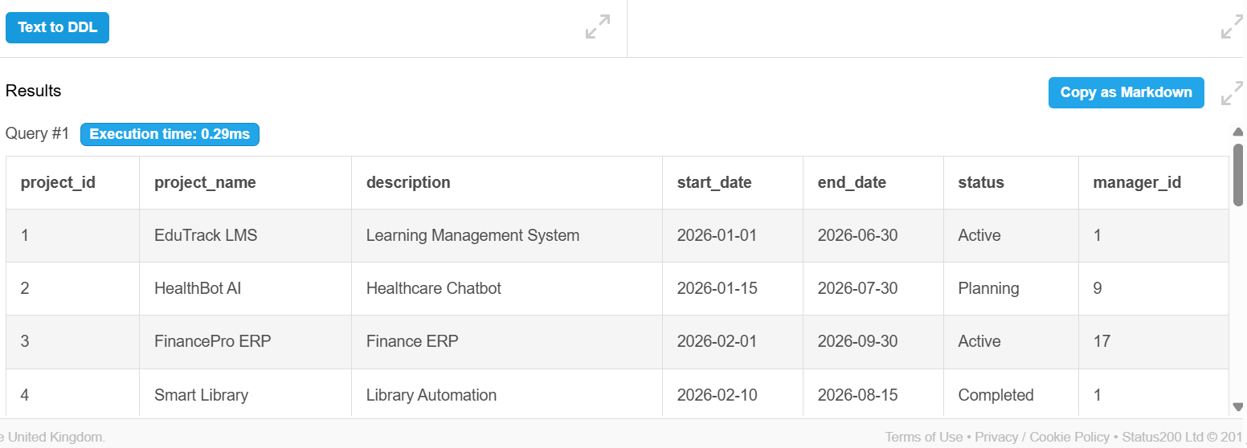

Q2. Display all Employees
SELECT * FROM Employee;
Output:
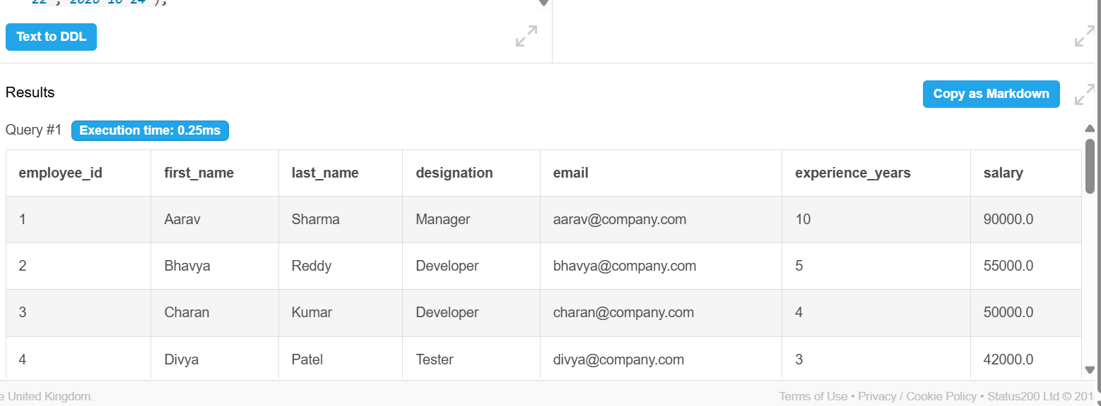

Q3. Display all Teams
SELECT * FROM Team;
Output:
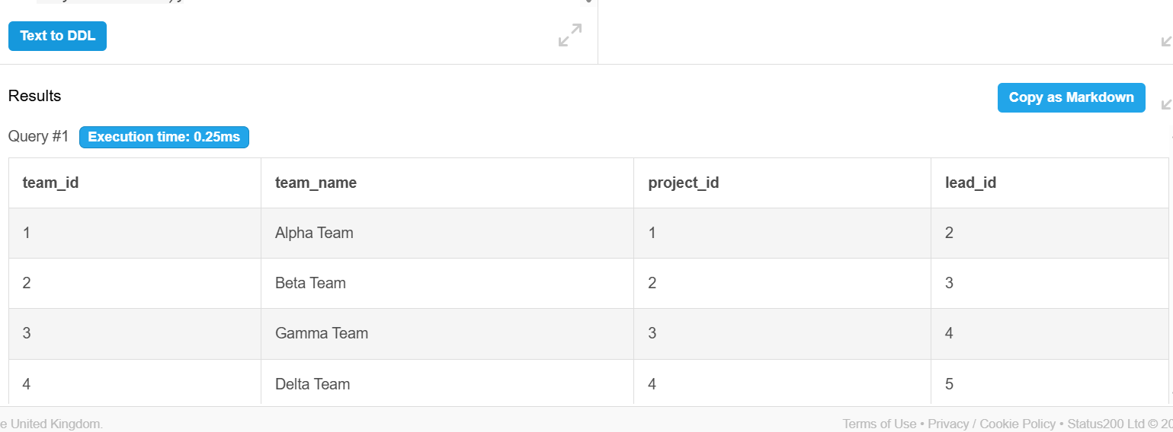
Q4. Display all Sprints
SELECT * FROM Sprint;
Output:
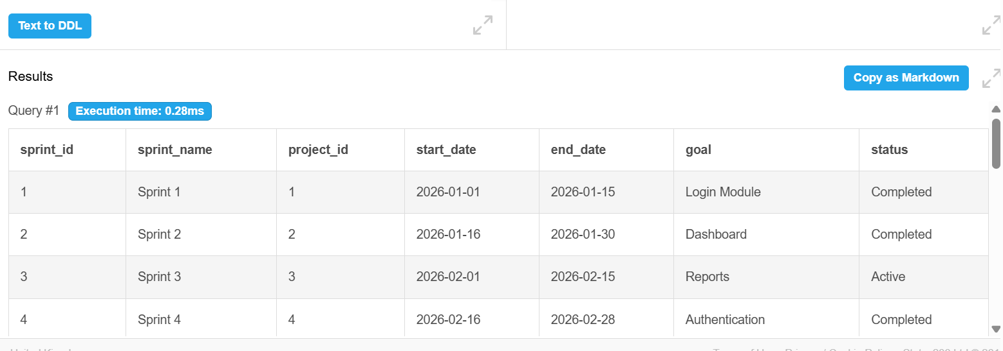

Q5. Display all Tasks
SELECT * FROM Task;
Output:
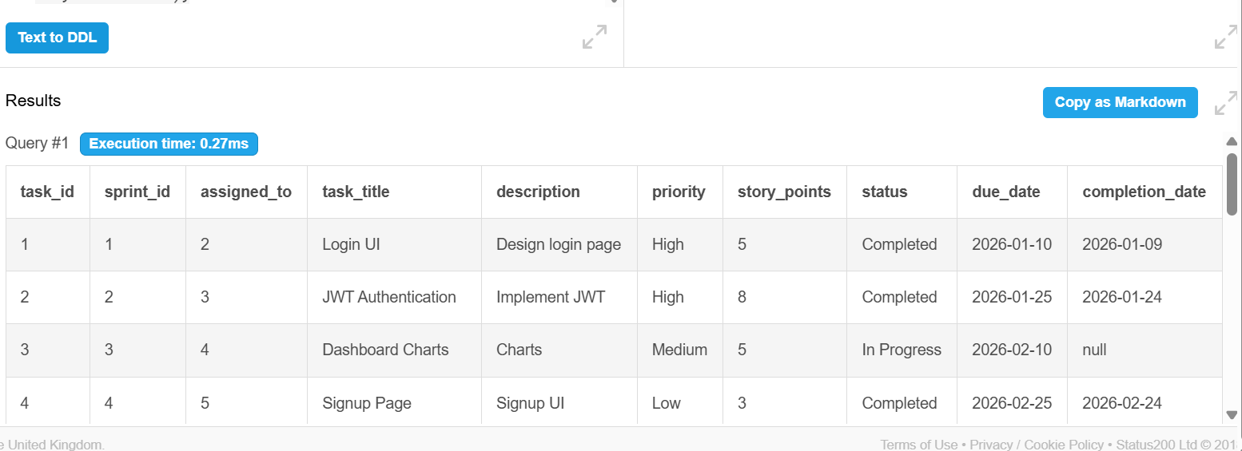

Q6. Display all Bugs
SELECT * FROM Bug;
Output:
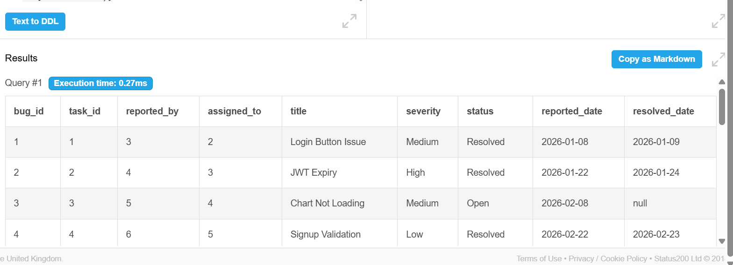
Q7. Display Active Projects
SELECT *FROM Project WHERE status = 'Active';
Output:
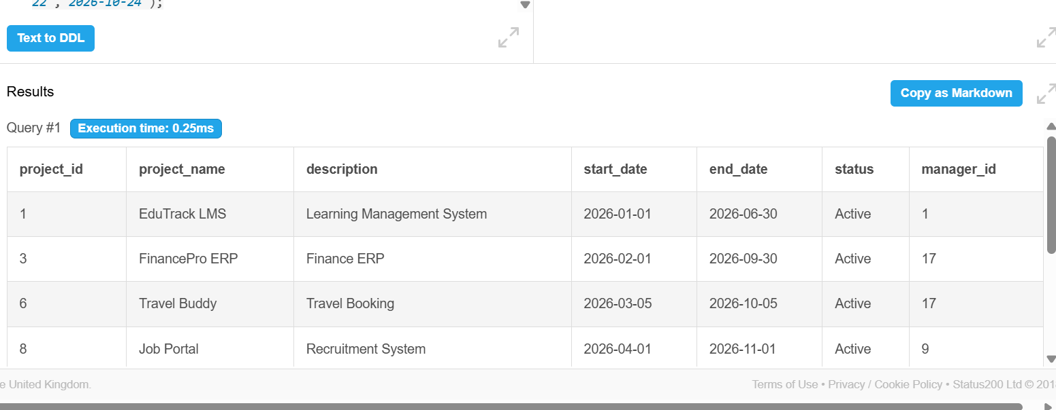
Q8. Display Completed Projects
SELECT * FROM Project WHERE status = 'Completed';
Output:
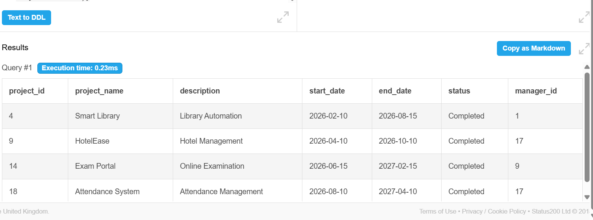

Q9. Display High Priority Tasks
SELECT * FROM Task WHERE priority = 'High';
Output:
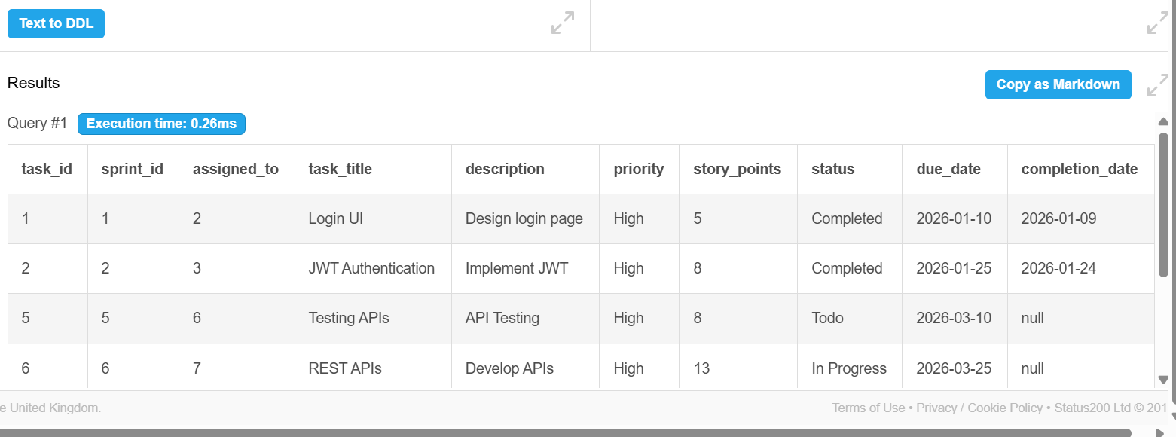
Q10. Display Open Bugs
SELECT * FROM Bug WHERE status = 'Open';
Output:
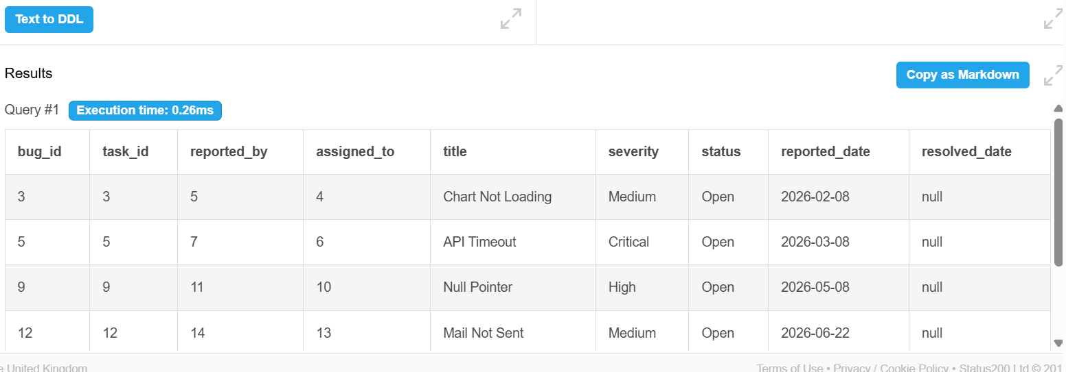

Q11. Employees sorted by Id
SELECT * FROM Employee ORDER BY employee_Id;
Output:
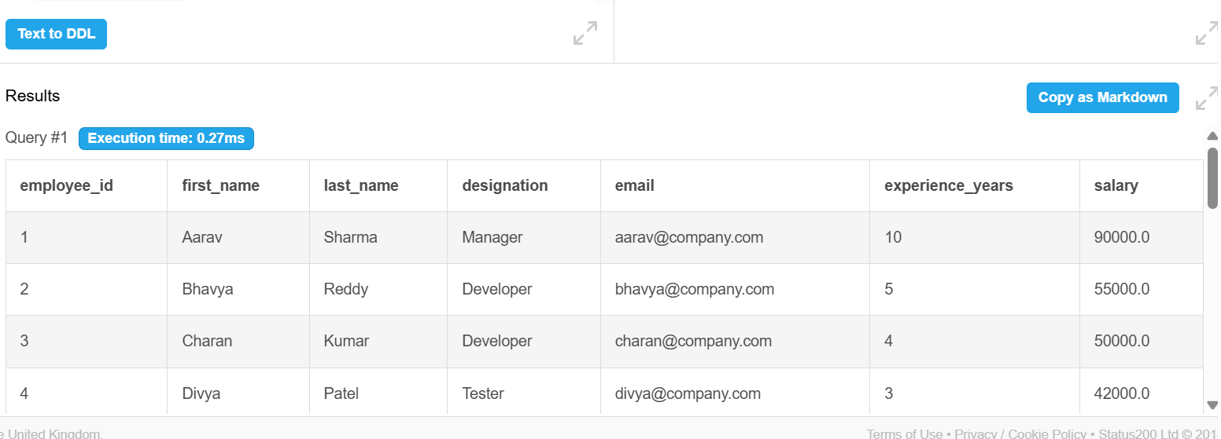

Q12. Projects sorted by Start Date
SELECT * FROM Project ORDER BY start_date DESC;
Output:
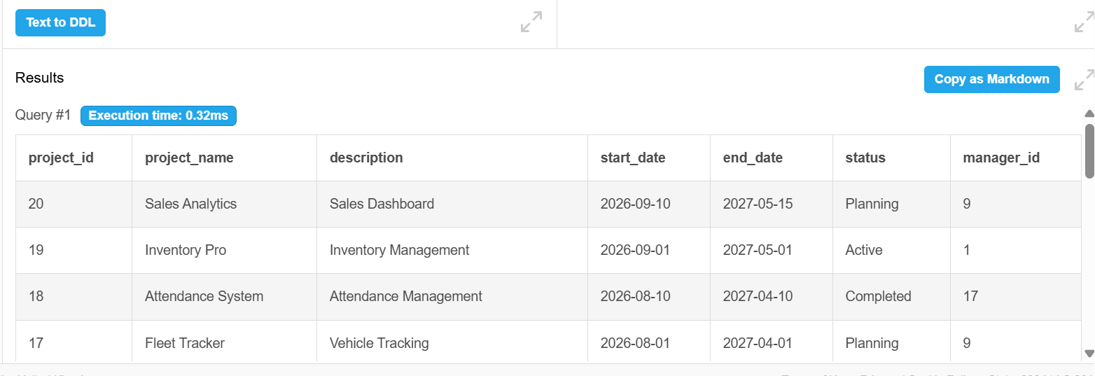

Q13. Display Task title and Status
SELECT task_title, status FROM Task;
Output:
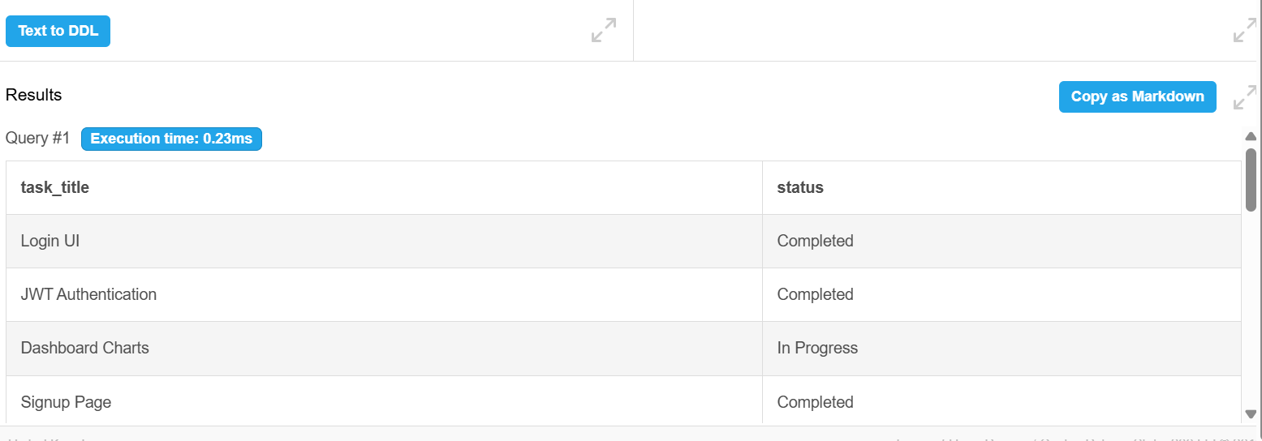

Q14. Project with Team
SELECT p.project_name, t.team_name FROM Project p JOIN Team t ON p.project_id = t.project_id;
Output:
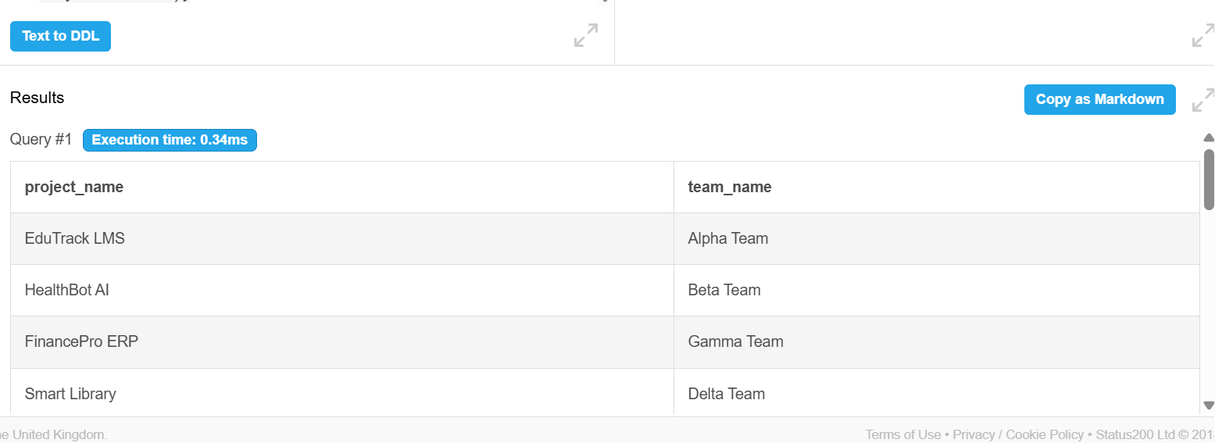

Q15. Task with Employee
SELECT t.task_title, CONCAT(e.first_name, ' ', e.last_name) AS employee_name FROM Task t JOIN Employee e ON t.assigned_to = e.employee_id;Output:
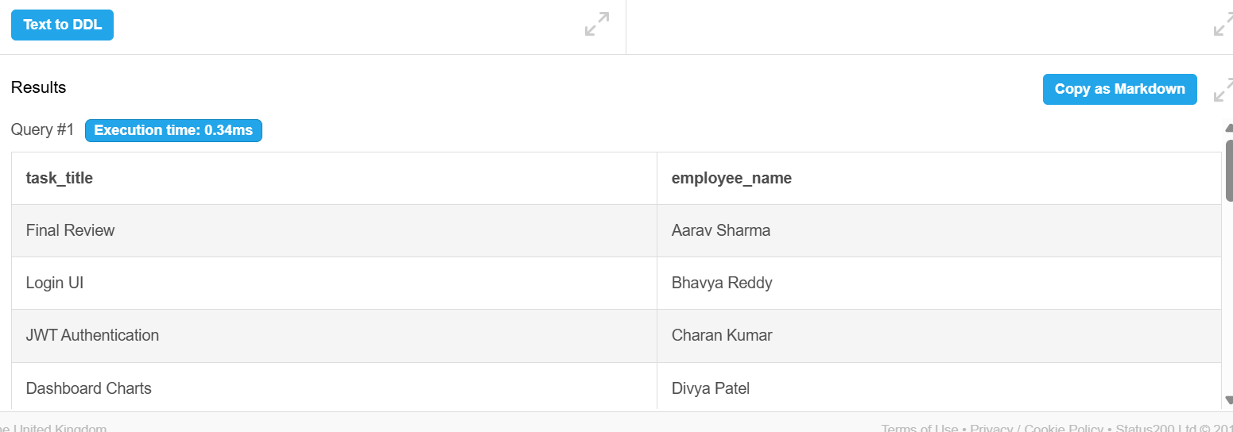
Q16. Bug with Project
SELECT b.title AS bug_title, p.project_name FROM Bug b JOIN Task t ON b.task_id = t.task_id JOIN Sprint s ON t.sprint_id = s.sprint_id JOIN Project ON s.project_id = p.project_id;
Output:
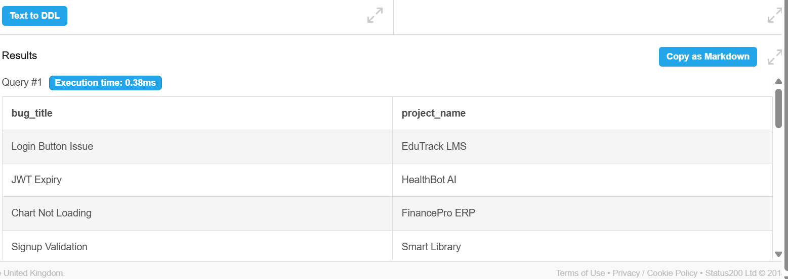

Q17. Sprint with Project
SELECT s.sprint_name, p.project_name FROM Sprint s JOIN Project p ON s.project_id = p.project_id;
Output:
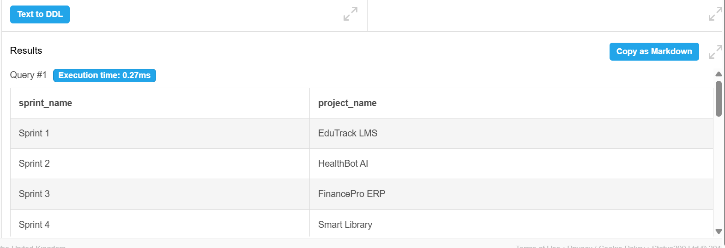

Q18. Number of Employees in each Team
SELECT tm.team_id, COUNT(tm.employee_id) AS employee_count FROM Team_Member tm GROUP BY tm.team_id;
Output:
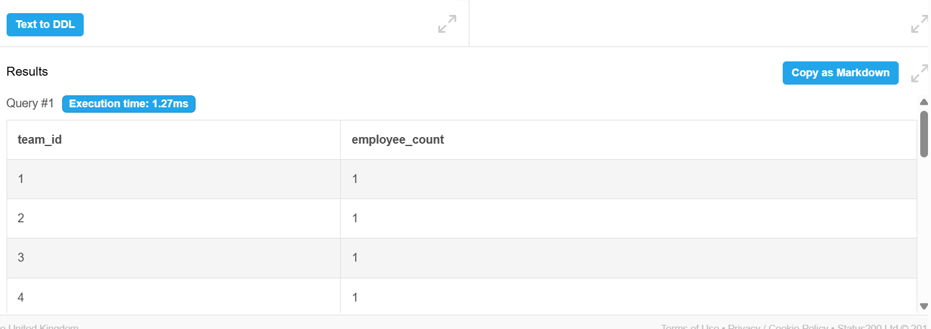

Q19. Number of Tasks in each Project
SELECT p.project_id, p.project_name, COUNT(t.task_id) AS total_tasks FROM Project p JOIN Sprint s ON p.project_id = s.project_id JOIN Task t ON s.sprint_id = t.sprint_id GROUP BY p.project_id, p.project_name;
Output:
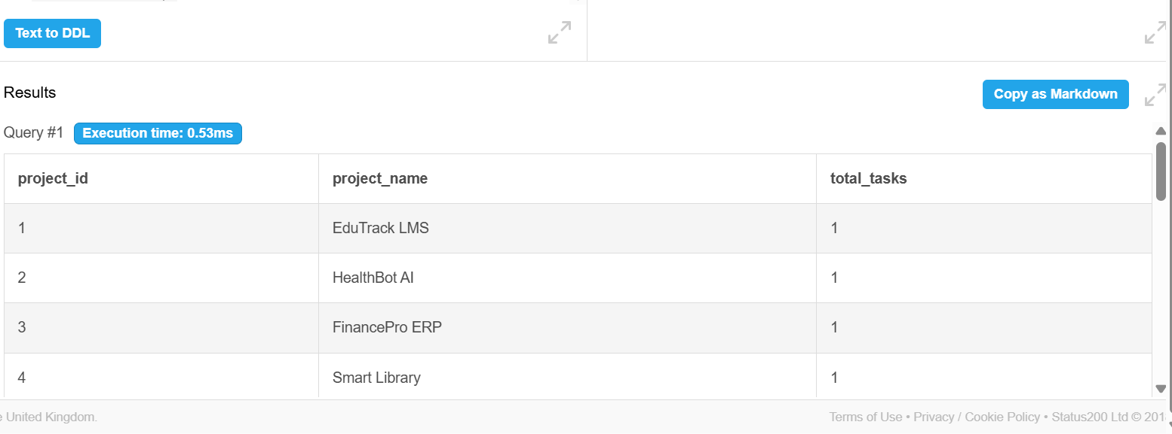

Q20. Number of Bugs in each Project
SELECT p.project_id, p.project_name,COUNT(b.bug_id) AS total_bugs FROM Project p JOIN Sprint s ON p.project_id = s.project_id JOIN Task t ON s.sprint_id = t.sprint_id JOIN Bug b ON t.task_id = b.task_id GROUP BY p.project_id, p.project_name;
Output:
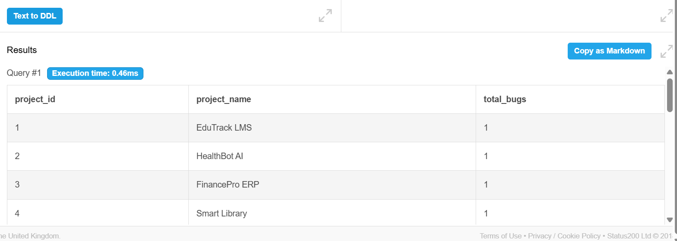

Q21. Count Total Employees
SELECT COUNT(*) AS "Total Employees"FROM Employee;
Output:
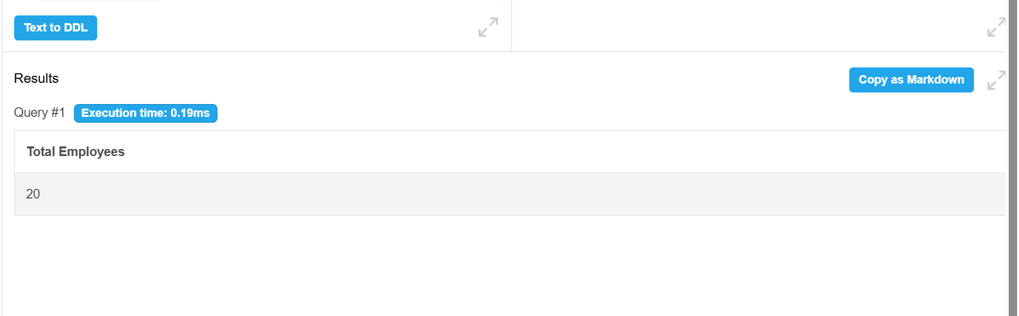

Q22. Average Employee Salary
SELECT AVG(salary) AS Average Salary FROM Employee;
Output:
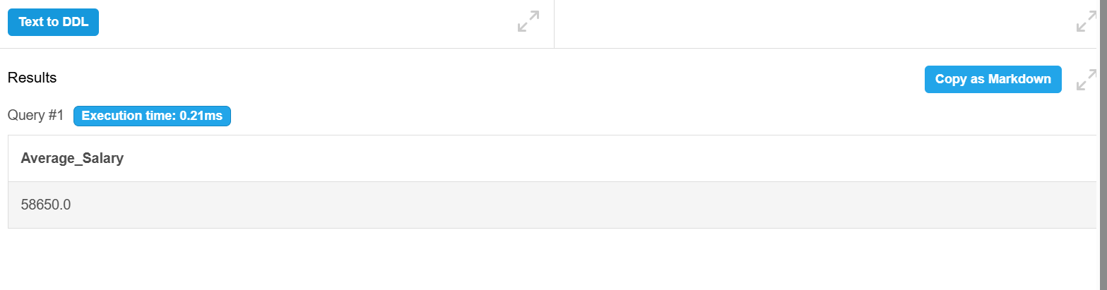

Q23. Employees with More Than 5 Years Experience
SELECT CONCAT(first_name,' ',last_name) AS Employee_Name, experience_years FROM Employee WHERE experience_years > 5;
Output:
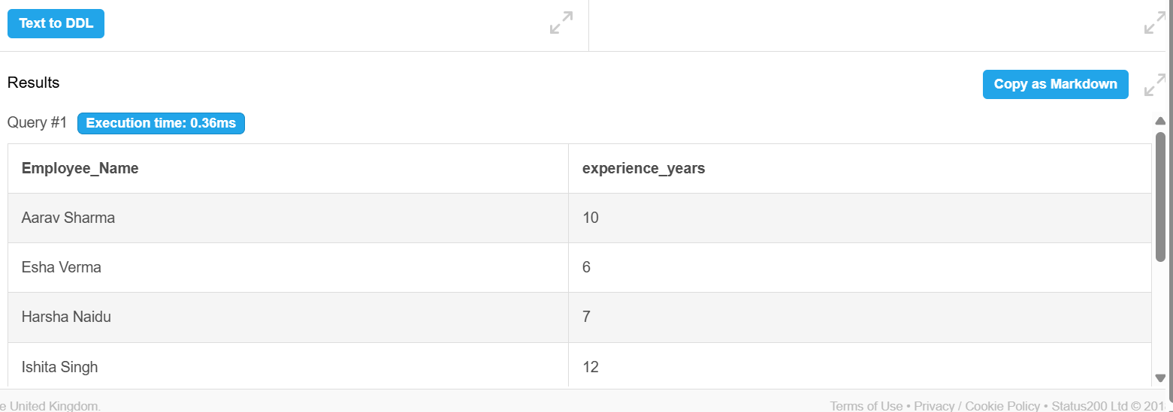

Q24. Project Manager Details
SELECT p.project_name, CONCAT(e.first_name,' ',e.last_name) AS Manager_Name FROM Project p JOIN Employee e ON p.manager_id = e.employee_id;
Output:
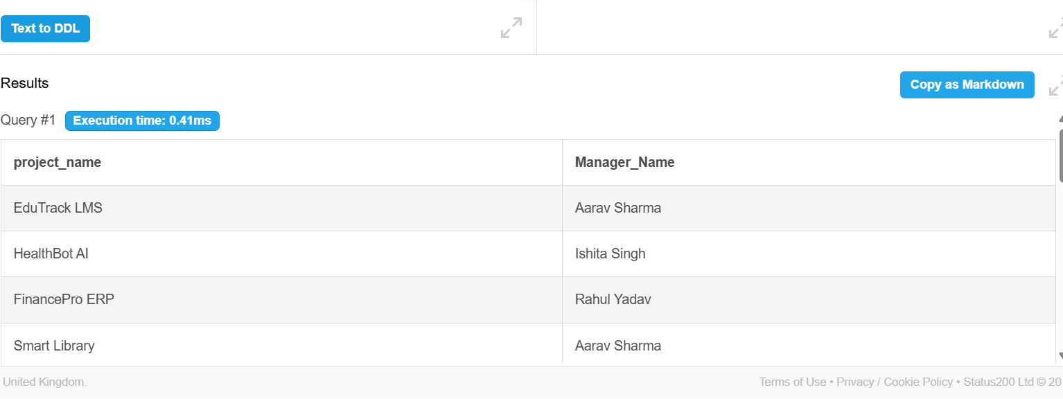

Q25. Count Tasks by Status
SELECT status,COUNT(*) AS Total_Tasks FROM Task GROUP BY status;
Output:
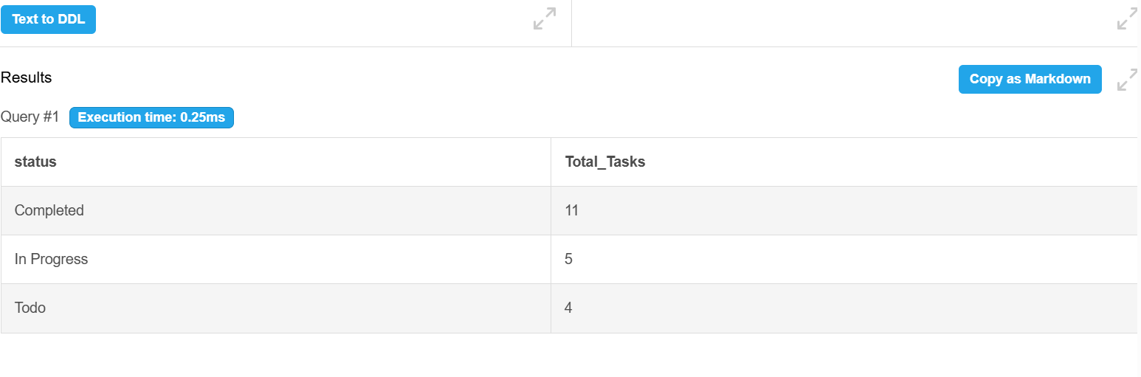
Q26. Teams Having More Than One Employee
SELECT team_id, COUNT(employee_id) AS Employee_Count FROM Team_Member GROUP BY team_id;
Output: 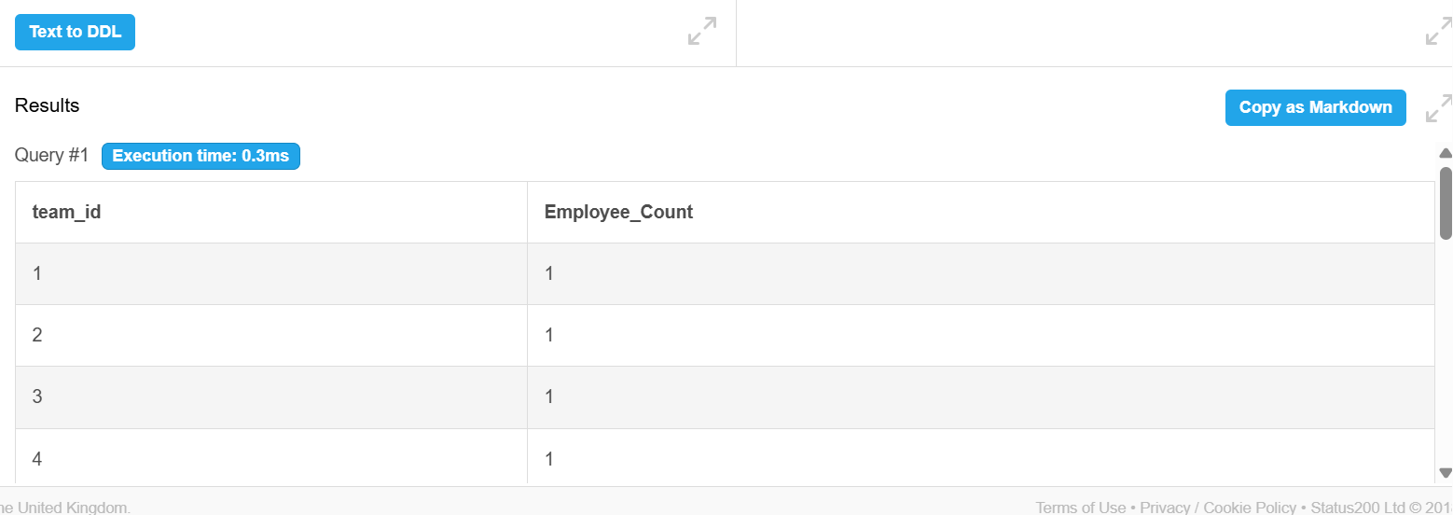
Q27. Display Completed Tasks
SELECT task_title FROM Task WHERE status = 'Completed';
Output:
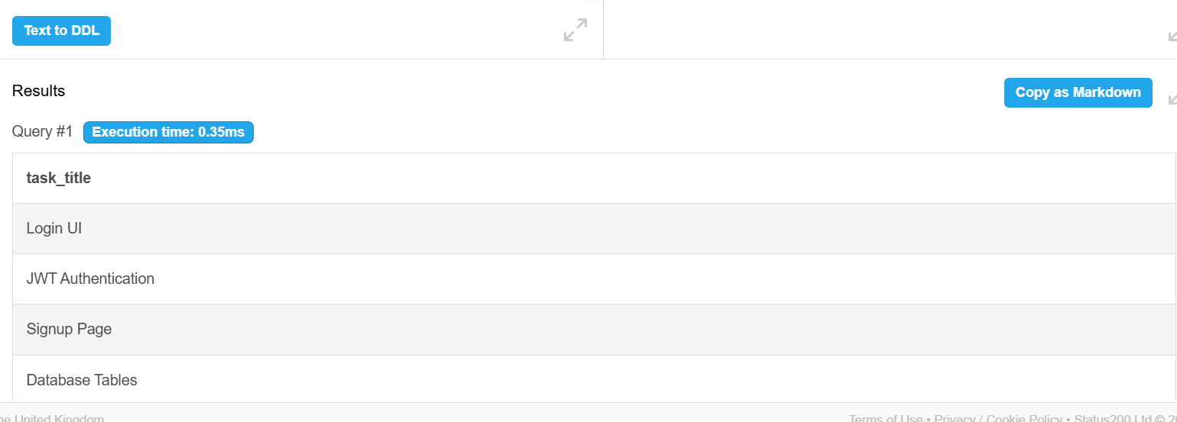

Q28. Employees Whose First Name Starts with 'A'
SELECT *FROM Employee WHERE first_name LIKE 'A%';
Output:
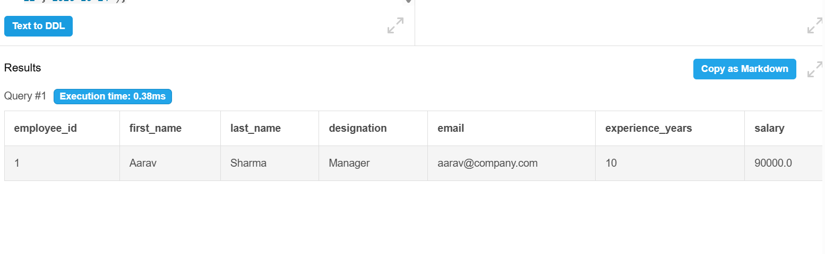

Q29. Search for "AI"
SELECT * FROM Project WHERE UPPER(project_name) LIKE '%AI%';
Output:
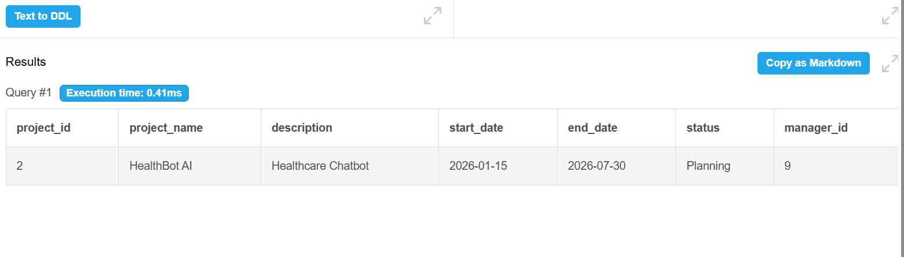
Q30. Bugs Assigned to Employees
SELECT b.title, CONCAT(e.first_name,' ',e.last_name) AS Assigned_Employee FROM Bug b JOIN Employee e ON b.assigned_to = e.employee_id;
Output:
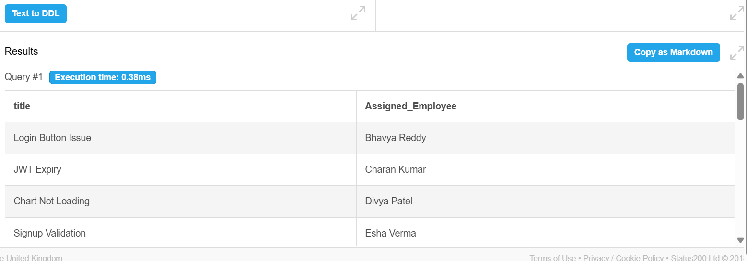
11. CONCLUSION
The Software Management System successfully demonstrates the application of DBMS concepts in managing software development activities. The project includes database design, ER modeling, normalization, relationships, constraints, and SQL operations for efficient data management. The database reduces redundancy, maintains data integrity, and enables quick retrieval of information through relational tables. Overall, the project achieves its objectives by providing a structured, reliable, and scalable solution for managing software projects, employees, sprints, tasks, teams, and bugs.

12. FUTURE ENHANCEMENTS
- Role-based access for Project Managers, Team Leads, Developers, and Testers.
- Web-based user interface for project and task management.
- Email or SMS notifications for task assignments, deadlines, and bug updates.
- Project progress dashboards with charts and performance reports.
- Integration with version control tools (Git/GitHub) and issue tracking systems.
- Backup, recovery, audit logging, and enhanced database security.
REFERENCES
- Elmasri, R., & Navathe, S. B. Fundamentals of Database Systems. Pearson Education.
- Silberschatz, A., Korth, H. F., & Sudarshan, S. Database System Concepts. McGraw-Hill.
- MySQL Documentation – https://dev.mysql.com/doc/
- Oracle Database Documentation – https://docs.oracle.com/en/database/
- W3Schools SQL Tutorial – https://www.w3schools.com/sql/

