Единый государственный экзамен по АНГЛИЙСКОМУ ЯЗЫКУ
Устная часть Инструкция по выполнению заданий
Устная часть КИМ ЕГЭ по английскому языку включает в себя 4 задания.
Задание 1 – чтение вслух небольшого текста научно-популярного характера. Время на подготовку – 1,5 минуты.
В задании 2 предлагается ознакомиться с рекламным объявлением и задать четыре вопроса на основе ключевых слов. Время на подготовку – 1,5 минуты.
В задании 3 предлагается дать интервью на актуальную тему, развёрнуто и точно ответив на пять вопросов.
В задании 4 предлагается проблемная тема для проектной работы и 2 фотографии; нужно обосновать выбор фотографий в качестве иллюстраций и выразить своё мнение по проблеме проектной работы. Время на подготовку – 2,5 минуты.
Общее время ответа одного экзаменуемого (включая время на подготовку) – 17 минут.
Каждое последующее задание выдаётся после окончания выполнения предыдущего задания. Всё время ответа ведётся аудио- и видеозапись.
Постарайтесь полностью выполнить поставленные задачи, старайтесь говорить ясно и чётко, не отходить от темы и следовать предложенному плану ответа. Так Вы сможете набрать наибольшее количество баллов.
Желаем успеха!
Задания открытого варианта представлены так, как они отображаются для участника ЕГЭ.

Task 1. Imagine that you are preparing a project with your friend. You have found some interesting material for the presentation and you want to read this text to your friend. You have 1.5 minutes to read the text silently, then be ready to read it out aloud. You will not have more than 1.5 minutes to read it.
1
Acid rain is a serious environmental problem these days. Basically, we have acid rain when water in the atmosphere mixes with dangerous gases and then falls onto the ground. It can fall as rain, snow, dust or even fog. When it comes into contact with animals, plants and even buildings or cars, it does a lot of harm to them. It also damages the soil. If it gets into a river or a lake, water creatures there suffer, too.
It is obvious that acid rain is caused by air pollution. Factories and plants send smoke into the air. People burn fossil fuels to produce energy. They also drive their cars or use public transport instead of using their bikes or walking. Sometimes acid rain happens because of volcanic activity or other natural causes, but in most cases, it is man-made. We should consider our environmental footprint seriously and start doing everything we can to stop acid rain.

Task 1. Read the text aloud.
1
Acid rain is a serious environmental problem these days. Basically, we have acid rain when water in the atmosphere mixes with dangerous gases and then falls onto the ground. It can fall as rain, snow, dust or even fog. When it comes into contact with animals, plants and even buildings or cars, it does a lot of harm to them. It also damages the soil. If it gets into a river or a lake, water creatures there suffer, too.
It is obvious that acid rain is caused by air pollution. Factories and plants send smoke into the air. People burn fossil fuels to produce energy. They also drive their cars or use public transport instead of using their bikes or walking. Sometimes acid rain happens because of volcanic activity or other natural causes, but in most cases, it is man-made. We should consider our environmental footprint seriously and start doing everything we can to stop acid rain.

Task 2. Study the advertisement.
2
You are considering joining the roller skating club and now you’d like to get more information. In 1.5 minutes you are to ask four direct questions to find out about the following:
- minimum age;
Join our roller skating club!
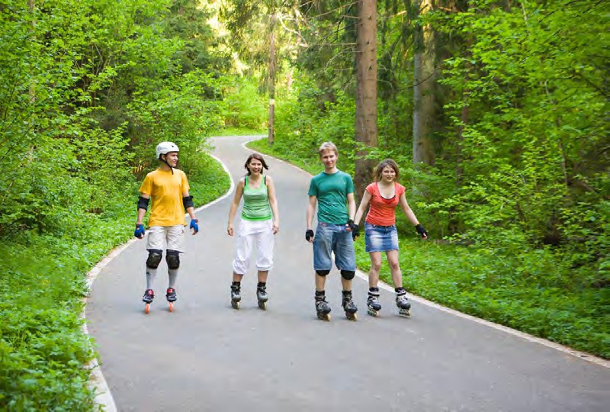

- special clothes;
- roller skates rental;
- competitions.

You have 20 seconds to ask each question.

Question 1.
2
- Ask a direct question about the following: minimum age.

Join our roller skating club!


Question 2.
2
- Ask a direct question about the following: special clothes.

Join our roller skating club!


Question 3.
2
- Ask a direct question about the following: roller skates rental.

Join our roller skating club!


Question 4.
2
- Ask a direct question about the following: competitions.

Join our roller skating club!


3
Task 3. You are going to give an interview. You have to answer five questions. Give full answers to the questions (2–3 sentences).
Remember that you have 40 seconds to answer each question.

3
Task 3. Interviewer

3
Task 3. Interviewer: question 1.

3
Task 3. Interviewer: question 2.

3
Task 3. Interviewer: question 3.

3
Task 3. Interviewer: question 4.

3
Task 3. Interviewer: question 5.

3
Task 3. Interviewer

Task 4. Imagine that you and your friend are doing a school project “Seasons”. You have found some photos to illustrate it but for technical reasons you cannot send them now. Leave a voice message to your friend explaining your choice of the photos and sharing some ideas about the project. In 2.5 minutes be ready to:
4
- explain the choice of the illustrations for the project by briefly describing them and noting the differences;
- mention the advantages (1–2) of the two seasons;
- mention the disadvantages (1–2) of the two seasons;
- express your opinion on the subject of the project – say which of the seasons presented in the pictures you preferred as a child and why.
You will speak for not more than 3 minutes (12–15 sentences). You have to talk continuously.

 | 

