Mathematics
Answer: A
Final Answer Key Paper 1
SECTION 1 (Maximum Marks: 12)

- This section contains FOUR (04) questions.
- Each question has FOUR options (A), (B), (C) and (D). ONLY ONE of these four options is the correct answer.
- For each question, choose the option corresponding to the correct answer.
- Answer to each question will be evaluated according to the following marking scheme:
Full Marks : +3
Zero Marks : 0
Negative Marks : −1
If ONLY the correct option is chosen;
If none of the options is chosen (i.e. the question is unanswered); In all other cases.

Q.1 | Let ℝ denote the set of all real numbers. Let 𝑎𝑖, 𝑏𝑖 ∈ ℝ for 𝑖 ∈ {1, 2, 3}.  Define the functions 𝑓: ℝ → ℝ, 𝑔: ℝ → ℝ, and ℎ: ℝ → ℝ by  𝑓(𝑥) = 𝑎1 + 10𝑥 + 𝑎2𝑥² + 𝑎3𝑥³ + 𝑥⁴,  𝑔(𝑥) = 𝑏1 + 3𝑥 + 𝑏2𝑥² + 𝑏3𝑥³ + 𝑥⁴, ℎ(𝑥) = 𝑓(𝑥 + 1) − 𝑔(𝑥 + 2).  If 𝑓(𝑥) ≠ 𝑔(𝑥) for every 𝑥 ∈ ℝ, then the coefficient of 𝑥³ in ℎ(𝑥) is
 | (A) | 8
 | (B) | 2
 | (C) | −4
 | (D) | −6

Q.2
Three students 𝑆₁, 𝑆₂, and 𝑆₃ are given a problem to solve. Consider the following events:

𝑈: At least one of 𝑆1, 𝑆2, and 𝑆3 can solve the problem,
𝑉: 𝑆₁ can solve the problem, given that neither 𝑆₂ nor 𝑆₃ can solve the problem,
𝑊: 𝑆₂ can solve the problem and 𝑆₃ cannot solve the problem,
𝑇: 𝑆₃ can solve the problem.

For any event 𝐸, let 𝑃(𝐸) denote the probability of 𝐸. If
𝑃(𝑈) = ,
1
2
𝑃(𝑉) = ,
1
1
10
and 𝑃(𝑊) = ,
12
then 𝑃(𝑇) is equal to
Answer: C

(A) | 13  36 | (B) | 1  3 | (C) | 19  60 | (D) | 1  4

Answer: C
Q.3 | Let ℝ denote the set of all real numbers. Define the function 𝑓: ℝ → ℝ by  2 − 2𝑥² − 𝑥² sin 1 if 𝑥 ≠ 0,  𝑓(𝑥) = { 𝑥  2 if 𝑥 = 0 .  Then which one of the following statements is TRUE?
 | (A) | The function 𝑓 is NOT differentiable at 𝑥 = 0
 | (B) | There is a positive real number 𝛿, such that 𝑓 is a decreasing function on the interval (0, 𝛿)
 | (C) | For any positive real number 𝛿, the function 𝑓 is NOT an increasing function on the interval  (−𝛿, 0)
 | (D) | 𝑥 = 0 is a point of local minima of 𝑓

Q.4
Consider the matrix
2 0 0
𝑃 = ( 0 2 0) .
0 0 3

Let the transpose of a matrix 𝑋 be denoted by 𝑋^{𝑇}. Then the number of 3 × 3 invertible matrices 𝑄
with integer entries, such that
𝑄−1 = 𝑄𝑇
and 𝑃𝑄 = 𝑄𝑃 ,
is
Answer: C

(A) | 32 | (B) | 8 | (C) | 16 | (D) | 24

SECTION 2 (Maximum Marks: 12)
Answer: A, C

- This section contains THREE (03) questions.
- Each question has FOUR options (A), (B), (C) and (D). ONE OR MORE THAN ONE of these four option(s) is(are) correct answer(s).
- For each question, choose the option(s) corresponding to (all) the correct answer(s).
- Answer to each question will be evaluated according to the following marking scheme:
Full Marks : +4 ONLY if (all) the correct option(s) is(are) chosen;
Partial Marks : +3 If all the four options are correct but ONLY three options are chosen;
Partial Marks : +2 If three or more options are correct but ONLY two options are chosen, both of which are correct;
Partial Marks : +1 If two or more options are correct but ONLY one option is chosen and it is a correct option;
Zero Marks : 0 If none of the options is chosen (i.e. the question is unanswered);
Negative Marks : −2 In all other cases.
- For example, in a question, if (A), (B) and (D) are the ONLY three options corresponding to correct answers, then
choosing ONLY (A), (B) and (D) will get +4 marks; choosing ONLY (A) and (B) will get +2 marks; choosing ONLY (A) and (D) will get +2 marks; choosing ONLY (B) and (D) will get +2 marks; choosing ONLY (A) will get +1 mark;
choosing ONLY (B) will get +1 mark; choosing ONLY (D) will get +1 mark;
choosing no option (i.e. the question is unanswered) will get 0 marks; and choosing any other combination of options will get −2 marks.

Q.5 | Let 𝐿₁ be the line of intersection of the planes given by the equations  2𝑥 + 3𝑦 + 𝑧 = 4 and 𝑥 + 2𝑦 + 𝑧 = 5 .  Let 𝐿2 be the line passing through the point 𝑃(2, −1, 3) and parallel to 𝐿1. Let 𝑀 denote the plane given by the equation  2𝑥 + 𝑦 − 2𝑧 = 6 .  Suppose that the line 𝐿₂ meets the plane 𝑀 at the point 𝑄. Let 𝑅 be the foot of the perpendicular drawn from 𝑃 to the plane 𝑀 .  Then which of the following statements is (are) TRUE?
 | (A) | The length of the line segment 𝑃𝑄 is 9√3
 | (B) | The length of the line segment 𝑄𝑅 is 15
 | (C) | The area of Δ𝑃𝑄𝑅 is 3 √234  2
 | (D) | The acute angle between the line segments 𝑃𝑄 and 𝑃𝑅 is cos⁻¹ ( 1 )  2√3

Answer: A, D
Answer: A, D
Q.6 | Let ℕ denote the set of all natural numbers, and ℤ denote the set of all integers. Consider the functions 𝑓: ℕ → ℤ and 𝑔: ℤ → ℕ defined by  (𝑛 + 1)/2 if 𝑛 is odd ,  𝑓(𝑛) = {  (4 − 𝑛)/2 if 𝑛 is even ,  and  3 + 2𝑛 if 𝑛 ≥ 0 ,  𝑔(𝑛) = {  −2𝑛 if 𝑛 < 0 .  Define (𝑔 ∘ 𝑓)(𝑛) = 𝑔(𝑓(𝑛)) for all 𝑛 ∈ ℕ, and (𝑓 ∘ 𝑔)(𝑛) = 𝑓(𝑔(𝑛)) for all 𝑛 ∈ ℤ. Then which of the following statements is (are) TRUE?
 | (A) | 𝑔 ∘ 𝑓 is NOT one-one and 𝑔 ∘ 𝑓 is NOT onto
 | (B) | 𝑓 ∘ 𝑔 is NOT one-one but 𝑓 ∘ 𝑔 is onto
 | (C) | 𝑔 is one-one and 𝑔 is onto
 | (D) | 𝑓 is NOT one-one but 𝑓 is onto

Q.7 | Let ℝ denote the set of all real numbers. Let 𝑧₁ = 1 + 2𝑖 and 𝑧₂ = 3𝑖 be two complex numbers, where 𝑖 = √−1 . Let  𝑆 = {(𝑥, 𝑦) ∈ ℝ × ℝ ∶ |𝑥 + 𝑖𝑦 − 𝑧1| = 2|𝑥 + 𝑖𝑦 − 𝑧2| }.  Then which of the following statements is (are) TRUE?
 | (A) | 𝑆 is a circle with centre | (− 1 , | 10)  3
 | (B) | 𝑆 is a circle with centre | 1 , 8)
 | (C) | 𝑆 is a circle with radius | √2
 |  |  | 3
 | (D) | 𝑆 is a circle with radius | 2√2
 |  |  | 3

Answer: 105
Answer: [1.15 to 1.25]
Answer: 762
SECTION 3 (Maximum Marks: 24)
- This section contains SIX (06) questions.
- The answer to each question is a NUMERICAL VALUE.
- For each question, enter the correct numerical value of the answer using the mouse and the on-screen virtual numeric keypad in the place designated to enter the answer.
- If the numerical value has more than two decimal places, truncate/round-off the value to TWO decimal places.
- Answer to each question will be evaluated according to the following marking scheme:
Full Marks
Zero Marks
: +4 If ONLY the correct numerical value is entered in the designated place;
: 0
In all other cases.

Q.8 | Let the set of all relations 𝑅 on the set {𝑎, 𝑏, 𝑐, 𝑑, 𝑒, 𝑓}, such that 𝑅 is reflexive and symmetric, and  𝑅 contains exactly 10 elements, be denoted by 𝒮.  Then the number of elements in 𝒮 is .

Q.9 | For any two points 𝑀 and 𝑁 in the 𝑋𝑌-plane, let 𝑀⃗⃗⃗⃗𝑁⃗⃗→ denote the vector from 𝑀 to 𝑁, and 0⃗→ denote the zero vector. Let 𝑃, 𝑄 and 𝑅 be three distinct points in the 𝑋𝑌-plane. Let 𝑆 be a point inside the triangle Δ𝑃𝑄𝑅 such that  𝑆⃗⃗𝑃⃗⃗→ + 5 𝑆⃗⃗⃗𝑄⃗⃗→ + 6 𝑆⃗⃗⃗𝑅⃗⃗→ = 0⃗→.  Let 𝐸 and 𝐹 be the mid-points of the sides 𝑃𝑅 and 𝑄𝑅, respectively. Then the value of  length of the line segment 𝐸𝐹 length of the line segment 𝐸𝑆  is .

Q.10 | Let 𝑆 be the set of all seven-digit numbers that can be formed using the digits 0, 1 and 2. For example, 2210222 is in 𝑆, but 0210222 is NOT in 𝑆.  Then the number of elements 𝑥 in 𝑆 such that at least one of the digits 0 and 1 appears exactly twice in 𝑥, is equal to .

Q.11 | Let 𝛼 and 𝛽 be the real numbers such that  𝑥  1 𝛼 1  lim 3 ( ∫ 2 𝑑𝑡 + 𝛽𝑥 cos 𝑥 ) = 2 .  𝑥→0 𝑥 2 1 − 𝑡  0  Then the value of 𝛼 + 𝛽 is .
Answer: [2.35 to 2.45]
Answer: 96
Answer: 2

Q.12 | Let ℝ denote the set of all real numbers. Let 𝑓: ℝ → ℝ be a function such that 𝑓(𝑥) > 0 for all  𝑥 ∈ ℝ , and 𝑓(𝑥 + 𝑦) = 𝑓(𝑥)𝑓(𝑦) for all 𝑥, 𝑦 ∈ ℝ.  Let the real numbers 𝑎1, 𝑎2, … , 𝑎50 be in an arithmetic progression. If 𝑓(𝑎31) = 64𝑓(𝑎25), and  50  ∑ 𝑓(𝑎𝑖) = 3(2²⁵ + 1) ,  𝑖=1  then the value of  30  ∑ 𝑓(𝑎𝑖)  𝑖=6  is .

Q.13 | For all 𝑥 > 0, let 𝑦1(𝑥), 𝑦2(𝑥), and 𝑦3(𝑥) be the functions satisfying  𝑑𝑦1 − (sin 𝑥)² 𝑦 = 0, 𝑦 (1) = 5 ,  𝑑𝑥 1 1  𝑑𝑦2 − (cos 𝑥)² 𝑦 = 0, 𝑦 (1) = 1 ,  𝑑𝑥 2 2 3  𝑑𝑦3 − 2−𝑥3) 𝑦 = 0, 𝑦 (1) = 3 , ( 3 3  𝑑𝑥 𝑥3 5𝑒  respectively. Then  𝑦₁(𝑥)𝑦₂(𝑥)𝑦₃(𝑥) + 2𝑥 lim 3𝑥  𝑥→0+ 𝑒 sin 𝑥  is equal to .

Answer: C

SECTION 4 (Maximum Marks: 12)

- This section contains THREE (03) Matching List Sets.
- Each set has ONE Multiple Choice Question.
- Each set has TWO lists: List-I and List-II.
- List-I has Four entries (P), (Q), (R) and (S) and List-II has Five entries (1), (2), (3), (4) and (5).
- FOUR options are given in each Multiple Choice Question based on List-I and List-II and ONLY ONE of these four options satisfies the condition asked in the Multiple Choice Question.
- Answer to each question will be evaluated according to the following marking scheme:
Full Marks : +4 ONLY if the option corresponding to the correct combination is chosen; Zero Marks : 0 If none of the options is chosen (i.e. the question is unanswered); Negative Marks : −1 In all other cases.

Q.14
Suppose that the sum of the frequencies is 19 and the median of this frequency distribution is 6.

For the given frequency distribution, let 𝛼 denote the mean deviation about the mean, 𝛽 denote the mean deviation about the median, and 𝜎² denote the variance.
Match each entry in List-I to the correct entry in List-II and choose the correct option.
Consider the following frequency distribution:
List-I
List-II
(P) 7𝑓₁ + 9𝑓₂ is equal to
(1) 146
(Q) 19𝛼 is equal to
(2) 47
(3) 48
(R) 19𝛽 is equal to
(4) 145
(S) 19𝜎² is equal to
(5) 55

Value | 4 | 5 | 8 | 9 | 6 | 12 | 11
Frequency | 5 | 𝑓1 | 𝑓2 | 2 | 1 | 1 | 3

(A) | (P) ⟶ (5) | (Q) ⟶ (3) | (R) ⟶ (2) | (S) ⟶ (4)
(B) | (P) ⟶ (5) | (Q) ⟶ (2) | (R) ⟶ (3) | (S) ⟶ (1)
(C) | (P) ⟶ (5) | (Q) ⟶ (3) | (R) ⟶ (2) | (S) ⟶ (1)
(D) | (P) ⟶ (3) | (Q) ⟶ (2) | (R) ⟶ (5) | (S) ⟶ (4)

Answer: B

Q.15
Let ℝ denote the set of all real numbers. For a real number 𝑥, let [𝑥] denote the greatest integer less than or equal to 𝑥. Let 𝑛 denote a natural number.
Match each entry in List-I to the correct entry in List-II and choose the correct option.
List-I | List-II
(P) The minimum value of 𝑛 for which the function  10𝑥³ − 45𝑥² + 60𝑥 + 35  𝑓(𝑥) = [ ]  𝑛  is continuous on the interval [1, 2], is | (1) 8
(Q) The minimum value of 𝑛 for which  𝑔(𝑥) = (2𝑛² − 13𝑛 − 15)(𝑥³ + 3𝑥),  𝑥 ∈ ℝ, is an increasing function on ℝ, is | (2) 9
(R) The smallest natural number 𝑛 which is greater than 5, such that 𝑥 = 3 is a point of local minima of  ℎ(𝑥) = (𝑥² − 9)^{𝑛}(𝑥² + 2𝑥 + 3),  is | (3) 5
(S) Number of 𝑥₀ ∈ ℝ such that  4  1  𝑙(𝑥) = ∑ (sin|𝑥 − 𝑘| + cos |𝑥 − 𝑘 + |),  2  𝑘=0 | (4) 6
𝑥 ∈ ℝ , is NOT differentiable at 𝑥₀, is | (5) 10

(A) | (P) ⟶ (1) | (Q) ⟶ (3) | (R) ⟶ (2) | (S) ⟶ (5)
(B) | (P) ⟶ (2) | (Q) ⟶ (1) | (R) ⟶ (4) | (S) ⟶ (3)
(C) | (P) ⟶ (5) | (Q) ⟶ (1) | (R) ⟶ (4) | (S) ⟶ (3)
(D) | (P) ⟶ (2) | (Q) ⟶ (3) | (R) ⟶ (1) | (S) ⟶ (5)

Q.16 Let 𝑤⃗→ = 𝚤̂ + 𝚥̂ − 2𝑘̂, and 𝑢⃗→ and 𝑣→ be two vectors, such that 𝑢⃗→ × 𝑣→ = 𝑤⃗→ and 𝑣→ × 𝑤⃗→ = 𝑢⃗→. Let
𝛼, 𝛽, 𝛾, and 𝑡 be real numbers such that
𝑢⃗→ = 𝛼𝚤̂ + 𝛽𝚥̂ + 𝛾𝑘̂ , − 𝑡 𝛼 + 𝛽 + 𝛾 = 0, 𝛼 − 𝑡 𝛽 + 𝛾 = 0, and 𝛼 + 𝛽 − 𝑡 𝛾 = 0. Match each entry in List-I to the correct entry in List-II and choose the correct option.
List-I | List-II
(P) |𝑣→|² is equal to | (1) 0
(Q) If 𝛼 = √3 , then 𝛾² is equal to | (2) 1
(R) If 𝛼 = √3 , then (𝛽 + 𝛾)² is equal to | (3) 2
(S) If 𝛼 = √2 , then 𝑡 + 3 is equal to | (4) 3
 | (5) 5
Answer: A
(A) | (P) ⟶ (2) | (Q) ⟶ (1) | (R) ⟶ (4) | (S) ⟶ (5)
(B) | (P) ⟶ (2) | (Q) ⟶ (4) | (R) ⟶ (3) | (S) ⟶ (5)
(C) | (P) ⟶ (2) | (Q) ⟶ (1) | (R) ⟶ (4) | (S) ⟶ (3)
(D) | (P) ⟶ (5) | (Q) ⟶ (4) | (R) ⟶ (1) | (S) ⟶ (3)

END OF THE QUESTION PAPER

Physics

SECTION 1 (Maximum Marks: 12)

- This section contains FOUR (04) questions.
- Each question has FOUR options (A), (B), (C) and (D). ONLY ONE of these four options is the correct answer.
- For each question, choose the option corresponding to the correct answer.
- Answer to each question will be evaluated according to the following marking scheme:
Full Marks : +3
Zero Marks : 0
Negative Marks : −1
If ONLY the correct option is chosen;
If none of the options is chosen (i.e. the question is unanswered); In all other cases.

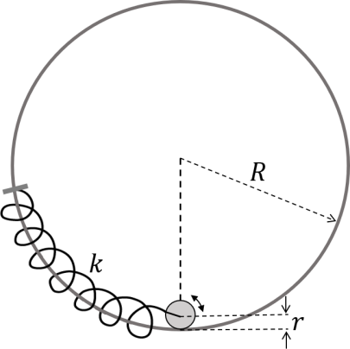
Q.1
The center of a disk of radius 𝑟 and mass 𝑚 is attached to a spring of spring constant 𝑘, inside a ring of radius 𝑅 > 𝑟 as shown in the figure. The other end of the spring is attached on the periphery of the ring. Both the ring and the disk are in the same vertical plane. The disk can only roll along the inside periphery of the ring, without slipping. The spring can only be stretched or compressed along the periphery of the ring, following the Hooke’s law. In equilibrium, the disk is at the bottom of the ring. Assuming small displacement of the disc, the time period of oscillation of center of mass of the disk
is written as 𝑇 = 2𝜋. The correct expression for 𝜔 is (𝑔 is the acceleration due to gravity):
𝜔
Answer: D

(A) | 2 𝑔 𝑘  √ ( + )  3 𝑅 − 𝑟 𝑚 | (B) | 2𝑔 𝑘  √ +  3(𝑅 − 𝑟) 𝑚
(C) | 1 𝑔 𝑘  √ ( + )  6 𝑅 − 𝑟 𝑚 | (D) | 1 𝑔 𝑘  √ ( + )  4 𝑅 − 𝑟 𝑚

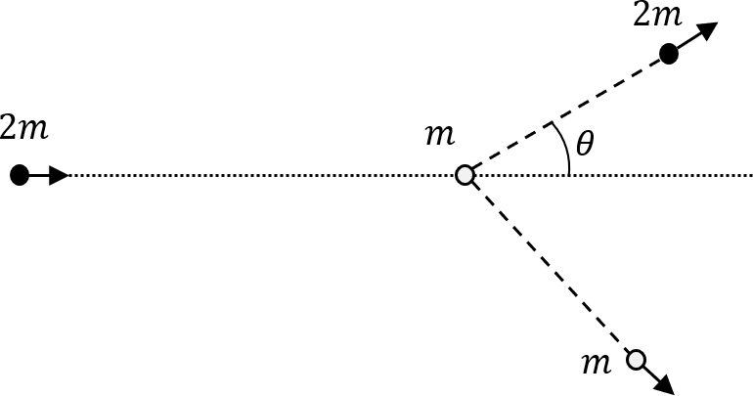
Q.2
In a scattering experiment, a particle of mass 2𝑚 collides with another particle of mass 𝑚, which is initially at rest. Assuming the collision to be perfectly elastic, the maximum angular deviation 𝜃 of the heavier particle, as shown in the figure, in radians is:
Answer: A

(A) | 𝜋 | (B) | tan⁻¹ (1)  2 | (C) | 𝜋  3 | (D) | 𝜋  6

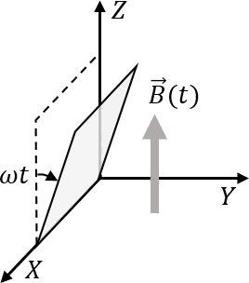
Q.3
A conducting square loop initially lies in the 𝑋𝑍 plane with its lower edge hinged along the 𝑋-axis. Only in the region 𝑦 ≥ 0, there is a time dependent magnetic field pointing along the 𝑍-direction,
𝐵⃗→(𝑡) = 𝐵₀(cos 𝜔𝑡)𝑘̂, where 𝐵₀ is a constant. The magnetic field is zero everywhere else. At time
𝑡 = 0, the loop starts rotating with constant angular speed 𝜔 about the 𝑋 axis in the clockwise direction as viewed from the +𝑋 axis (as shown in the figure). Ignoring self-inductance of the loop and gravity, which of the following plots correctly represents the induced e.m.f. (𝑉) in the loop as a function of time:
Answer: C

(A) | 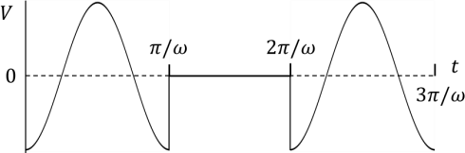 | (B) | 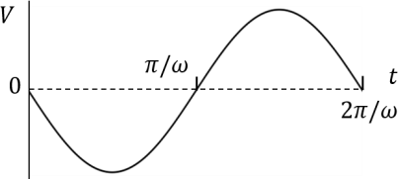
(C) | 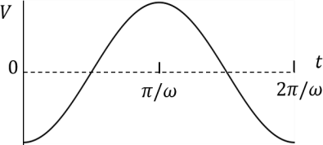 | (D) | 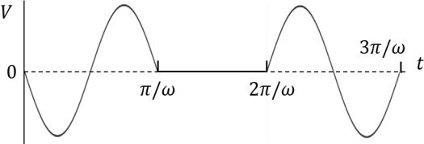

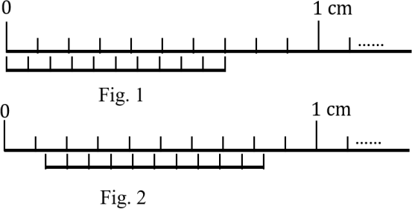
Q.4
Figure 1 shows the configuration of main scale and Vernier scale before measurement. Fig. 2 shows the configuration corresponding to the measurement of diameter 𝐷 of a tube. The measured value of
𝐷 is:
Answer: A

(A) | 0.12 cm
(B) | 0.11 cm
(C) | 0.13 cm
(D) | 0.14 cm

SECTION 2 (Maximum Marks: 12)

- This section contains THREE (03) questions.
- Each question has FOUR options (A), (B), (C) and (D). ONE OR MORE THAN ONE of these four option(s) is(are) correct answer(s).
- For each question, choose the option(s) corresponding to (all) the correct answer(s).
- Answer to each question will be evaluated according to the following marking scheme:
Full Marks : +4 ONLY if (all) the correct option(s) is(are) chosen;
Partial Marks : +3 If all the four options are correct but ONLY three options are chosen;
Partial Marks : +2 If three or more options are correct but ONLY two options are chosen, both of which are correct;
Partial Marks : +1 If two or more options are correct but ONLY one option is chosen and it is a correct option;
Zero Marks : 0 If none of the options is chosen (i.e. the question is unanswered);
Negative Marks : −2 In all other cases.
- For example, in a question, if (A), (B) and (D) are the ONLY three options corresponding to correct answers, then
choosing ONLY (A), (B) and (D) will get +4 marks; choosing ONLY (A) and (B) will get +2 marks; choosing ONLY (A) and (D) will get +2 marks; choosing ONLY (B) and (D) will get +2 marks; choosing ONLY (A) will get +1 mark;
choosing ONLY (B) will get +1 mark; choosing ONLY (D) will get +1 mark;
choosing no option (i.e. the question is unanswered) will get 0 marks; and choosing any other combination of options will get −2 marks.

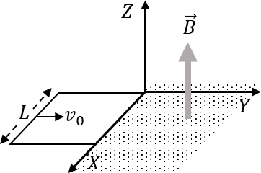
Q.5
A conducting square loop of side 𝐿, mass 𝑀 and resistance 𝑅 is moving in the 𝑋𝑌 plane with its edges parallel to the 𝑋 and 𝑌 axes. The region 𝑦 ≥ 0 has a uniform magnetic field, 𝐵⃗→ = 𝐵₀𝑘̂. The magnetic
field is zero everywhere else. At time 𝑡 = 0, the loop starts to enter the magnetic field with an initial
velocity 𝑣 𝚥̂ m/s, as shown in the figure. Considering the quantity 𝐾 =
𝐵 𝐿
2
2
0
0
𝑅𝑀
in appropriate units,
ignoring self-inductance of the loop and gravity, which of the following statements is/are correct:

(A) | If 𝑣₀ = 1.5𝐾𝐿, the loop will stop before it enters completely inside the region of magnetic field.
(B) | When the complete loop is inside the region of magnetic field, the net force acting on the loop is zero.
(C) | If 𝑣 = 𝐾𝐿, the loop comes to rest at 𝑡 = (1 ) ln 5).  0 10 𝐾 (  2
(D) | If 𝑣₀ = 3𝐾𝐿, the complete loop enters inside the region of magnetic field at time  𝑡 = (1 ) ln 3).  (  𝐾 2

Q.6
Length, breadth and thickness of a strip having a uniform cross section are measured to be 10.5 cm,
0.05 mm, and 6.0 𝜇m, respectively. Which of the following option(s) give(s) the volume of the strip in cm³ with correct significant figures:
Answer: B, D
Answer: D

(A) | 3.2 × 10⁻⁵ | (B) | 32.0 × 10⁻⁶ | (C) | 3.0 × 10⁻⁵ | (D) | 3 × 10⁻⁵

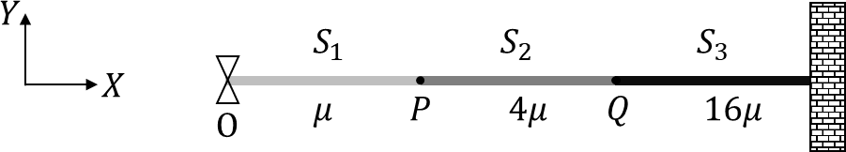
Q.7
Consider a system of three connected strings, 𝑆₁, 𝑆₂ and 𝑆₃ with uniform linear mass densities 𝜇 kg/m, 4𝜇 kg/m and 16𝜇 kg/m, respectively, as shown in the figure. 𝑆₁ and 𝑆₂ are connected at the point 𝑃, whereas 𝑆₂ and 𝑆₃ are connected at the point 𝑄, and the other end of 𝑆₃ is connected to a wall. A wave generator O is connected to the free end of 𝑆₁. The wave from the generator is
represented by 𝑦 = 𝑦0 cos(𝜔𝑡 − 𝑘𝑥) cm, where 𝑦0, 𝜔 and 𝑘 are constants of appropriate dimensions. Which of the following statements is/are correct:
Answer: A, D

(A) | When the wave reflects from 𝑃 for the first time, the reflected wave is represented by  𝑦 = 𝛼1y0 cos(𝜔𝑡 + 𝑘𝑥 + 𝜋) cm, where 𝛼1 is a positive constant.
(B) | When the wave transmits through 𝑃 for the first time, the transmitted wave is represented by  𝑦 = 𝛼2y0 cos(𝜔𝑡 − 𝑘𝑥) cm, where 𝛼2 is a positive constant.
(C) | When the wave reflects from 𝑄 for the first time, the reflected wave is represented by  𝑦 = 𝛼3y0 cos(𝜔𝑡 − 𝑘𝑥 + 𝜋) cm, where 𝛼3 is a positive constant.
(D) | When the wave transmits through 𝑄 for the first time, the transmitted wave is represented by  𝑦 = 𝛼4y0 cos(𝜔𝑡 − 4𝑘𝑥) cm, where 𝛼4 is a positive constant.

SECTION 3 (Maximum Marks: 24)

- This section contains SIX (06) questions.
- The answer to each question is a NUMERICAL VALUE.
- For each question, enter the correct numerical value of the answer using the mouse and the on-screen virtual numeric keypad in the place designated to enter the answer.
- If the numerical value has more than two decimal places, truncate/round-off the value to TWO decimal places.
- Answer to each question will be evaluated according to the following marking scheme:
Full Marks
Zero Marks
: +4 If ONLY the correct numerical value is entered in the designated place;
: 0
In all other cases.

Q.8
A person sitting inside an elevator performs a weighing experiment with an object of mass 50 kg. Suppose that the variation of the height 𝑦 (in m) of the elevator, from the ground, with time 𝑡 (in s)
2𝜋𝑡
is given by 𝑦 = 8 [1 + sin ( )], where 𝑇 = 40𝜋 s. Taking acceleration due to gravity, 𝑔 = 10
𝑇
m/s², the maximum variation of the object’s weight (in N) as observed in the experiment is

Q.9
A cube of unit volume contains 35 × 10⁷ photons of frequency 10¹⁵ Hz. If the energy of all the photons is viewed as the average energy being contained in the electromagnetic waves within the
same volume, then the amplitude of the magnetic field is 𝛼 × 10⁻⁹ T. Taking permeability of free
space 𝜇 = 4𝜋 × 10⁻⁷ Tm/A, Planck’s constant ℎ = 6 × 10⁻³⁴Js and 𝜋 = 22, the value of 𝛼 is
0
7
Answer: 2
Answer: [21 to 25]

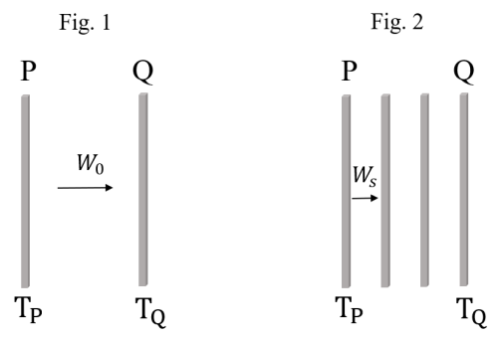
Q.10
Two identical plates P and Q, radiating as perfect black bodies, are kept in vacuum at constant absolute temperatures TP and TQ, respectively, with TQ < TP, as shown in Fig. 1. The radiated power transferred per unit area from P to Q is 𝑊₀. Subsequently, two more plates, identical to P and Q, are introduced between P and Q, as shown in Fig. 2. Assume that heat transfer takes place only between adjacent plates. If the power transferred per unit area in the direction from P to Q (Fig. 2) in the
steady state is 𝑊 , then the ratio is
𝑊
0
𝑆
𝑊𝑆
Answer: 0.5 OR 0.75

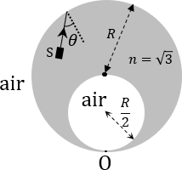
Q.11
A solid glass sphere of refractive index 𝑛 = √3 and radius 𝑅 contains a spherical air cavity of radius
^{𝑅}, as shown in the figure. A very thin glass layer is present at the point O so that the air cavity
2
(refractive index 𝑛 = 1) remains inside the glass sphere. An unpolarized, unidirectional and monochromatic light source 𝑆 emits a light ray from a point inside the glass sphere towards the periphery of the glass sphere. If the light is reflected from the point O and is fully polarized, then the
angle of incidence at the inner surface of the glass sphere is 𝜃. The value of sin 𝜃 is
Answer: 3

Q.12
A single slit diffraction experiment is performed to determine the slit width using the equation, ^{𝑏𝑑} =
𝐷
𝑚λ, where 𝑏 is the slit width, 𝐷 the shortest distance between the slit and the screen, 𝑑 the distance
between the 𝑚^{th} diffraction maximum and the central maximum, and λ is the wavelength. 𝐷 and 𝑑 are measured with scales of least count of 1 cm and 1 mm, respectively. The values of λ and 𝑚 are known precisely to be 600 nm and 3, respectively. The absolute error (in 𝜇m) in the value of 𝑏
estimated using the diffraction maximum that occurs for 𝑚 = 3 with 𝑑 = 5 mm and 𝐷 = 1 m is

Q.13
Consider an electron in the 𝑛 = 3 orbit of a hydrogen-like atom with atomic number 𝑍. At absolute
temperature 𝑇, a neutron having thermal energy 𝑘B𝑇 has the same de Broglie wavelength as that of
2 2
this electron. If this temperature is given by 𝑇 =
𝑍 ℎ
𝛼𝜋2𝑎2𝑚𝙽𝑘B
, (where ℎ is the Planck’s constant, 𝑘
𝐵
0
is the Boltzmann constant, 𝑚N is the mass of the neutron and 𝑎₀ is the first Bohr radius of hydrogen atom) then the value of 𝛼 is
Answer: [75 to 79] OR [94 to 95]
Answer: 72

SECTION 4 (Maximum Marks: 12)

- This section contains THREE (03) Matching List Sets.
- Each set has ONE Multiple Choice Question.
- Each set has TWO lists: List-I and List-II.
- List-I has Four entries (P), (Q), (R) and (S) and List-II has Five entries (1), (2), (3), (4) and (5).
- FOUR options are given in each Multiple Choice Question based on List-I and List-II and ONLY ONE of these four options satisfies the condition asked in the Multiple Choice Question.
- Answer to each question will be evaluated according to the following marking scheme:
Full Marks : +4 ONLY if the option corresponding to the correct combination is chosen; Zero Marks : 0 If none of the options is chosen (i.e. the question is unanswered); Negative Marks : −1 In all other cases.

Answer: C

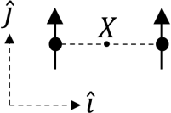
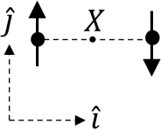
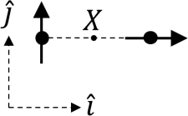
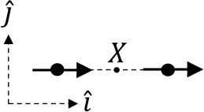
Q.14
List-I shows four configurations, each consisting of a pair of ideal electric dipoles. Each dipole has a dipole moment of magnitude 𝑝, oriented as marked by arrows in the figures. In all the configurations the dipoles are fixed such that they are at a distance 2𝑟 apart along the 𝑥 direction. The midpoint of the line joining the two dipoles is 𝑋. The possible resultant electric fields 𝐸⃗→ at 𝑋 are given in List-II.
Choose the option that describes the correct match between the entries in List-I to those in List-II.
List-I
List-II
(P)
(1) 𝐸⃗→ = 0
(Q)
(2) 𝐸⃗→ = −
𝑝
2𝜋𝜖0𝑟3
𝚥̂
(3) 𝐸⃗→ = −
𝑝
4𝜋𝜖0𝑟3
(𝚤̂ − 𝚥̂)
(S)
(4) 𝐸⃗→ =
𝑝
4𝜋𝜖0𝑟3
(2𝚤̂ − 𝚥̂)
(5) 𝐸⃗→ =
𝑝
𝜋𝜖0𝑟3
𝚤̂
(R)

(A) | P→3, Q→1, R→2, S→4
(B) | P→4, Q→5, R→3, S→1
(C) | P→2, Q→1, R→4, S→5
(D) | P→2, Q→1, R→3, S→5

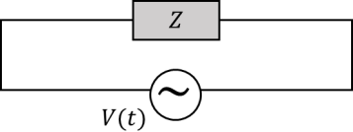
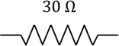
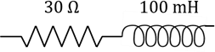
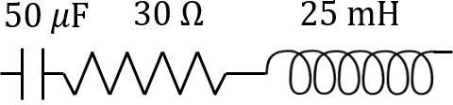
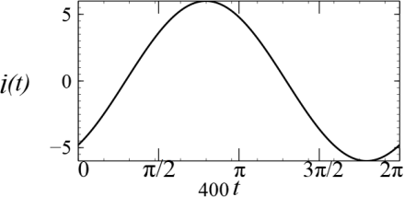
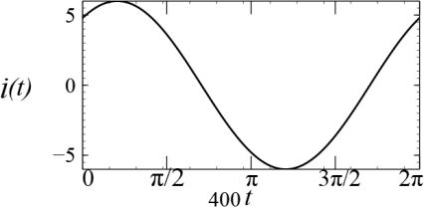
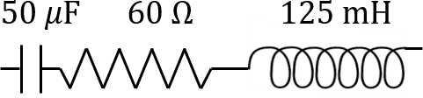
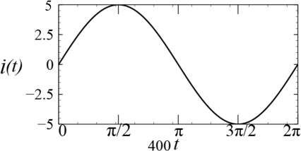
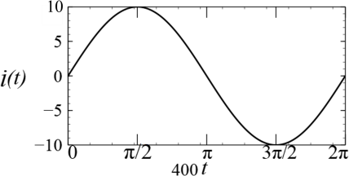
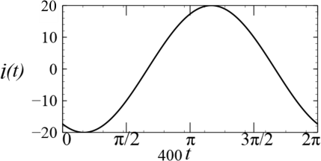
Q.15 A circuit with an electrical load having impedance 𝑍 is connected with an AC source as shown in the diagram. The source voltage varies in time as 𝑉(𝑡) = 300 sin(400𝑡) V, where 𝑡 is time in s. List-I shows various options for the load. The possible currents 𝑖(𝑡) in the circuit as a function of time are given in List-II.
Answer: A

Choose the option that describes the correct match between the entries in List-I to those in List-II.

List-I List-II
(1)
(P)

(2)
(Q)

(R) (3)

(S) (4)

(5)

(A) | P→3, Q→5, R→2, S→1
(B) | P→1, Q→5, R→2, S→3
(C) | P→3, Q→4, R→2, S→1
(D) | P→1, Q→4, R→2, S→5

Q.16
List-I shows various functional dependencies of energy (𝐸) on the atomic number (𝑍). Energies associated with certain phenomena are given in List-II.
Choose the option that describes the correct match between the entries in List-I to those in List-II.
List-I
List-II
(P) 𝐸 ∝ 𝑍²
(1) energy of characteristic x-rays
(Q) 𝐸 ∝ (𝑍 − 1)²
- electrostatic part of the nuclear binding energy for stable nuclei with mass numbers in the range 30 to 170
- energy of continuous x-rays
- 𝐸 ∝ 𝑍(𝑍 − 1)
(4) average nuclear binding energy per nucleon
- 𝐸 is practically independent of 𝑍 for stable nuclei with mass number in the range
30 to 170

(5) energy of radiation due to electronic transitions from hydrogen-like atoms

(A) | P→4, Q→3, R→1, S→2
(B) | P→5, Q→2, R→1, S→4
(C) | P→5, Q→1, R→2, S→4
(D) | P→3, Q→2, R→1, S→5

END OF THE QUESTION PAPER
Answer: C

Chemistry
SECTION 1 (Maximum Marks: 12)

- This section contains FOUR (04) questions.
- Each question has FOUR options (A), (B), (C) and (D). ONLY ONE of these four options is the correct answer.
- For each question, choose the option corresponding to the correct answer.
- Answer to each question will be evaluated according to the following marking scheme:
Full Marks : +3
Zero Marks : 0
Negative Marks : −1
If ONLY the correct option is chosen;
If none of the options is chosen (i.e. the question is unanswered); In all other cases.

Q.1
The heating of NH4NO2 at 60−70 °C and NH4NO3 at 200−250 °C is associated with the formation of nitrogen containing compounds X and Y, respectively. X and Y, respectively, are

(A) | N2 and N2O
(B) | NH3 and NO2
(C) | NO and N2O
(D) | N2 and NH3

Q.2
The correct order of the wavelength maxima of the absorption band in the ultraviolet-visible region for the given complexes is
Answer: A

(A) | [Co(CN)6]³⁻ < [Co(NH3)6]³⁺ < [Co(NH3)5(H2O)]³⁺ < [Co(NH3)5(Cl)]²⁺
(B) | [Co(NH3)5(Cl)]²⁺ < [Co(NH3)5(H2O)]³⁺ < [Co(NH3)6]³⁺ < [Co(CN)6]³⁻
(C) | [Co(CN)6]³⁻ < [Co(NH3)5(Cl)]²⁺ < [Co(NH3)5(H2O)]³⁺ < [Co(NH3)6]³⁺
(D) | [Co(NH3)6]³⁺ < [Co(CN)6]³⁻ < [Co(NH3)5(Cl)]²⁺ < [Co(NH3)5(H2O)]³⁺

Q.3
One of the products formed from the reaction of permanganate ion with iodide ion in neutral aqueous medium is
Answer: A
Answer: B

(A) | I2 | (B) | −  IO3 | (C) | −  IO4 | (D) | −  IO2

Answer: B

Q.4
Consider the depicted hydrogen (H) in the hydrocarbons given below. The most acidic hydrogen
(H) is

(A) | H | (B) | H
(C) | H | (D) | H

SECTION 2 (Maximum Marks: 12)

- This section contains THREE (03) questions.
- Each question has FOUR options (A), (B), (C) and (D). ONE OR MORE THAN ONE of these four option(s) is(are) correct answer(s).
- For each question, choose the option(s) corresponding to (all) the correct answer(s).
- Answer to each question will be evaluated according to the following marking scheme:
Full Marks : +4 ONLY if (all) the correct option(s) is(are) chosen;
Partial Marks : +3 If all the four options are correct but ONLY three options are chosen;
Partial Marks : +2 If three or more options are correct but ONLY two options are chosen, both of which are correct;
Partial Marks : +1 If two or more options are correct but ONLY one option is chosen and it is a correct option;
Zero Marks : 0 If none of the options is chosen (i.e. the question is unanswered);
Negative Marks : −2 In all other cases.
- For example, in a question, if (A), (B) and (D) are the ONLY three options corresponding to correct answers, then
choosing ONLY (A), (B) and (D) will get +4 marks; choosing ONLY (A) and (B) will get +2 marks; choosing ONLY (A) and (D) will get +2 marks; choosing ONLY (B) and (D) will get +2 marks; choosing ONLY (A) will get +1 mark;
choosing ONLY (B) will get +1 mark; choosing ONLY (D) will get +1 mark;
choosing no option (i.e. the question is unanswered) will get 0 marks; and choosing any other combination of options will get −2 marks.

Q.5
Regarding the molecular orbital (MO) energy levels for homonuclear diatomic molecules, the INCORRECT statement(s) is(are)

(A) | Bond order of Ne2 is zero.
(B) | The highest occupied molecular orbital (HOMO) of F2 is σ-type.
(C) | Bond energy of O⁺ is smaller than the bond energy of O2.  2
(D) | Bond length of Li2 is larger than the bond length of B2.

Q.6
The pair(s) of diamagnetic ions is(are)
Answer: B, C
Answer: A, B

(A) | La³⁺, Ce⁴⁺
(B) | Yb²⁺, Lu³⁺
(C) | La²⁺, Ce³⁺
(D) | Yb³⁺, Lu²⁺

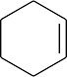
Q.7
For the reaction sequence given below, the correct statement(s) is(are)
HBr
P
Finkelstein reaction
Q
Swarts reaction
R
(In the options, X is any atom other than carbon and hydrogen, and it is different in P, Q and R)
Answer: B

(A) | C−X bond length in P, Q and R follows the order Q > R > P.
(B) | C−X bond enthalpy in P, Q and R follows the order R > P > Q.
(C) | Relative reactivity toward SN2 reaction in P, Q and R follows the order P > R > Q.
(D) | pKa value of the conjugate acids of the leaving groups in P, Q and R follows the order R > Q > P.

SECTION 3 (Maximum Marks: 24)

- This section contains SIX (06) questions.
- The answer to each question is a NUMERICAL VALUE.
- For each question, enter the correct numerical value of the answer using the mouse and the on-screen virtual numeric keypad in the place designated to enter the answer.
- If the numerical value has more than two decimal places, truncate/round-off the value to TWO decimal places.
- Answer to each question will be evaluated according to the following marking scheme:
Full Marks
Zero Marks
: +4 If ONLY the correct numerical value is entered in the designated place;
: 0
In all other cases.
Q.8
In an electrochemical cell, dichromate ions in aqueous acidic medium are reduced to Cr³⁺. The current (in amperes) that flows through the cell for 48.25 minutes to produce 1 mole of Cr³⁺ is .

Use: 1 Faraday = 96500 C mol⁻¹

Q.9
At 25 ℃, the concentration of H⁺ ions in 1.00 × 10⁻³ M aqueous solution of a weak monobasic acid having acid dissociation constant (Ka) of 4.00 × 10⁻¹¹ is 𝑿 × 10⁻⁷ M. The value of 𝑿 is .

Use: Ionic product of water (Kw) = 1.00 × 10⁻¹⁴ at 25 ℃
Answer: 100

Q.10
Molar volume (Vm) of a van der Waals gas can be calculated by expressing the van der Waals equation
as a cubic equation with Vm as the variable. The ratio (in mol dm⁻³) of the coefficient of 𝑉² to the
m
coefficient of Vm for a gas having van der Waals constants a = 6.0 dm⁶ atm mol⁻² and b = 0.060
dm³ mol⁻¹ at 300 K and 300 atm is .
Use: Universal gas constant (R) = 0.082 dm³ atm mol⁻¹ K⁻¹
Answer: [2.2 to 2.3]

Q.11
Considering ideal gas behavior, the expansion work done (in kJ) when 144 g of water is electrolyzed completely under constant pressure at 300 K is .

Use: Universal gas constant (R) = 8.3 J K⁻¹ mol⁻¹; Atomic mass (in amu): H = 1, O = 16
Answer: [-7.2 to -7]

Q.12
The monomer (X) involved in the synthesis of Nylon 6,6 gives positive carbylamine test. If 10 moles of X are analyzed using Dumas method, the amount (in grams) of nitrogen gas evolved is
.

Use: Atomic mass of N (in amu) = 14
Answer: [-29.95 to -29.8] OR [29.8 to 29.95]
Answer: 280

Answer: 175
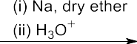
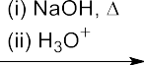
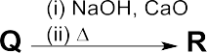
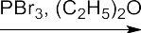
Q.13
The reaction sequence given below is carried out with 16 moles of X. The yield of the major product in each step is given below the product in parentheses. The amount (in grams) of S produced is .

Use: Atomic mass (in amu): H = 1, C = 12, O = 16, Br = 80

Answer: A
SECTION 4 (Maximum Marks: 12)

- This section contains THREE (03) Matching List Sets.
- Each set has ONE Multiple Choice Question.
- Each set has TWO lists: List-I and List-II.
- List-I has Four entries (P), (Q), (R) and (S) and List-II has Five entries (1), (2), (3), (4) and (5).
- FOUR options are given in each Multiple Choice Question based on List-I and List-II and ONLY ONE of these four options satisfies the condition asked in the Multiple Choice Question.
- Answer to each question will be evaluated according to the following marking scheme:
Full Marks : +4 ONLY if the option corresponding to the correct combination is chosen; Zero Marks : 0 If none of the options is chosen (i.e. the question is unanswered); Negative Marks : −1 In all other cases.

Q.14
The correct match of the group reagents in List-I for precipitating the metal ion given in List-II from solutions, is
List-I
List-II
- Passing H2S in the presence of NH4OH
- (NH4)2CO3 in the presence of NH4OH
- NH4OH in the presence of NH4Cl
- Passing H2S in the presence of dilute HCl
- Cu²⁺
- Al³⁺
- Mn²⁺
- Ba²⁺
- Mg²⁺

(A) | P → 3; Q → 4; R → 2; S → 1
(B) | P → 4; Q → 2; R → 3; S → 1
(C) | P → 3; Q → 4; R → 1; S → 5
(D) | P → 5; Q → 3; R → 2; S → 4

Answer: B

Q.15
- PCl₅
- NH₃
- P₄O₁₀, Δ
The major products obtained from the reactions in List-II are the reactants for the named reactions mentioned in List-I. Match each entry in List-I with the appropriate entry in List-II and choose the correct option.
List-I
(ii) H₃O+
(5)
- (CH₃CO)₂O, Pyridine
- HNO₃, H₂SO₄, 288 K
Aniline (iii) aq. NaOH
(4)
(S) Cannizzaro reaction
(R) Hoffmann bromamide degradation reaction (3)
List-II
Benzoic acid
(2)
(Q) Sandmeyer reaction
Toluene
(i) CrO₂Cl₂/CS₂
(1)
(P) Stephen reaction

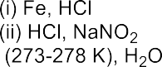

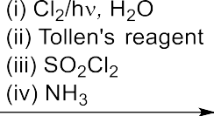

(A) | P → 2; Q → 4; R → 1; S → 3
(B) | P → 2; Q → 3; R → 4; S → 1
(C) | P → 5; Q → 3; R → 4; S → 2
(D) | P → 5; Q → 4; R → 2; S → 1

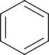
Q.16
O
(Q)
O
HO
OMe
(1) Reaction with phenyl diazonium salt gives yellow dye.
O
NH₂ H
N
(P)
List-II
List-I
Match the compounds in List-I with the appropriate observations in List-II and choose the correct option.
(4) Lassiagne extract of the compound treated with dilute HCl followed by addition of aqueous FeCl3 gives blood red color.
(S)
(3) Reaction with glucose will give corresponding hydrazone.
NH₃+Cl−
(R)
O
OMe
O
H N
(2) Reaction with ninhydrin gives purple color and it also reacts with FeCl3 to give violet color.
(5) After complete hydrolysis, it will give ninhydrin test and it DOES NOT give positive phthalein dye test.
NH

(A) | P → 1; Q → 5; R → 4; S → 2
(B) | P → 2; Q → 5; R → 1; S → 3
(C) | P → 5; Q → 2; R → 1; S → 4
(D) | P → 2; Q → 1; R → 5; S → 3
END OF THE QUESTION PAPER
Answer: B

