A:

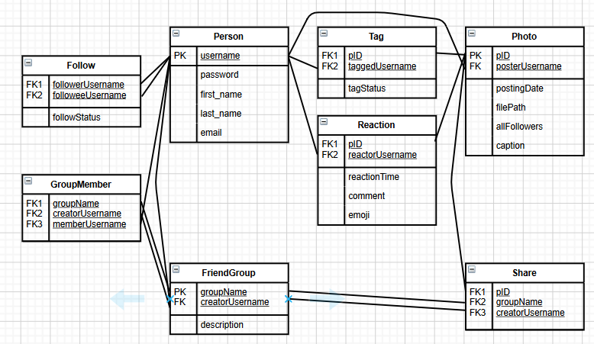

B:

create table Person

(username VARCHAR(20),

password VARCHAR(20),

first_name VARCHAR(20),

last_name VARCHAR(20),

email VARCHAR(20),

primary key(username)

);

create table Photo

(pID INT,

posterUsername VARCHAR(20),

postingDate DATETIME,

filePath VARCHAR(20),

allFollowers BOOLEAN,

caption VARCHAR(20),

primary key(pID,posterUsername),

foreign key(posterUsername)

references Person(username)

);

create table FriendGroup

(groupName VARCHAR(20),

creatorUsername VARCHAR(20),

description VARCHAR(20),

primary key(groupName,creatorUsername),

foreign key(creatorUsername)

references Person(username)

);

create table Follow

(followerUsername VARCHAR(20),

followeeUsername VARCHAR(20),

followStatus BOOLEAN,

primary key(followerUsername,followeeUsername),

foreign key(followerUsername)

references Person(username),

foreign key(followeeUsername)

references Person(username)

);

create table Tag

(pID INT,

taggedUsername VARCHAR(20),

tagStatus BOOLEAN,

primary key(pID,taggedUsername),

foreign key(pID)

references Photo(pID),

foreign key(taggedUsername)

references Person(username)

);

create table Reaction

(pID INT,

reactorUsername VARCHAR(20),

reactionTime DATETIME,

comment VARCHAR(20),

emoji VARCHAR(20),

primary key(pID,reactorUsername),

foreign key(pID)

references Photo(pID),

foreign key(reactorUsername)

references Person(username)

);

create table GroupMember

(groupName VARCHAR(20),

creatorUsername VARCHAR(20),

memberUsername VARCHAR(20),

primary key(groupName,creatorUsername,memberUsername),

foreign key(groupName,creatorUsername)

references FriendGroup(groupName,creatorUsername),

foreign key(memberUsername)

references Person(username)

);

create table Share

(pID INT,

groupName VARCHAR(20),

creatorUsername VARCHAR(20),

primary key(pID,groupName,creatorUsername),

foreign key(pID)

references Photo(pID),

foreign key(groupName,creatorUsername)

references FriendGroup(groupName,creatorUsername)

);

C:

SELECT DISTINCT pID

FROM GroupMember NATURAL JOIN FriendGroup NATURAL JOIN Share

WHERE memberUsername='Ann'