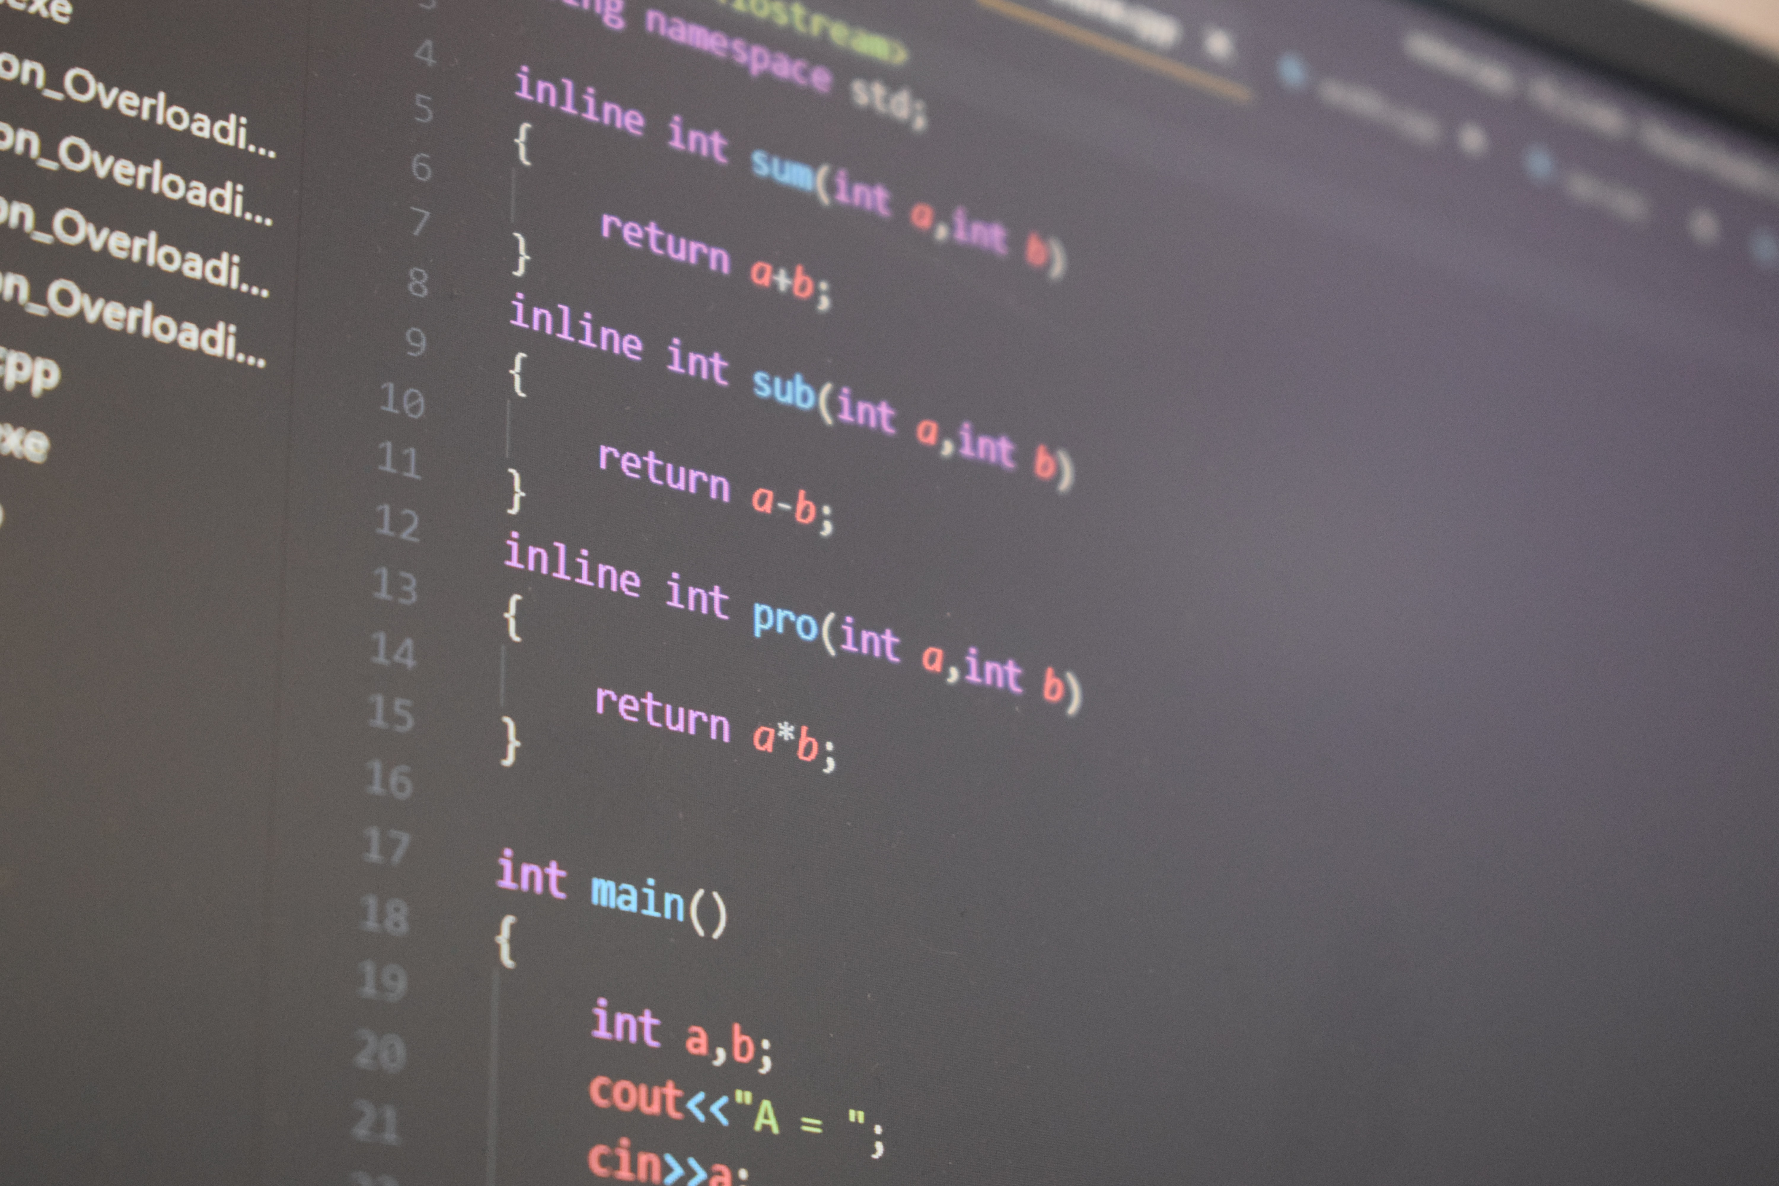

|  |  |  |
| --- | --- | --- |
|  |  |  |
|  | **CS105 – Development Principles-2**  **Assessment 2** |  |
|  |  |  |

Diploma in Software Development

Yoobee Online

**CASE STUDY REPORT**

**GILBERTO GABON**

Author

[270204759@yoobeestudent.ac.nz](mailto:270204759@yoobeestudent.ac.nz)

1. **Section 1 – Question 1: Pointer to Objects**
   1. **Task 1: Code for the scenario – contains creation of classes and the output display:**

/***********************************************************************************  
 * Title : CS-105 Development Principles-2 Assessment 2  
 * File : healthapp.cpp  
 * Purpose : Section 1 - Question 1: Pointer to Objects  
 * This program showcases the use of pointer to objects.  
 * Parameters : N/A  
 * Returns : N/A  
 * Author : Gilberto Gabon - Student No.: 270204759  
 ************************************************************************************/  
  
#include <iostream>  
#include <string>  
  
using namespace std;  
  
// define the class  
class HealthActivity  
{  
private:  
 int walkingSteps;  
 float runningDistance;  
 string name;  
  
public:  
 // Setter function to save user input into the object of the class HealthActivity  
 void SetFunction(string nameUser, int stepsWalked, float kmsRun)  
 {  
 walkingSteps = stepsWalked;  
 runningDistance = kmsRun;  
 name = nameUser;  
 }  
  
 // Getter functions  
 string GetName()  
 {  
 return name;  
 }  
 int GetSteps()  
 {  
 return walkingSteps;  
 }  
 float GetRuns()  
 {  
 return runningDistance;  
 }  
 // Display data from the class  
 void GetFunction()  
 {  
 cout << "Name: " << name << endl;  
 cout << "Steps: " << walkingSteps << " steps" << endl;  
 cout << "Walking + Running: " << runningDistance << " kms" << endl;  
 }  
};  
  
int main()  
{  
 HealthActivity users[5], *ptrUsers; // define an array of users and a pointer to the array of type HealthActivity class  
 ptrUsers = users; // pointer to the array users of type HealthActivity  
 string userName = "";  
 int walkSteps = 0, steps = 0;  
 float runKms = 0.00, runs = 0.00;  
 float averageSteps = 0.00, averageDistance = 0.00;  
  
 // get data inputs  
 for (int i = 0; i < 5; i++)  
 {  
 cout << "Enter the name, number of steps and walking + running distance: ";  
 cin >> userName;  
 cin >> walkSteps;  
 cin >> runKms;  
 (ptrUsers + i)->SetFunction(userName, walkSteps, runKms); // save the inputted data into the array via the pointer by calling the SetFunction() method from the HealthActivity class  
 }  
  
 // display output  
 for (int i = 0; i < 5; i++)  
 {  
 (ptrUsers + i)->GetFunction(); // Display the inputted data via a pointer by calling the GetFunction() method from the HealthActivity class  
 steps += (ptrUsers + i)->GetSteps(); // sum the steps from the array of users via a pointer by calling the GetSteps() method from the HealthActivity class  
 runs += (ptrUsers + i)->GetRuns(); // sum the distance from the array of users via a pointer by calling the GetRuns() method from the HealthActivity class  
 }  
  
 averageSteps = steps / 5; // Compute the average of 5 users  
 averageDistance = runs / 5; // Compute the average of 5 users  
 cout << "Average steps of 5 users: " << averageSteps << " steps" << endl;  
 cout << "Average distance of walking + running for 5 users: " << averageDistance << " kms" << endl;  
  
 return 0;  
}

* 1. **Task 2: Process to solve the problem**
     1. A **class HealthActivity** was created first with the following:
        + Properties:
          - Private: These are variables to store user information including number of steps walking and the distance travelled.

**int walkingSteps;** //number of steps waked

**float runningDistance; //** records distance covered

**string name; /**/name of the user

* + - * Methods:
        + Public: These are getters and setter functions

v**oid SetFunction(string nameUser, int stepsWalked, float kmsRun)** //Settter function to save user inputs into the object of the class HealthActivity.

**string GetName()** //function to get the name

**int GetSteps()** //function to get the number of steps taken

**float GetRuns()** //function to get the distance run+waked

**void GetFunction()** //function to display the user data (name, steps taken, and running+walking distance in kilometers).

* + 1. In the **main()** function, an array of objects of the class HealthActivity containing five (5) elements and a pointer of type HealthActivity class are defined. Variables to hold the user inputs, such as for the user name, the steps taken and the total distance in kilometers taken for walking and running are also defined.
    2. Next, a loop of five (5) iterations is created. Each iteration, user inputs for name, steps, and total distance for walking and running in kilometers are asked. Once all data is entered, the setter function SetFunction() is called via a pointer using pointer arithmetic:

(ptrUsers + i)>SetFunction(userName, walkSteps, runKms) to save each input into the object of the class HealthActivity

* + 1. Once all the inputs the are done (five iterations), another loop is created to display the user inputs and to compute for the sum of all steps taken and the total distance travelled for walking and running. These accumulated data are used later in the code to compute for the averages of steps and running and walking distances.
    2. Lastly, the average steps for the five (5) users and the average distance of walking and running for the five (5) are displayed.
  1. **Screenshot**

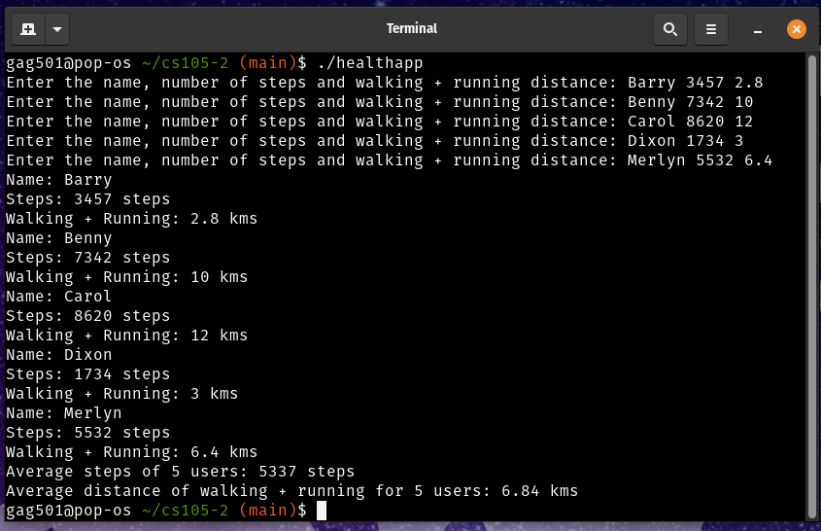

1. **Section 2 – Question 2: Polymorphism**
   1. **Task 1: Code for the scenario – contains creation of classes and the output display**

/***********************************************************************************

* Title : CS-105 Development Principles-2 Assessment 2

* File : videostore.cpp

* Purpose : Section 2 - Question 2: Polymorphism

* This program showcases inheritance and polymorphism

* Parameters : N/A

* Returns : N/A

* Author : Gilberto Gabon - Student No.: 270204759

************************************************************************************/

#include <iostream>

#include <string>

#include <math.h>

#include <vector>

#include <limits>

using namespace std;

// Base Class

class VideoGame

{

private:

string title;

float price;

public:

// Virtual function to get data inputs from user. Made this virtual function for dynamic binding

virtual void getVideoData()

{

cin.ignore(numeric_limits<std::streamsize>::max(), '\n'); // this clears the buffer thereby ensuring that any pending newline character does not get fed into variable and eventually causing a skip in the input

cout << "Enter title of game: ";

getline(cin, title); // direct straight saving to the class' property

cout << " Enter price: ";

cin >> price; // direct straight saving to the class' property

}

// Display data from the class. Make this function a virtual function to effect dynamic binding

virtual void display()

{

cout << "\n*********************************" << endl;

cout << " Title: " << title << endl;

cout << " Price: " << price << endl;

}

};

// Derived Class

class ComputerGame : public VideoGame

{

private:

string os;

public:

// display() function - function overriding - polymorphism. This display() function has added the display of the OS type.

void display()

{

VideoGame::display(); // call the display function of the base class

cout << " OS Type: " << os << endl; // then add the derived class' display method

cout << "*********************************" << endl;

}

// getVideoData() function - function overriding - polymorphism. This getVideoData() function has added the input for the OS of the game

void getVideoData()

{

VideoGame::getVideoData(); // call the getVideoData() function of the base class

cin.ignore(numeric_limits<std::streamsize>::max(), '\n'); // clear the buffer

cout << " Operating System: ";

getline(cin, os); // save straight to the class property

}

};

// Derived Class

class ConsoleGame : public VideoGame

{

private:

string os;

public:

// display() function - function overriding - polymorphism. This display() function has added the display of the console type.

void display()

{

VideoGame::display(); // call the display function of the base class

cout << "Console Type: " << os << endl; // then add the derived class' display method

cout << "*********************************" << endl;

}

// getVideoData() function - function overriding - polymorphism. This getVideoData() function has added the input for the console type of the game

void getVideoData()

{

VideoGame::getVideoData();

cin.ignore(numeric_limits<std::streamsize>::max(), '\n'); // clear the buffer

cout << " Console type: ";

getline(cin, os); // direct - straight saving to the object's property

}

};

int main()

{

vector<VideoGame *> ptrVideoGames; // Define the vector array that will contain all the pointer to objects. This is a pointer variable that is a vector of type VideoGame

ComputerGame *ptrgames; // Define the pointer to the game objects

ConsoleGame *ptrconsoles; // Define the pointer to the console objects

// int choice = 1, ch = 1;

char choice = ' ', ch = ' ';

cout << "\n**************************************************************************" << endl;

cout << " Video Games Data Entry" << endl;

cout << "**************************************************************************" << endl;

while (true)

{

ptrgames = new ComputerGame; // always create a new object for every iteration

ptrconsoles = new ConsoleGame; // always create a new object for every iteration

cout << "Do you want to enter data for a Computer Game [o] or a Console Game [c]: ";

cin >> ch;

if (ch == 'o' || ch == 'O')

{

ptrgames->getVideoData(); // get games input - this made the code cleaner by placing the routine to take user input inside the Base Class and the specific data inputs are then defined in the Derived classes.

ptrVideoGames.push_back(ptrgames); // save into the array of pointers

}

else

{

if (ch == 'c' || ch == 'C')

{

ptrconsoles->getVideoData(); // get console inputs - this made the code cleaner by placing the routine to take user input inside the Base Class and the specific data inputs are then defined in the Derived classes.

ptrVideoGames.push_back(ptrconsoles); // save into the array of pointers

}

else

{

cout << "Please select only 'o' or 'c'" << endl;

continue; // this causes to loop back to the top - avoiding the execution of code below

}

}

cout << "\nDo you want to add another item (y/n)? ";

cin >> choice;

if (choice == 'n' || choice == 'N')

{

break;

}

}

cout << "\n*************************************************************************" << endl;

cout << " Video Games List:" << endl;

cout << "*************************************************************************" << endl;

for (int j = 0; j < (int)ptrVideoGames.size(); j++)

{

ptrVideoGames[j]->display(); // polymorphism in action! The function display() here calls the relevant display() function based on the kind of object contained in the current element of the array of pointers

}

return 0;

}

* 1. **Task 2: Process to solve the problem**
     + A **class VideoGame** was created first with the following:
       - Properties:
         * Private: These are variables to store information about a video

string title; //holds the title of the game

float price; //holds the price of the game

* + - * Methods:
        + Public: These are getters and setter functions

**virtual void getVideoData()** // Virtual function to get data inputs from user. Made this virtual function for dynamic binding

**virtual void display()** // Display data from the class. Made this function a virtual function to effect dynamic binding

* + - Next, two (2) Derived classes are created, namely ComputerGame and ConsoleGame. Each derived class has added its own properties and methods. Class ComputerGame and ConsoleGame, added a property ‘os’ to contain the operating system or the console type of each ComputerGame or ConsoleGame object. Added also in each of these derived classes are two (2) methods:
      1. **void display()** - which displays the video information inherited from the base class VideoGame plus the the added property ‘os’ that contains the operating system of the ComputerGame or the Console type object.
      2. **void getVideoData()** - this gets the user input for the title and price (inherited from the base class VideoGame) and the added property ‘os’ of the ComputerGame class or the console type of the ConsoleGame class.
    - In the **main()** function, a vector of type VideoGame class pointer is defined - **ptrVideoGames**. Pointers for ComputerGame and ConsoleGame classes are also defined. Variables that will hold the user’s menu choices are defined too (‘choices’, and ‘ch’).
    - Following the variables definition area, the code goes into a ‘while’ loop to repeatedly ask the user for inputs (game title, price, and operating system/console type). Each iteration in the loop creates new objects for each of the derived classes. This loop continues until the user chooses to end it by answering the ‘n’ to the question whether to add another item or not.
    - While inside the ‘while’ loop, the user is asked to choose between entering data for ComputerGame (o) or ConsoleGame (c). If the user chooses ‘c’, then program asks the user to enter the video data by calling the **ptrgames->getVideoData()** method. The call is made using the pointer **ptrgames**. Once all the data is entered, it is then added to the **vector array ptrVideoGame** to save the data. If the user chooses ‘o’, the program also asks for the user inputs by calling the **ptrconsoles->getVideoData()** method**.** The call is made using the pointer **ptrconsoles.** Once all the data is entered, the program saves the data into **vector array ptrVideoGames.**

The loop continues by asking the user if he/she wants to continue adding items. If the user answers yes, then the loop continues and repeats the process. If the user says no, then the program exits from the loop and displays the contents of the vector array pointer **ptrVideoGames**. The call to display is done inside a loop of finite length, i.e. the length of the vector array **ptrVideoGames.** Inside the loop, the display() method for each element in the vector array is called. Each element contains a pointer to an object of either from the derived class ComputerGame or ConsoleGame. By doing dynamic data binding, run-time polymorphism is effected.

* 1. **Screenshot**

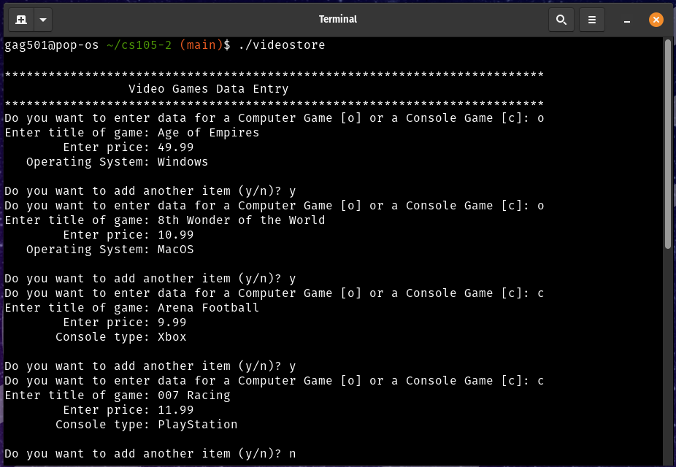

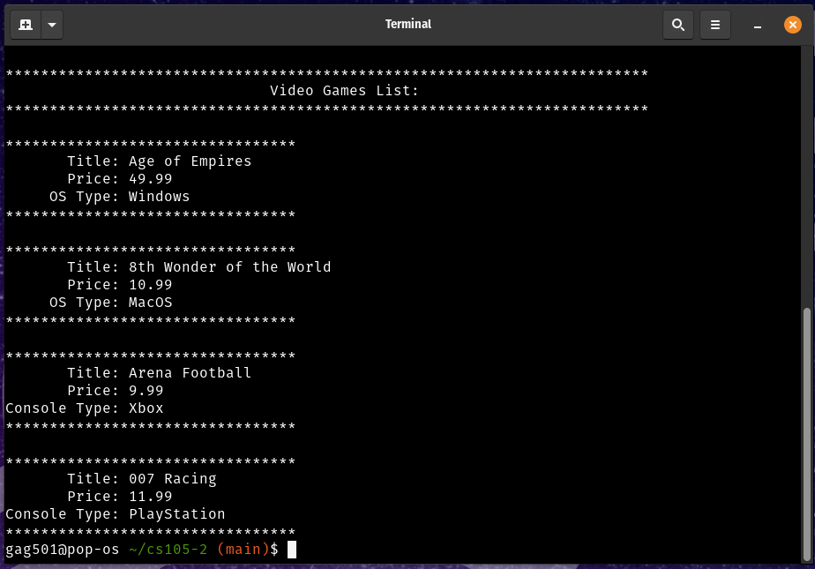

1. **Section 2 – Question 3: Operator Overloading**
   1. **Task 1: Code for the scenario – contains creation of classes and the output display**

/***********************************************************************************

* Title : CS-105 Development Principles-2 Assessment 2

* File : complex.cpp

* Purpose : Section 2 - Question 3: Operator Overloading

* This program showcases operator overloading for '+', '-', '*' and using this on complex numbers

* Parameters : N/A

* Returns : N/A

* Author : Gilberto Gabon - Student No.: 270204759

************************************************************************************/

#include <iostream>

#include <string>

#include <stdlib.h>

#include <math.h>

using namespace std;

class Complex

{

private:

int a, b;

public:

Complex(int var1, int var2)

{

a = var1;

b = var2;

}

string GetComplexNum()

{

return to_string(a) + " + " + to_string(b) + "i";

};

// Overload the '+' operator to add two complex number and return the sum in a string format

string operator+(Complex const &otherNum)

{

string retVal = "";

int sumA = 0, sumB = 0;

sumA = this->a + otherNum.a;

sumB = this->b + otherNum.b;

retVal = to_string(sumA) + " + " + to_string(sumB) + "i";

return retVal;

}

// Overload the '-' operator to subtract two complex number and return the difference in a string format

string operator-(Complex const &otherNum)

{

string retVal = "", optrString = " + ";

int diffA = 0, diffB = 0;

diffA = this->a - otherNum.a;

diffB = this->b - otherNum.b;

optrString = diffB < 0 ? " - " : " + ";

retVal = to_string(abs(diffA)) + optrString + to_string(abs(diffB)) + "i";

return retVal;

}

// Overload the '*' operator to multiply two complex number and return the result in a string format

string operator*(Complex const &otherNum)

{

string retVal = "", optrString = " + ";

int prodA = 0, prodB = 0;

prodA = (this->a * otherNum.a) - (this->b * otherNum.b);

prodB = (this->a * otherNum.b) + (this->b * otherNum.a);

retVal = to_string(prodA) + optrString + to_string(prodB) + "i";

return retVal;

}

};

void displayAddition(Complex num1, Complex num2)

{

cout << "Addition" << endl;

cout << "C1: " << num1.GetComplexNum() << endl;

cout << "C2: " << num2.GetComplexNum() << endl;

cout << "C3: " << num1 + num2 << endl; // add two complex numbers with the '+' operator as an overloaded operator

}

void displaySubtraction(Complex num1, Complex num2)

{

cout << "Subtraction" << endl;

cout << "C1: " << num1.GetComplexNum() << endl;

cout << "C2: " << num2.GetComplexNum() << endl;

cout << "C3: " << num1 - num2 << endl; // subtract two complex numbers with the '-' operator as an overloaded operator

}

void displayMultiplication(Complex num1, Complex num2)

{

cout << "Multiplication" << endl;

cout << "C1: " << num1.GetComplexNum() << endl;

cout << "C2: " << num2.GetComplexNum() << endl;

cout << "C3: " << num1 * num2 << endl; // multiply two complex numbers with the '*' operator as an overloaded operator

}

int main()

{

Complex num1(3, 2); // initialize first complex number;

int realNum, imaginaryNum;

int choice = 0;

cout << "1st Complex number: " << num1.GetComplexNum() << endl

<< endl;

cout << "Enter 2nd Complex number values:" << endl;

cout << "Enter real value: ";

cin >> realNum;

cout << "Enter imaginary value: ";

cin >> imaginaryNum;

Complex num2(realNum, imaginaryNum); // define complex number2

while (choice != 4)

{

cout << "\nChoose Operation from Menu:" << endl;

cout << "1. Addition" << endl;

cout << "2. Subtraction" << endl;

cout << "3. Multiplication" << endl;

cout << "4. Exit" << endl;

cout << "\nPlease enter your option: ";

cin >> choice;

switch (choice)

{

case 1:

displayAddition(num1, num2);

break;

case 2:

displaySubtraction(num1, num2);

break;

case 3:

displayMultiplication(num1, num2);

break;

default:

break;

}

}

return 0;

}

* 1. **Task 2: Process to solve the problem**
     1. A **class Complex** was created first with the following:
        + Properties:
          - Private: These are variables to store information on the real and imaginary numbers.

**int a;** //real number

**Int b; //** imaginary number coefficient

* + - * Methods:
        + Public: These are getters and overloading functions

**Complex(int var1, int var2)** //Constructor function for the class

**string GetComplexNum()** //returns a string for the complex number which contains the real number and the imaginary number

**string operator+(Complex const &otherNum)**  //overloading of the ‘+’ operator to add two (2) complex numbers

**string operator-(Complex const &otherNum)**  //overloading of the ‘-’ operator to subtract two (2) complex numbers

**string operator*(Complex const &otherNum)**  //overloading of the ‘*’ operator to multiply two (2) complex numbers

* + - **void displayAddition(Complex num1, Complex num2)** - utility function to display the result of the addition of two (2) complex numbers.
    - **void displaySubtraction(Complex num1, Complex num2)** - utility function to display the result of the subraction of two (2) complex numbers.
    - **void displayMultiplication(Complex num1, Complex num2)** - utility function to display the result of the multiplication of two (2) complex numbers.
    - In the **main()** function, the first complex number is defined by creating a variable (object) named **num1** with the type Complex class. This object is created using the constructor of this class. Initial values are saved into this class through the constructor’s execution.
    - The program then proceeds to ask for user inputs for the second complex numbers. Inputs asked from the user are the real and the coefficient of the imaginary number. The second complex number is created by calling the Complex class constructor and feeding into the constructor the real and imaginary numbers
    - Once done, the application continues and goes into a ‘while’ loop for the display of the application menu. The user is asked to choose from a range of different operations, i.e. Addition, Subtraction, Multiplication, Exit.
    - On selection of the operation, the appropriate function is called to display the result of operation of the two (2) complex numbers.
  1. **Screenshot**

