SRINIVAS UNIVERSITY

INSTITUTE OF ENGINEERING & TECHNOLOGY

(SUBJECT : ADVANCED MACHINE LEARNING) (SUBJECT CODE : 24SAL051)
A INDIVIDUAL TASK REPORT ON

“DIABETES PREDICTION USING MACHINE LEARNING”
Submitted in the partial fulfilment of the requirements for the fifth semester

BACHELOR OF TECHNOLOGY IN AIML
Submitted by GAGAN 01SU24AI031

UNDER THE GUIDENCE OF
Prof . Mahesh Kumar V B Department of AIML
SRINIVAS UNIVERSITY INSTITUTE OF ENGINEERING & TECHNOLOGY MUKKA, MANGALURU-574146

2026

SRINIVAS UNIVERSITY
INSTITUTE OF ENGINEERING AND TECHNOLOGY
MUKKA, MANGALURU-574146

Department of Artificial Intelligence and Machine Learning

CERTIFICATE

This is to certify that, Mr. Gagan (01SU24AI031) has satisfactorily completed the assessment (Report) in Advanced Machine Learning (24SAL051) prescribed by the Srinivas University for the 5th semester B. Tech course during the year 2026.

MARKS AWAREDED

Staff In charge
Name: Prof . Mahesh Kumar V B Assistant Professor, Department of AIML Date: 11/09/2026

TABLE OF CONTENTS

No. | Section | Page
1. | Introduction | 5
2. | Problem Statement, Objectives and Scope | 6
3. | Dataset and Data Understanding | 7
4. | System Requirements and Development Environment | 9
5. | Methodology and System Architecture | 10
6. | Machine Learning Models | 11
7. | Implementation and Experimental Procedure | 12
8. | Results and Model Comparison | 13
9. | Discussion, Limitations and Applications | 16
10. | Conclusion, Future Scope and References | 18

ABSTRACT
Diabetes is one of the most common chronic diseases and can affect a person’s overall health if it is not detected and managed at an early stage. Early identification of diabetes can help individuals take appropriate preventive measures, make necessary lifestyle changes, and seek medical guidance when required. The increasing availability of healthcare data has created opportunities to apply computational techniques for analyzing patient information. Machine learning provides useful techniques for identifying patterns within healthcare datasets and developing predictive models that can assist in preliminary disease risk assessment.
The project titled “Diabetes Prediction Using Machine Learning” focuses on developing a classification system that predicts whether a person is likely to have diabetes or not based on health-related attributes. The dataset contains information about patients and their medical characteristics, which are used as input features for the prediction process. The dataset is first loaded and explored to understand its structure, features, data types, and target variable. This initial analysis helps in identifying the important attributes that can be used for building the prediction models. Data preprocessing is then performed to prepare the information for machine learning algorithms and improve the reliability and consistency of the prediction process.
The project follows a systematic machine learning workflow. The available patient data is first examined and prepared for analysis. Relevant input features are separated from the target variable, which represents the diabetes outcome. The dataset is then divided into training and testing sets. The training data is used to learn patterns and relationships between the health-related attributes and diabetes outcomes, while the testing data is used to determine how well the trained models perform on previously unseen records.
In this project, classification algorithms are applied to learn patterns from the available patient data. Logistic Regression, Decision Tree, and Naive Bayes are used as classification models for predicting diabetes. Logistic Regression estimates the probability of a patient belonging to a particular class, while the Decision Tree makes predictions through a sequence of feature-based decisions. Naive Bayes uses probability-based calculations to determine the most likely class for a given patient record. Implementing different algorithms allows their performance to be compared under similar experimental conditions.
The models predict the outcome in two classes: diabetic and non-diabetic. After training, each model is applied to the testing data to generate predictions. These predictions are compared with the actual outcomes in order to measure the effectiveness of the models. The performance of the developed models is compared using commonly used evaluation measures such as accuracy, precision, recall, F1-score, and confusion matrix. These measures provide different perspectives on model performance and help in understanding both correct and incorrect classifications.
Accuracy provides an overall measure of correctly classified cases, while precision indicates the correctness of positive predictions. Recall measures the ability of the model to correctly identify actual diabetic cases, and the F1-score provides a balance between precision and recall. The confusion matrix provides a detailed representation of the predicted and actual classes. Using multiple evaluation measures provides a more complete understanding of the performance of the implemented algorithms rather than relying only on accuracy.

INTRODUCTION

Diabetes is a common chronic disease that affects the way the body regulates blood glucose levels. If diabetes is not detected and managed properly, it can lead to various health complications and affect a person’s quality of life. Early identification of individuals who may be at risk of diabetes is therefore important for timely medical attention and appropriate lifestyle management.
The increasing availability of healthcare data has created opportunities to use machine learning techniques for disease prediction. Machine learning algorithms can analyze large amounts of patient information, identify patterns in the data, and make predictions based on previously observed cases. This makes machine learning a useful approach for developing predictive systems in the healthcare domain.
The project titled “Diabetes Prediction Using Machine Learning” focuses on developing a classification system that predicts whether a person is likely to have diabetes or not based on relevant health and medical attributes. The system uses patient-related features as input and produces a binary prediction indicating a diabetic or non-diabetic outcome.
The project follows a systematic machine learning workflow. The dataset is first loaded and analyzed to understand its structure, features, and target variable. Data preprocessing is then performed to prepare the dataset for model training. The processed data is divided into training and testing sets so that the trained models can be evaluated using previously unseen data.
Classification algorithms are then applied to learn patterns from the training data and generate predictions. The performance of the models is evaluated using measures such as Accuracy, Precision, Recall, F1-score, and Confusion Matrix. These evaluation measures provide a better understanding of how effectively the models classify diabetic and non-diabetic cases.
The main purpose of this project is to demonstrate the practical application of machine learning in healthcare prediction. Comparing multiple classification algorithms helps identify a model that performs effectively for the selected diabetes dataset. The project also provides an understanding of important machine learning stages, including data preprocessing, model training, prediction, evaluation, and comparison.
The developed system can be considered a preliminary analytical tool for diabetes risk prediction. It may help demonstrate how patient data can be used to identify patterns associated with diabetes. However, machine learning predictions are not a replacement for professional medical diagnosis. The system should be treated as an academic and analytical application that demonstrates the potential of machine learning for healthcare-related prediction.
Overall, this project presents a complete machine learning approach for diabetes prediction, beginning with data preparation and continuing through model development, evaluation, and comparison. Further improvements can include using larger datasets, additional health-related features, advanced algorithms, and model optimization techniques to improve prediction reliability.

PROBLEM STATEMENT, OBJECTIVES AND SCOPE

2.1 Problem Statement
Diabetes is a serious health condition that can develop due to a combination of different health and lifestyle factors. Identifying diabetes at an early stage can be difficult when several patient attributes need to be considered together. Traditional assessment methods may require clinical examination and medical testing, making automated prediction a useful area for machine learning research.
The problem addressed in this project is to develop a machine learning classification system that predicts whether a person is likely to have diabetes based on available patient health-related information. The system analyzes the given dataset, applies suitable preprocessing techniques, trains classification algorithms, and predicts the diabetes outcome.
Different machine learning algorithms are implemented and their performance is compared using suitable evaluation metrics. The objective is to identify the algorithm that provides the most effective prediction for the selected dataset.
2.2 Objectives
The main objectives of the project are:
- To analyze the diabetes dataset and understand the available patient-related attributes.
- To preprocess the dataset and prepare the data for machine learning.
- To develop a classification system for predicting diabetic and non-diabetic cases.
- To implement suitable machine learning classification algorithms.
- To evaluate the models using Accuracy, Precision, Recall, F1-score, and Confusion Matrix.
- To compare the performance of the implemented algorithms.
- To identify the best-performing model for diabetes prediction.
- To demonstrate the practical application of machine learning in healthcare data analysis.
2.3 Scope
The scope of this project is limited to predicting diabetes using the available patient health-related attributes in the selected dataset. The project covers data exploration, preprocessing, feature preparation, model training, prediction, evaluation, and comparison of classification algorithms.
The system is intended primarily as an academic machine learning project demonstrating the use of classification techniques for healthcare-related data. The prediction can provide preliminary analytical information about the likelihood of diabetes based on the input data.
The project does not replace medical professionals or clinical diagnosis. The predictions should be considered supportive information rather than a final medical decision. Future development can include larger datasets, additional health attributes, advanced machine learning algorithms, and deployment as a user-friendly healthcare prediction application.

DATASET AND DATA UNDERSTANDING

3.1 Dataset Description
The dataset used for the project contains medical and health-related information of patients for diabetes prediction. It includes numerical attributes representing different health measurements and personal characteristics. These features are analyzed to identify patterns that can help classify whether a patient is likely to have diabetes.
The dataset is suitable for a supervised machine learning classification problem because it contains input features along with a known outcome for each patient. Before applying machine learning algorithms, the dataset is explored to understand its structure, feature types, target distribution, and data quality.

3.2 Dataset Variables
The important variables present in the dataset are:
Variable | Description
Pregnancies | Number of times the patient has been pregnant
Glucose | Blood glucose concentration
BloodPressure | Blood pressure measurement
SkinThickness | Thickness of the skin fold
Insulin | Insulin level in the blood
BMI | Body Mass Index of the patient
DiabetesPedigreeFunction | Measure related to family history of diabetes
Age | Age of the patient
Outcome | Indicates whether the patient is diabetic or non-diabetic
These variables provide different types of health information that can be used by machine learning algorithms during the classification process.

3.3 Input Features
The input features consist mainly of numerical health measurements. Glucose level is an important feature for diabetes prediction, while BMI, blood pressure, insulin level, age, and other attributes provide additional information about the patient's health condition.
The combination of these features allows the machine learning models to identify relationships and patterns between patient characteristics and diabetes outcomes.

3.4 Target Variable
The target variable is Outcome, which represents the final diabetes classification.
- 0 – Non-Diabetic
- 1 – Diabetic
The machine learning models learn from the input features and their corresponding outcomes. After training, the models can predict the outcome for new or unseen patient records.

3.5 Data Preprocessing
Data preprocessing is performed before applying the machine learning algorithms. The dataset is examined for missing, incorrect, or unusual values. The input features are then prepared in a suitable numerical format for model training.
Feature scaling may be applied to numerical variables so that features with different ranges can be handled more effectively by algorithms that are sensitive to feature magnitude. The dataset is also divided into training and testing sets. The training set is used to build the models, while the testing set is used to measure their performance on unseen data.

3.6 Data Understanding
Data understanding is an important stage of the project because it helps determine whether the dataset is suitable for prediction. Exploratory analysis is performed to examine the distribution of the features and the Outcome variable. This helps in understanding the characteristics of diabetic and non-diabetic cases in the dataset.
The relationships between health-related attributes and the diabetes outcome can provide useful information for model development. After completing the data exploration and preprocessing steps, the prepared dataset is used for training different classification algorithms.
Overall, the dataset provides a suitable foundation for developing a diabetes prediction system and comparing the performance of machine learning classification models.
The dataset analysis also helps in identifying the importance of different patient attributes in the prediction process. By examining the available features and their relationship with the Outcome variable, useful patterns can be identified for model development. This understanding helps ensure that the selected data is appropriately prepared before applying the classification algorithms and supports a more systematic and reliable prediction process.
.

SYSTEM REQUIREMENTS AND DEVELOPMENT ENVIRONMENT

4.1 Hardware Requirements
The Diabetes Prediction project can be implemented on a standard computer without requiring high-end hardware. The basic requirements are:
Component | Requirement
Processor | Intel Core i3 or equivalent
RAM | Minimum 4 GB
Storage | Minimum 10 GB free space
Display | Standard monitor
Input | Keyboard and mouse
A system with higher RAM and processing capability can provide faster execution when working with larger datasets.
4.2 Software Requirements
The following software and libraries are required for developing and executing the project:
Software/Tool | Purpose
Python | Programming language
Jupyter Notebook | Development and experimentation environment
Pandas | Data loading and manipulation
NumPy | Numerical operations
Scikit-learn | Machine learning algorithms and evaluation
Matplotlib | Data visualization
Seaborn | Statistical visualization
Operating System | Windows/Linux/macOS

4.3 Development Environment
Python is used as the primary programming language because it provides a wide range of libraries for data analysis and machine learning. Jupyter Notebook is used as the development environment, allowing the implementation to be divided into separate cells for data loading, preprocessing, model training, prediction, and evaluation.

METHODOLOGY AND SYSTEM ARCHITECTURE
5.1 Methodology
The methodology followed in the Diabetes Prediction project consists of several stages, starting from dataset preparation and ending with model evaluation. The steps are designed to transform the raw patient data into a form suitable for machine learning and generate diabetes predictions.
- Dataset Collection and Loading
The diabetes dataset is loaded into the Python environment using Pandas. The structure, number of records, features, and target variable are examined.
- Data Understanding
The dataset is analyzed to understand the different patient health attributes and the distribution of diabetic and non-diabetic cases.
- Data Preprocessing
The dataset is checked for missing or invalid values. The input features are prepared and, where required, numerical features are scaled to improve model performance.
- Feature and Target Separation
The patient health attributes are considered as input features, while the Outcome variable is used as the target variable.
- Train-Test Split
The prepared dataset is divided into training and testing sets. The training data is used for model development, while the testing data is used for evaluating predictions on unseen records.
- Model Training
Suitable classification algorithms are trained using the prepared training data. Each model learns patterns between patient attributes and diabetes outcomes.
- Prediction
The trained models are used to predict whether test patients belong to the diabetic or non-diabetic category.
- Model Evaluation
The predictions are evaluated using Accuracy, Precision, Recall, F1-score, and Confusion Matrix.
- Model Comparison
The performance of the implemented algorithms is compared to determine which model provides the most suitable results for the given dataset.

The architecture represents the complete workflow of the system. The raw diabetes dataset is first loaded and analyzed. After preprocessing and feature preparation, the data is divided into training and testing sets. Classification models are then trained using the training data and used to make predictions on unseen data. Finally, the models are evaluated and compared using suitable performance metrics, and the best-performing model is selected for diabetes prediction.
.

MACHINE LEARNING MODELS

6.1 Logistic Regression
Logistic Regression is a classification algorithm used to predict whether a patient is diabetic or non-diabetic. It calculates the probability of each class based on the given health-related features.

6.2 Decision Tree
Decision Tree classifies patients using a series of feature-based decisions. In this project, features such as HbA1c level, blood glucose level, age, and BMI are used for prediction.
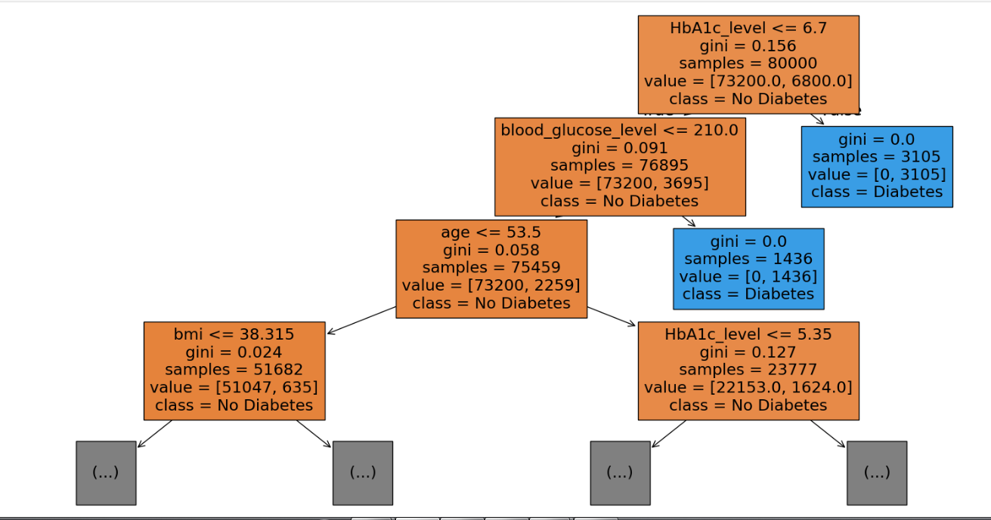Figure 6.1: Decision Tree Model for Diabetes Prediction

6.3 Naive Bayes
Naive Bayes is a probability-based classification algorithm. It predicts whether a patient is diabetic or non-diabetic by calculating the probability of each class based on the input features.

6.4 Model Comparison
The models are compared using Accuracy, Precision, Recall, F1-score, and Confusion Matrix. The model with the best overall performance is selected for diabetes prediction.

IMPLEMENTATION AND EXPERIMENTAL PROCEDURE

The implementation of the Diabetes Prediction system follows a systematic machine learning process. The main objective is to prepare the patient data, train different classification models, generate predictions, and compare their performance.
7.1 Data Loading and Understanding
The diabetes dataset is first loaded using the Pandas library in Python. The dataset is examined to understand its rows, columns, input features, and target variable. Basic analysis is performed to identify the type of data and understand the distribution of diabetic and non-diabetic cases.
7.2 Data Preprocessing
The collected data is prepared before applying machine learning algorithms. The dataset is checked for missing, inconsistent, or invalid values. The input features are separated from the target variable. Numerical features are scaled when required so that differences in feature ranges do not affect the learning process.
7.3 Feature and Target Selection
The health-related attributes are selected as input features for prediction. The Outcome variable is used as the target variable. An Outcome value of 0 represents a non-diabetic case, while a value of 1 represents a diabetic case. This makes the problem a binary classification task.
7.4 Train-Test Splitting
The prepared dataset is divided into training and testing sets. The training data is used to learn patterns and relationships between patient features and diabetes outcomes. The testing data is kept separate and used to evaluate how well the trained models perform on unseen patient records.
7.5 Model Implementation
Three machine learning classification algorithms are implemented: Logistic Regression, Decision Tree, and Naive Bayes. Each model is trained using the same training dataset. This allows the algorithms to be compared under similar experimental conditions.
Logistic Regression predicts the probability of a patient belonging to the diabetic or non-diabetic class. Decision Tree uses a sequence of feature-based decisions to classify patients. Naive Bayes uses probability calculations based on the input features to determine the most likely class.
7.6 Prediction
After training, the models are applied to the testing dataset. Each model produces a predicted class for every test record. These predictions are then compared with the actual Outcome values present in the dataset.
7.7 Performance Evaluation
The performance of the implemented models is evaluated using Accuracy, Precision, Recall, F1-score, and Confusion Matrix. Accuracy measures the overall number of correctly classified cases. Precision indicates how accurately positive predictions are made, while Recall measures the ability to correctly identify diabetic cases. The F1-score provides a balance between Precision and Recall.
The Confusion Matrix is also used to understand the number of correctly and incorrectly classified diabetic and non-diabetic cases.

RESULTS AND MODEL COMPARISON

The implemented machine learning models were evaluated using the test data to compare their performance in predicting diabetes. The models were compared using accuracy and other classification measures. The results obtained from the experiments are presented below.
8.1 Model Comparison
The performance of Logistic Regression, Decision Tree, and Naive Bayes was compared based on their classification results. The comparison helps identify which model performs better for the given diabetes dataset.

8.2 Accuracy Comparison
The accuracy of the implemented models is compared to determine the model that correctly predicts the highest number of diabetic and non-diabetic cases.
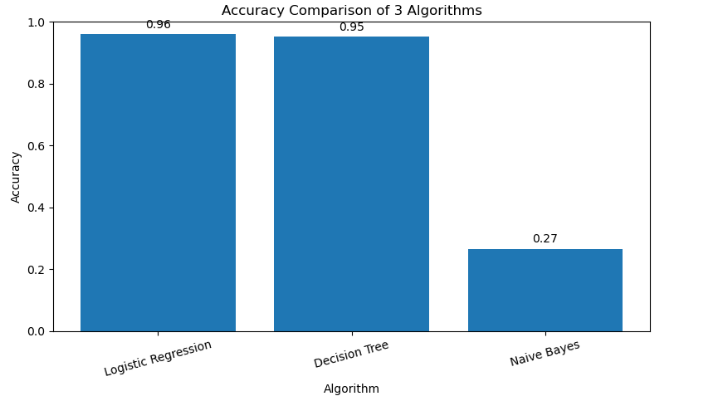
Figure 8.2: Accuracy Comparison of Machine Learning Models

8.3 Naive Bayes Confusion Matrix
The confusion matrix of the Naive Bayes model shows the number of correctly and incorrectly classified diabetic and non-diabetic cases. It provides a clear view of the model's classification performance.

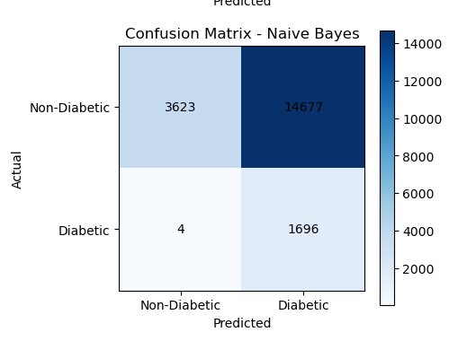

Figure 8.3: Confusion Matrix of Naive Bayes Model

8.4 Result Analysis
The results obtained from the experiments are analyzed to identify the best-performing model. The model with higher accuracy better classification performance is considered more suitable for the diabetes prediction task.
The comparison of the models also helps in understanding the strengths and weaknesses of each classification algorithm. By analyzing the accuracy and other evaluation measures, the models can be ranked according to their overall performance. The selected model can then be considered more suitable for predicting diabetic and non-diabetic cases in the given dataset.

DISCUSSION, LIMITATIONS AND APPLICATIONS

9.1 Discussion
The Diabetes Prediction project demonstrates the practical use of machine learning algorithms for predicting diabetes from patient health-related information. The main purpose of the system is to identify patterns within the available data and use these patterns to classify patients into diabetic and non-diabetic categories.
In this project, three classification algorithms, namely Logistic Regression, Decision Tree, and Naive Bayes, are implemented. The models are trained using the prepared dataset and tested using unseen data. Applying multiple algorithms makes it possible to compare their performance and understand which technique is more suitable for the given classification problem.
The results are evaluated using different performance metrics such as Accuracy, Precision, Recall, F1-score, and Confusion Matrix. Accuracy provides an overall indication of how many predictions are correct. Precision helps measure the correctness of positive predictions, while Recall indicates how effectively the model identifies actual diabetic cases. The F1-score provides a combined measure of Precision and Recall. The Confusion Matrix further helps in understanding the correct and incorrect classifications made by the model.
The comparison of the implemented models provides useful information about their strengths and weaknesses. A model that performs well across multiple evaluation measures can be considered more suitable than a model that performs well on only one metric. This comparison is particularly important in healthcare-related classification because incorrect predictions can affect the interpretation of the results.
The project also demonstrates the importance of preprocessing before model training. Preparing the dataset, selecting the appropriate features, separating the target variable, and dividing the data into training and testing sets are important steps in achieving meaningful results. The experimental procedure provides a complete workflow from raw data to final prediction.
The developed system can therefore be considered a basic machine learning framework for diabetes prediction. It provides an academic demonstration of how healthcare data can be processed and analyzed using classification algorithms. The results obtained from the experiment can also serve as a basis for further improvement of the prediction system.
9.2 Limitations
Although the developed system provides useful results, several limitations need to be considered. The first limitation is that the performance of the prediction models depends heavily on the quality of the dataset. If the dataset contains missing, incorrect, inconsistent, or insufficient information, the performance of the trained models may be affected.
Another limitation is the number and type of features available in the dataset. Diabetes can be influenced by several medical, genetic, lifestyle, and environmental factors. If some relevant factors are not included in the dataset, the models may not be able to consider them while making predictions.
The models are also trained using a specific dataset, and their performance may change when they are applied to data from different populations. Differences in age groups, health conditions, lifestyle patterns, and other characteristics can affect the generalization of the models.

Another limitation is that machine learning predictions are based on patterns learned from historical data. Therefore, a prediction generated by the system should not be considered a confirmed diagnosis. Medical diagnosis requires appropriate clinical examination, laboratory testing, and evaluation by qualified healthcare professionals.
The project also focuses on a limited number of machine learning algorithms. More advanced algorithms and optimization techniques could be explored in future work to determine whether prediction performance can be improved.
9.3 Applications
The diabetes prediction system has several potential applications in the field of healthcare data analysis. It can be used as a preliminary prediction tool to identify individuals who may have a higher likelihood of diabetes based on their available health information.
One possible application is preliminary risk assessment. The system can process patient-related attributes and provide a predicted class, which may help indicate whether further medical evaluation could be considered.
The system can also be useful in healthcare research. Researchers can use similar machine learning approaches to analyze patient datasets, compare algorithms, and study relationships between different health attributes and diabetes outcomes.
Another application is education and academic learning. The project provides a practical example of supervised machine learning, including data preprocessing, feature selection, model training, prediction, and evaluation. It can therefore be used to demonstrate the complete machine learning workflow to students and learners.
The system can also serve as a foundation for developing a more advanced healthcare application. A future version could include a user interface where health-related information is entered and the trained model provides a preliminary prediction. Additional features, larger datasets, and improved algorithms could be incorporated to make the system more comprehensive.
Overall, the project demonstrates that machine learning can provide useful support for analyzing healthcare data and performing diabetes classification. However, the system should be used as a supporting analytical tool rather than as a replacement for professional medical diagnosis.
Overall, the project demonstrates that machine learning can provide valuable support in analyzing healthcare data and predicting diabetes-related outcomes. By combining patient health attributes with suitable classification techniques, the system can identify patterns that may be useful for preliminary risk assessment. The implementation also shows how different machine learning models can be trained, evaluated, and compared to select a suitable approach for the given dataset. With further improvements in data quality, feature selection, model optimization, and application design, the system can be developed into a more comprehensive diabetes prediction framework for academic and research purposes.

CONCLUSION AND FUTURE SCOPE
10.1 Conclusion
The project “Diabetes Prediction Using Machine Learning” demonstrates the application of supervised machine learning techniques to predict diabetes based on patient health-related attributes. The project follows a systematic process that includes dataset analysis, data preprocessing, feature and target selection, train-test splitting, model training, prediction, and performance evaluation.
Three classification algorithms, Logistic Regression, Decision Tree, and Naive Bayes, were implemented and compared. The models were evaluated using Accuracy, Precision, Recall, F1-score, and Confusion Matrix. The comparison of these models provides an understanding of their effectiveness in classifying diabetic and non-diabetic cases.
The project shows that machine learning can be useful for identifying patterns in healthcare data and generating preliminary predictions. The developed system can serve as a supporting analytical tool for diabetes risk assessment. However, the predictions generated by the system should not be considered a replacement for professional medical diagnosis or clinical testing.
Overall, the project provides practical knowledge of applying machine learning to a real-world healthcare classification problem and demonstrates the importance of proper data preparation, model selection, and performance evaluation.
10.2 Future Scope
The project can be further improved in several ways. A larger and more diverse dataset can be used to improve the generalization of the prediction models. Additional health and lifestyle attributes can also be included to provide more comprehensive information for prediction.
Advanced machine learning and ensemble techniques can be explored and compared with the existing models. Hyperparameter tuning and feature-selection methods can also be applied to improve model performance.
The system can further be developed into a web or mobile application where users can enter relevant health information and receive a preliminary prediction. Integration with healthcare databases or electronic health records could also be explored, subject to appropriate privacy and security requirements.
Future work can also focus on improving model interpretability so that healthcare professionals can better understand which features contribute to a prediction. With larger datasets, better preprocessing, advanced algorithms, and proper validation, the system can become a more robust research-oriented diabetes prediction framework.
REFERENCES
- UCI Machine Learning Repository, “Pima Indians Diabetes Database,” University of California, Irvine.
- Pedregosa, F., et al., “Scikit-learn: Machine Learning in Python,” Journal of Machine Learning Research, Vol. 12, pp. 2825–2830, 2011.
- McKinney, W., “Python for Data Analysis: Data Wrangling with Pandas, NumPy, and IPython,” O’Reilly Media.
- Géron, A., “Hands-On Machine Learning with Scikit-Learn, Keras, and TensorFlow,” O’Reilly Media.
- Han, J., Kamber, M., and Pei, J., “Data Mining: Concepts and Techniques,” Morgan Kaufmann.

APPENDIX A – IMPLEMENTATION SUMMARY

The implementation of the Diabetes Prediction system was carried out using Python and machine learning libraries. The complete process consists of data loading, preprocessing, model training, prediction, and evaluation.
A.1 Dataset Loading
The diabetes dataset was loaded using the Pandas library. The dataset was examined to understand its features, records, and target variable.
A.2 Data Preprocessing
The data was checked and prepared before model training. Input features were separated from the Outcome variable. The data was also scaled where required to improve the performance of the classification algorithms.
A.3 Model Implementation
Three machine learning classification algorithms were implemented:
- Logistic Regression
- Decision Tree
- Naive Bayes
Each model was trained using the training portion of the dataset.
A.4 Prediction
The trained models were applied to the testing data to predict whether a patient was diabetic or non-diabetic. The predicted values were compared with the actual outcomes.
A.5 Model Evaluation
The performance of the models was evaluated using Accuracy, Precision, Recall, F1-score, and Confusion Matrix. The results were compared to identify the model with better prediction performance.
A.6 Tools and Libraries Used
- Python
- Jupyter Notebook
- Pandas
- NumPy
- Scikit-learn
- Matplotlib
- Seaborn
A.7 Implementation Workflow
The overall implementation follows:
Dataset → Data Preprocessing → Feature Selection → Train-Test Split → Model Training → Prediction → Evaluation → Model Comparison
This implementation provides a complete workflow for developing and evaluating a machine learning-based diabetes prediction system.

