WEEK 1 TASK REPORT
Designing a Scalable IoT Architecture
IoT Systems Engineer Internship
Candidate | Gagan Basude
Task | Week 1 – Designing a Scalable IoT Architecture
Deliverable | Architecture Design + Simulation + Risk Assessment
Document Type | Technical Design Report

1. Objective
The objective is to design a scalable IoT architecture that can support a growing network of devices and sensors. The design covers device connectivity, edge processing, communication protocols, cloud ingestion, storage, analytics, security, monitoring, fault tolerance and scalability. The architecture is intentionally modular so that additional devices and workloads can be added without redesigning the complete system.

2. Proposed IoT Architecture
The proposed architecture uses multiple logical layers. Sensors and actuators collect measurements and perform actions. Edge gateways aggregate device traffic, perform local validation and buffering, and translate protocols where required. A cloud ingestion layer receives authenticated telemetry through an MQTT broker/API gateway. Stream processing performs filtering, transformation and rule evaluation. Recent telemetry is stored in a time-series database while historical information can be moved to a data lake. Dashboards and applications access authorized information through APIs.
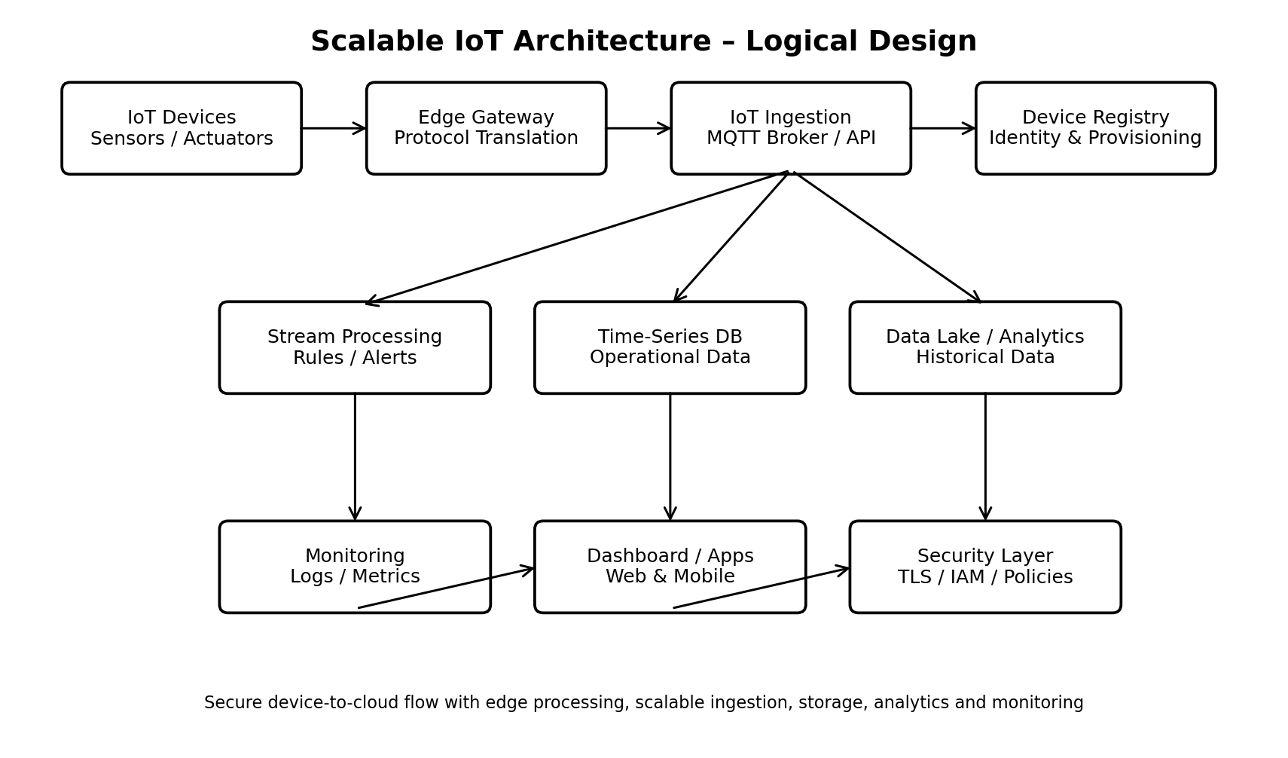
Figure 1. Logical scalable IoT architecture.

3. Network Topology and Communication
A hierarchical/star topology is proposed at the logical level: multiple sensors connect to an edge gateway, and multiple gateways connect to the cloud ingestion layer. This reduces the number of direct cloud connections and allows local buffering and processing. MQTT uses a publish/subscribe pattern for telemetry. HTTPS/REST is suitable for management and application APIs, while CoAP can be considered for highly constrained devices. TLS is used to protect data in transit.

4. Major Components and Design Choices
Component | Design choice / purpose | Reason
Sensors / Actuators | Unique IDs; periodic telemetry; command support | Simple device lifecycle and traceability.
Edge Gateway | Aggregation, filtering, buffering, protocol translation | Reduces cloud traffic and improves outage tolerance.
MQTT Broker | Publish/subscribe telemetry ingestion | Decouples producers from consumers and supports horizontal scaling.
Device Registry | Identity, metadata, provisioning state | Central device lifecycle management.
Stream Processing | Filtering, transformation, rules and alerts | Supports real-time responses without querying storage for every event.
Time-Series DB | Recent telemetry and operational queries | Efficient storage for timestamped measurements.
Data Lake | Long-term raw/historical data | Supports large-scale analytics and archival.
Dashboard / APIs | Applications and monitoring | Provides controlled access to processed data.

5. End-to-End Data Flow
1. Sensors collect measurements and send telemetry at a configured interval.
2. The edge gateway receives and validates device messages.
3. The gateway filters unnecessary data and buffers messages during network interruptions.
4. Valid messages are published to the MQTT ingestion layer.
5. Stream-processing workers consume messages, apply rules and generate alerts.
6. Recent telemetry is stored in a time-series database; historical data is archived to a data lake.
7. Dashboards and applications obtain authorized information through secure APIs.
8. Control commands travel back through the authenticated gateway/device path.

6. Scalability Challenges and Proposed Upgrades
• High device count: use multiple gateway instances and horizontally scaled MQTT brokers.
• High message volume: partition message streams and add processing workers as load increases.
• Database growth: apply retention policies, partitioning and tiered archival.
• Network instability: use gateway buffering and retry queues.
• Traffic spikes: use load balancing, queues and autoscaling.
• Operational complexity: use centralized logs, metrics, health checks and device monitoring.

7. Simulation Method and Assumptions
To demonstrate scalability, a lightweight workload simulation was performed. The model assumes each IoT device publishes one telemetry message every 10 seconds. This corresponds to 0.1 messages per second per device. A processing worker is conservatively modeled with a sustainable capacity of approximately 80 messages per second. The simulation calculates the telemetry rate and the minimum number of workers required at each device population. The simulation is an engineering capacity model rather than a measurement of a specific commercial platform.
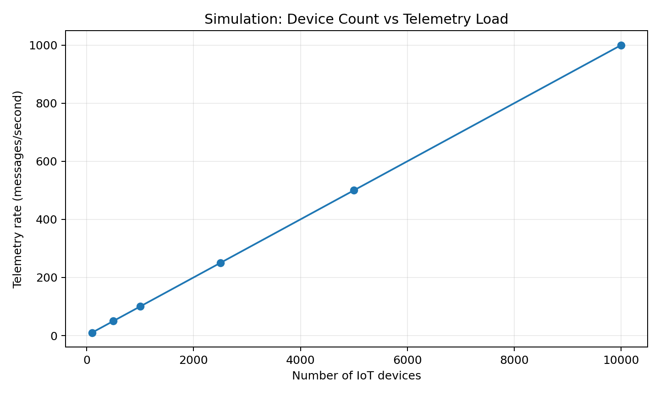
Figure 2. Simulated telemetry load as the number of devices increases.

8. Simulation Results
Devices | Telemetry (msg/s) | Min. workers | Workers provisioned | Utilization
100 | 10.0 | 1 | 1 | 12.5%
500 | 50.0 | 1 | 1 | 62.5%
1000 | 100.0 | 2 | 2 | 62.5%
2500 | 250.0 | 4 | 4 | 78.1%
5000 | 500.0 | 7 | 7 | 89.3%
10000 | 1000.0 | 13 | 13 | 96.2%
The simulation shows that telemetry load increases approximately linearly with device count. For example, 1,000 devices generate about 100 messages/second under the stated assumptions, while 10,000 devices generate about 1,000 messages/second. The architecture therefore needs horizontally scalable processing rather than relying on a single worker. In a production deployment, actual throughput should be measured using the selected broker, processing framework and message payload size.

9. Simulation / Modeling Tools
For a network-level demonstration, the proposed design can also be modeled in Cisco Packet Tracer or GNS3 using routers, switches, gateways and simulated end devices. For the submission, the quantitative capacity simulation above demonstrates the relationship between device count and processing load. A future prototype can connect an MQTT broker and simulated publishers to validate latency, throughput and packet-loss behavior under increasing load.

10. Security Design
• Unique device identities and secure provisioning.
• TLS encryption for device-to-gateway and gateway-to-cloud communication.
• Role-based access control and least-privilege permissions.
• Credential/certificate rotation during the device lifecycle.
• Input validation and protection against malformed or unauthorized messages.
• Audit logging for administrative and security-sensitive operations.

11. Reliability and Fault Tolerance
Edge gateways buffer telemetry during temporary network outages and retry delivery when connectivity returns. Cloud services should use replicated instances and health checks. Message processing should support retries and dead-letter handling. Monitoring should detect inactive devices, gateway failures, abnormal traffic, processing delays and storage problems.

12. Risk Assessment
Risk | Impact | Mitigation
Network outage | Delayed/lost telemetry | Edge buffering and retry queues.
Device compromise | Unauthorized access or false data | Strong identity, TLS, least privilege and credential rotation.
Traffic spike | Latency and backlog | Horizontal scaling, load balancing and queues.
Rapid storage growth | Higher cost and slower queries | Retention, partitioning and archival.
Service failure | Temporary processing outage | Replication, health checks and restart/recovery.
Faulty sensor | Incorrect decisions | Range checks, validation and anomaly detection.

13. Expected Performance Metrics
The following metrics should be monitored during a real prototype or Packet Tracer/GNS3/cloud test: messages per second, end-to-end latency, packet/message loss, CPU and memory utilization, queue depth, database write latency, device availability and alert-processing time. These metrics provide evidence that the architecture continues to operate acceptably as device count increases.

14. Implementation Roadmap
Phase 1: Prototype several sensors, one gateway and MQTT telemetry.
Phase 2: Add device registration, authentication and secure communication.
Phase 3: Add stream processing, time-series storage and dashboards.
Phase 4: Run increasing-load tests and record throughput, latency and resource utilization.
Phase 5: Add high availability, autoscaling, stronger monitoring and long-term analytics.

15. Conclusion
The proposed design provides a scalable and practical foundation for an IoT deployment. Its layered architecture separates device connectivity, edge processing, ingestion, stream processing, storage and applications. The capacity simulation demonstrates how workload grows with device count and why the processing layer must scale horizontally. Security, buffering, replication and monitoring address major operational risks. The architecture can be adapted to smart buildings, industrial monitoring, agriculture, energy management and other IoT applications.

16. Submission Description (200+ Words)
This report presents a scalable Internet of Things architecture designed for a growing network of sensors and connected devices. The design uses a layered architecture consisting of IoT devices, edge gateways, secure message ingestion, stream processing, storage, analytics, applications and monitoring. MQTT is proposed for telemetry because its publish/subscribe model separates device publishers from processing consumers. HTTPS/REST can support management and application APIs, while TLS protects data in transit. The architecture addresses scalability by allowing gateways, message brokers and processing workers to be scaled horizontally. A lightweight capacity simulation was included to demonstrate how telemetry load changes as the device population increases. Under the stated assumption of one message every ten seconds per device, 1,000 devices produce approximately 100 messages per second and 10,000 devices produce approximately 1,000 messages per second. The simulation illustrates why a distributed processing layer is preferable to a single processing worker. Reliability is addressed through edge buffering, retries, replication, health checks and monitoring. Security measures include unique device identities, TLS, least-privilege access, credential rotation and audit logging. The report also identifies risks such as network outages, device compromise, traffic spikes, rapid storage growth and faulty sensor data, and provides mitigation strategies. Expected performance metrics include throughput, latency, message loss, queue depth, resource utilization and device availability. The architecture can be modeled further using Cisco Packet Tracer or GNS3 and can be adapted to smart buildings, industrial monitoring, agriculture, energy management and other IoT use cases.

17. References / Further Reading
MQTT – OASIS Standard, Message Queuing Telemetry Transport.
CoAP – IETF Constrained Application Protocol (RFC 7252).
NIST – IoT cybersecurity and privacy risk management guidance.
ISO/IEC 27001 – Information security management systems.

