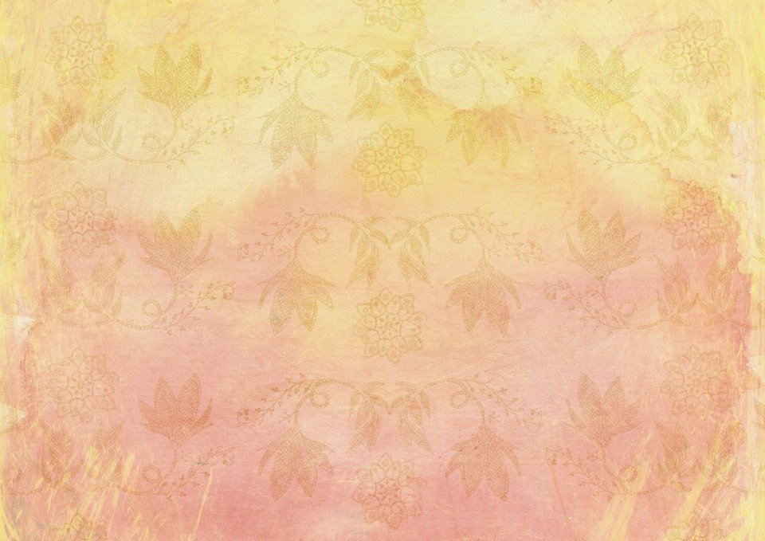 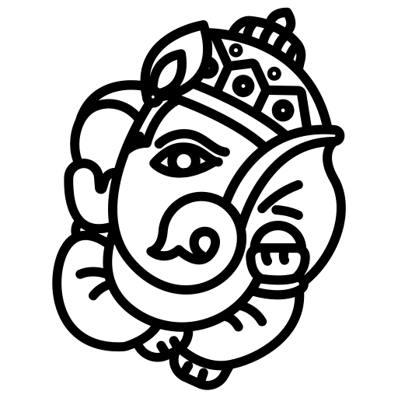

**BIODATA**

**Mobile: 7772995606**

Full Name : Gagan Chaurasiya

Date of Birth : 5th Oct, 1995

Birth Time : 6 : 00 AM

Place of Birth : Nowgong

­Height : 5 Feet 8 Inches

Education : Bachelor Of Technology In Computer Science

Occupation : Senior Software Engineer

Work Location : Bengaluru, Karnataka

**Family Details**

GrandFather’s Name : Late Mr. Krishna Prasad Chaurasia

(Professor, Govt. Polytechnic Nowgong)

GrandMother’s Name : Late Mrs. Heera Devi Chaurasia

Father’s Name : Mr. Pradeep Chaurasia

Father’s Occupation : Business

Mother’s Name : Mrs. Usha Chaurasia

Brother : Prashant Chaurasia (Younger Brother)

Brother Occupation : Probationary Officer At Govt. Indian Bank

Residential Address : Main Market, Nowgong , Distt : Chhatarpur (M.P.)