**FILTERS**

* **grep :**

It highlights the text ,written after this command in the syntax.

**Syntax:**

$ grep text filename

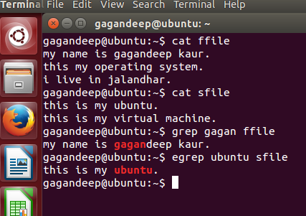

* **diff:**

It compares the two files and reports the difference between two.

**Syntax:**

$ diff file1 file2

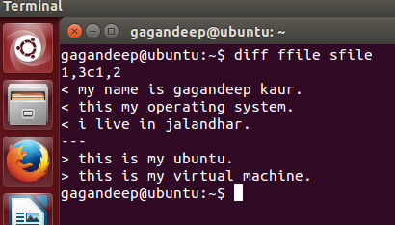

* **df –l filename:**

It gives space usage.

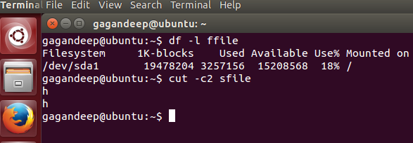

* **sort:**

It sorts the line of text.

**Syntax:**

$ sort filename

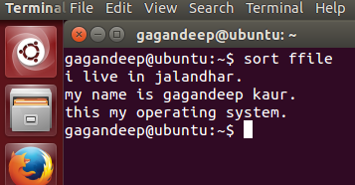

* **sort –r:**

It sort the lines of text in reverse.

**Syntax:**

Sort –r filename

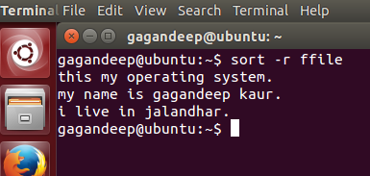

* **ls –li filename:**

It gives the info about time, date ,mode of file.

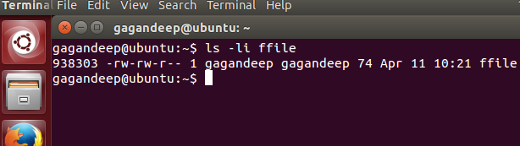

* **head:**

It displays the lines of text in the file.

**Syntax:**

head filename

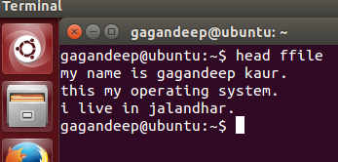

* **head -2 filename:**

It displays the first two lines.

* **head -3 filename:**

It displays the first three lines .

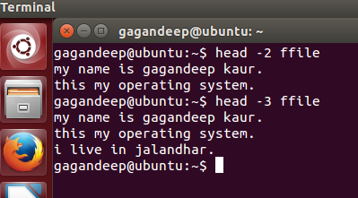

* **tail:**

Displays line of text.

* **tail -2 :**

displays last two lines of text.

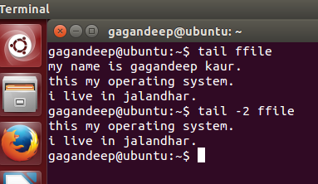

* **cat:**

It concatenates the lines of text of both files.

**Syntax:**

cat file 1,file 2

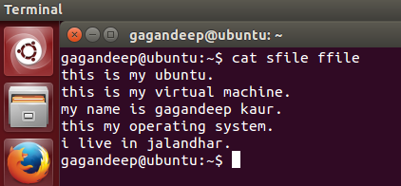

Inode

* **ls –li filename:-**

Displays inode number of a file.

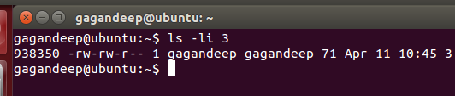

* **df –l filename:-**

Displays inode information.

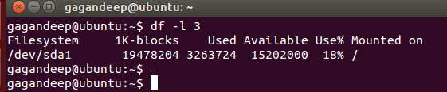

* **chown changed_name filename/directorty_name:-**

Change owner of particular file.

* **chgrp group_name file/directory_name:-**

Change group owner of a file.

* **chmod mode_name file/directory_name:-**

Example:

* chmod u=rwx, g=rx, o=r myfile:- This is an example of using symbolic permissions notation. The letters u, g, and o stand for "user", "group", and "other". The equals sign ("=") means "set the permissions exactly like this," and the letters "r", "w", and "x" stand for "read", "write", and "execute", respectively. The commas separate the different classes of permissions, and there are no spaces in between them.
* chmod 754 myfile :- Here the digits 7, 5, and 4 each individually represent the permissions for the user, group, and others, in that order. Each digit is a combination of the numbers 4, 2, 1, and0: 4 stands for "read", 2 stands for "write", 1 stands for "execute", and 0 stands for "no permission." So 7 is the combination of permissions 4+2+1 (read, write, and execute), 5 is 4+0+1(read, no write, and execute), and 4 is 4+0+0 (read, no write, and no execute).