**GNDU RC JALANDHAR**

**COMPUTER SCIENCE DEPARTMENT**



**Submitted by: Gagandeep Kaur**

**Submitted to:Dr.Pankajdeep**

**Roll no: 2014CSA1408**

**B.TECH CSE IV SEM**

**LINUX COMMANDS**

1. **DATE:-**

**USAGE:** Prints or sets the system time and date . It can also be used to display a date in a format you specify.

**SYNTAX:**

Date [OPTION]…[+FORMAT]

1. **CAL:-**

**USAGE:** Display a conveniently – formatted calendar from the command line.

**SYNTAX:**

Cal [options][[[day]month]year]

**EXAMPLE:**

Cal 12 2016(displays the calendar for December of the year 2016)

1. **ECHO:-**

**USAGE:** Echo is a fundamental command found in most operating systems that offer a command line. It helps to display line of text and is used in scripts ,batch files ,etc.

**SYNTAX:**

echo [SHORT-OPTION]….[STRING]….

**EXAMPLE:**

Echo Hello,World! (It outputs the text Hello,World!)

1. **CLEAR:-**

**USAGE:** It helps to clear the screen.

**SYNTAX:**

clear

1. **WHOAMI:-**

**USAGE:** It displays the effective user ID.

**SYNTAX:**

whoami[OPTION]

**EXAMPLE:**

Whoami (displays the name of the user who runs the command)

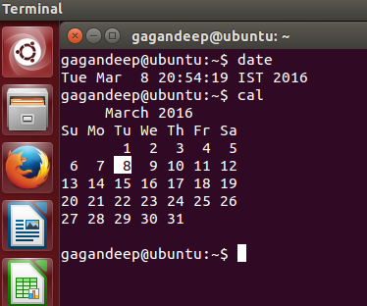

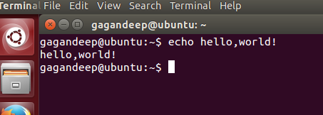

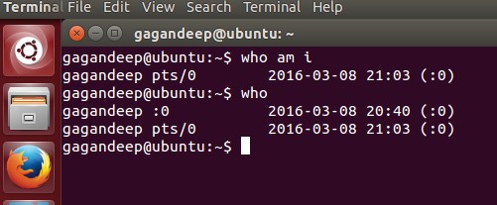

1. **WHO:-**

**USAGE:** It helps to display who is logged on to the system.

**SYNTAX:**

who[OPTION]….[FILE][AMI]

**EXAMPLE:**

Who (it displays the username ,line and time of all curebtly logged in sessions.)

1. **EXIT:-**

**USAGE:**It helps to exit the shell.

**SYNTAX:**

exit

1. **UNAME:-**

**USAGE:** It prints the information about the current system.

**SYNTAX:**

uname [OPTION]

**EXAMPLE:**

uname -a(It displays system information.)

1. **TIME:-**

**USAGE:** It reports how long it took for a command to execute.

**SYNTAX:**

time[-p]command[argument…..]

**EXAMPLE:**

Time df (it calculate free disk space using the df command and reports how long it took for the command to complete.)

1. **HELP:-**

**USAGE:**It helps to display the information about in command.

**SYNTAX:**

help[-dms][PATTERN…]

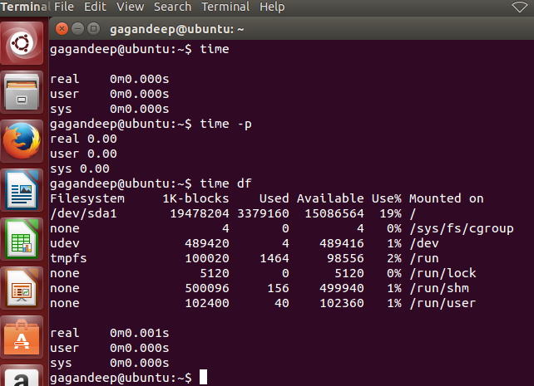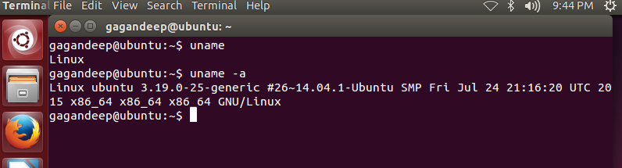

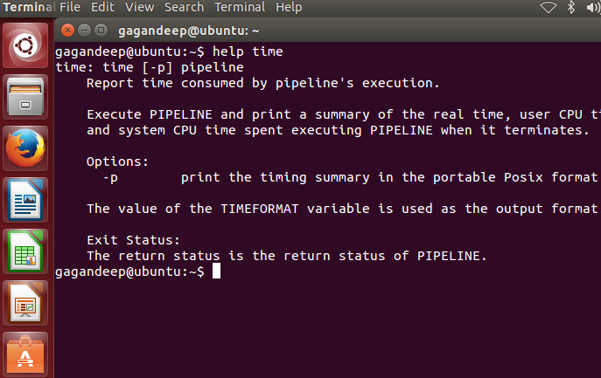

1. **<COMMAND> - -h:-**

**USAGE:** It provide a quickoverview of the command and its uses.

**EXAMPLE:**

cal - -h (provide information about cal command)

1. **FREE:-**

**USAGE:** Itdisplays the amount of free space available on the system .

**SYNTAX:**

free

**EXAMPLE:**

free –m (provide information in MB)

1. **DF(Display File):-**

**USAGE:** Displays information about the disk space usage of all mounted filesystem .

**SYNTAX:**

df [OPTION][-h]

**EXAMPLE:**

df -h(uses KB,MB,GB format)

1. **PWD(Print Working Directory)**

**USAGE:**It prints the name of the working directory.

**SYNTAX:**

pwd

1. **LS(List):-**

**USAGE:**List all file and folders in your current working directory.

**SYNTAX:**

**ls**

1. **CD(Change Diectory):-**

**USAGE:-**Changes the directory you are currently working in.

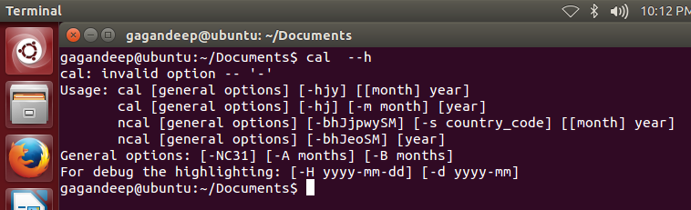

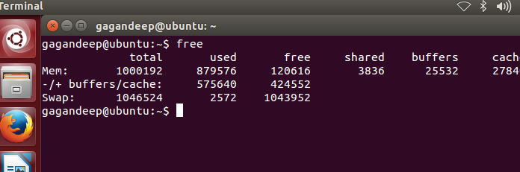

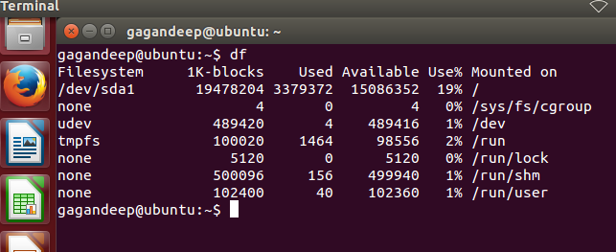

**SYNTAX:-**

cd / takes you to root directory.

cd – takes you to the previous directory.

1. **MKDIR:-**

**USAGE:**Allows you to create a new directory.

**SYNTAX:**

mkdir new(create a directory new)

1. **RMDIR:-**

**USAGE:**It removesan empty directory

**SYNTAX:**

rmdir

1. **CAT:-**

**USAGE:**CAT stands for “catenate”. It reads data from files and output their contents.It is simplest way to display the contents of a file at command line.

**SYNTAX:**

cat[OPTION]…[FILE]..

**EXAMPLE:**

Cat file.txt(It reads the contents of file.txtand displays them on the screen)

1. **HISTORY:-**

**USAGE:**Displays all of your previous commands up to the history limit.

**SYNTAX:**

history

1. **MAN:-**

**USAGE:**MAN is the interface used to viewthe system ‘s reference manuals.

**SYNTAX:**man

