**VI Editor**

Vi/’vi:’ai/ is a screen oriented text editior originally created for the UNIX operating system. The portable subset of the behavior of vi and programs based on it, and the ex edition language supported within these programs, is described by the single UNIX specification.

It operates in either insert mode (where typed text becomes part of the documents ) or normal mode (where keystrokes are interpreted as commands that control the edit screen).

For eg:- type [i] while in normal mode switches the editor to insert mode, but typing [i] again at this point places “ i” character in the documents. From insert mode ,pressing[ESC] switches the editor back to normal mode.

Vi is the standard Unix text editing program.

* There are several versions of vi available including vi, eivis , vile and vim.
* There is a improved version of vi editor nowadays called vim(vi improved) that is fully in text mode, which means that all actions are carried out with the help of text commands and is available on any version of linux.
* Syntax: vi<option><filename>

**STARTING VI:**

* vi filename: Creates a new file if it already does not exist otherwise opens existing file.
* vi -R filename: Opens an existing file, R is the file number.
* vi filename: Opens an existing file.
* For e.g: to create a new File named my new, type

$vi mynew.

**OPERATION MODES:**

1. Command mode: This mode enables you to perform administrative tasks such as saving files, executing commands, moving the cursor, cutting and pasting lines or words, and finding and replacing. In this mode, whatever you type is interpreted as a command.
2. Insert mode : This mode enables you to insert text into the file. Everything that's typed in this mode is interpreted as input and finally it is put in the file.

COMMANDS IN VI EDITOR

**Moving within a File: (command mode)**

* **k** : Moves the cursor up one line.
* **J** : Moves the cursor down one line.
* **h** : Moves the cursor to the left one character position.
* **I** : Moves the cursor to the right one character position.
* **o** : Positions cursor at beginning of line.
* **w** : Positions cursor to the next word.
* **b** : Positions cursor to previous word.
* **$** : positions cursor at end of line.
* **{** / **}**: move a paragraph backward/forward.
* **M** / **L**: move to middle/bottom of screen.

**Editing files: (input mode)**

* a: : Inserts text after current cursor location.
* i : Inserts text before current cursor location.
* I: Inserts text at beginning of current line.
* A: Inserts text at end of current line.
* o : Creates a new line for text entry below cursor location.
* O: Creates a new line for text entry below cursor location

**Deleting:**

* **x:** Deletes the character under the cursor location.
* **X:** Deletes the character before the cursor location.
* **d^:** Deletes from current cursor position to the beginning of the line.
* **d$:** Deletes from current cursor position to the beginning/end of the line.
* **dd :** Deletes the line the cursor is on.

**Searching:**

**String:**

* / : searches forward in the file.
* ? : searches backward in the file.

**Character:**

* ^ : Search at the beginning of the line.
* $ : Search at the end of the line.
* . : matches a single character.
* * : Matches zero or more of the previous character.

**Copy and Paste :**

* **yy :** copy the current line.
* **P :** Puts the copied text after the cursor.
* **Vi:**

It opens the file for VI editing.

**Syntax:** vi filename

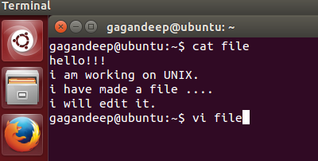

This page displays the contents in the file. The position of cursor is at “h”->first char.

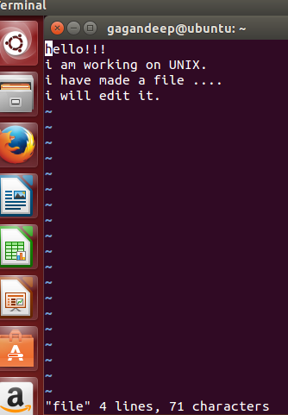

* **dd:-**

This command deletes the first line .Now, cursor’s is at “i”.

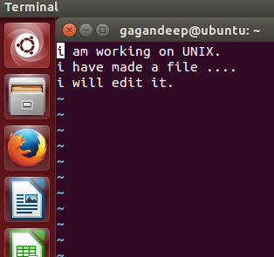

* **J:-**

It moves the cursor down .i.e. now its position is a “i” .i.e. start of next line.

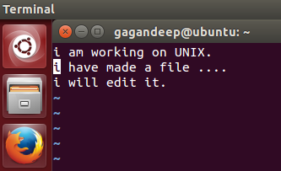

* **W:-**

It moves the cursor at next word. i.e here,cursor’s position is changed to “h”from i.

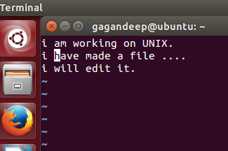

* **K:-**

Moves the cursor upward i.e here its position is changed from “h”to”a”.

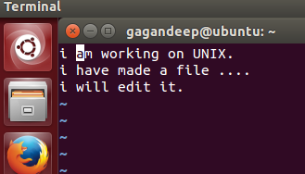

* **yy:-**

It copies the line of text.

* **P:-**

It paste the copied line.

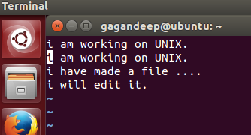

* **a:-**

It moves the cursor after current location.

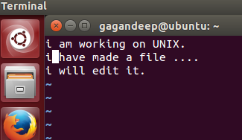

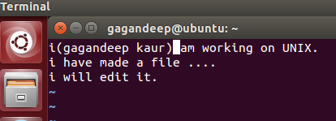

* **A:-**

It inserts text at the end of line.

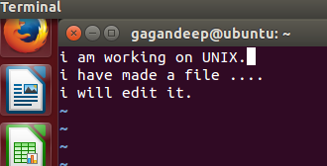

* **$:-**

It moves the cursor at the end of line.

