Istio is a service mesh.

CRD – Custom Resource Definitions. Extension to K8s api

Service mesh is a layer sitting underneath all of the pods in our system.

Telemetry : process of gathering metrics

Tracing: Tracking network calls

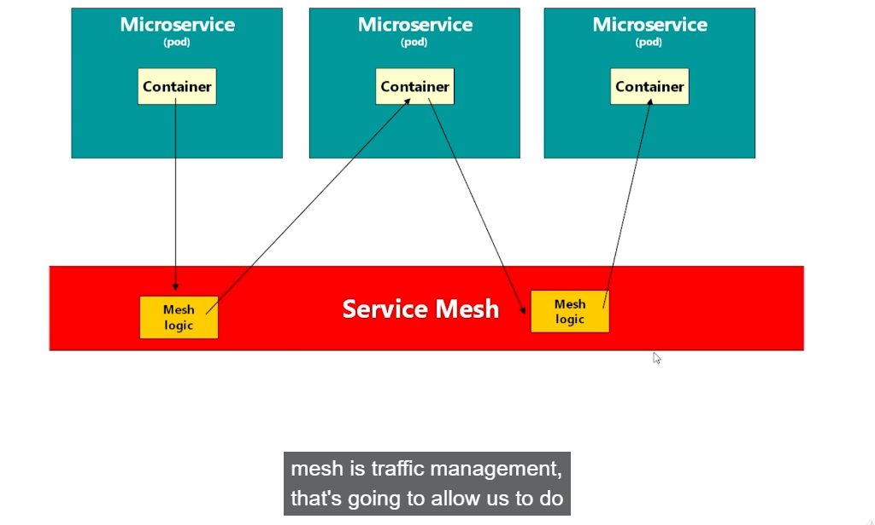

**Istio injects add its own container inside the pod named proxy**

Istio-system: Istio pods running in their own namespaces

Istiod- Istio daemon. IT is earlier called pilot.

IStiod – performs telemetry

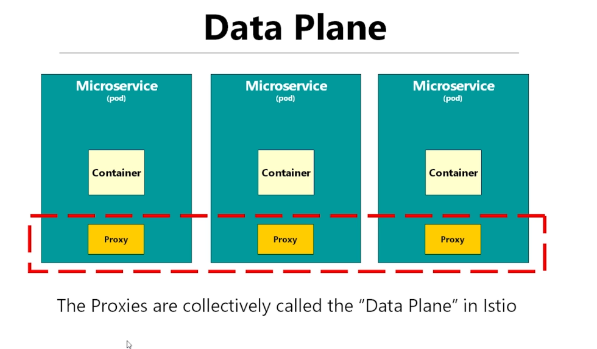

Istio Proxy – are sidecar container injected using istiod pod inside istio-system namespace in the application pod.

1. We need to setup a label on a namespace to automatically inject sidecar container inside the application pod.
2. Label name: istio-injection=enabled on default namespace

Envoy is a proxy for cluster based applications.

Kiali UI – Visualising Pods and how they are connected together