Documentation of pizza assignment

Name: Gagandeep Kaur Sandhu

E-Mail id: [sandhugagandeep9810@gmail.com](mailto:sandhugagandeep9810@gmail.com)

Topic of assignment: Pizza Store

Client Name: Selina

Client Requirement: Web App for Pizza store



Introduction

In this 21century everyone is getting online even food industry is effected a lot with this online globalization . ordering food is becoming normal nowadays, it is easy and convenient means of ordering food which is very quick , effective method .

People adopt many methods of being online and selling their product online for example ecommerce website , informational website and many other types of website and Mobile Applications :

In solution everyone is making their own websites, mobile applications. Here our client has made pizza website for his store and also we have added CMS so that admin can add information by its own without having any information about the coding:

Things needed before building the website:

* All information about the business
* Types of pizza they made
* Their working hours

Goals

Goal is to attain more and more customers online with beautiful website that is delivering excellence knowledge of pizzas .

With help of CMS admin can optimize the products on screen

Basic Requirements

* Microsoft SQL Server: It is Microsoft-owned relational database management system. The database server will allow storage and retrieval of data for the pizza store web application.
* AngularJS: A JavaScript MVW Framework that allows extending of HTML vocabulary to produce a more dynamic, expressive, and easy to develop web applications
* Summernote: A JavaScript library that will be used as the editor for this iteration of the project. It features a WYSIWYG (What You See Is What You Get) design while allowing customizations fit to the requirements which makes it a decent alternative to for this project.
* Bootstrap: A CSS Design library available for free. It boasts modern templates and a mobilefirst design.

**Project Specifications**

• Secure log in and registration

• Word-editing capabilities which will be available to authors

• Including auto-generation of table of content and auto-formatting which will include removal of widows/orphans, headers and footers, chapter adjustment

• Editor will provide the output in PDF file

• Manage projects and printing jobs

• Instant Messaging

Admin Access:

Only authorized person who admin username and password has access to add and delete the data that will be shown on the website

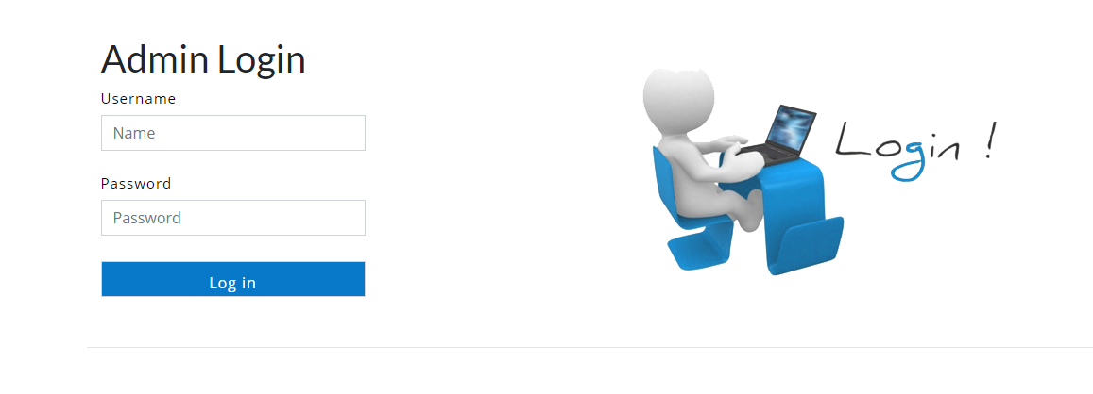

Username : admin

Password : admin

With this admin login person can add the new pizza entry for the website .

This Page will redirect to all the entries that has been entered to the database 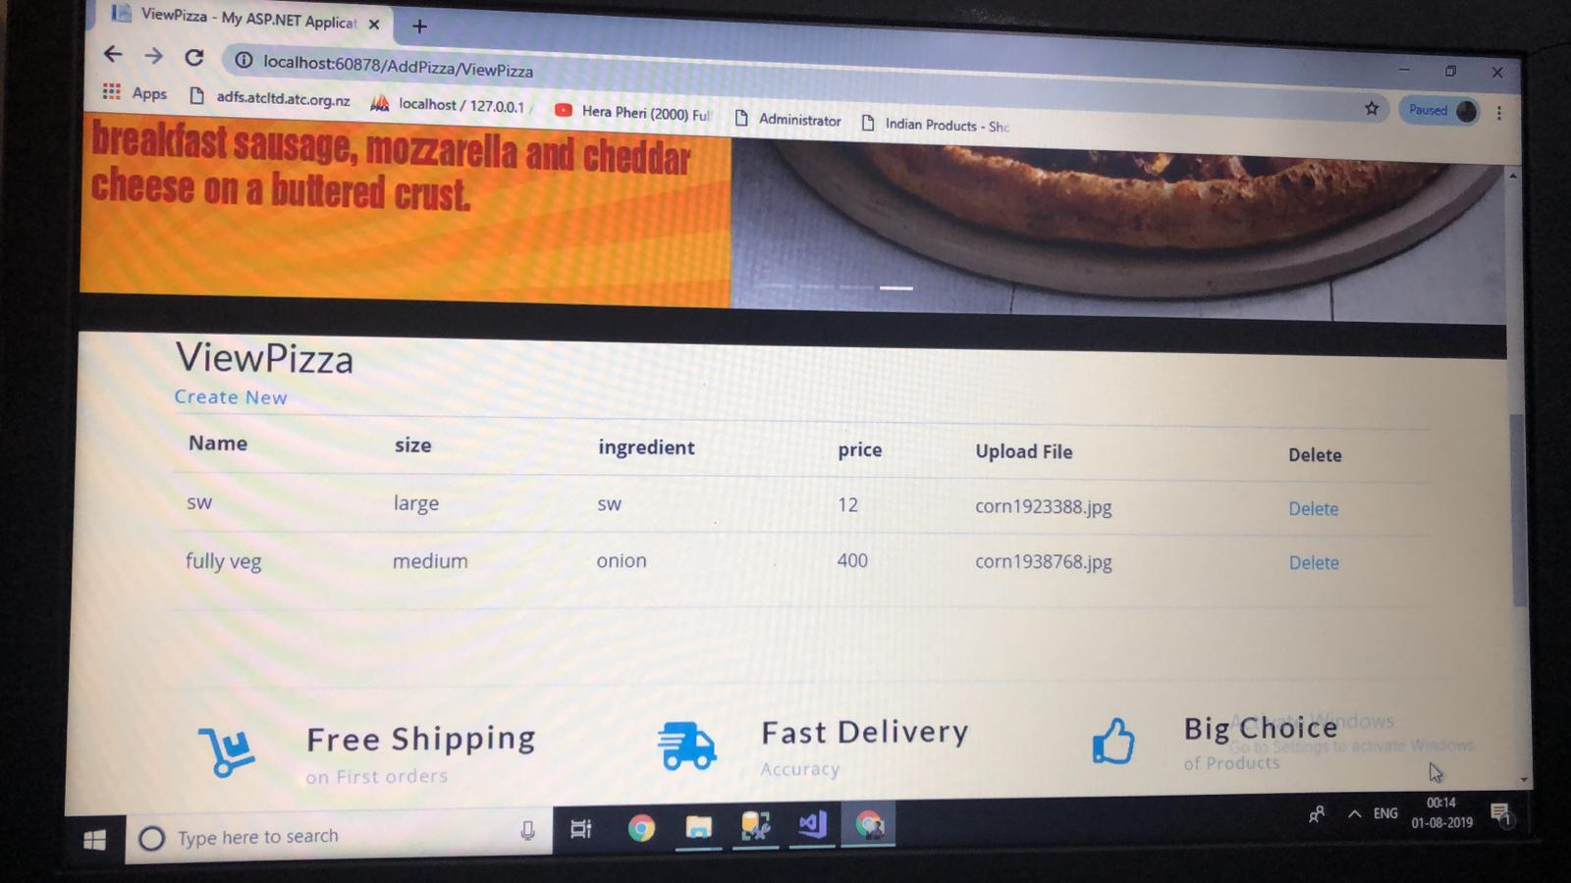

There is a create button, if admin want to create any new data he can add the information by clicking this button.

By clicking on the delete button entry will be deleted and by clicking on the create new link new page will redirected to the adding the new record :

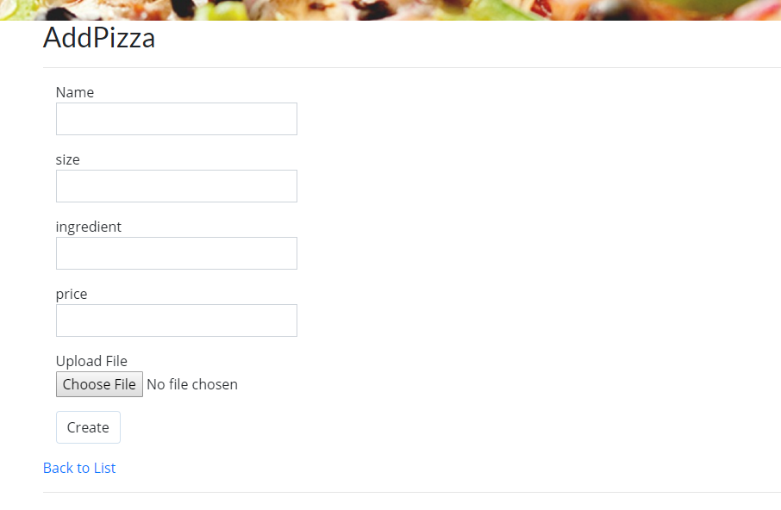

Here is the requirements for create new enteries first of all add name of pizza and size, ingredients, prize then choose file and click the create button. Then go to the Back list and you can see the new enteries there.

Homepage :

Index page is view point of the website which is very much attractive on the customers point of view . slider is added with very beautiful images of pizza representing the complete hunger inside the customer.There are four pages in this website.

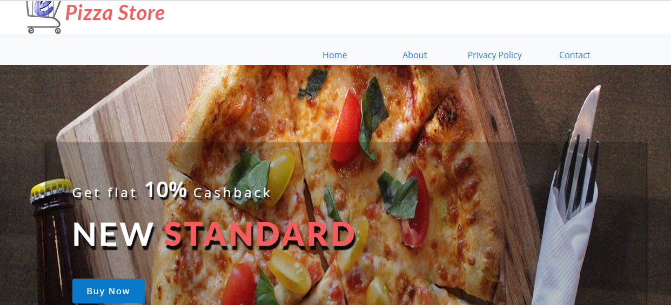

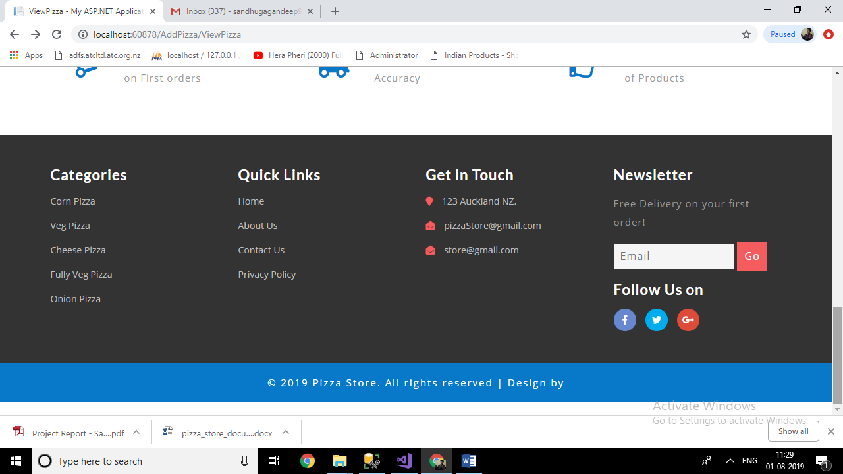

In this page there are the varaties of pizza such as veg pizza, cheese pizza and many more.

About :

In about page about information about the company is given so that their customers can know about the company character and many more things:

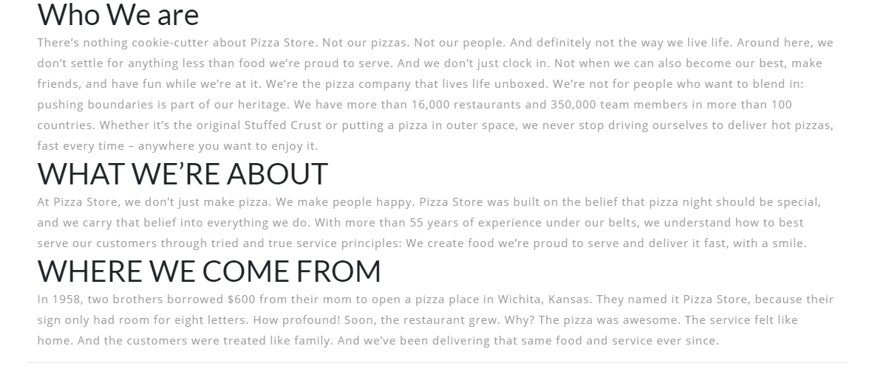

Privacy policy

Privacy policy page is telling information about do and don’t of the company and all other delivery related information is given on this page

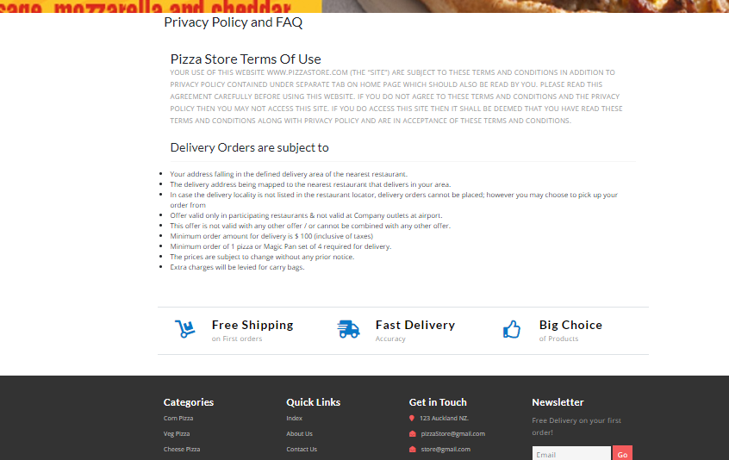

Contact

Contact page is general query handling page that if any customer who want to contact us regarding any query or other information about us can directly contact through the contact page

