Name: Vinayak Kalaskar

SJSU ID.: 010718253

**Assignment 6**

Handle internet disconnect in the web application. Display an alert when there is no internet connection.

This can be achieved using the web API called **NavigatorOnLine.online**. This returns the online status of the browser. The property returns a boolean value, with true meaning online and false meaning offline. The property sends updates whenever the browser's ability to connect to the network changes.

Source: <https://developer.mozilla.org/en-US/docs/Web/API/NavigatorOnLine/onLine>

Web Page when internet connection is working

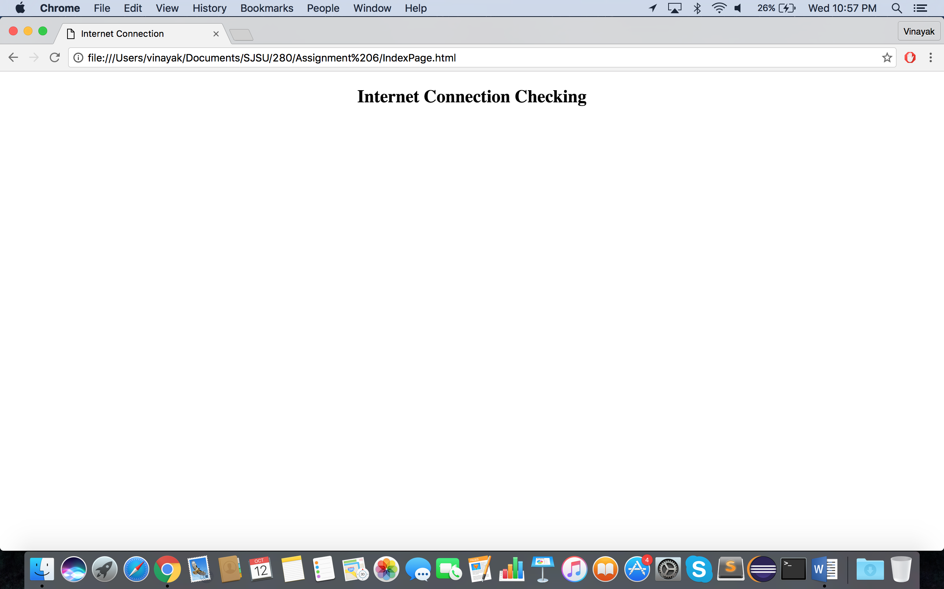

Web Page when internet connection is not working

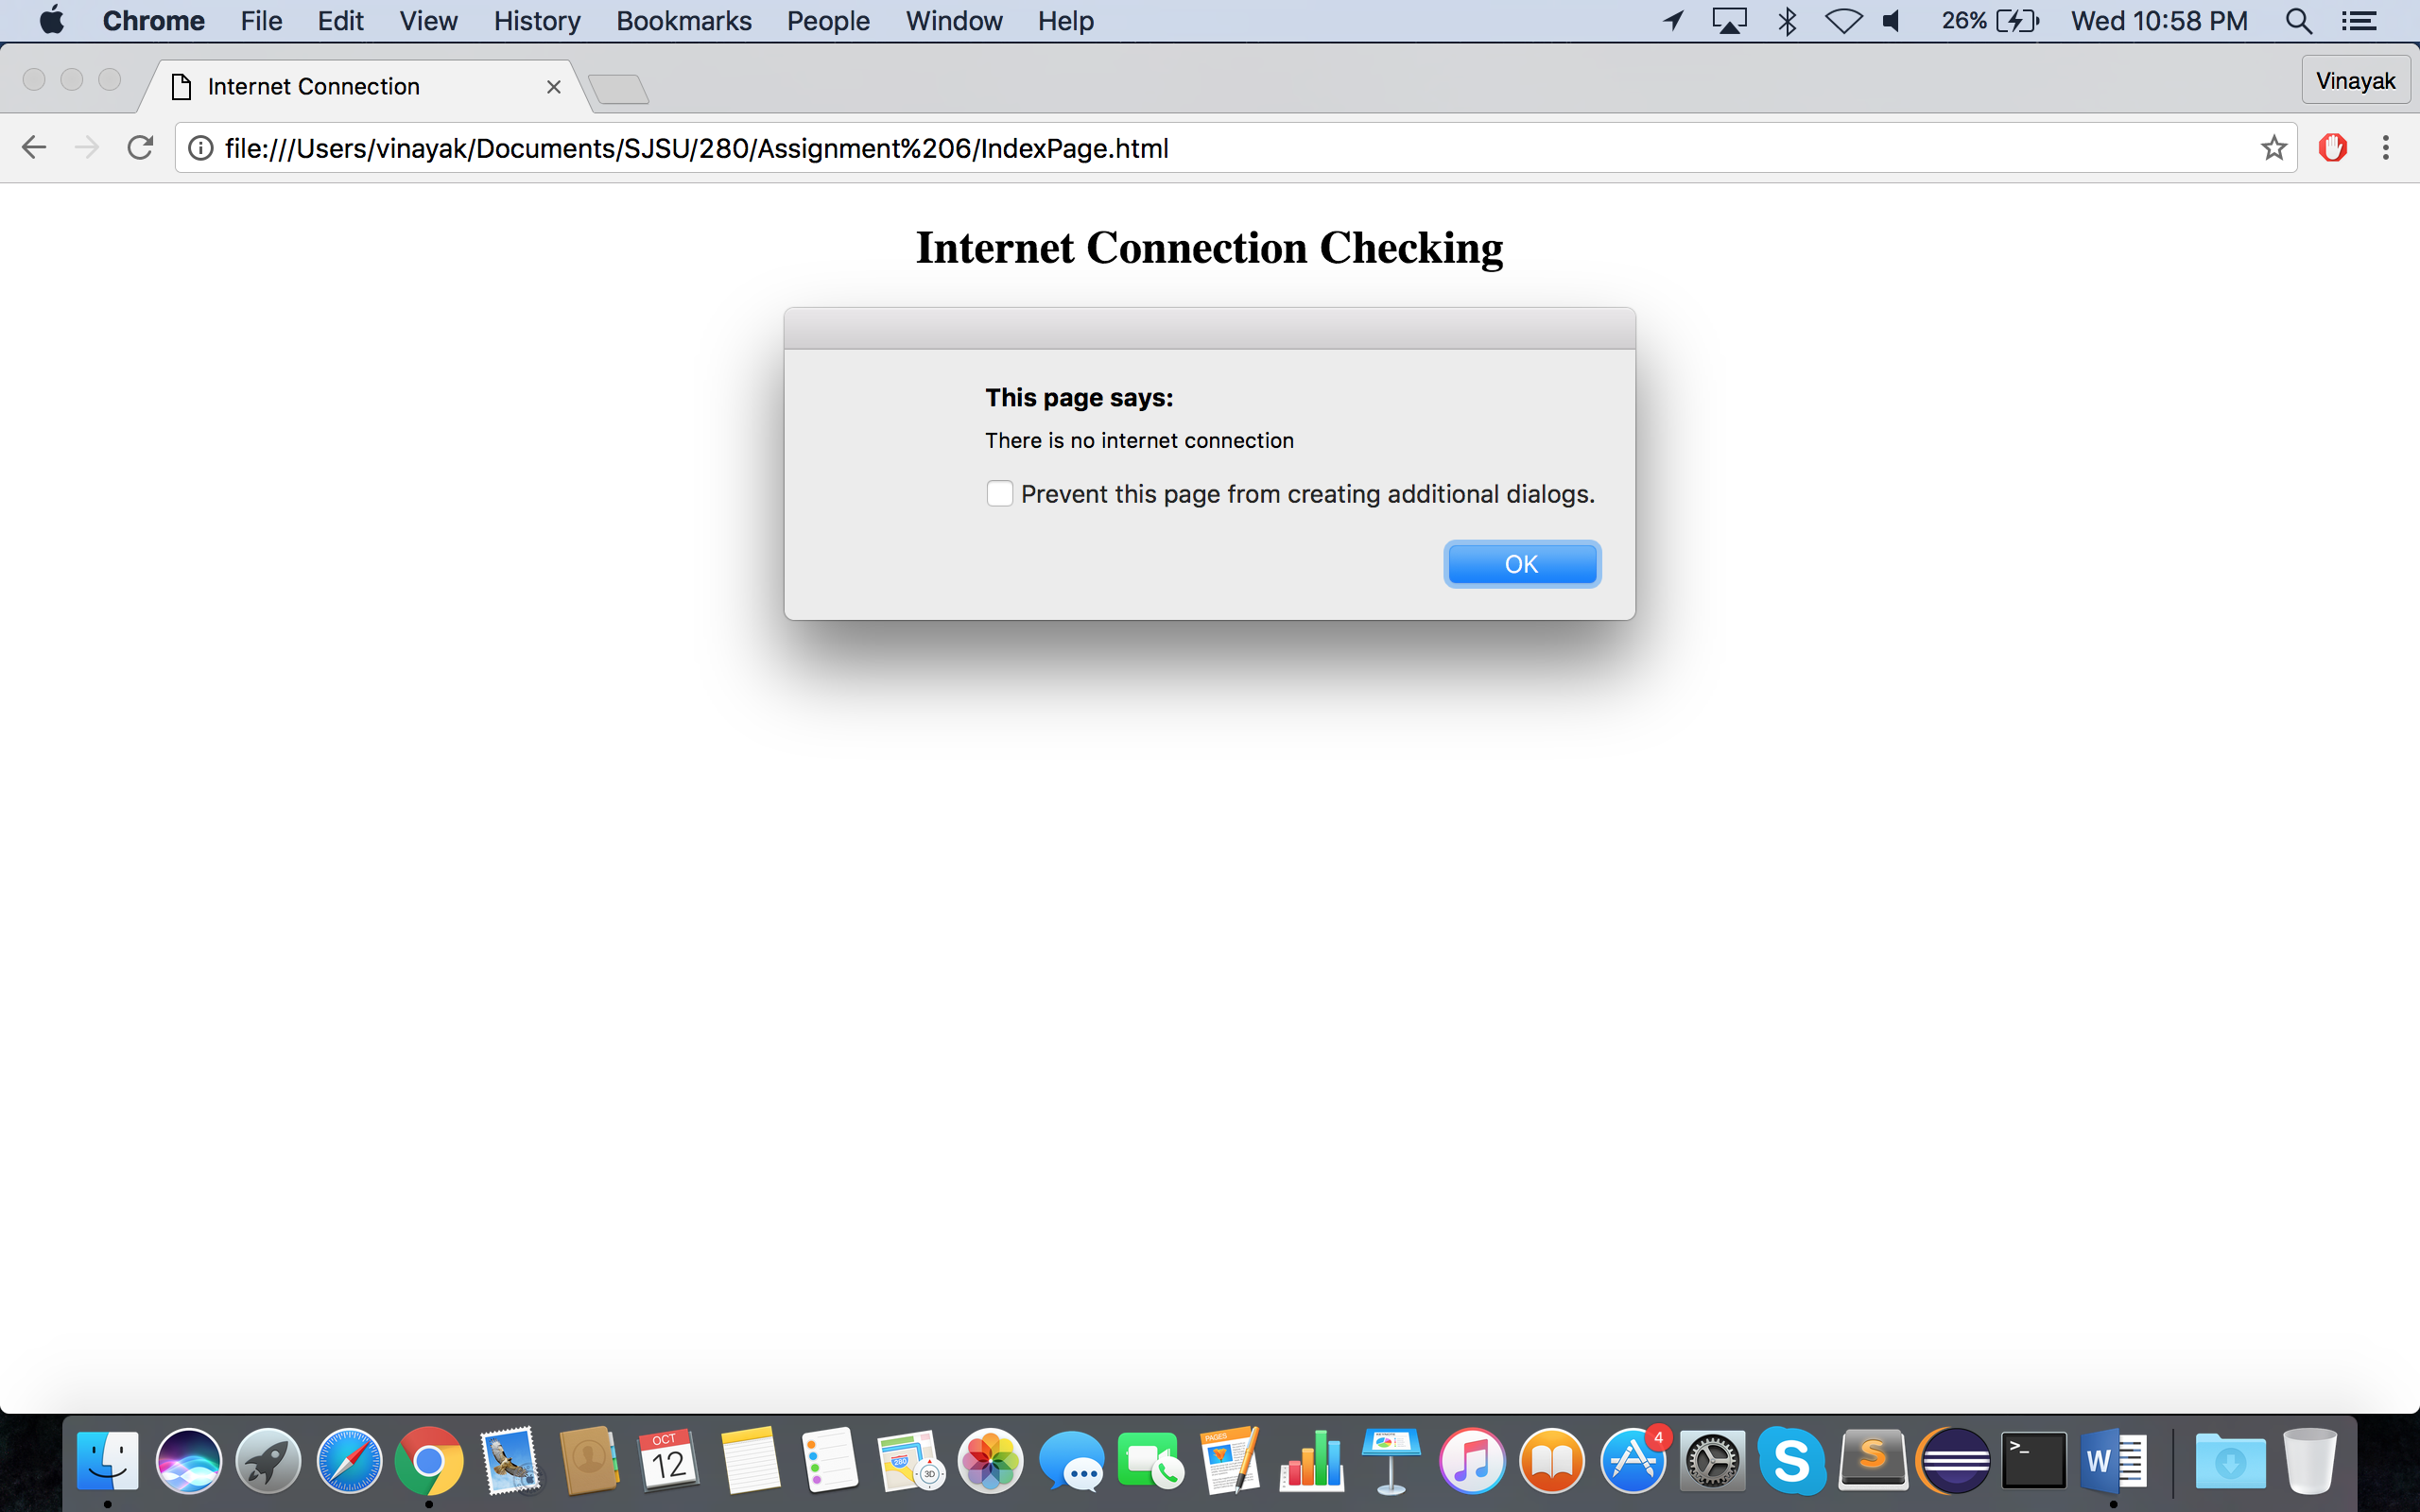

Code:

