Part1: Learning Blockchain

Prereq’s:

* Learn chaincode(https://github.com/IBM-Blockchain/learn-chaincode)
* Comfortable with Node and express module
* GoLang Environment (only needed to build your own chaincode, not needed if you just run the marbles app as is).

Application background:

* Demonstrate transferring marbles between two users leveraging IBM Blockchain
* The backend of this application will be the GoLang code running in our blockchain network.
* The chaincode itself will create a marble by storing it to the chaincode state. The chaincode itself is able to store data as a string in a key/value pair setup.

Requirements:

* Create a Web UI that can set these values and pass them to the chaincode.
* Interacting with the chaincode is done with a HTTP REST call to a peer on the network.
* ibc-js SDK will abstract the details of the REST calls away.

Application Communication Flow:

1. The user will interact with our Node.js application in their browser.
2. This client side JS code will open a websocket to the backend Node.js application. The client JS will send messages to the backend when the user interacts with the site.
3. The backend Node.js will send HTTP requests (via the SDK) to a blockchain peer to carry out the user's actions.
4. The peer will communicate to its chaincode container at its leisure. Note that the previous HTTP request was really a 'submission' of chaincode to be run. It will actually run at a later date (usually milliseconds).
5. The cc container will carry out the desired operation and record it to the ledger. ie create/transfer a marble

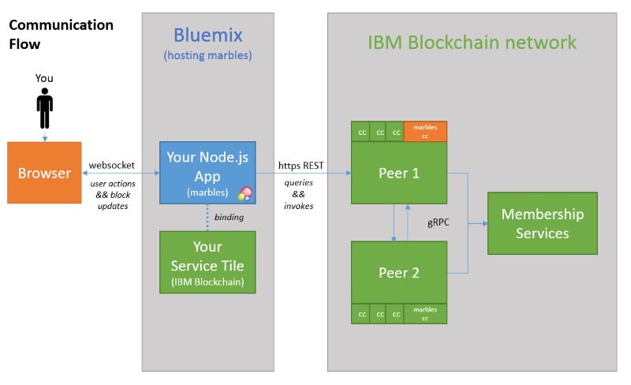

There are certain keywords and context clues to help you identify one from another.

* The Chaincode Part - This is GoLang code that runs on/with a peer on your blockchain network. Also, called cc. Anything blockchain happens here.
* The Client Side JS Part - This is JavaScript code running in the user's browser. User interaction code happens here.
* The Server Side JS Part - This is JavaScript code running our application's backend. Sometimes referred to as our node or server code. Functions as the glue between the user and our blockchain.

Backlog Items:

* Learn and use Chaincode

https://github.com/IBM-Blockchain/learn-chaincode

* Install Chaincode Development Environment

(https://github.com/IBM-Blockchain/learn-chaincode/blob/v2.0/docs/setup.md)

* Download code for marbles app

git clone http://gopkg.in/ibm-blockchain/marbles.v2

* Create blockchain network (either on IBM Bluemix or locally)

IBM Bluemix: https://github.com/IBM-Blockchain/marbles/blob/master/docs/use_bluemix_hyperledger.md

Local: https://github.com/IBM-Blockchain/marbles/blob/master/docs/use_local_hyperledger.md

* Host Application on IBM Bluemix or local

IBM Bluemix: https://github.com/IBM-Blockchain/marbles/blob/master/docs/host_marbles_bluemix.md

Local: https://github.com/IBM-Blockchain/marbles/blob/master/docs/host_marbles_locally.md