Stock Discovery system design
Version 1.0 • 9 October 2026 • Owner Gagan Jawa
[Certain] The agreed product is a private Indian equity research and recommendation platform that discovers stocks, explains its suggestions and measures what happened afterward. The current plan contains 10 epics, 30 stories and 90 tasks; it does not establish that the application has been implemented. [P1]
[Likely] Build one modular Python application with a React dashboard, a dedicated worker and PostgreSQL. Historical replay, live paper evaluation and live recommendations must use the same versioned analysis code. Keep optional real-order execution behind a separate release gate.

Product scope
Capability | Expected user result
Discovery | Ranked candidates from price, volume, market context and material news.
Company research | Evidence-linked business, disclosed customers, financials, valuation and risks.
Strategy profiles | Separate swing, intraday and long-term suggestions; clear entry, exit and review conditions.
Historical evaluation | Choose an old date, freeze the suggestion, reveal later prices and inspect outcomes.
IPO and portfolio | Separate IPO assessments; both broker holdings; contributions separated from returns.
Learning and control | Compare rules, ML and LLM contributions; diagnose failures; retain rejected experiments.

Delivery constraints
[Certain] The requested operating budget is approximately INR 3,000 per month. Contributions may be up to INR 50,000 per month with skipped months. These are distinct from active trading capital and loss limits. Upstox and Zerodha are the requested broker integrations. [P1]
[Likely] The first usable release is daily-candle swing replay with an accuracy screen. Expand the same application through news and company research, portfolio workflows, intraday and model experiments. Avoid a distributed-service architecture until a measured bottleneck justifies it.
Reading guide: architecture 2; modules 3; data 4; recommendations 5; evaluation 6; AI 7; operations 8; sourcing and costs 9; releases 10; decisions and references 11.

1 Technical architecture
[Likely] Use one private deployment and two application processes sharing the same codebase. Only the HTTPS gateway is publicly reachable; owner authentication protects the UI and API. The database and file volume stay on the internal network.
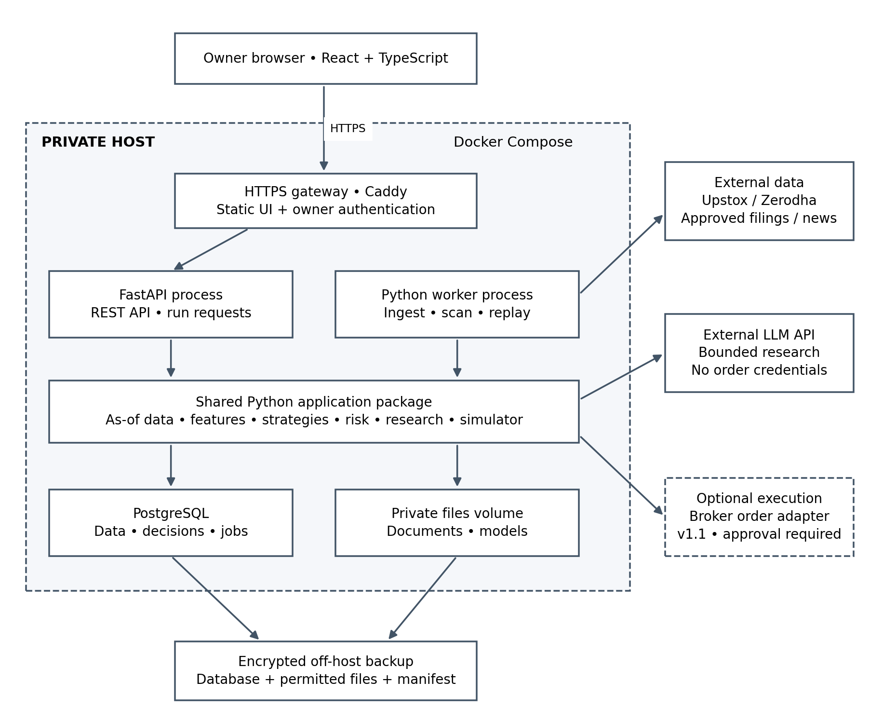
Figure 1. Deployable components and external boundaries. Arrows indicate dependencies; responses return over the same connection. The optional order adapter runs in the backend, never inside the LLM tool set.

Storage and deployment choices
[Likely] PostgreSQL holds structured data, full-text document search, job state and audit metadata. A private mounted filesystem holds permitted source files and model artifacts. Back up both together. Begin without Redis, Celery, Kubernetes, a dedicated vector database or a separate model-serving service.
[Likely] A single host is an accepted availability trade-off. Recovery uses encrypted off-host backups; it is not high availability. Heavy model training and large replays run locally or in an isolated maintenance window so they cannot starve scheduled ingestion.

2 Application modules and interfaces
[Likely] Keep module boundaries explicit inside one repository. FastAPI serves short requests and records long-running jobs; the worker executes those jobs. React never receives provider secrets or accesses PostgreSQL directly.
Module | Responsibility and boundary
Adapters and ingestion | Broker prices/accounts, permitted documents/news, instruments, calendars, retries and normalization.
Data access | Live or replay clock; as-of filtering, source rights, coverage and immutable dataset manifests.
Features and discovery | Pandas/NumPy with validated TA-Lib/custom functions; liquidity, market regime and transparent candidate ranking.
Strategy and risk | Versioned conditions, sizing and eligibility. Research can flag contradictions; cannot bypass numerical rules.
Research | Bounded LLM tool calls, PostgreSQL retrieval, financial tools, citations and uncertainty.
Replay and scoring | Future-price simulator, cost model, separate forecast/trade labels, scorecards and failure classification.
Portfolio and operations | Account reconciliation, cash ledger, budget caps, durable jobs, source status and alerts.

Initial API surface
Endpoint | Contract
GET /v1/discovery | Filter by strategy/horizon; return candidates, freshness and coverage.
POST /v1/research-runs | Instrument + mode + cutoff; return HTTP 202 and run_id.
POST /v1/replay-runs | Universe, dates, strategy version, dataset and simulation assumptions; return run_id.
GET /v1/runs/{id} | Queued/running/succeeded/failed/cancelled; progress, warnings and artifact references.
GET /v1/recommendations/{id} | Frozen decision, evidence and separately authorized outcome view.
GET /v1/scorecards | Metrics with denominators, exclusions, versions and benchmark.
GET /v1/portfolio | Broker-specific reconciled positions, cash and synchronization time.

[Likely] Requests use validated Pydantic schemas, UTC timestamps and an exchange timezone. Mutating run requests accept an idempotency key. Read endpoints paginate. Broker connect/callback routes stay backend-only; same-origin secure sessions protect UI requests.

3 Data model and time correctness
[Likely] Every historical decision needs a reproducible view of what was knowable at its cutoff. Store publication/event time separately from when data was obtained. A financial period end is not its publication date.
Entity group | Essential fields and relationships
instrument / symbol_mapping | Stable internal ID, ISIN, exchange, series; symbol and broker-ID validity ranges.
universe_membership / action | Membership effective dates; splits, dividends and other corporate actions with source/version.
candle_version | Instrument, interval, bar start/end, OHLCV, provider, revision, available_at, adjustment basis and quality flags.
document / fact / news_event | Source URL/hash, version, publication time, fetched_at, verified historical availability; fact value, unit, fiscal period, scope, page.
dataset_manifest / run | Selected immutable revisions, coverage, rights reference, clock, code/strategy/prompt/model versions and config hash.
recommendation / evidence_link | Decision ID and cutoff, strategy, action, levels, expiry, sizing inputs; source/fact references.
outcome / simulated_fill | Recommendation ID, evaluator version, fill assumptions, status, timestamps, costs and P&L.
account / ledger / position | Broker account ID, reconciled snapshot, deposits, withdrawals and position movements.
job / experiment / source_rights | Lease/retries; trial and promotion records; permitted uses, retention and terms-review dates.

As of access rules
[Likely] Live decisions require data actually received by the cutoff and closed candles only. Historical reconstruction may use a later-downloaded archive only when contemporaneous publication/version availability can be established. Label that run as reconstructed; never pretend fetched_at occurred last year.
[Likely] Select the latest revision available at the cutoff, not today’s restatement. Preserve raw prices; version corporate-action adjustments and apply historically appropriate factors. Use raw executable prices and quantity adjustments in the simulator. Do not let future split-adjustment metadata leak into features.
[Likely] Enforce unique provider/instrument/interval/time/revision keys, transactional writes and indexes on instrument/time and available_at. Start with ordinary PostgreSQL tables; partition candles only after measuring query/storage pressure. Financial money uses Decimal/NUMERIC; analytical arrays may use floating point with tolerance tests.

4 Recommendation and strategy contract
[Likely] Every suggestion is immutable. Corrections and reassessments create linked records. Store WAIT and INSUFFICIENT_EVIDENCE as visible outcomes, rather than discarding unsuccessful or inconvenient cases.
Contract area | Required content
Identity | Decision ID, instrument, strategy/horizon, mode, cutoff, dataset/run and code/config/model versions.
Action | BUY, EXIT/REDUCE, HOLD, WAIT or INSUFFICIENT_EVIDENCE. Selling a holding is distinct from a short trade.
Conditions | Entry rule, validity window, stop/invalidation, targets, holding horizon and time-exit policy.
Evidence | Calculated features, market context, source IDs and dates, contradictions, missing inputs and validation results.
Risk | Selected active capital, proposed quantity, expected costs, concurrent exposure and rejection reason.
Prediction | Precisely defined target/horizon; probability only when produced and calibrated by an evaluated model.

Technical engine
[Likely] Begin with EMA trend, prior-window breakout and relative volume, using ATR for risk levels. Freeze lookback windows and thresholds per strategy version. The breakout reference excludes the decision bar; only completed bars enter calculations. Missing warm-up data produces no actionable signal.
[Likely] Add SMA, Ichimoku, RSI/MACD, Bollinger Bands, OBV, session VWAP and a small candlestick set as tested alternatives. Ichimoku plotting offsets must never change when a value becomes knowable. VWAP resets by session. Compare combinations on the same datasets rather than treating correlated indicators as independent votes.

Risk and cash rules
[Likely] Size by both cash and planned loss: the largest integer quantity satisfying quantity × stop distance + estimated charges/slippage ≤ risk budget, and total purchase cost ≤ available allocated cash. Also enforce instrument/sector concentration and combined open-position risk. A gap can exceed planned stop loss.
[Certain] Earlier discussions proposed initial limits of 0.25% per trade, 0.5% combined planned risk and a 1% monthly review threshold on selected active capital. They are proposals to confirm in STK-003, not activated settings or guarantees. [P1]
[Likely] Deposits do not become profit or reset loss limits. Freeze the monthly risk base and a documented P&L-based pause rule; risk increases require a deliberate new configuration. Long-term thesis/valuation reviews use a separate profile rather than automatically inheriting swing stop rules.

5 Historical replay and outcome evaluation
[Likely] Implement the requested experience directly: choose 6 August 2025 → generate suggestions with evidence available then → commit the decisions → reveal subsequent prices → score them. The simulator can read future prices; the recommendation engine cannot.

Replay protocol
1. Resolve a versioned universe and dataset; check coverage, rights, warm-up and decision cutoffs. Record unavailable historic news or constituent history.
2. Advance ReplayClock. Build features and evidence through an as-of adapter. Disable current network retrieval for the decision engine.
3. Execute the same strategy/risk code used live. Freeze output, evidence and configuration before evaluation.
4. Simulate the earliest realistic entry after signal availability, then exits, gaps, corporate actions, cash and date-effective costs.
5. Persist scored outcomes separately. Show the original chart and future reveal, plus counts of pending, no-entry, ambiguous and invalid-data cases.

What counts as correct
Measure | Definition
Directional accuracy | Correct sign forecasts / eligible matured forecasts, under a fixed reference-price and horizon convention. Define flat/tie handling before running.
Target before stop | Target-first / all resolved, unambiguous triggered trades. Time exits remain in this denominator; report them separately.
Net expectancy | Mean realized net P&L per closed simulated trade, including fees and slippage. Report return/risk-normalized results too.
Portfolio result | Cash-constrained equity curve, maximum drawdown, turnover and exposure; suitable benchmark under the same capital/period assumptions.
Coverage and uncertainty | Triggered, no-entry, WAIT, missing-data and ambiguous counts; results by regime, sector and horizon with sample size and uncertainty.

[Likely] A daily candle touching both stop and target cannot establish their order. Use permitted finer data or mark ambiguous; show sensitivity bounds rather than silently selecting a winning fill. Targets reached after a stopped-out trade do not convert that trade into a win.
[Likely] Split experiments chronologically, purge overlapping label windows and fit preprocessing only on training periods. Tune on development/validation sets; preserve a final untouched period. Compare rules-only, rules plus research and ML challengers under identical execution assumptions. Forward paper evaluation is required to check live behavior and historical LLM contamination.

6 Research agent and predictive models
[Likely] Use an existing LLM for bounded investigation and explanation. Use deterministic Python for indicators, financial arithmetic and risk. A separate learned model may predict defined outcomes after the replay baseline works.

Research contract
[Likely] Retrieve by instrument, document type and cutoff using PostgreSQL full-text search. Tools expose permitted evidence, computed ratios and strategy findings. Begin with a bounded tool loop and structured output; add orchestration or pgvector only if measured retrieval/workflow limitations justify it.
[Likely] The agent investigates business quality, disclosed customers, catalysts, debt, cash flow, margins, valuation and contradictory evidence. Validate citation existence and date eligibility, then check whether each material claim is supported. Preserve page/section references and explicit unknowns. Reject numerical claims that conflict with calculation outputs.
[Likely] Research may downgrade a candidate to watch-only or propose a structured assessment. A versioned decision policy controls how that assessment changes ranking/action; it cannot alter hard risk limits. Log the quantitative baseline and research-adjusted result so we can measure the incremental contribution.

Predictive experiment
[Likely] Create as-of price/volume features and future labels under a fixed entry/exit convention. Train a simple scikit-learn baseline, then one LightGBM challenger. Keep feature order, preprocessing, split manifests and model artifacts together. Load approved artifacts in the worker; a separate serving platform is unnecessary initially.
[Likely] Promotion requires predeclared criteria for net performance, drawdown, calibration where relevant, adequate samples and forward shadow results. Record every trial and rejection. A failed predictive model does not prevent shipping useful research software.

Three evaluators with separate authority
Evaluator | Permitted judgement
pytest and deterministic checks | Arithmetic, feature alignment, data cutoffs, citation membership, sizing and state transitions.
DeepEval plus human review | Evidence support, relevance, contradiction handling, abstention and tool use. Judge sees no future outcome.
Historical simulator / forward tracker | Forecast correctness, fills, financial outcomes and performance after costs.

[Likely] Calibrate LLM-judge rubrics on reviewed cases before trusting scores. A strong faithfulness score is not a trading-success label. Even cutoff-filtered documents cannot remove historical facts already memorized by an LLM; evaluate live recommendations recorded before outcomes occur.

7 Reliability security and failure handling
[Likely] Store queued jobs in PostgreSQL with a unique logical job key, status, attempts, lease expiry and heartbeat. One worker claims work transactionally. A crash makes expired leases retryable; idempotent writes prevent duplicate data and alerts. Checkpoint large replay jobs and prioritize ingestion over batch analysis.
Failure | System behavior
Missing/stale data or expired broker token | Mark source unhealthy, suppress affected actionable suggestions and show reauthentication/backfill status.
LLM timeout or spending cap | Stop optional research; keep validated numerical output with an explicit research-unavailable label.
Bad units, restatements or conflicting sources | Quarantine facts/revisions; retain provenance and last valid data without masking its age.
Weak strategy or changed regime | Break down results by period/regime; pause candidate promotion and preserve prior champion/version.
Live versus replay mismatch | Compare feature values, clocks, dataset versions and fill assumptions in a parity report.
Host/database loss | Restore database and permitted artifacts from a matching backup manifest; invalidate uncertain live state and reconcile accounts.
Future order submission timeout | Mark status unknown and reconcile with broker; never blindly resubmit. Execution is outside initial releases.

Security boundaries
[Likely] Use a single-owner allowlist, secure HttpOnly sessions, CSRF protection where applicable and HTTPS. Keep API secrets encrypted server-side with the encryption key outside the database. Redact credentials and account identifiers from logs; separate read and future execution capabilities.
[Likely] Treat filings/news as untrusted content. Extract in resource-limited parsers, allowlist retrieval domains, block private-network URL fetches and prevent documents from changing agent instructions. Send only permitted research data to the LLM, excluding credentials and unnecessary portfolio identifiers.

Operating targets to validate
[Guessing] Start capacity testing at 50–100 liquid instruments with daily candles. Target sub-second cached API reads and completion of the daily scan within 15 minutes of validated data arrival. These are acceptance targets, not measured results. Intraday coverage and cadence are separate capacity decisions.
[Likely] Track job lag, candle coverage, source freshness, account-sync age, AI cost, analysis duration and failure rate. Use nightly encrypted backups and a restore drill per release; initial recovery objectives are ≤24 hours of data loss and ≤4 hours to restore, subject to validation. Retention must follow each source agreement.

8 Integrations rights and operating cost
[Likely] Integrate one approved price provider first. NSE/BSE/SEBI are separate document/data authorities, not interchangeable buy/sell APIs. For each source record coverage, timestamps, permitted retention, replay/paper use, ML training, external-LLM transfer and termination obligations.
Party | Role and activation condition
Upstox | Candidate primary price/history feed and account reads. Advertises free trading/market-data API access [R1]; required data-use rights remain a sourcing task.
Zerodha | Account integration; optional alternate feed. Personal is free without market/history data; Connect is INR 500/app/month [R2]. Mock-use and copying restrictions require use-specific resolution [R3].
NSE and BSE | Instrument/corporate-action/filing sources; licensed products or approved vendor routes where required. Do not assume unsupported scraping is a feed.
SEBI and issuer IR | Offer documents, disclosures and regulatory references; permitted manual import is a fallback. Preserve source version and publication evidence.
News and LLM providers | Select by coverage, historical availability, rights and measured cost/quality. Premium archives are unpriced.
Lightweight Charts | UI chart rendering only. Retain the required notice and TradingView link [R4].

Monthly allocation from the agreed plan
Item | INR per month | Basis
Host / PostgreSQL / worker | 1,000 | Planning allocation
LLM research and judge | 900 | Metered cap
Off-host backup | 150 | Planning allocation
Optional domain | 100 | Annual fee amortized
Upstox API | 0 | Advertised access price
Tax / FX / data reserve | 850 | Optional Kite subscription draws from this
Total target | 3,000 | Not a vendor quotation

[Certain] Broker prices and the cited Kite/Lightweight Charts terms were checked on 9 October 2026. [R1–R4] [Likely] Archive licences, professional advice, setup charges, trading fees and capital are outside this allocation. If approved data cannot fit, narrow scope or revise the budget before purchase.
[Likely] Enable features by approved use, not merely by API connectivity. A sourcing blocker can disable news replay while permitting price-only development. Reassess applicable requirements before serving other users or enabling orders; this document makes no registration exemption claim.

9 Releases and implementation sequence
[Certain] The current plan defines the following releases. The Kanban board is the working ticket interface. [P1] [Likely] Keep task-hour estimates there; do not replace its revised estimates with an older aggregate calendar promise.
Release | Usable scope | Exit gate
v0.1 | Contracts, source decisions, application skeleton and private deployment | Auth, synthetic workflow, backup restore and rollback.
v0.2 | Daily technical baseline, historical replay and scorecard | Permitted history, cutoff isolation and hand-verified outcomes.
v0.3 | Discovery, live watchlists, broker reads, portfolio and forward paper tracking | Permitted data use, reconciliation and outage behavior.
v0.4 | News, financial/company/IPO research and LLM evaluation | Dated citations, groundedness checks and explicit coverage gaps.
v0.5 | Intraday replay and forward paper workflows | Interval/session correctness, latency and cost sensitivity.
v0.6 | Predictive challenger experiment | Untouched test, shadow evidence and promote/reject decision.
v1.0 | Stable personal research system | Recovery, budgets, lifecycle controls and end-to-end acceptance.
v1.1 optional | Owner-approved broker orders | Current eligibility, concrete approvals and reconciled lifecycle tests.

First implementation slice
[Likely] Pull STK-001 to freeze the recommendation contract and one worked historical example. Complete STK-002 scoring definitions and STK-003 capital/risk semantics. Resolve STK-004–009 source rights, quotes and notices while implementing synthetic fixtures. Then deliver one daily swing path end to end before adding more signals.

Kanban and release discipline
[Certain] Planned flow: Backlog → Ready → In Progress → Review/Test → Ready for Release → Done, with a separate blocked flag. The agreed work-in-progress limit is one task in progress and one in review. [P1]
[Likely] A release records a code tag, schema migration, dataset/strategy compatibility, acceptance evidence, backup and rollback target. Feature flags control unfinished modules. Software release readiness and investment-performance promotion are separate decisions.
[Likely] Suggested promotion gates must be fixed in STK-002 before viewing held-out outcomes. Avoid inventing a minimum accuracy percentage now: acceptance depends on strategy horizon, net returns, drawdown, sample size and baseline comparison.

10 Decisions traceability and references

Open decisions with owners
Decision | Owner and ticket
Initial universe, horizons, entry/expiry conventions and benchmark | Gagan + implementation owner; STK-001–002.
Active allocation, loss accounting and long-term profile | Gagan; STK-003. No assumed automatic monthly deployment of funds.
Source rights, usable historical coverage and provider quotes | Gagan for accounts/purchases; STK-004–009.
Long-term model and valuation-review acceptance criteria | Clarify S18/S21/STK-054 and STK-063 before v0.4; the current board lacks a dedicated long-term strategy story.
Host region/capacity, authentication provider and LLM model | Implementation proposal and owner selection; S03–S06/S18.
Statistical and forward-validation promotion gates | STK-002, STK-042 and STK-069; decide before final testing.

Architecture decisions retained
[Likely] Keep the React/FastAPI/PostgreSQL stack from the plan. Use the same analysis package in historical and live modes. Freeze decisions and datasets; separate research quality from market outcomes. Make predictive ML a challenger. Use source-specific permissions and cost caps. Keep execution optional and outside LLM tools.

Project references
[Certain] [P1] stock-platform-kanban-plan.md, current version 2, modified 9 October 2026. Source of scope, release IDs, task mapping and budget allocations. The design expands implementation detail without marking tickets complete.
[Certain] [P2] Kanban board supplied in the project conversation: https://stock-platform-kanban.jawagag.chatgpt.site . Ticket estimates and statuses are maintained there; they were not independently re-audited for this document.

Official sources checked on 9 October 2026
[R1] Upstox API product page and advertised access pricing. https://upstox.com/trading-api/
[R2] Zerodha API subscription pricing. https://support.zerodha.com/category/trading-and-markets/general-kite/kite-api/articles/what-are-the-charges-for-kite-apis
[R3] Kite Connect terms, especially permitted access and content restrictions. https://kite.trade/terms/
[R4] Lightweight Charts software licence and attribution instructions. https://github.com/tradingview/lightweight-charts#license
[Likely] Recheck provider terms before activating the affected feature. Version 1.0 of this document is a proposed implementation reference; source feasibility and measured performance determine which capabilities can be enabled.

