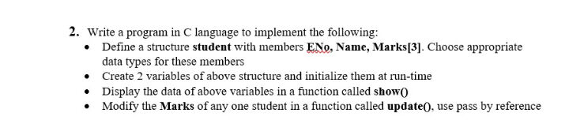

#include <stdio.h>

#include <string.h>

struct Student {

int ENO;

char Name[50];

int Marks[3];

};

void show(struct Student s) {

printf("ENO: %d\n", s.ENO);

printf("Name: %s\n", s.Name);

printf("Marks: %d, %d, %d\n", s.Marks[0], s.Marks[1], s.Marks[2]);

}

void update(struct Student \*s) {

printf("Enter new marks for the student:\n");

for (int i = 0; i < 3; i++) {

scanf("%d", &s->Marks[i]);

}

}

int main() {

printf("Gagan jha \t Class: BCA 1A Practical exam\n");

printf("\n\*\*\*\*\*\*\*\*\*\*\*\*\*\*\*\*\*\*\*\*\*\*\*\*\*\*\*\*\*\*\*\*\*\*\*\*\*\*\*\n\n");

struct Student s1, s2;

printf("Enter details for student 1:\n");

printf("ENO: ");

scanf("%d", &s1.ENO);

printf("Name: ");

scanf("%s", s1.Name);

printf("Marks (3): ");

for (int i = 0; i < 3; i++) {

scanf("%d", &s1.Marks[i]);

}

printf("Enter details for student 2:\n");

printf("ENO: ");

scanf("%d", &s2.ENO);

printf("Name: ");

scanf("%s", s2.Name);

printf("Marks (3): ");

for (int i = 0; i < 3; i++) {

scanf("%d", &s2.Marks[i]);

}

printf("\nStudent 1 Details:\n");

show(s1);

printf("\nStudent 2 Details:\n");

show(s2);

printf("\nUpdating marks for student 1:\n");

update(&s1);

printf("\nStudent 1 Details after update:\n");

show(s1);

return 0;

}

