Blue-IQ Resume Parser
The Complete Knowledge Book
How the product works, what it considers, how it maps IDs and
scores confidence, with diagrams, scenarios, and client-ready answers.

AI model: GPT-4.1-mini · Region: us-east-2 · Single-Lambda deployment
Ocean Blue Solutions · Internal reference

Contents
PART I — UNDERSTANDING THE PRODUCT
1. Executive Summary
2. What the Product Does
3. Technology Stack (and the AI model)
PART II — HOW IT WORKS
4. System Architecture
5. The Parse Pipeline, End to End
6. What the Tool Considers (extraction & inference rules)
7. Synchronous vs Asynchronous Parsing
8. The Time Budget
9. The Multi-Agent Orchestrator
10. Text Extraction & OCR
PART III — MATCHING & SCORING (THE INTELLIGENCE)
11. Normalization & Catalog Matching
12. Specialty ID — Deep Dive
13. Geography, City & Facility IDs
14. How the Confidence Score Works
PART IV — THE OUTPUT & THE API
15. The Output Schema (field by field)
16. API Endpoints Reference
17. Authentication & Security
18. Infrastructure & Deployment
PART V — USING IT WELL
19. Performance & Latency
20. Scenarios — Worked Walk-throughs
21. FAQ — Answering Client Questions
22. Glossary
APPENDIX A — Implemented Improvements & Tuning Flags

PART I — Understanding the Product

1. Executive Summary
The Blue-IQ Resume Parser is an enterprise, privacy-first HTTP API that turns a healthcare (nursing / allied-health) resume — PDF, DOCX, RTF, or a scanned image — into clean, structured, validated JSON. The output is normalized against the client's GigHealth platform vocabulary (specialty IDs, facility IDs, geography and city IDs) so it can auto-fill candidate-profile and Work-History forms.
It is built for accuracy and safety first, guided by six hard invariants:
- Never return nothing — there is always a deterministic floor.
- Never return a silent partial — degraded records are always flagged with warnings.
- Never fabricate — a value is filled only when it is actually present in the resume.
- Never drop a role — every employer is preserved, even if its details couldn't be read.
- Never blow the gateway ceiling — the sync path degrades before the connection times out.
- Never log PII — resume content and filenames are never written to logs.
KEY: The single most useful signal in the output is the confidence score per section, and — for specialties — the matched flag. Both are explained in full in Parts III and IV.

2. What the Product Does
A client uploads a resume and receives structured JSON. In one request the parser:
- Detects the file type and extracts the text (digital extraction, or OCR for scans).
- Uses the AI model plus deterministic rules to structure the resume into personal info, work history, education, skills, certifications, and licenses.
- Normalizes and maps entities to catalog IDs — profession, specialty, facility, geography (country/state), and city — wherever a confident match exists.
- Scores confidence per section so low-quality records can be routed to human review.
- Returns a flagged partial (never a crash) if any stage fails, so the client always gets a usable record.

3. Technology Stack (and the AI model)
AI MODEL: The AI model is GPT-4.1-mini. It is set once in configuration (openai_model = "gpt-4.1-mini") and every LLM call in the system uses that setting — the single-shot parser, all multi-agent agents, and the specialty-matching AI tier. Decoding is deterministic (temperature 0 with a fixed seed) so identical resumes parse consistently.
Layer | Technology
Language / runtime | Python 3.12
Web framework | FastAPI + Uvicorn; Mangum adapter for AWS Lambda
Validation | Pydantic v2 + pydantic-settings
AI model | OpenAI GPT-4.1-mini (temperature 0, fixed seed)
Digital extraction | PyMuPDF (PDF), python-docx (DOCX), striprtf (RTF)
OCR | Tesseract, escalating to AWS Textract on low confidence
Storage / state | DynamoDB (7 tables) + S3 (temp files, deleted after parse)
Testing / quality | pytest (~560 tests), moto, ruff, mypy
Async queue | Amazon SQS + dead-letter queue (DLQ), draining a dedicated Worker Lambda

PART II — How It Works

4. System Architecture
Two AWS Lambda functions from one container image (region us-east-2). The API Lambda serves the HTTP API and, for async work, pushes a job onto an Amazon SQS queue and returns in about a second; a separate Worker Lambda drains that queue and runs the heavy OCR / multi-agent pipeline, sized for that load independently. A dead-letter queue captures jobs that fail past their retries as an alertable event. State lives in DynamoDB; temporary files live in S3 and are deleted immediately after parsing.
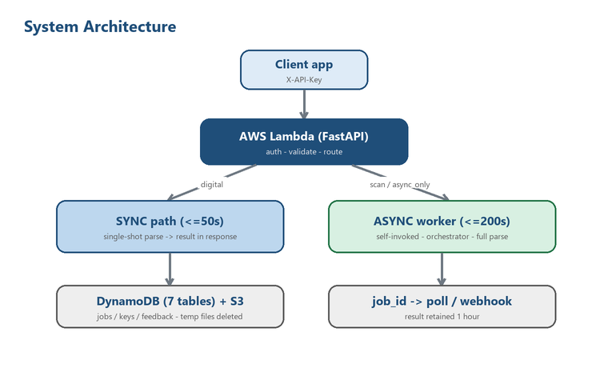
Figure 1 — Request flow from client to result.

5. The Parse Pipeline, End to End
Every parse runs the same ordered pipeline (app/services/pipeline.py). Each step is time-bounded; a failure degrades gracefully rather than crashing.
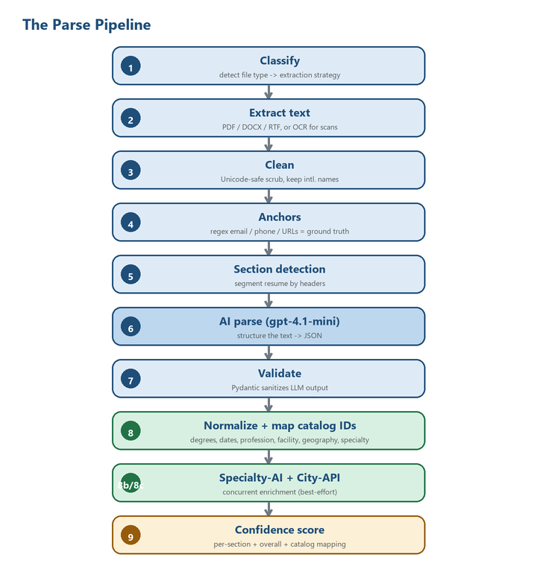
Figure 2 — The nine pipeline stages.
Stage | What happens
1. Classify | Inspect file (magic bytes + content); pick PDF / DOCX / RTF / OCR strategy.
2. Extract | Pull raw text; a garbled PDF text layer falls back to OCR.
3. Clean | Unicode-safe scrub; preserve international names and line breaks.
4. Anchors | Regex-extract email, phone, and URLs as authoritative ground truth.
5. Sections | Segment the resume by headers.
6. AI parse | GPT-4.1-mini turns the text into structured data.
7. Validate | Pydantic sanitizes the output so bad data never crashes the pipeline.
8. Normalize | Clean degrees/dates/credentials; map profession, facility, geography, specialty IDs.
8b/8c. Enrich | Specialty-AI tier + live City-API lookup (run concurrently, best-effort).
9. Score | Per-section + overall confidence, plus a catalog-mapping score.

6. What the Tool Considers (extraction & inference rules)
This section answers "what does the parser actually look at, and what will it and won't it fill in?" — the questions clients ask most about accuracy.

Ground-truth anchors
Before the AI sees the text, a regex pass extracts the email, phone, LinkedIn, GitHub, and portfolio URLs. These are handed to the model as authoritative — the model is told to trust them over anything it might infer, which is why contact fields are highly reliable.

The structure map drives work history
On the async path, a Structure agent first maps every role and its exact bullet count. Each role is then extracted by its own focused LLM call that already knows the employer, dates, and (for travel nurses) the staffing agency. This is what prevents dropped employers and the "travel assignment flattened into one Unknown role" failure.

What it fills ONLY when explicitly stated
The parser is deliberately conservative. It fills these only when the resume actually says so, and never invents them:
Field | Rule
Dates | Kept at the precision written ("August 2018" -> "08/2018", never "08/01/2018"). "Present" for current roles.
city / state / country / zip | Filled only if written. "VA" stays "VA"; country stays null unless named.
Embedded city | If a facility NAME contains a real city ("Elderwood of Lockport" -> "Lockport") it is used; a state/university/person name is never mined as a city.
Bed counts | Only from an explicit count for that facility/unit ("32-bed MICU"); never inferred from the summary.
Compliance flags | vaccination / TB / physical set True only when explicitly mentioned.
Specialties | Only the short unit label named for that role ("ICU", "Med Surg/Tele") — never a duty-bullet phrase or a whole sentence.

Cross-bucket hygiene
The normalizer keeps fields where they belong: RN/LPN/LVN move from certifications to licenses; BLS/ACLS/CPR and a driver's license move out of skills; trailing credential suffixes ("RN", "BSN") are stripped from the name and preserved separately.

7. Synchronous vs Asynchronous Parsing
Two request shapes exist because they have very different time budgets.
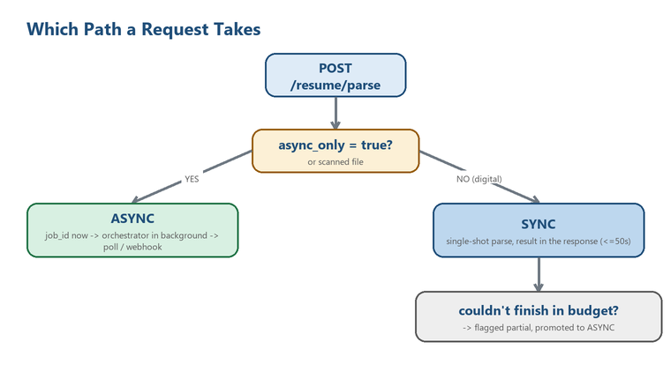
Figure 3 — How the path is chosen.
 | Synchronous | Asynchronous
Trigger | Digital PDF/DOCX/RTF (default) | Scan/image, or async_only=true
Budget | 50 seconds (gateway ceiling) | 200 seconds (full)
Strategy | Fast single-shot parse | Multi-agent orchestrator
Client gets | Result in the response | job_id -> poll / webhook
If it runs long | Degrades to a flagged partial | Runs to completion in background

IMPORTANT: A caller behind a gateway with a short request timeout (e.g. AWS Amplify's hard 30-second SSR limit) MUST send async_only=true and poll. Otherwise the connection is cut before the parse finishes. This is the fix for the "parsing is too slow" complaint — see Section 19.

8. The Time Budget
All deadlines live in one place (app/services/budget.py). Every constant traces to a real production incident. The key values:
Constant | Value | Meaning
TOTAL_BUDGET | 200 s | Overall soft budget for one async parse
SYNC_WALL_BUDGET | 50 s | Wall budget for a synchronous request
TIMEOUT_EXTRACTION | 60 s | Digital text extraction cap
TIMEOUT_OCR | 90 s | OCR / Textract cap for scans
TIMEOUT_AI_PARSE | 90 s | Single-shot LLM parse cap
TIMEOUT_ORCHESTRATOR | 130 s | Hard net above the multi-agent orchestrator

9. The Multi-Agent Orchestrator
The async path uses specialized agents so each part of the resume is extracted accurately. This is why the async path is thorough — and why it takes longer.
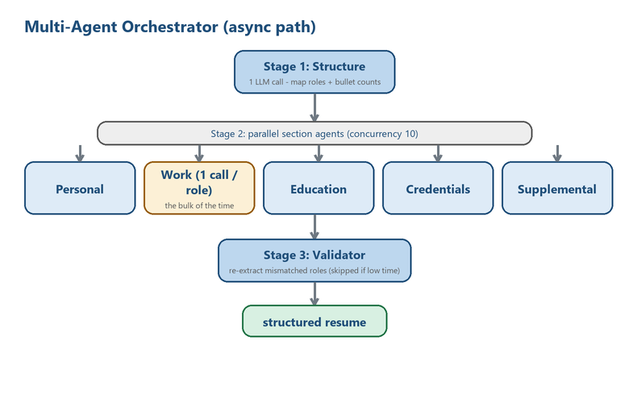
Figure 4 — Structure -> parallel agents -> validator.
- Stage 1 — Structure: one LLM call maps every role and its bullet count.
- Stage 2 — Parallel agents: Personal, Work, Education, Credentials, Supplemental run together. The Work agent makes one LLM call per role (the biggest time cost), capped at 10 concurrent. A failed role is recovered from the structure map — never lost.
- Stage 3 — Validator: re-extracts any role whose bullet count doesn't match; skipped if little time remains.
WHY TWO PATHS: The sync path does NOT use this orchestrator: under the tight sync budget the per-role fan-out was getting cancelled and silently dropping all work history. Sync uses a single call instead. The two paths must stay separate.

10. Text Extraction & OCR
- Classifier — validates magic bytes, then routes digital vs OCR.
- Digital — PyMuPDF (PDF), python-docx (DOCX), striprtf (RTF).
- Low-quality detection — a garbled PDF text layer (e.g. CID fonts) is redirected to OCR instead of feeding the AI garbage.
- OCR — images are preprocessed (auto-rotate, grayscale, upscale, denoise, sharpen, binarize), read by Tesseract, and escalated to AWS Textract when confidence is low. Clients can force Textract with force_textract=true.

PART III — Matching & Scoring (the Intelligence)

11. Normalization & Catalog Matching
The normalizer turns raw AI output into clean, catalog-mapped data. It resolves five kinds of platform IDs per role:
Entity | How it resolves | ID field
Profession | Deterministic mapping from the role's profession | profession_id
Specialty | 4-tier cascade (Section 12) | specialty_id (per specialty)
Facility | Exact / near-miss vs the bundled facility catalog | facility_id
Country / State | Offline exact match (state scoped to country) | country_id / state_id
City | Live fuzzy lookup vs the cities endpoint (>= 0.9 only) | city_id

Each match carries its own confidence, and those feed the catalog-mapping score (Section 14).

12. Specialty ID — Deep Dive
This is the most-asked-about part of the output, so it is covered in full. Each specialty named for a role is cleaned and mapped to a catalog ID through a tiered cascade. Matching is profession-scoped — an RN's "ICU" is not a CNA's "ICU".
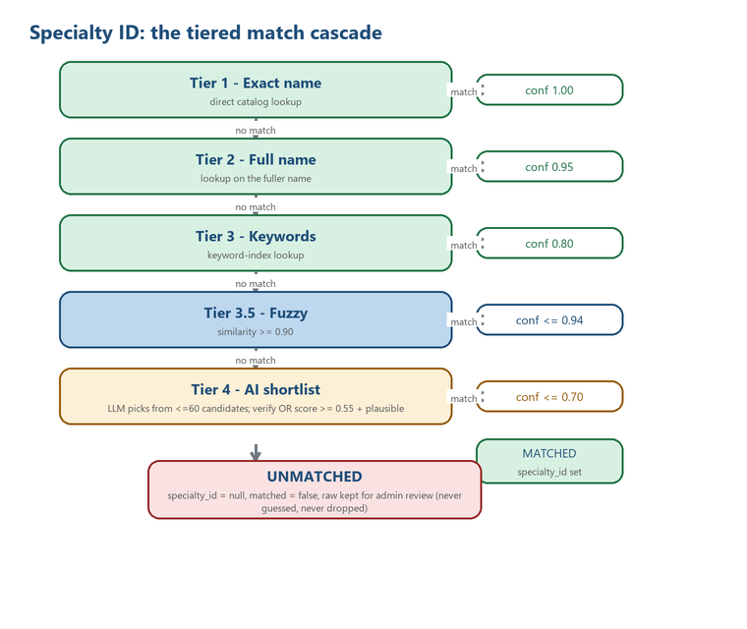
Figure 5 — The five-tier specialty cascade and its two outcomes.

The tiers
Tier | Method | Rule | Confidence
1 | Exact name | Direct catalog lookup | 1.00
2 | Full name | Lookup on the fuller name | 0.95
3 | Keywords | Keyword-index lookup | 0.80
3.5 | Fuzzy | String similarity >= 0.90 | up to 0.94
4 | AI shortlist | LLM picks from <=60 candidates; must verify against the record OR score >= 0.55 and pass a plausibility check | up to 0.70

What happens on a weak match (e.g. 30-40% similarity)
- It clears none of the tiers — fuzzy needs >= 90%, and the AI tier rejects a pick below 55% (or one that fails the plausibility check, or an ID not on the shortlist).
- It is not force-fit to the closest ID. The entry is returned with specialty_id = null and matched = false — and is never dropped, so an admin can review it.
- The raw string is always preserved; the name field is always a cleaned version of it.

Crucial nuance: a filled name is NOT proof of a match
The AI (and the deterministic tiers) only ever fill name with a tidied string — fixing typos, normalizing casing, expanding acronyms. It is populated whether or not a catalog ID was found. There is even an edge case where the built-in taxonomy recognizes the NAME (so confidence = 1.0 and match_tier = "name") but the client catalog has no ID for it — you still get specialty_id = null and matched = false.
READ THIS: The ONLY reliable signal that a specialty came from the catalog is matched = true (equivalently specialty_id is not null). Never read a filled name, or a high confidence, as "we found a match."

13. Geography, City & Facility IDs
- Country / State resolve offline against a bundled catalog — an exact match (confidence 1.0) or null. State is scoped to the resolved country so "Georgia" the US state is not confused with the country.
- City is the only LIVE lookup at parse time: a fuzzy search against the GigHealth cities endpoint. An ID is stamped only on a >= 0.9 match (a wrong city_id is worse than null), with results cached across resumes. If the endpoint is disabled or unreachable, city_id is simply null — this is not a parse failure.
- Facility matches exact / near-miss against the bundled facility catalog; a real employer that doesn't match keeps its name with facility_id = null.

14. How the Confidence Score Works
Confidence is a 0.0-1.0 score, computed per section and combined into an overall score. Clients use it to route low-confidence records to human review. Each sub-score is a simple, explainable formula.
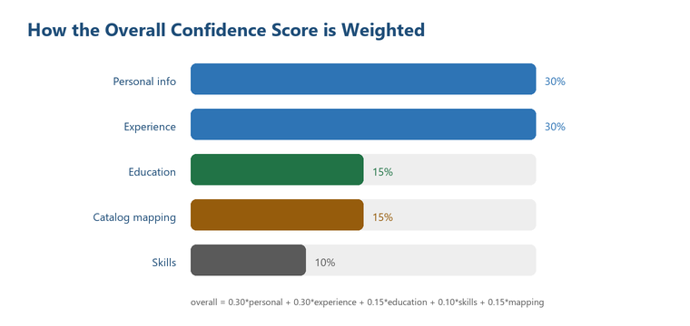
Figure 6 — The five sub-scores and their weights.

The five sub-scores

Personal info (out of 5 points)
Signal | Points
Full name (2+ words) | 1.0
Valid email | 1.5
Phone (7+ digits) | 1.0
Location present | 0.5
LinkedIn or GitHub | 1.0

Score = points / 5.0 (capped at 1.0). Email is weighted highest because it is the most reliable identity anchor.

Experience (mean across roles)
Per role: company +0.3, role +0.3, start_date +0.2, any description/achievements +0.2. The section score is the average across all roles.

Education (mean across entries)
Per entry: institution +0.4, degree +0.3, graduation year +0.3. Averaged across entries.

Skills
0 skills -> 0.0; 5 or more -> 1.0; otherwise count / 5.

Catalog mapping (the accuracy dimension)
The mean match confidence of every resolved entity across all roles: profession, facility (a real company, not "Unknown"), country, state, city (counted only when it actually got an ID), and each specialty. An unmatched entity contributes 0.0. This is what rewards a resume whose entities map cleanly to platform IDs.

The overall score
overall = 0.30*personal + 0.30*experience + 0.15*education
+ 0.10*skills + 0.15*catalog_mapping

Worked example
A resume with: name+email+phone+location+LinkedIn (personal = 5/5 = 1.0); two fully detailed roles (experience = 1.0); one complete degree (education = 1.0); 8 skills (1.0); and entities that mostly resolved (catalog_mapping = 0.80):
overall = 0.30*1.0 + 0.30*1.0 + 0.15*1.0 + 0.10*1.0 + 0.15*0.80
= 0.30 + 0.30 + 0.15 + 0.10 + 0.12 = 0.97 (High)

Confidence bands
Range | Meaning | Suggested action
0.90-1.00 | High — fields present and valid | Auto-accept
0.70-0.89 | Good — minor gaps | Light review
0.50-0.69 | Partial — verify key fields | Review before use
< 0.50 | Low | Manual review

PART IV — The Output & The API

15. The Output Schema (field by field)
On a completed parse, data holds the structured resume. All fields are nullable — missing information is null, never omitted. Top-level shape:
{
"personal_info": { full_name, credentials[], headline, email,
phone, phone_secondary, location, linkedin_url,
github_url, portfolio_url, summary },
"experience": [ {
company, role, start_date, end_date, is_current,
location, city, state, country, zip_code,
country_id, state_id, city_id, // system-filled IDs
profession, profession_id, facility_id,
specialties: [ { name, raw, specialty_id, group,
confidence, matched, match_tier } ],
shift, agency_name, employment_type, ...,
description[], achievements[] } ],
"education": [...], "skills": [...],
"certifications": [...], "licenses": [...],
"projects": [...], "languages": [...], ...
}

The specialties object — field by field
Field | Filled by | Meaning
name | AI / rules | Cleaned specialty name (NOT proof of a catalog match)
raw | System | Original text exactly as written
specialty_id | System | Catalog ID, or null when unmatched
group | System | Specialty group label
confidence | System | 0.0-1.0 match confidence
matched | System | true ONLY when a specialty_id was assigned — the reliable signal
match_tier | System | name / full_name / keywords / fuzzy / ai, or null

16. API Endpoints Reference
All endpoints are under /api/v1 and require the X-API-Key header (except /health).
Method & Path | Purpose
POST /resume/parse | Upload & parse. Send async_only=true to always get a job_id (recommended for UIs).
POST /resume/upload-url | Presigned S3 URL for files over ~6 MB (up to 10 MB).
POST /resume/parse-uploaded | Parse a file uploaded via the presigned URL.
GET /resume/job/{job_id} | Poll an async job (processing -> completed/failed).
POST /resume/{job_id}/retry | Re-parse (re-upload the file). Up to 3 retries.
POST /resume/{job_id}/feedback | Submit original + corrected JSON (202). The only PII store.
POST /resume/batch | Parse up to 200 files at once (202).
GET /resume/batch/{batch_id} | Batch status counts.
POST/GET/DELETE /webhooks | Manage HMAC-signed result webhooks.
GET /health | Liveness + dependency check (no auth).

17. Authentication & Security
- API keys (rp_live_...) stored only as a SHA-256 hash; cached in memory 300 s.
- Webhooks are HMAC-SHA256 signed over "timestamp.body"; verify on every delivery.
- SSRF protection — webhook URLs must be public HTTPS; internal addresses rejected.
- File validation — magic-byte checks; zip-bomb / renamed-file defenses.
- Tenant isolation — every job/webhook/batch/feedback is scoped to the company.
- PII discipline — resume content and filenames are never logged.

18. Infrastructure & Deployment
- Compute – two AWS Lambda functions from one image (container, us-east-2): an API Lambda (HTTP) and a Worker Lambda (async parse), decoupled by an SQS queue and sized independently.
- Async queue – Amazon SQS carries parse jobs from the API to the Worker; a dead-letter queue holds messages that fail past 3 retries (an alertable poison-message signal), and queue depth is the backpressure metric.
- State — 7 DynamoDB tables: api-keys, jobs (1 h TTL), batches (24 h TTL), webhooks, companies, audit-logs (content-free), feedback (90-day TTL — the only PII store).
- Temp files — S3, deleted immediately after parsing.
- Deployment – push to main builds the image, pushes to ECR, updates BOTH Lambdas (API + Worker), runs a health smoke test.

PART V — Using It Well

19. Performance & Latency
The common question is "why does a parse take 25-55 seconds, and can we make it faster without breaking anything?" Here is the complete answer.

Where the time goes
The 25-55 s figure is the ASYNC path — the high-accuracy multi-agent pipeline. It is a sequence of LLM calls, each a network round-trip. It is not a slow server or a bug:
Stage | Cost
Extraction (or OCR for scans) | Fast for digital; OCR adds seconds
Orchestrator — structure | 1 LLM call
Orchestrator — per-role work fan-out | The bulk: 1 LLM call per role, 10 at a time
Orchestrator — validator | 1 LLM call
Specialty-AI + City-API enrichment | 1 LLM call + HTTP (now run concurrently)

The correct fix — never block the user
The async path is a background job. The client should fire the parse with async_only=true, get a job_id in about one second, and poll (or use a webhook). The user is unblocked instantly while the accurate parse finishes in the background. This is required behind any short gateway timeout.
# 1) kick off — returns in ~1s
POST /api/v1/resume/parse (form field: async_only=true)
-> { "job_id": "...", "status": "processing",
"poll_url": "/api/v1/resume/job/{job_id}" }
# 2) poll every 2-3s until terminal
GET /api/v1/resume/job/{job_id}
-> { "status": "completed", "data": {...}, ... }
RECOMMENDATION: Making the parse itself dramatically faster would require dropping accuracy stages (the validator, the per-role fan-out) or a weaker model — not recommended. On the server we already parallelized the two final enrichment tiers, a small risk-free speedup. The real fix is the integration pattern above.

20. Scenarios — Worked Walk-throughs

Scenario A — A clean two-role digital resume
A digital PDF with two well-formatted nursing roles. Path: SYNC. The single-shot parser returns a complete record in the response in ~15-20 s. Specialties match at tier 1-3, confidence is high (~0.9+). The client uses data immediately.

Scenario B — A dense 12-role travel-nurse resume
Path: ASYNC (its size trips the multi-agent threshold, or the client sent async_only). The Structure agent maps all 12 facilities; the Work agent fires 12 per-role calls (10 at a time); the validator cleans up mismatches. Total ~40-55 s. Each facility keeps its own specialty and agency. The client polls and gets a complete, accurate record.

Scenario C — A specialty that doesn't exist in the catalog
A role lists "Cardiac Stepdown Telemetry Overflow Unit." It clears no tier (fuzzy < 90%, AI below threshold / not plausible). Output:
{ "name": "Cardiac Stepdown Telemetry Overflow Unit",
"raw": "Cardiac Stepdown Telemetry Overflow Unit",
"specialty_id": null, "matched": false,
"confidence": 0.0, "match_tier": null }
The client keys off matched = false and queues it for admin review. No wrong ID is ever assigned.

Scenario D — A scanned (photographed) resume
Path: ASYNC OCR. Images are preprocessed and read by Tesseract; low confidence escalates to AWS Textract. Parsing then proceeds normally. Because OCR is slow, this is always async.

Scenario E — The client is behind AWS Amplify (30 s SSR limit)
A synchronous call to a dense resume would exceed 30 s and the gateway would sever the connection (a bare 504 with no data). Fix: the client sends async_only=true, gets a job_id in ~1 s, and polls. This is exactly the situation the async pattern exists for.

Scenario F — A partial / degraded parse
If the AI parse can't finish, the pipeline returns a rule-based floor with partial = true and a human-readable warning (e.g. "returned a recovered record; work history not semantically verified"). The record is never empty and never silently wrong.

21. FAQ — Answering Client Questions

Q. A specialty only weakly matches (30-40%). Do you still return the closest ID?
No. A weak match clears no tier, so we do not borrow the closest ID. It comes back with specialty_id = null and matched = false, raw text preserved for review. We never guess an ID.

Q. If the name field is filled, doesn't that mean it came from our master list?
No. name is just a cleaned version of the candidate's text. It is filled whether or not a catalog ID was found. The only reliable "came from the catalog" signal is matched = true (specialty_id not null). Do not rely on name or confidence for that.

Q. So the flow is direct match -> AI -> if weak, return nulls except raw?
Roughly, with three precisions: (1) the 90% threshold is only the fuzzy step — exact name/keyword lookups come first; (2) the AI tier isn't only a 55% gate — a pick must also be plausible and on the shortlist; (3) the output isn't "all nulls except raw" — name is always a cleaned value.

Q. Why is parsing 25-55 seconds, and can you speed it up safely?
That is the accurate background pipeline (multiple LLM calls). The safe fix is the integration pattern: send async_only=true and poll (or use a webhook) so the user is unblocked in ~1 s. Cutting the parse itself would trade away accuracy. See Section 19.

Q. Is a partial result ever returned silently?
No. A degraded record always has partial = true and warnings explaining what to verify.

Q. Do you store the resume or the candidate's data?
No — files are processed in memory and deleted immediately; async results live 1 hour then auto-delete. The only exception is the opt-in feedback endpoint (90-day retention). If the client's policy forbids it, they simply don't call feedback.

Q. Which AI model do you use?
GPT-4.1-mini, with deterministic decoding (temperature 0, fixed seed) so identical resumes parse consistently. An optional same-model fallback to Azure OpenAI can be enabled for provider-outage resilience; because it uses the same model and settings, results do not change.

22. Glossary
Term | Meaning
Sync parse | Result returned in the HTTP response; caller waits. 50 s budget.
Async parse | API returns a job_id; caller polls or gets a webhook. 200 s budget.
async_only | Request flag forcing async — returns a job_id immediately, never blocks.
Partial | A flagged, incomplete record returned when a stage failed (never silent).
Orchestrator | The multi-agent async parser (structure -> per-role -> validator).
Single-shot | The one-call sync parser used under the tight sync budget.
matched | Boolean — true only when a catalog specialty_id was assigned.
Catalog | The GigHealth reference vocabulary (specialty / facility / geography / city IDs).
catalog_mapping | Confidence sub-score = mean match confidence of resolved entities.
Anchors | Regex-extracted email/phone/URLs given to the model as ground truth.

Appendix A — Implemented Improvements & Tuning Flags

This appendix records the accuracy and latency improvements shipped in the parser, and the configuration flags that let the opt-in ones be validated and enabled safely. The guiding rule: anything that could change extraction or matching accuracy defaults to the previous behaviour and must be validated on the benchmark before being turned on.

A.1 Shipped and active (no configuration needed)
Improvement | What it does | Effect
Concurrent enrichment | The specialty-AI and city-API tiers run at the same time (they touch different fields) | A few seconds off the tail, no accuracy change
Prompt-cache layout (per-role) | The per-role Work agent now puts the static rules + full résumé as a stable prefix and only the role instruction varies | Roles 2..N of the fan-out prefill from cache: faster + cheaper, identical content
Structure / section overlap | Personal, Education, Credentials, Supplemental agents run during the Structure call and free concurrency slots for the Work fan-out | Overlaps latency + de-contends the fan-out on dense résumés
Per-stage instrumentation | TokenMeter now tracks prompt/completion/cached token split and per-agent latency; logged in orchestrator_complete | Pinpoint the slow/expensive stage without a profiler
Benchmark perf view | benchmark/run.py --local now prints p50/p95 latency and tokens/résumé alongside the accuracy score | Judge every change on accuracy + speed + cost together
SQS async worker + DLQ | The API enqueues async jobs onto Amazon SQS; a separate Worker Lambda drains them, with a dead-letter queue for messages that fail past 3 retries. | Decouples the fast request path from the heavy parse; adds free retry on transient faults, a queue-depth backpressure metric, and an alertable poison-message signal.
LLM resilience layer | Every model call goes through one executor: retry with backoff+jitter on 429/5xx/timeout (honoring Retry-After), a circuit breaker that fast-fails to the deterministic floor during an outage, and an optional same-model Azure fallback. | A provider blip no longer fails both parse paths in lockstep; jobs degrade fast instead of hanging, and recovery is automatic.

A.2 Opt-in (default OFF — validate on the benchmark, then enable)
Flag (config / .env) | Default | Enables
openai_model_fast | "" (unset) | Routes the simple section agents (Education, Credentials, Supplemental) to a cheaper/faster model, e.g. gpt-4.1-nano. Hard stages (Structure, Work, Validator) always stay on the primary model.
specialty_fuzzy_token_set | false | Adds a token-sorted comparison to the fuzzy specialty tier so a pure word-order variant ("Telemetry Med Surg" vs "Med Surg Telemetry") can match deterministically instead of falling to the slower AI tier.
azure_openai_api_key / _endpoint | "" (unset) | Same-model fallback to Azure OpenAI when the primary is exhausted or its circuit is open. Same model + params, so no accuracy shift (no benchmark needed).
llm_rate_limit_rpm | 0 (off) | Per-process token-bucket ahead of the fan-out that smooths the per-role burst against the account requests-per-minute ceiling.

HOW TO VALIDATE: Validate any opt-in flag with: python -m benchmark.run --local --resumes-dir <folder> — compare the 9 accuracy metrics AND the new latency/token summary before and after enabling it. Only turn it on in production if accuracy holds.

A.3 How the model is set
The AI model is GPT-4.1-mini for every stage by default (openai_model). Model tiering (A.2) only changes the three simple section agents, and only when openai_model_fast is set. Decoding stays deterministic (temperature 0, fixed seed) throughout. Every model call runs through one shared executor (app/services/llm) that adds retry/backoff on transient faults and a circuit breaker; an optional Azure fallback uses the SAME model, so it does not shift accuracy.

A.4 Deliberately deferred
Confidence-score calibration (making the 0.0-1.0 bands reflect measured correctness rather than field presence) was NOT changed. It requires the hand-labelled benchmark set to calibrate, and altering the confidence math without that data would silently change every client's scores. It remains a documented next step, to be done against the labelled data.
Full semantic (embedding-based) specialty matching is also a future step: it would catch meaning-level near-misses the token/string tiers can't, and could resolve more phrases without the LLM tier. It needs an embedding source and benchmark validation, so the lower-risk token-set option (A.2) ships first.

— End of the Knowledge Book —

