Task 1

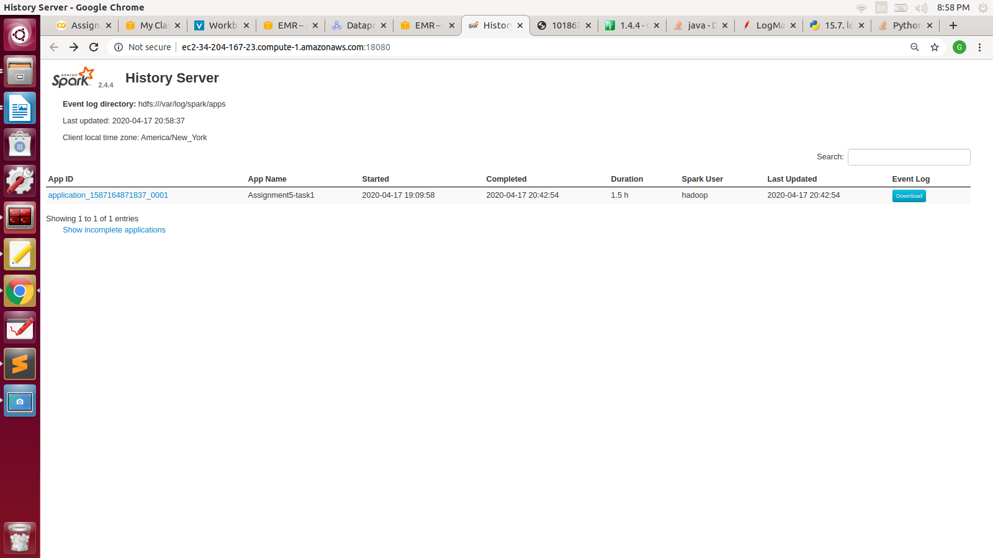

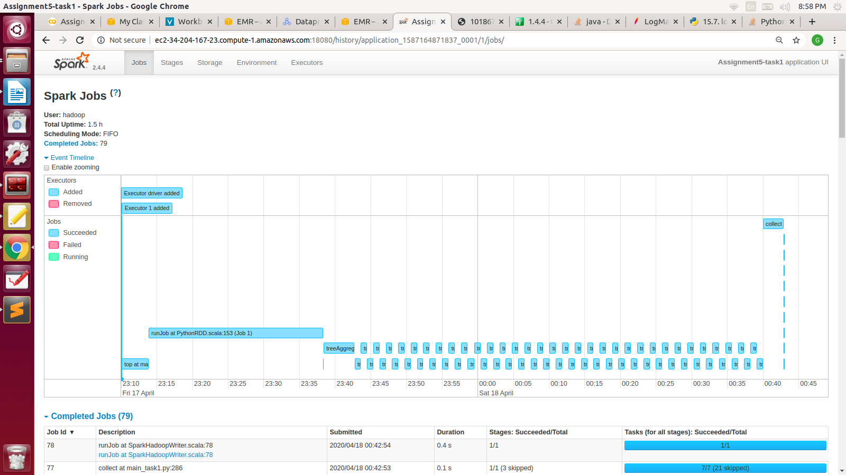

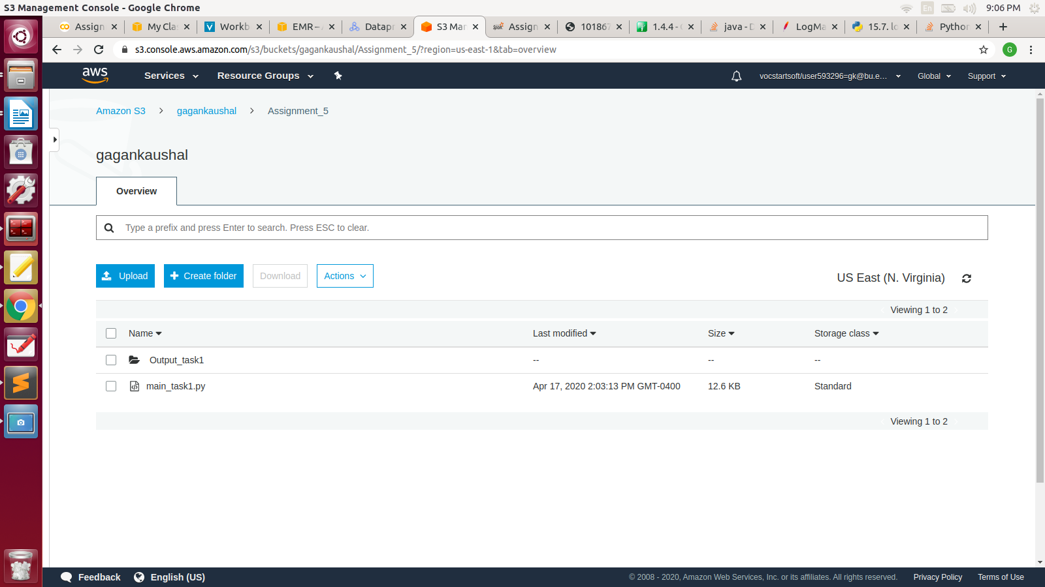



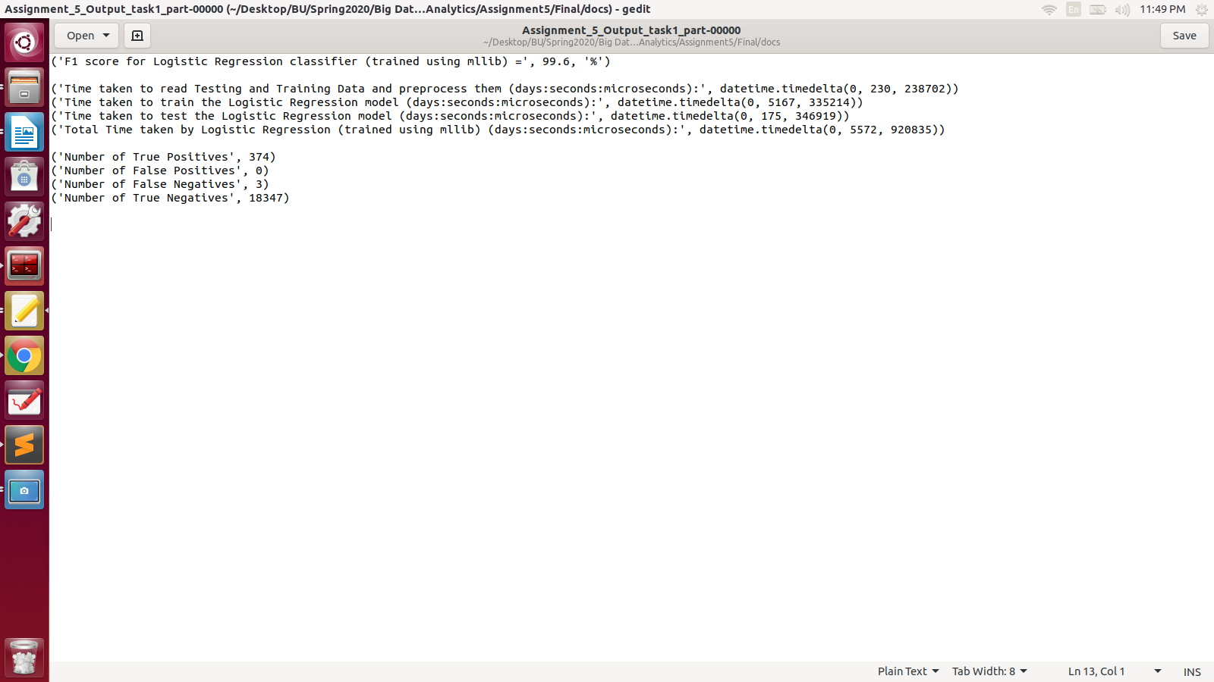

P. T.O.

**Task 2**

App ID: [application_1587174763389_0002](https://kbykz5pprvbobdkfz4hhqc2r6u-dot-us-east1.dataproc.googleusercontent.com/gateway/default/sparkhistory/history/application_1587174763389_0002/1/jobs/)

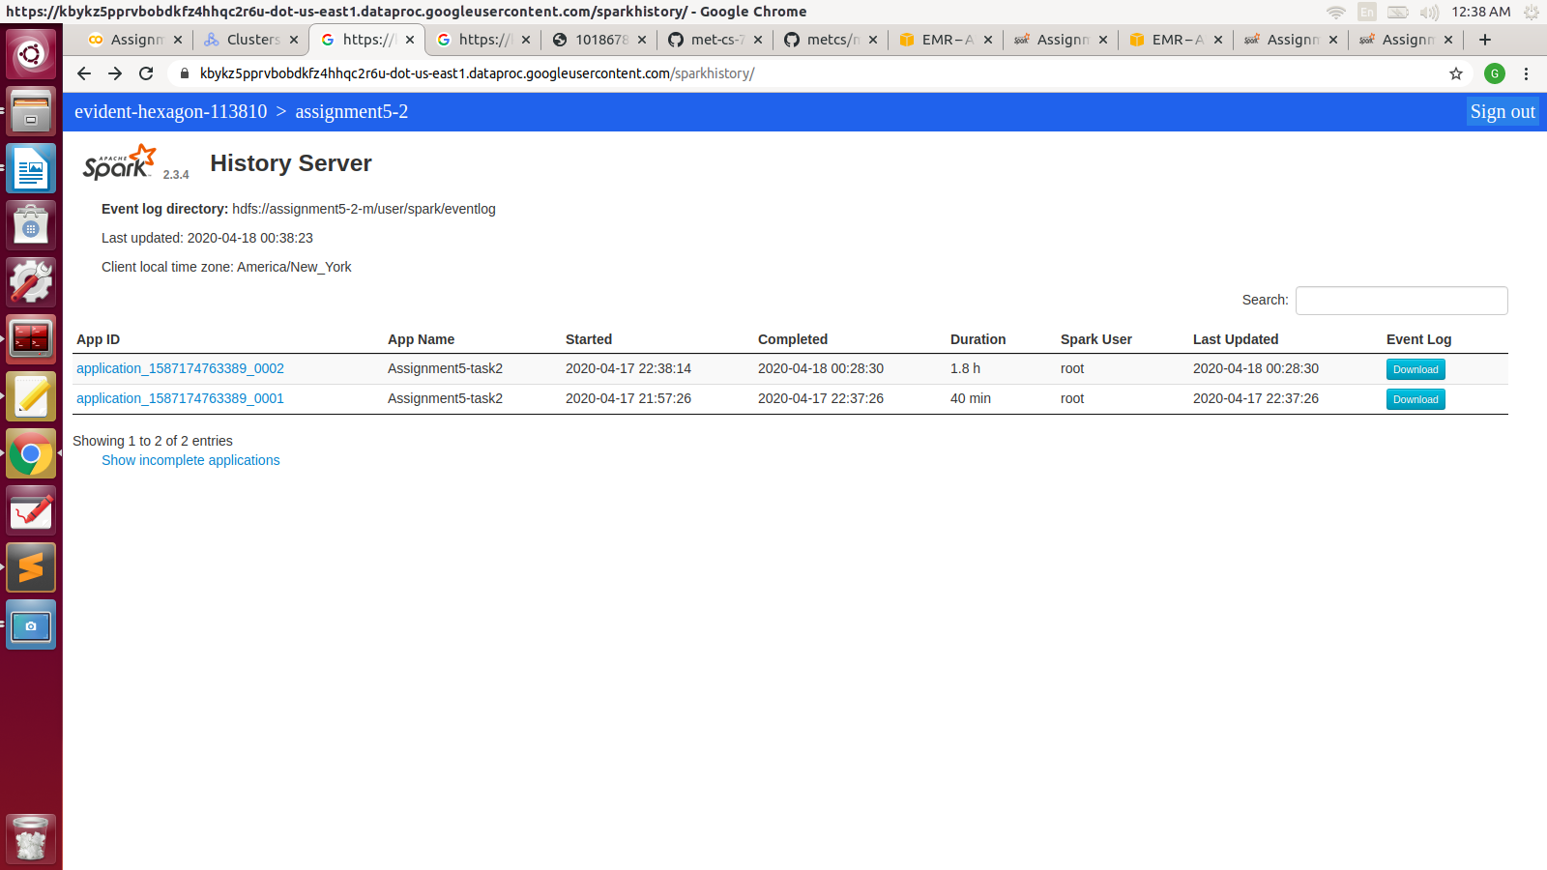

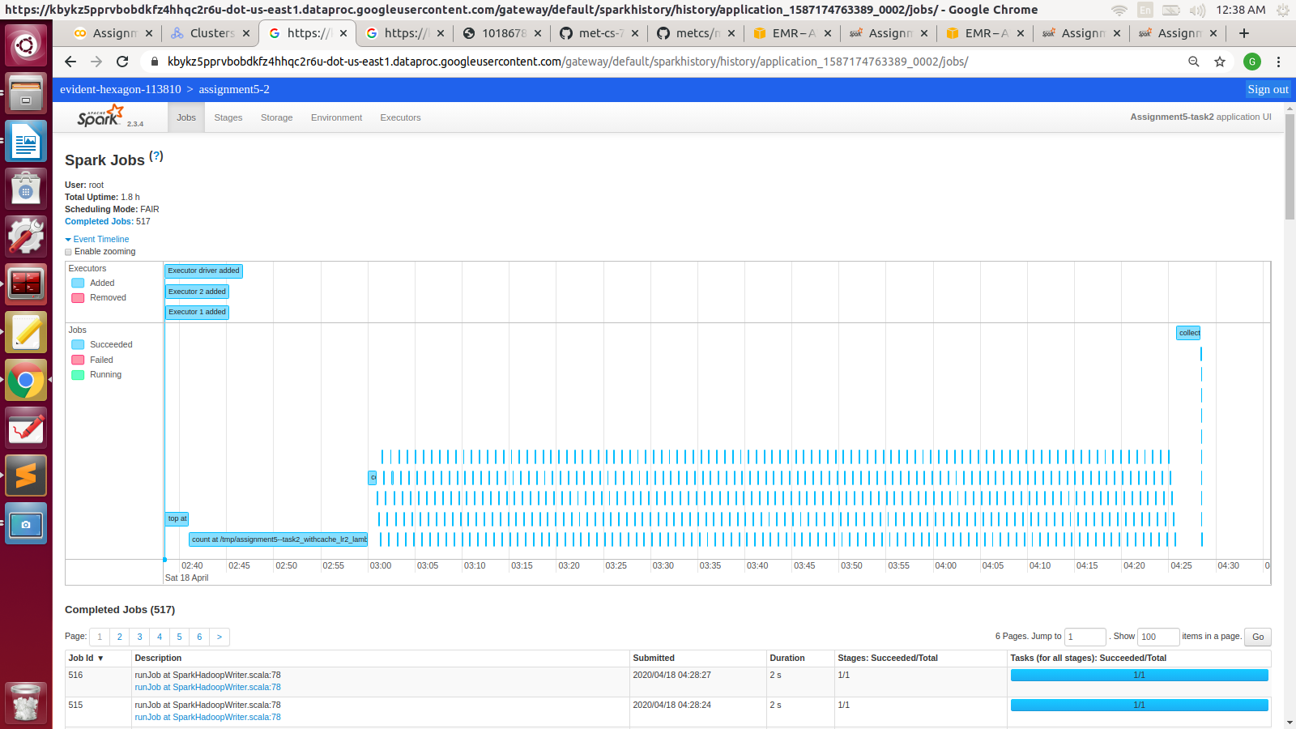

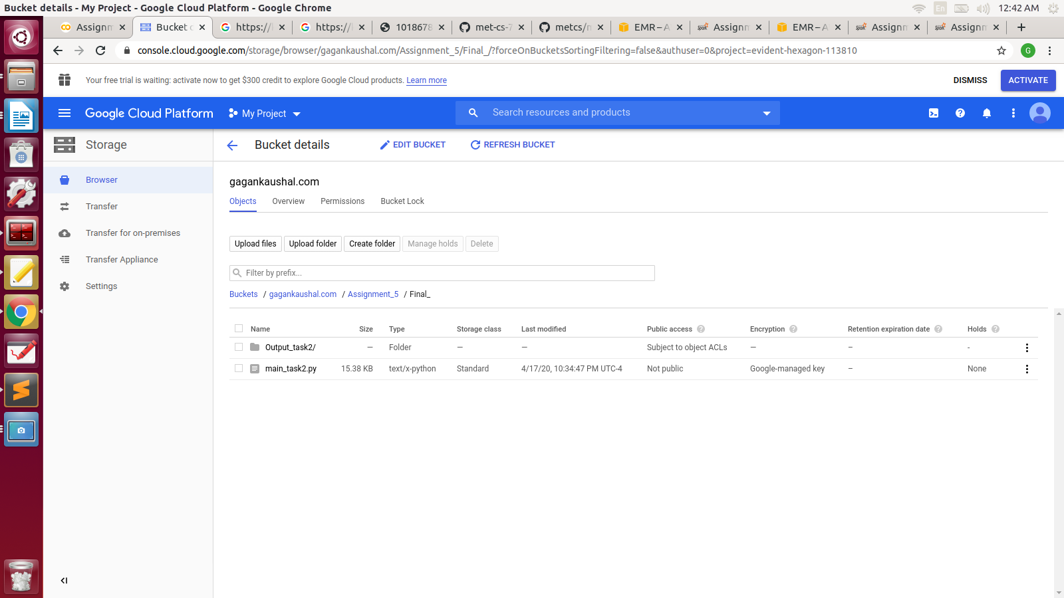

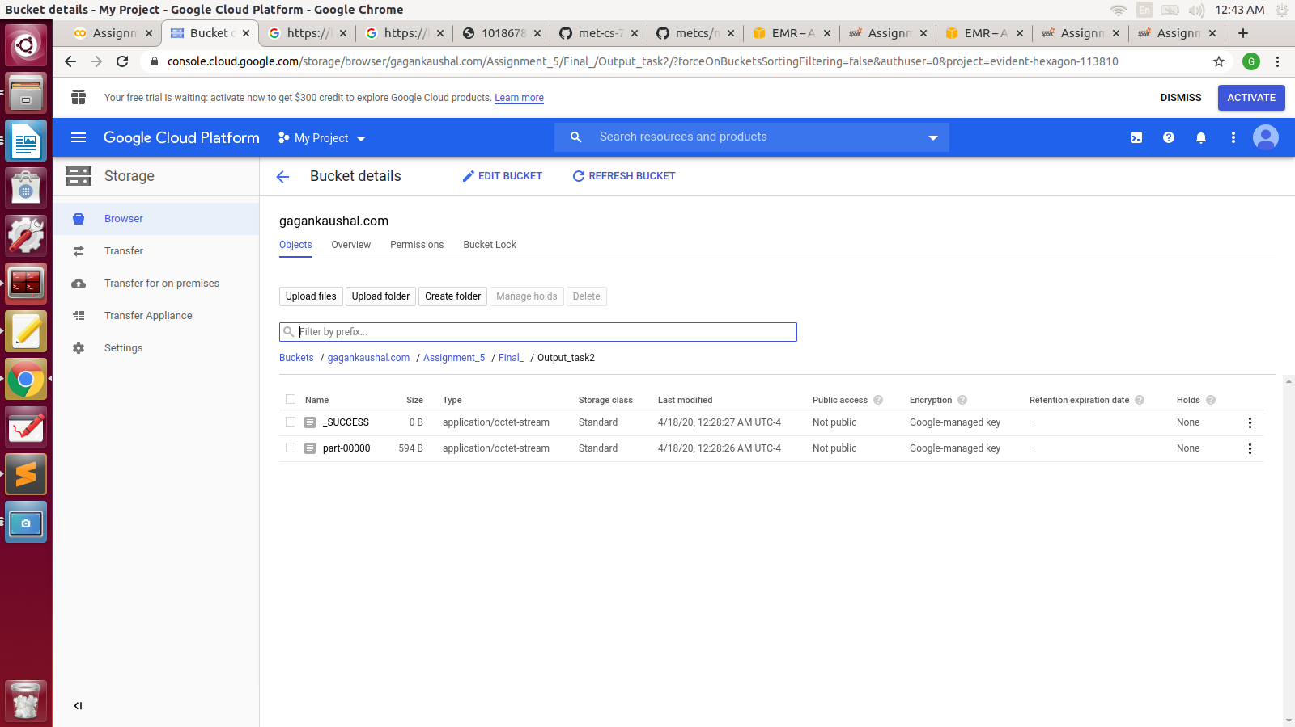

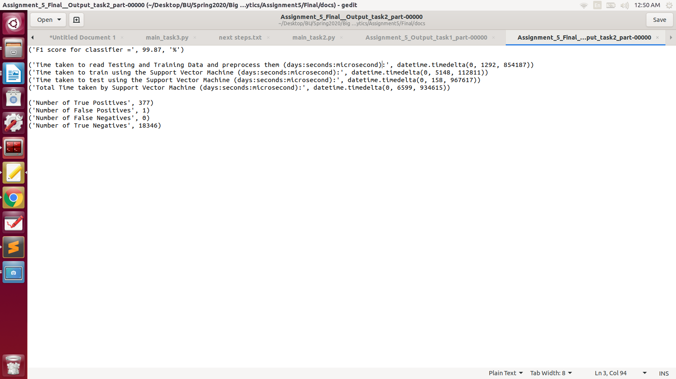

**P.T.O.**

**Task 3**

**App ID:** [application_1587164871837_0003](http://ec2-34-204-167-23.compute-1.amazonaws.com:18080/history/application_1587164871837_0003/1/jobs/)

