ADAPTIVE RESOURCE CONTRACT ENGINE (ARC)
Event-Driven OS Policy Engine

Course Project Report — BCSE303L Operating Systems

Submitted by
Gagan Kishore (24BDE0073)
Shikhar Sahay (24BYB0029)

Under the guidance of
Dr. Balasubramani M

SCHOOL OF COMPUTER SCIENCE, ENGINEERING AND INFORMATION SYSTEMS

Abstract
Modern operating systems expose several mechanisms for controlling system resources, including CPU scheduling priorities, CPU affinity, process control, and control groups (cgroups). While these mechanisms offer fine-grained control over individual processes and can be modified dynamically, they do not inherently provide a unified policy layer that adapts resource allocation to changing runtime conditions. This report presents the Adaptive Resource Contract Engine (ARC), an event-driven user-space policy engine that continuously monitors system conditions such as CPU utilization, memory usage, process activity, and battery status, and automatically enforces user-defined resource contracts. Each contract defines a trigger condition, one or more resource-management actions (process priority, CPU affinity, suspend/resume, cgroup limits), and a restoration rule that reverts the system to its previous state when the condition no longer holds. ARC coordinates existing Linux interfaces rather than replacing them, adding a lightweight policy abstraction with complete trigger-action-restoration lifecycle. The prototype is implemented in portable Python with explicit concurrency control and capability-aware degradation across Linux, macOS, and Windows (WSL). Experimental evaluation shows trigger-to-enforcement latency of 202.1 ms at a 0.2 s sampling interval with sub-millisecond jitter, engine overhead of 1.44% CPU at the default 1 Hz sampling rate, and 40/40 exact restorations of modified process state. Under CPU contention, contract-based priority enforcement raised a protected workload's CPU share from 67% to 99.6% of a core. The results demonstrate that event-driven contract enforcement can make OS resource management adaptive while remaining transparent and reversible.

1. Introduction and Literature Survey

1.1 Introduction
Operating systems manage CPU time, memory, and device access among competing processes. Linux provides scheduling priorities through nice and renice, CPU affinity through sched_setaffinity(2), resource isolation through cgroups, and observability through the /proc filesystem [1][2][7]. These interfaces are powerful and can be changed at runtime, but they remain low-level primitives: deciding when to change a priority, which processes to restrict, and when to undo a change is left entirely to administrators and scripts.
Modern workloads are dynamic. A developer compiling a large project temporarily needs more CPU, background applications should be deprioritized during the build and restored afterwards, and a laptop on low battery should restrict non-essential work until it is plugged in. Automating this with one-off shell scripts produces policies that are hard to maintain, coordinate, and reason about. ARC addresses this gap by treating resource-management requirements as explicit contracts with a defined lifecycle.

1.2 Literature Survey
Linux resource management. Process scheduling behavior can be influenced through nice and renice, while CPU affinity restricts processes to selected processors. Control groups extend resource management to groups of processes for CPU, memory, and I/O. The /proc filesystem exposes runtime information about processes and overall system state [1][2][7]. Together these facilities provide the observation and enforcement primitives required for adaptive resource management, but they operate as independent interfaces without a general policy model.
Existing automation tools. Ananicy and Ananicy-cpp use configurable rules to identify processes and automatically adjust CPU and I/O priorities, and can use cgroups for resource settings [3]. Their policy model is centered on identifying applications and assigning predefined settings. systemd-oomd monitors memory pressure and acts against selected workloads when configured thresholds are met [4], demonstrating event-oriented response but focused on memory exhaustion protection rather than a general policy framework. TuneD adjusts system parameters through workload-oriented profiles and monitoring plugins [5], organized around tuning profiles rather than independently defined contracts with a complete trigger-action-restoration lifecycle.
Research studies. Goodarzy et al. proposed SmartOS, which explores automated and user-adaptive allocation of system resources based on observed user preferences [6]. SmartOS relies on learning inferred preferences; ARC instead uses an explicit contract model where the user directly specifies conditions and desired behavior, making policies deterministic and inspectable without the complexity of preference learning.
Limitations and research gap. The technical building blocks for adaptive resource management already exist, and several tools demonstrate partial automation. However, monitoring and enforcement remain separate, policies are predominantly static, and no lightweight abstraction connects runtime conditions, resource actions, and restoration behavior within a single user-defined contract. ARC investigates exactly this gap: a policy layer that coordinates existing mechanisms rather than replacing them.

2. Problem Statement
Linux provides powerful mechanisms for process and resource management, including CPU scheduling, CPU affinity, cgroups, and process control. However, these mechanisms are generally configured independently and often require predefined or manual policies. The system does not inherently provide a unified mechanism that can continuously monitor runtime conditions, interpret user-defined resource contracts, detect relevant system events, and dynamically modify resource policies in response.
Research question: How can an event-driven policy engine dynamically enforce user-defined resource contracts on Linux based on changing runtime system conditions?
The problem addressed by this project is the coordination of runtime system monitoring, policy decisions, and resource enforcement. ARC aims to investigate whether these separate capabilities can be brought together through an event-driven policy layer that allows resource-management decisions to adapt automatically to changing system conditions.

2.1 Motivation
A resource allocation suitable for one workload may become inefficient when another application starts, CPU or memory pressure increases, or the system switches to battery operation. As the number of conditions and applications increases, manual policies become difficult to maintain and reason about. A contract can describe what should happen when a system condition occurs and what should happen when that condition no longer applies, allowing policy to follow the lifecycle of the workload. Academically, the project integrates process management, CPU scheduling, resource allocation, monitoring, concurrency, system calls, and protection into one real Linux system rather than a simulated environment.

3. Methodology and Design

3.1 Architecture
ARC is a user-space policy engine with five stages: monitoring, event detection, contract evaluation, enforcement, and restoration, with execution logging throughout. A sampler thread periodically observes the system and posts events to a thread-safe queue; a coordinator thread evaluates contracts and executes actions serially, so enforcement can never race monitoring.
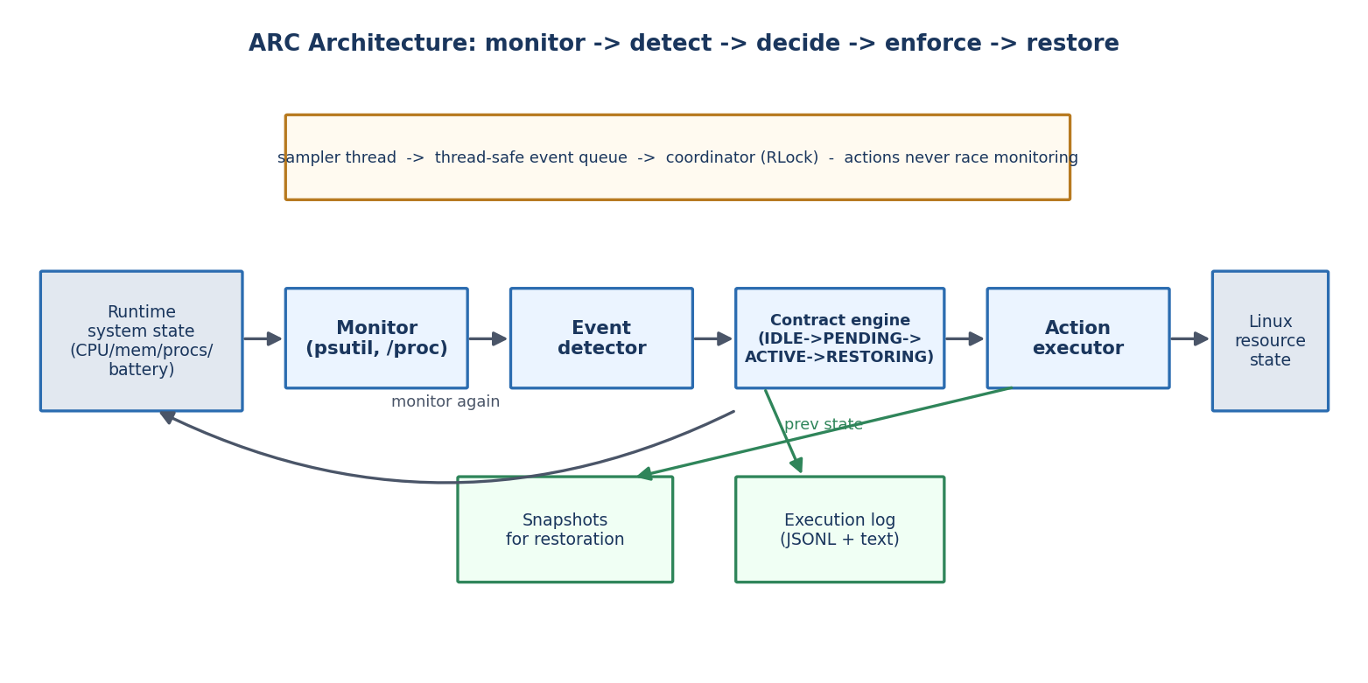
Figure 1: ARC architecture. Monitoring feeds event detection; the contract engine decides; the executor enforces through existing OS interfaces; snapshots enable restoration.

3.2 Contract Model
Each resource contract has three primary components: a trigger condition, one or more resource-management actions, and a restoration rule. Contracts are stored in human-readable YAML so users define policy without modifying engine source code. Trigger types include process appearance/disappearance (regex-matched against process names and command lines), metric thresholds (CPU percentage, memory percentage, load average, with hold-time semantics), and battery level. Actions include setting process priority (nice), setting CPU affinity, suspending and resuming processes, applying cgroup limits on Linux, and structured logging. The restoration rule defines when changes are reverted: when the trigger clears, after a timeout, or never (one-shot policies).

3.3 Contract Lifecycle and Restoration
Each contract runs a small state machine: IDLE, PENDING (condition held through the anti-flap debounce or hold window), ACTIVE (actions applied), and RESTORING (snapshots reverted). At activation ARC snapshots the previous nice value, affinity mask, and process state of every target. At restoration each change is reverted in reverse order, and each process is re-validated by PID and create-time to guard against PID reuse. A cooldown window prevents immediate re-triggering.
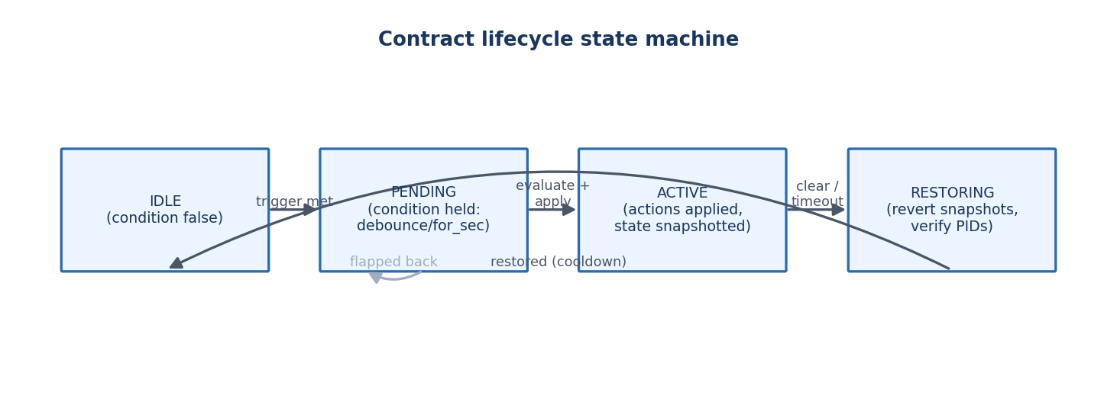
Figure 2: Per-contract lifecycle. Restoration returns the system to its pre-contract state.

3.4 Concurrency and Safety
The sampler thread only observes; the coordinator performs all resource changes, serialized through an event queue and a re-entrant lock guarding contract state. This satisfies the project's concurrency requirement: ARC continuously observes system state while potentially applying resource changes, without data races. On engine shutdown, any still-active contract is restored before exit, so temporary policies never persist accidentally.

3.5 Cross-Platform Strategy and Privilege Handling
The implementation is portable Python built on psutil, with a capability layer that detects platform features at startup. Linux and WSL support the full action set; macOS degrades gracefully where affinity is unavailable; Windows supports priority and affinity but not POSIX signal suspend. Several operations require elevated privileges (negative nice values, cgroups, and restoring a raised nice value on POSIX). ARC detects privileges at startup, clamps unprivileged nice changes to safe values, and logs skipped actions instead of failing.

4. Implementation Steps
The prototype was implemented as a modular Python package with seven components:
- platform_compat.py - capability detection (affinity, signals, cgroups, battery, privileges) so every action checks support before execution.
- monitors.py - real system monitor built on psutil (/proc on Linux) sampling CPU utilization, memory usage, load, battery status, and a full process table; and a synthetic monitor that replays scripted scenarios through the identical engine for deterministic demos.
- events.py - typed data structures for process snapshots, system samples, and engine events.
- contracts.py - YAML schema, validation with clear error messages, trigger predicates, and the per-contract lifecycle state machine.
- actions.py - action executors (set_nice, set_affinity, suspend, resume, cgroup_limit, log) with snapshot/restore records and PID-reuse safety checks.
- engine.py - sampler thread, event queue, coordinator, debounce and cooldown timing, and shutdown restoration.
- logger.py and cli.py - JSONL plus human-readable execution logs, and a command-line interface (validate, run, simulate, selftest, status, web).
- web.py - a zero-dependency live dashboard (arc web) showing CPU/memory/battery gauges, contract lifecycle states, managed processes with before/after resource state, and a streaming event feed, used for real-time demonstration of policy decisions.
Step-by-step workflow:
- Define contracts in YAML (see contracts/examples/full_suite.yaml) covering compilation boosting, CPU-overload guarding, battery saving, and memory-pressure guarding.
- Validate contracts with `python3 -m arc validate` before deployment.
- Run the engine with `sudo python3 -m arc run --contracts <file> --interval 1` on Linux/WSL, or replay a scenario with `python3 -m arc simulate` on any platform.
- Observe decisions in the execution log (trigger times, applied actions with before/after state, restoration results).
- Verify correctness with the test suite: 21 unit and integration tests covering schema validation, trigger semantics, debounce, timeout restoration, shutdown restoration, nice and affinity revert, PID-reuse safety, and end-to-end lifecycle.

5. Results and Discussion
Experiments were run on a Linux machine (2 logical CPUs, 2 GB RAM, kernel 6.1) with elevated privileges. The full experiment suite (experiments/run_experiments.py) is reproducible from the project repository.

5.1 Trigger-to-Enforcement Latency (E1)
Latency was measured from process spawn (ground truth) to the first enforced action, for different sampling intervals and debounce settings (10 trials each).
sampling interval | debounce | mean (ms) | stdev (ms) | min (ms) | max (ms)
0.2s|debounce=0.0 | 202.1 | 0.3 | 201.6 | 202.6
0.2s|debounce=0.2 | 402.6 | 0.8 | 402.0 | 404.8
0.5s|debounce=0.0 | 503.2 | 0.6 | 502.6 | 504.4
0.5s|debounce=0.2 | 1004.0 | 0.6 | 1003.1 | 1004.9
1.0s|debounce=0.0 | 1007.2 | 6.1 | 1004.9 | 1024.5
1.0s|debounce=0.2 | 2009.3 | 3.6 | 2006.3 | 2016.6

Latency is dominated by, and scales linearly with, the configured sampling interval; engine processing itself contributes less than a millisecond of jitter (standard deviation below 6 ms in all configurations). With zero debounce the engine responds within one sampling interval; the anti-flap debounce window adds exactly one evaluation cycle by design. Operators can therefore trade monitoring overhead against responsiveness deterministically.
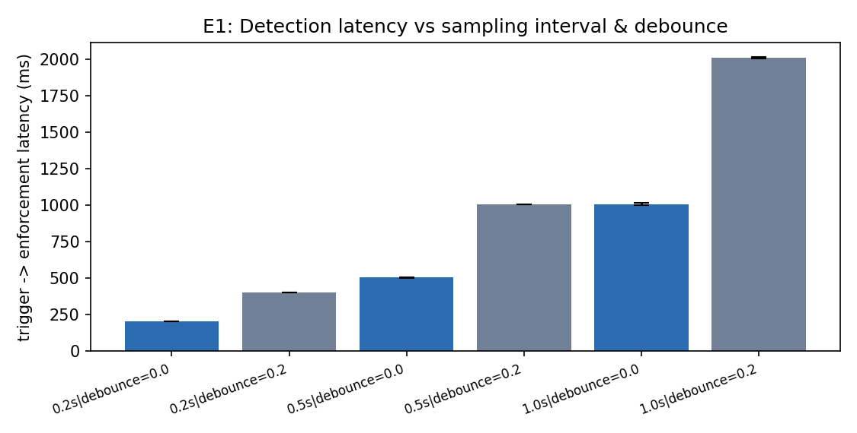
Figure 3: Detection latency versus sampling interval and debounce (mean ± stdev).

5.2 Engine Overhead (E2)
sampling interval | CPU % (mean) | CPU % (max) | RSS (MB)
0.5 | 2.56 | 3.0 | 18.6
1.0 | 1.44 | 2.0 | 18.6
2.0 | 0.75 | 1.5 | 18.6

With 20 background processes, ARC consumes 1.44% CPU and 18.6 MB RAM at the default 1 Hz sampling rate, falling to 0.75% at 0.5 Hz-equivalent (2 s) sampling. Overhead scales linearly with sampling frequency, so the engine is practical for continuous background operation alongside user workloads.
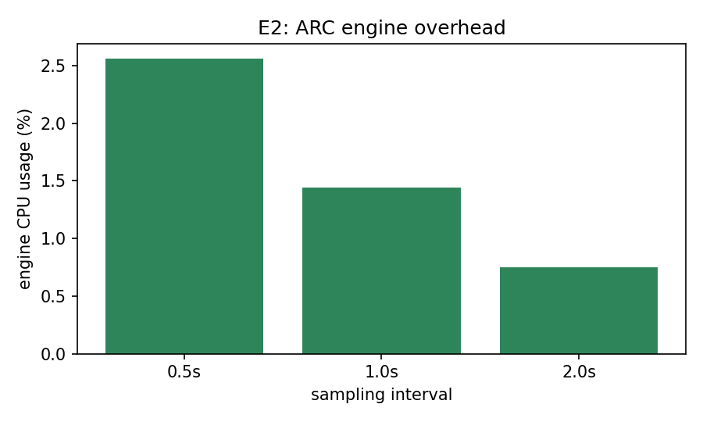
Figure 4: ARC CPU overhead versus sampling interval (20 background processes).

5.3 Restoration Correctness (E3)
In 40 independent trials, a process's priority and CPU affinity were modified by contract actions and then reverted when the contract deactivated. ARC restored the exact original state in 40 of 40 trials (100.0%). This validates the snapshot mechanism and the PID-reuse guard, and confirms the project's policy-restoration requirement: temporary policies do not unnecessarily persist.

5.4 Enforcement Efficacy (E4)
To quantify the effect of contract actions, a CPU-bound worker competed with two background CPU hogs on two cores under different priority configurations. The worker's CPU share over an 8 s window was:
configuration | worker CPU share (one core)
all-nice-0 | 67.1%
worker--5-hogs-0 | 99.6%
worker-0-hogs-19 | 99.6%
worker-19-hogs-0 | 13.9%

Without policy the worker received about 67% of a core under contention. Deprioritizing the background hogs (nice 19) or boosting the worker (nice -5) through contract actions raised the protected workload to more than 99% of a core, while deprioritizing the worker reduced it to under 14%. Contract actions therefore translate directly into measurable scheduling outcomes, confirming that ARC's enforcement layer meaningfully influences resource allocation.
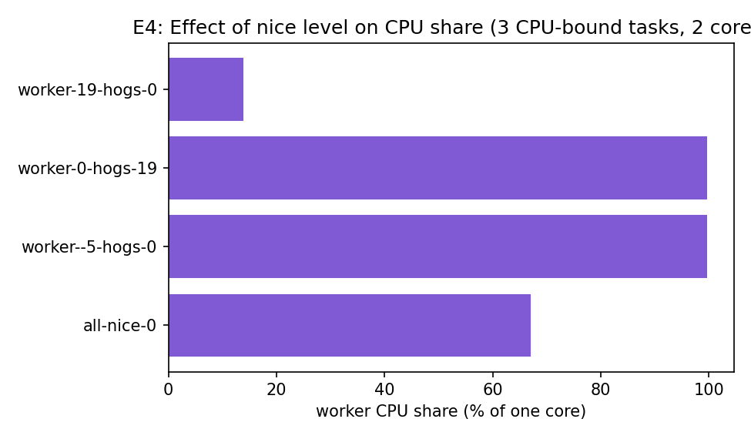
Figure 5: Worker CPU share under contention for different contract-enforced priority levels.

5.5 Live Contract Lifecycle (E5)
A full live contract was exercised with real processes and real actions: when a compiler process appeared, its priority was raised and a background workload was deprioritized; when the compiler exited, all changes were reverted. Trigger-to-first-action latency was 304.3 ms at the 0.2 s sampling interval, and the background workload's nice value returned exactly to its original value (restore exact: True). Figure 6 shows the observed lifecycle timeline.
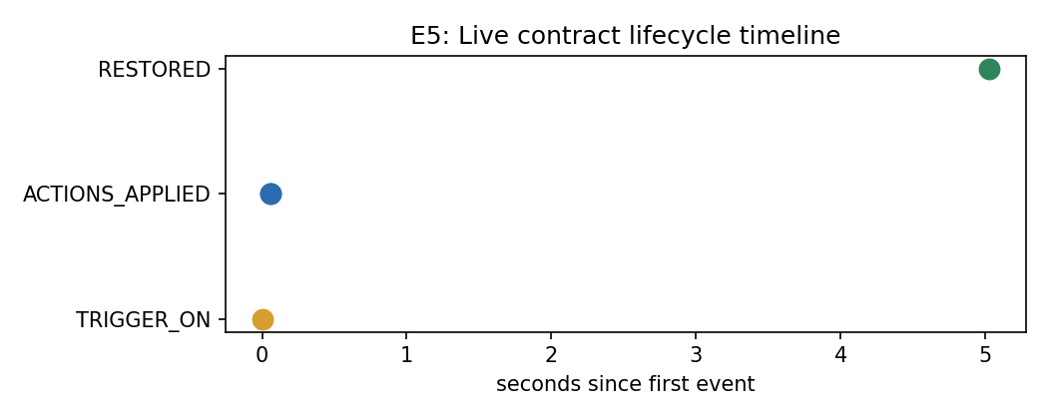
Figure 6: Live contract lifecycle: trigger, enforcement, restoration.

5.6 Memory-Pressure Contract (E6)
A contract monitored memory utilization and deprioritized the largest memory consumer when usage stayed above 55% for 2 s. During the experiment, memory rose from 25.4% to 70.0% under a real 900 MB allocation workload. The contract triggered (True), the hog's priority was changed to nice 10, and the change was restored (True) once the pressure cleared. This demonstrates the complete condition-to-restoration loop on a memory metric, matching the behavior of pressure-driven protectors such as systemd-oomd but within a general contract framework.

5.7 Discussion
The evaluation supports three claims. First, event-driven contract enforcement is fast enough for interactive resource management: sub-second at 1 Hz sampling, tunable to 200 ms at 5 Hz. Second, the engine is lightweight (under 3% CPU even at 5 Hz with a busy process table), so continuous monitoring is practical. Third, restoration is reliable and exact, addressing a common weakness of ad-hoc scripting where manual changes frequently persist after their justification has expired. Limitations include the sampling-based (rather than kernel-event) detection model, which bounds latency by the sampling interval, and privilege requirements for priority-raising actions on POSIX systems.

6. Conclusion and Future Work
This project designed, implemented, and evaluated ARC, an event-driven policy engine that brings monitoring, event detection, contract evaluation, dynamic resource control, and policy restoration into a single user-space layer over existing Linux mechanisms. The prototype delivers the complete contract lifecycle - activation from a system condition through restoration when the condition no longer holds - with observable logs, explicit concurrency control, capability-aware cross-platform behavior, and exact restoration verified in experimentation. ARC demonstrates how operating-system concepts including process management, CPU scheduling, resource allocation, system calls, monitoring, concurrency, and protection combine in a practical system.
Future work includes: additional event sources (network usage, disk I/O, temperature); richer resource controls (I/O priority, memory.high limits); conflict resolution between overlapping contracts; a graphical or curses-based management interface; kernel-event integration (proc connectors, eBPF) to reduce detection latency below the sampling bound; and packaging ARC as a systemd service. With broader evaluation, the work could be extended toward a conference or journal publication as encouraged by the course's expected research outcomes.

References
[1] Linux Kernel Documentation, "Control Group v2." https://www.kernel.org/doc/html/latest/admin-guide/cgroup-v2.html
[2] Linux Kernel Documentation, "The /proc Filesystem." https://www.kernel.org/doc/html/latest/filesystems/proc.html
[3] Ananicy-cpp, "Ananicy-cpp: An Auto Nice Daemon." https://github.com/CachyOS/ananicy-cpp
[4] systemd, "systemd-oomd.service." https://www.freedesktop.org/software/systemd/man/latest/systemd-oomd.service.html
[5] TuneD Project, "TuneD Documentation." https://tuned-project.org/docs/
[6] S. Goodarzy, M. Nazari, R. Han, E. Keller, and E. Rozner, "SmartOS: Towards Automated Learning and User-Adaptive Resource Allocation in Operating Systems," in Proc. ACM SIGOPS Asia-Pacific Workshop on Systems (APSys), 2021.
[7] M. Kerrisk, "sched_setaffinity(2) - Linux man-pages." https://man7.org/linux/man-pages/man2/sched_setaffinity.2.html
[8] W. M. Stevens and S. A. Rago, Advanced Programming in the UNIX Environment, 3rd ed. Addison-Wesley, 2013.
[9] psutil Developers, "psutil - Cross-platform lib for process and system utilities in Python." https://psutil.readthedocs.io

