DAYANAND SAGAR UNIVERSITY
(Affiliated to Dayanand Sagar University, Bengaluru)


⸻

TRAINING PROJECT REPORT ON PRODUCT INVENTORY

SUBMITTED BY
Vijay Kumar D SCA25MCA149 Tanushree M Reddy SCA24MCA143 T Gagan Mudagre SCA25MCA142 Tenzin Gaphel SCA25MCA144

PRODUCT INVENTORY INDEX

- Objective of the Project
- Scope of the Project 3.Feasibility Study
- Existing System
- Proposed System
- System Design
- Entity–Relationship Diagram
- Database Design Screenshots
- Coding
- Application Screenshots
- Conclusion
- Future Enhancement

Objective of the Project
The primary objective of the Product Inventory System is to design and develop an efficient and reliable software application that helps in managing inventory, products, customers, and orders in an organized manner. In traditional systems, inventory management is often handled manually, which leads to errors, inefficiency, and difficulty in
maintaining accurate records. This project aims to overcome these issues by providing a computerized solution.

The system enables the administrator to manage inventory details such as adding new inventory locations, updating
product information, and maintaining stock levels. It also
allows customers to log in, view available products, and place orders easily. The system ensures that stock quantities are updated automatically after every transaction, thereby
reducing the chances of overstocking or stock shortages.

Another important objective of this project is to improve data accuracy and accessibility. By storing all information in a
centralized database, the system allows quick retrieval and updating of data. It also enhances decision-making by
providing real-time information about product availability and order status.

Overall, the project aims to create a user-friendly, efficient, and scalable inventory management system that reduces manual effort, saves time, and improves productivity.

Scope of the Project
The scope of the Product Inventory System includes the
development of a console-based application that manages various aspects of inventory and order processing. The system is designed primarily for small and medium-sized businesses that require a simple yet effective solution for managing their stock and customer transactions.

The system covers key functionalities such as inventory
management, product management, customer management, and order processing. The administrator has the ability to add, update, and view inventory and product details.
Customers can register, log in, browse products, and place
orders. The system also maintains order history and detailed transaction records.

The application is limited to a single-user environment where the admin and customers interact through a command-line interface. It uses a MySQL database to store and retrieve information, ensuring data consistency and integrity. The system supports basic CRUD (Create, Read, Update, Delete)

operations and maintains relationships between different entities such as products, customers, and orders.

Although the current system is console-based, it can be
extended in the future to include graphical user interfaces, web-based access, and mobile compatibility. The project lays a strong foundation for further enhancements such as real- time analytics, reporting, and advanced security features.

Feasibility Study
The feasibility study of the Product Inventory System evaluates whether the project is practical and beneficial in terms of technical, economic, and operational aspects.

From a technical perspective, the system is feasible as it uses widely available technologies such as Java and MySQL. These technologies are easy to learn, implement, and maintain. The development environment does not require any specialized hardware or software, making it suitable for students and
small-scale developers.

Economically, the project is highly feasible because it involves minimal cost. The tools used, such as Java Development Kit (JDK) and MySQL, are open-source and freely available. There is no need for expensive licenses or infrastructure, which
makes the system cost-effective.

Operational feasibility is also high because the system is
designed with a simple and user-friendly interface. Users can easily navigate through the menu options and perform
operations without requiring advanced technical knowledge. The automation of inventory and order management reduces manual work and improves efficiency.
Thus, considering all these factors, the Product Inventory System is a feasible project that can be successfully
implemented and used in real-world scenarios.

Existing System
In the existing system, inventory management is typically carried out manually using paper- based records or basic
spreadsheets. This approach is time-consuming and prone to human errors. Maintaining accurate records of products,
stock levels, and customer orders becomes difficult, especially as the volume of data increases.

One of the major drawbacks of the existing system is the lack of real-time updates. For example, when a product is sold,
the stock is not updated immediately, leading to
inconsistencies in data. This can result in overstocking or stock shortages, affecting business operations.

Another issue is the difficulty in retrieving information. Searching for specific product or customer details in manual records requires significant time and effort. There is also a risk of data loss due to damage or misplacement of physical records.
Security is another concern in the existing system. Sensitive information such as customer details and transaction records are not well protected. Additionally, there is no proper mechanism for tracking orders or generating reports.
Overall, the existing system is inefficient, unreliable, and not suitable for modern business requirements, which highlights the need for an automated solution.

Proposed System
The proposed system is a computerized Product Inventory System designed to overcome the limitations of the existing manual system. It provides an efficient and reliable way to manage inventory, products, customers, and orders using a centralized database.

In this system, the administrator can easily add and manage inventory and product details. The system allows updating product prices, quantities, and other relevant information.
Customers can log in using their credentials, view available products, and place orders conveniently.

One of the key features of the proposed system is real-time data processing. Whenever an order is placed, the system automatically updates the stock levels in the database. This ensures accuracy and prevents issues such as overstocking or stock shortages.

The system also provides better data security and integrity by storing information in a structured database. It reduces manual work, minimizes errors, and improves overall
efficiency. Additionally, the system is scalable and can be enhanced with additional features such as graphical
interfaces, online payment systems, and advanced reporting tools.
Thus, the proposed system offers a modern, efficient, and user-friendly solution for inventory management.

System Design
The system design of the Product Inventory System is based on a modular and structured approach. The system is divided into different layers and modules to ensure better
organization, maintainability, and scalability.

The application consists of three main layers: the
presentation layer, the business logic layer, and the database layer. The presentation layer is responsible for interacting
with the user through a console-based interface. The

business logic layer contains the core functionalities of the system, such as processing user inputs, managing operations, and handling transactions. The database layer is responsible for storing and retrieving data using MySQL.

The system is further divided into modules such as Admin Module, Customer Module, Product Module, and Order Module. Each module performs specific tasks. For example, the Admin Module manages inventory and product details, while the Customer Module handles user login and order
placement.
The design ensures that all components of the system work together efficiently. It also makes it easier to update or modify individual modules without affecting the entire system.

Figure: System design block diagram.

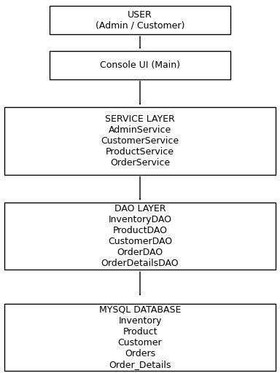

Entity–Relationship Diagram
The Entity–Relationship (ER) Diagram represents the structure of the database and the relationships between
different entities in the system. It helps in understanding how data is organized and how different tables are connected.

The main entities in the Product Inventory System are Inventory, Product, Customer, Orders, and Order Details. Each entity has its own set of attributes. For example, the Product entity includes attributes such as product_id, product_name, brand, price, and quantity.

The relationships between entities are defined as follows:
One inventory can contain multiple products (one-to-many relationship). A customer can place multiple orders, and each order can contain multiple products through the order details table.
The order details entity acts as a bridge between orders and products.

The ER diagram ensures that the database is properly structured and avoids data redundancy. It also helps in
maintaining data integrity by defining primary and foreign key relationships.

Figure: Entity–Relationship Diagram of Product Inventory System

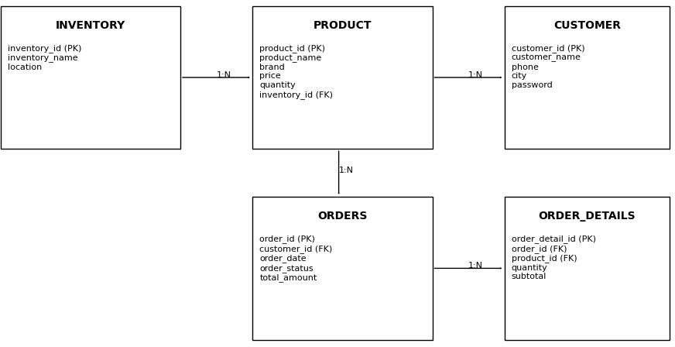

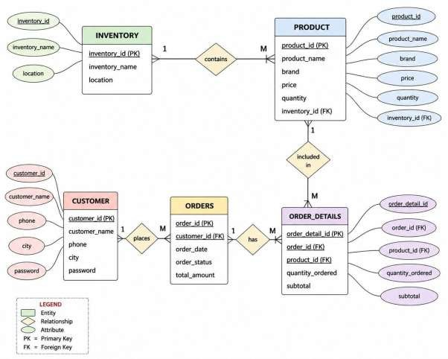

Database Design Screenshots
The database design of the Product Inventory System is
implemented using MySQL. It consists of multiple tables such as inventory, product, customer, orders, and order_details.
Each table is designed with appropriate fields, data types, and constraints.

The inventory table stores information about inventory
locations. The product table contains details about products, including price and quantity. The customer table stores user information such as name, phone number, and password. The

orders table maintains order details, while the order_details table stores information about individual products in each
order.

Screenshots of these tables can be captured from MySQL Workbench or any database management tool. These
screenshots provide a visual representation of the database structure and help in understanding how data is stored.

Coding
The coding part of the project is implemented using Java
programming language with JDBC for database connectivity. The system consists of multiple classes such as Main,
WarehouseOperations, and DBConnection.

The Main class serves as the entry point of the application and provides a menu-driven interface. The
WarehouseOperations class contains all the business logic, including admin operations, customer operations, and order processing. The DBConnection class is responsible for
establishing a connection with the MySQL database.

The code is structured in a modular way, making it easy to understand and maintain. Proper exception handling is used to manage errors during database operations. The use of
prepared statements ensures security and prevents SQL injection.

Implementation Details
The system is implemented using Java (JDBC) for backend
logic and MySQL for database management. The application follows a modular and layered approach, similar to industry-level projects.

Business Logic Class (WarehouseOperations.java)
package project;
//WarehouseOperations.java

import java.sql.*; import java.util.Scanner;

public class WarehouseOperations
{
Scanner sc = new Scanner(System.in);

// ================= ADMIN LOGIN =================

//================= ADMIN LOGIN =================

public void adminLogin() throws Exception
{
sc.nextLine();

System.out.println("\n========= WAREHOUSE INCHARGE LOGIN =========");

System.out.println("Enter Username:"); String username = sc.nextLine();

System.out.print("Enter Password: ");

String password = "";

while(true)
{
char ch = (char)System.in.read();

if(ch == '\n' || ch == '\r')
{
break;
}

password += ch;

System.out.print("*");
}

System.out.println();

if(username.equals("admin") && password.equals("admin123"))
{
System.out.println("\nLogin Successful");

adminMenu();
}

else
{
System.out.println("Invalid Login");
}
}
// ================= ADMIN MENU =================

public void adminMenu()
{
while(true)
{
System.out.println("\n========= WAREHOUSE INCHARGE MENU =========");

System.out.println("1. Add Inventory");

System.out.println("2. Add Product"); System.out.println("3. Add Customer"); System.out.println("4. Display Products"); System.out.println("5. Delete Product "); System.out.println("6. View Order By Order ID"); System.out.println("7. Logout");

System.out.println("\nEnter Choice:");

int choice = sc.nextInt();

switch(choice)
{
case 1:
addInventory(); break;

case 2:
addProduct(); break;

case 3:
addCustomer(); break;

case 4:
viewProducts(); break;

case 5:
deleteProduct(); break;

case 6:
viewOrderById(); break;

case 7:
return;

default:
System.out.println("Invalid Choice");
}
}
}

// ================= ADD INVENTORY =================

public void addInventory()
{
try
{
Connection con = DBConnection.getConnection();

System.out.println("Enter Inventory ID:"); int id = sc.nextInt();

sc.nextLine();

System.out.println("Enter Inventory Name:"); String name = sc.nextLine();

System.out.println("Enter Location:"); String location = sc.nextLine();

String query =
"insert into inventory values(?,?,?)";

PreparedStatement pst = con.prepareStatement(query);

pst.setInt(1, id); pst.setString(2, name); pst.setString(3, location);

pst.executeUpdate();

System.out.println("\nInventory Added Successfully");

con.close();
}

catch(Exception e)
{
System.out.println(e);

}
}

// ================= ADD PRODUCT =================

public void addProduct()
{
try
{
Connection con = DBConnection.getConnection();

System.out.println("Enter Product ID:"); int id = sc.nextInt();
sc.nextLine();

System.out.println("Enter Product Name:"); String name = sc.nextLine();

System.out.println("Enter Brand:"); String brand = sc.nextLine();

System.out.println("Enter Price:"); double price = sc.nextDouble();

System.out.println("Enter Quantity:"); int quantity = sc.nextInt();

System.out.println("Enter Inventory ID:");

int inventoryId = sc.nextInt();

String query =
"insert into product values(?,?,?,?,?,?)";

PreparedStatement pst = con.prepareStatement(query);

pst.setInt(1, id); pst.setString(2, name); pst.setString(3, brand); pst.setDouble(4, price); pst.setInt(5, quantity); pst.setInt(6, inventoryId);

pst.executeUpdate();

System.out.println("\nProduct Added Successfully");

con.close();
}

catch(Exception e)
{
System.out.println(e);
}
}

// ================= ADD CUSTOMER =================

public void addCustomer()
{
try
{
Connection con = DBConnection.getConnection();

System.out.println("Enter Customer ID:"); int id = sc.nextInt();
sc.nextLine();

System.out.println("Enter Customer Name:"); String name = sc.nextLine();

System.out.println("Enter Phone:"); String phone = sc.nextLine();

System.out.println("Enter City:"); String city = sc.nextLine();

System.out.println("Enter Password:"); String password = sc.nextLine();

String query =
"insert into customer values(?,?,?,?,?)";

PreparedStatement pst =

con.prepareStatement(query);

pst.setInt(1, id); pst.setString(2, name); pst.setString(3, phone); pst.setString(4, city); pst.setString(5, password);

pst.executeUpdate();

System.out.println("\nCustomer Added Successfully");

con.close();
}

catch(Exception e)
{
System.out.println(e);
}
}

// ================= DISPLAY PRODUCTS =================

public void viewProducts()
{
try
{
Connection con = DBConnection.getConnection();

String query =
"select * from product";

Statement st = con.createStatement();

ResultSet rs = st.executeQuery(query);

System.out.println("\n============================================================
=======================================");

System.out.printf("%-10s %-30s %-20s %-15s %-10s\n", "ID",
"PRODUCT NAME", "BRAND",
"PRICE",
"QUANTITY");

System.out.println("==============================================================
=====================================");

while(rs.next())
{
System.out.printf("%-10d %-30s %-20s %-15.2f %-10d\n",

rs.getInt("product_id"),

rs.getString("product_name"),

rs.getString("brand"),

rs.getDouble("price"),

rs.getInt("quantity"));
}

System.out.println("==============================================================
=====================================");

con.close();
}

catch(Exception e)
{
System.out.println(e);
}
}

//================= DELETE PRODUCT =================

public void deleteProduct()
{
try
{

Connection con = DBConnection.getConnection();

viewProducts();

System.out.print("\nEnter Product ID To Delete: "); int productId = sc.nextInt();

// CHECK IF PRODUCT EXISTS IN ORDER_DETAILS
String checkQuery =
"select * from order_details where product_id=?";

PreparedStatement checkStmt = con.prepareStatement(checkQuery);

checkStmt.setInt(1, productId);

ResultSet rs = checkStmt.executeQuery();

if(rs.next())
{
System.out.println("\nCannot delete this product."); System.out.println("It is already used in orders.");

return;
}

// DELETE PRODUCT
String deleteQuery =

"delete from product where product_id=?";

PreparedStatement pst = con.prepareStatement(deleteQuery);

pst.setInt(1, productId);

int rows = pst.executeUpdate();

if(rows > 0)
{
System.out.println("\nProduct Deleted Successfully");
}
else
{
System.out.println("\nProduct Not Found");
}

con.close();
}
catch(Exception e)
{
System.out.println(e);
}
}
// ================= VIEW ORDER BY ID =================

public void viewOrderById()

{
try
{
Connection con = DBConnection.getConnection();

System.out.println("Enter Order ID:"); int orderId = sc.nextInt();

String query =
"select o.order_id, c.customer_name, p.product_name, od.quantity_ordered, od.subtotal, o.order_date " +
"from orders o " +
"join customer c on o.customer_id = c.customer_id " + "join order_details od on o.order_id = od.order_id " + "join product p on od.product_id = p.product_id " + "where o.order_id=?";

PreparedStatement pst = con.prepareStatement(query);

pst.setInt(1, orderId);

ResultSet rs = pst.executeQuery();

boolean found = false;

System.out.println("\n================ ORDER DETAILS ================\n");

while(rs.next())
{
found = true;

System.out.println("Order ID : " + rs.getInt(1)); System.out.println("Customer Name : " + rs.getString(2)); System.out.println("Product Name : " + rs.getString(3)); System.out.println("Quantity : " + rs.getInt(4)); System.out.println("Subtotal : " + rs.getDouble(5)); System.out.println("Order Date : " + rs.getDate(6));

System.out.println(" ");
}

if(found == false)
{
System.out.println("Order Not Found");
}

con.close();
}

catch(Exception e)
{
System.out.println(e);
}
}

// ================= CUSTOMER LOGIN =================

//================= CUSTOMER LOGIN =================

public void customerLogin() throws Exception
{
try
{
sc.nextLine();

Connection con = DBConnection.getConnection();

System.out.println("\n========= CUSTOMER LOGIN =========");

System.out.println("Enter Phone Number:"); String phone = sc.nextLine();

System.out.print("Enter Password: ");

String password = "";

while(true)
{
char ch = (char)System.in.read();

if(ch == '\n' || ch == '\r')
{
break;

}

password += ch;

System.out.print("*");
}

System.out.println();

String query =
"select * from customer where phone=? and password=?";

PreparedStatement pst = con.prepareStatement(query);

pst.setString(1, phone); pst.setString(2, password);

ResultSet rs = pst.executeQuery();

if(rs.next())
{
int customerId = rs.getInt("customer_id");

System.out.println("\nLogin Successful");

customerMenu(customerId);
}

else
{
System.out.println("Invalid Login");
}

con.close();
}

catch(Exception e)
{
System.out.println(e);
}
}
// ================= CUSTOMER MENU =================

public void customerMenu(int customerId)
{
while(true)
{
System.out.println("\n========= CUSTOMER MENU =========");

System.out.println("1. View Available Products"); System.out.println("2. Place New Order"); System.out.println("3. View My Orders"); System.out.println("4. View My Order Details");

System.out.println("5. Logout");

System.out.println("\nEnter Choice:");

int choice = sc.nextInt();

switch(choice)
{
case 1:
viewProducts(); break;

case 2:
placeOrder(customerId); break;

case 3:
viewMyOrders(customerId); break;

case 4:
viewMyOrderDetails(customerId); break;

case 5:
return;

default:

System.out.println("Invalid Choice");
}
}
}

// ================= PLACE ORDER =================

public void placeOrder(int customerId)
{
try
{
Connection con = DBConnection.getConnection();

viewProducts();

int orderId = 1019;

String idQuery =
"select max(order_id) from orders";

Statement st = con.createStatement();

ResultSet rsId = st.executeQuery(idQuery);

if(rsId.next() && rsId.getInt(1) != 0)
{

orderId = rsId.getInt(1) + 1;
}

int detailId = 5000;

String detailQueryId =
"select max(order_detail_id) from order_details";

ResultSet rsDetail = st.executeQuery(detailQueryId);

if(rsDetail.next() && rsDetail.getInt(1) != 0)
{
detailId = rsDetail.getInt(1) + 1;
}

System.out.println("\nGenerated Order ID: " + orderId);

System.out.println("Enter Product ID:"); int productId = sc.nextInt();

System.out.println("Enter Quantity:"); int quantity = sc.nextInt();

String query =
"select * from product where product_id=?";

PreparedStatement pst = con.prepareStatement(query);

pst.setInt(1, productId);

ResultSet rs = pst.executeQuery();

if(rs.next())
{
int stock = rs.getInt("quantity");

String productName = rs.getString("product_name");

String brand = rs.getString("brand");

double price = rs.getDouble("price");

if(stock >= quantity)
{
double total = quantity * price;

String orderQuery =
"insert into orders values(?,?,?,?,?)";

PreparedStatement pst2 = con.prepareStatement(orderQuery);

pst2.setInt(1, orderId);

pst2.setInt(2, customerId);

pst2.setDate( 3,
new java.sql.Date( System.currentTimeMillis())
);

pst2.setString(4, "Dispatched");

pst2.setDouble(5, total);

pst2.executeUpdate();

String detailQuery =
"insert into order_details values(?,?,?,?,?)";

PreparedStatement pst3 = con.prepareStatement(detailQuery);

pst3.setInt(1, detailId); pst3.setInt(2, orderId); pst3.setInt(3, productId); pst3.setInt(4, quantity); pst3.setDouble(5, total);

pst3.executeUpdate();

int newStock = stock - quantity;

String updateQuery =
"update product set quantity=? where product_id=?";

PreparedStatement pst4 = con.prepareStatement(updateQuery);

pst4.setInt(1, newStock); pst4.setInt(2, productId);

pst4.executeUpdate();

// ================= BILL =================

System.out.println("\n========================================================");

System.out.println(" CUSTOMER BILL");

System.out.println("========================================================");

System.out.println("Order ID : " + orderId);

System.out.println("Customer ID : " + customerId);

System.out.println("Date : " +
new java.sql.Date(System.currentTimeMillis()));

System.out.println(" ");

System.out.println("Product Name : " + productName);

System.out.println("Brand : " + brand);

System.out.println("Price : " + price);

System.out.println("Quantity : " + quantity);

System.out.println(" ");

System.out.println("Total Amount : " + total);

System.out.println("Order Status : Dispatched");

System.out.println("========================================================");

System.out.println(" THANK YOU FOR SHOPPING WITH US");

System.out.println("========================================================");

System.out.println("\nRemaining Stock: " + newStock);
}

else
{
System.out.println("Insufficient Stock");
}
}

else
{
System.out.println("Product Not Found");
}

con.close();
}

catch(Exception e)
{
System.out.println(e);
}
}

// ================= VIEW MY ORDERS =================

public void viewMyOrders(int customerId)
{
try
{
Connection con = DBConnection.getConnection();

String query =
"select * from orders where customer_id=?";

PreparedStatement pst = con.prepareStatement(query);

pst.setInt(1, customerId);

ResultSet rs = pst.executeQuery();

boolean found = false;

System.out.println("\n================ MY ORDERS ================\n");

while(rs.next())
{
found = true;

System.out.println( "Order ID : " +

rs.getInt("order_id") +

" | Date : " + rs.getDate("order_date") +

" | Status : " + rs.getString("order_status") +

" | Total : " + rs.getDouble("total_amount")
);
}

if(found == false)
{
System.out.println("No Orders Yet");
}

con.close();
}

catch(Exception e)
{
System.out.println(e);
}
}

// ================= VIEW ORDER DETAILS =================

public void viewMyOrderDetails(int customerId)
{
try
{
Connection con = DBConnection.getConnection();

String query =
"select od.order_id, p.product_name, od.quantity_ordered, od.subtotal " + "from order_details od " +
"join orders o on od.order_id = o.order_id " +
"join product p on od.product_id = p.product_id " + "where o.customer_id=?";

PreparedStatement pst = con.prepareStatement(query);

pst.setInt(1, customerId);

ResultSet rs = pst.executeQuery();

boolean found = false;

System.out.println("\n================ MY ORDER DETAILS ================\n");

while(rs.next())
{

found = true;

System.out.println( "Order ID : " + rs.getInt(1) +

" | Product : " + rs.getString(2) +

" | Quantity : " + rs.getInt(3) +

" | Subtotal : " + rs.getDouble(4)
);
}

if(found == false)
{
System.out.println("No Order Details Yet");
}

con.close();
}

catch(Exception e)
{
System.out.println(e);

}
}
}

Major Functional Modules
- Admin (Warehouse Incharge) Module
This module allows the admin to manage the entire inventory system. Functionalities:
  - Admin login authentication
  - Add new inventory locations
  - Add new products to the system
  - Add/register customers
  - View all available products in formatted form
  - Delete products from inventory (with validation)
  - View complete order details using Order ID
- Customer Module
This module provides features for customers to interact with the system. Functionalities:
  - Login using phone number and password
  - View product list with price and availability
  - Place new orders
  - View all previous orders
  - View detailed order history

- Order Processing Module
This module handles the complete lifecycle of an order. Functionalities:
  - Automatically generates unique Order IDs
  - Validates stock availability before placing order
  - Calculates total bill dynamically
  - Inserts data into orders and order_details tables
  - Updates product quantity after order placement
  - Generates a formatted bill for the customer

- Product Management Module
This module deals with product-related operations. Functionalities:
  - Display products in structured tabular format
  - Add new products with price and quantity
  - Delete products (only if not used in orders)

  - Maintain real-time stock updates
- Order Status Management
The system dynamically determines order status based on time. Logic:
  - Orders placed within 2 days → Dispatched
  - Orders after 2 days → Delivered
This avoids unnecessary database updates and improves efficiency.

- Database Interaction (JDBC)
The class uses JDBC to interact with the database. Operations performed:
  - Insert (Add Product, Customer, Inventory)
  - Select (View Products, Orders)
  - Update (Reduce stock after order)
  - Delete (Remove product)
Key Features of the Class
  - Modular and well-structured design
  - Uses PreparedStatement for secure queries
  - Ensures data integrity using foreign key constraints
  - Handles exceptions properly
  - Provides user-friendly console output
  - Supports role-based access (Admin & Customer)

Advantages
  - Real-time inventory updates
  - Prevents invalid operations (like deleting used products)
  - Efficient order processing system
  - Easy to maintain and extend
  - Suitable for small to medium warehouse systems

Main Class (Main.java)
This is the entry point of the application. It provides a menu-driven interface for Admin and Customer login.
Code:
import java.util.Scanner;

public class Main
{
public static void main(String args[])
{
Scanner sc = new Scanner(System.in);

WarehouseOperations wo = new WarehouseOperations();

while(true)
{
System.out.println("\n===== WAREHOUSE INVENTORY SYSTEM =====");

System.out.println("1. Customer Login"); System.out.println("2. Admin Login"); System.out.println("3. Exit");

System.out.println("Enter Choice:"); int choice = sc.nextInt();
switch(choice)
{
case 1:
wo.customerLogin(); break;

case 2:
wo.adminLogin(); break;

case 3:
System.exit(0);

default:
System.out.println("Invalid Choice");
}
}

}
}
Explanation
- Displays main menu
- Redirects user to Admin or Customer module
- Uses infinite loop for continuous execution

Business Logic Class
This is the core class of the system. It handles:
- Admin operations
- Customer operations
- Order processing
- Database interactions Key Functionalities
- Admin Module
  - Login validation (static credentials)
  - Add Inventory
  - Add Product
  - Add Customer
  - View Products
- Customer Module
  - Login using phone & password

  - View products
  - Place orders
  - View order history
- Order Processing
  - Auto-generates Order ID
  - Checks stock availability
  - Updates product quantity
  - Stores order & order details

Database Connectivity (DBConnection.java)
This class is responsible for establishing connection with MySQL database using JDBC. Code:
import java.sql.Connection; import java.sql.DriverManager;

public class DBConnection
{
public static Connection getConnection()
{
Connection con = null;

try
{
Class.forName("com.mysql.cj.jdbc.Driver");

con = DriverManager.getConnection(

"jdbc:mysql://localhost:3306/warehouse_inventory", "root", "YOUR_PASSWORD"
);
}

catch(Exception e)
{
System.out.println(e);
}

return con;
}
}
Explanation
  - Loads MySQL JDBC driver

  - Connects to database
  - Returns connection object

Database Schema (SQL)

CREATE DATABASE warehouse_inventory; USE warehouse_inventory;

CREATE TABLE inventory( inventory_id INT PRIMARY KEY, inventory_name VARCHAR(50), location VARCHAR(50)
);

CREATE TABLE product( product_id INT PRIMARY KEY, product_name VARCHAR(50), brand VARCHAR(50),
price DOUBLE, quantity INT, inventory_id INT,

FOREIGN KEY (inventory_id) REFERENCES inventory(inventory_id)

);

CREATE TABLE customer( customer_id INT PRIMARY KEY, customer_name VARCHAR(50), phone VARCHAR(15),
city VARCHAR(50),

password VARCHAR(50)

);

CREATE TABLE orders( order_id INT PRIMARY KEY, customer_id INT, order_date DATE, order_status VARCHAR(20), total_amount DOUBLE,
FOREIGN KEY (customer_id) REFERENCES customer(customer_id)
);

CREATE TABLE order_details( order_detail_id INT PRIMARY KEY, order_id INT,
product_id INT, quantity INT, subtotal DOUBLE,
FOREIGN KEY (order_id) REFERENCES
orders(order_id),

FOREIGN KEY (product_id) REFERENCES product(product_id)

);

  - Application Screenshots
The Product Inventory System is a console-based application developed using Java. The system provides a menu-driven interface that allows both administrators and customers to interact with the application efficiently.

The following screenshots illustrate the main menu, admin panel, product display, and order processing functionalities available in the system. These screenshots demonstrate how users can navigate through different modules such as inventory management, product management, and order
placement.

Figure: Console interface of the Product Inventory System.

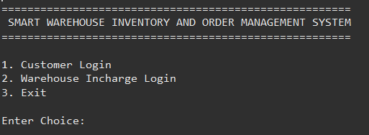
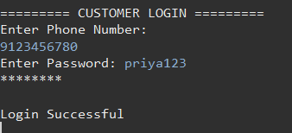

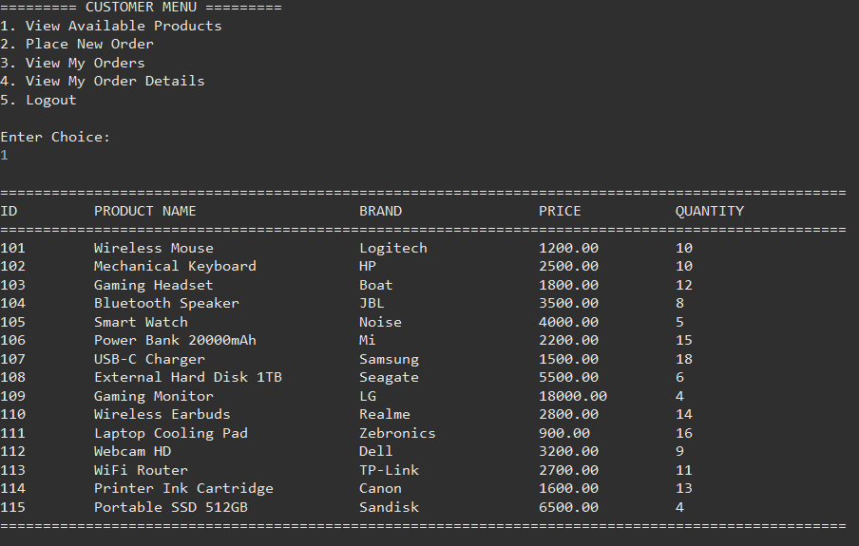

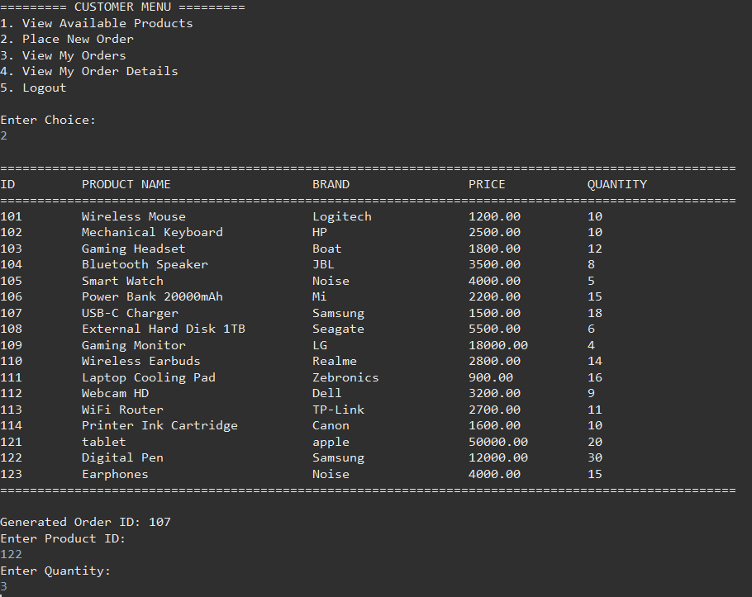
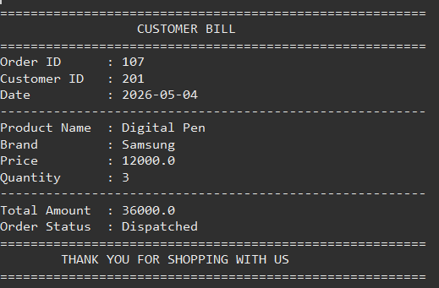

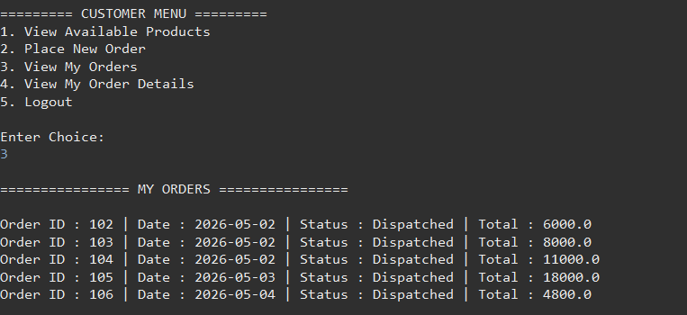

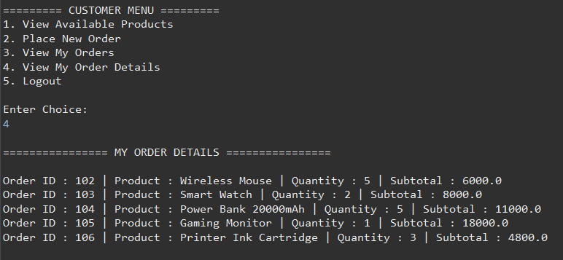

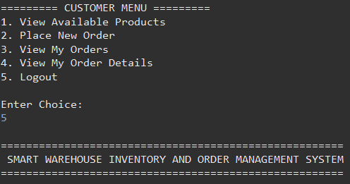

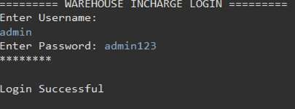

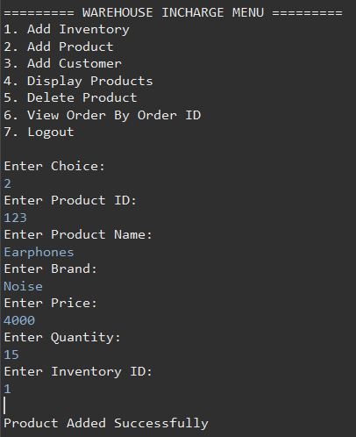



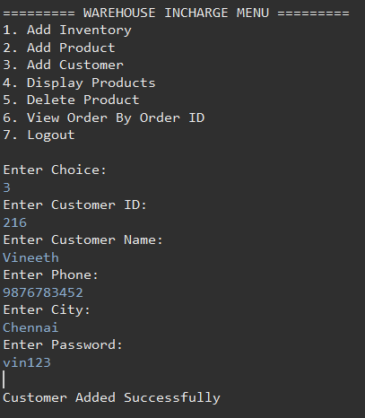

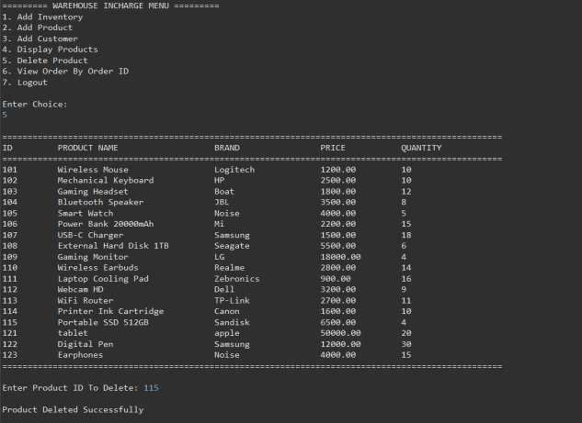

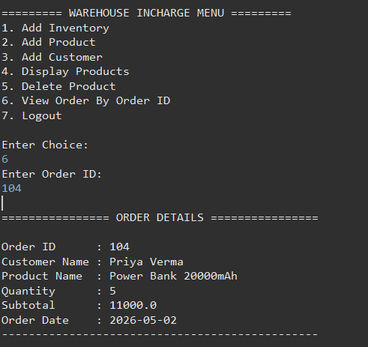
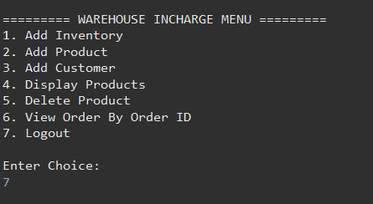

SQL Schema and Queries This document includes:
- The database schema used in the system

- All SQL queries used by the application (implemented in Java using JDBC)

Database Schema
CREATE DATABASE IF NOT EXISTS warehouse_inventory; USE warehouse_inventory;

Table: inventory
Purpose: Stores inventory location details. CREATE TABLE inventory (
inventory_id INT PRIMARY KEY, inventory_name VARCHAR(50), location VARCHAR(50)
);
  - Primary Key: inventory_id

Table: product

Purpose: Stores product information. CREATE TABLE product (
product_id INT PRIMARY KEY, product_name VARCHAR(50), brand VARCHAR(50),
price DOUBLE, quantity INT, inventory_id INT,
FOREIGN KEY (inventory_id) REFERENCES inventory(inventory_id)
);
  - Primary Key: product_id
  - Foreign Key: inventory_id → inventory

Table: customer
Purpose: Stores customer details for login and order tracking. CREATE TABLE customer ( customer_id INT PRIMARY KEY,
customer_name VARCHAR(50), phone VARCHAR(15), city VARCHAR(50),
password VARCHAR(50)
);
  - Primary Key: customer_id

¡/#Table: orders
Purpose: Stores order information placed by customers. CREATE TABLE orders ( order_id INT PRIMARY KEY, customer_id
INT,
order_date DATE,
order_status VARCHAR(20), total_amount DOUBLE,
FOREIGN KEY (customer_id) REFERENCES customer(customer_id)
);
  - Primary Key: order_id
  - Foreign Key: customer_id → customer

Table: order_details
Purpose: Stores detailed information about each product in an order. CREATE TABLE order_details (
order_detail_id INT PRIMARY KEY, order_id INT, product_id INT, quantity
INT, subtotal DOUBLE,
FOREIGN KEY (order_id) REFERENCES orders(order_id), FOREIGN KEY (product_id) REFERENCES product(product_id)
);
  - Primary Key: order_detail_id
  - Foreign Keys:
    - order_id → orders
    - product_id → product

Application SQL (JDBC Layer)
All SQL operations are executed in:
  - WarehouseOperations.java

➤ Insert Inventory
Purpose: Add new inventory
INSERT INTO inventory VALUES(?, ?, ?);

➤ Insert Product
Purpose: Add new product
INSERT INTO product VALUES(?, ?, ?, ?, ?, ?);

➤ Insert Customer
Purpose: Register new customer
INSERT INTO customer VALUES(?, ?, ?, ?, ?);

➤ View Products
Purpose: Display all available products SELECT * FROM product;

➤ Customer Login
Purpose: Validate customer credentials
SELECT * FROM customer WHERE phone=? AND password=?;

➤ Get Product by ID

Purpose: Fetch product for order
SELECT * FROM product WHERE product_id=?;

➤ Insert Order
Purpose: Store order details
INSERT INTO orders VALUES(?, ?, ?, ?, ?);

➤ Insert Order Details
Purpose: Store product-level order data INSERT INTO order_details VALUES(?, ?, ?, ?, ?);

➤ Update Product Stock
Purpose: Reduce quantity after order
UPDATE product SET quantity=? WHERE product_id=?;

➤ View Customer Orders
SELECT * FROM orders WHERE customer_id=?;

➤ View Order Details
SELECT od.order_id, p.product_name, od.quantity, od.subtotal FROM order_details od

JOIN orders o ON od.order_id = o.order_id
JOIN product p ON od.product_id = p.product_id WHERE o.customer_id=?;

Main Menu
The main menu is the first screen displayed when the application starts. It provides the user with options to
navigate through the system. The available options include Customer Login, Admin Login, and Exit. This menu acts as the central entry point and ensures that users can access the required module easily.
The design is simple and user-friendly, allowing users to input their choice using numeric values. Based on the selection, the system redirects the user to the corresponding functionality.
Figure: Main Menu of the Product Inventory System
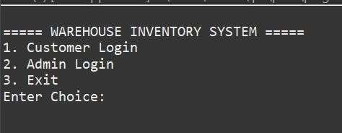

Admin Login

The admin login screen is used to authenticate the
administrator before granting access to sensitive operations. The admin must enter a valid username and password.
If the credentials match the predefined values, access is granted to the admin dashboard. Otherwise, an error message is displayed. This ensures security and prevents unauthorized access to system data.
Figure: Admin Login Screen

Customer Login
The customer login screen allows registered users to access their account using their phone number and password. The system verifies the credentials from the database.
If the login is successful, the customer is redirected to the customer dashboard. Otherwise, an invalid login message is displayed. This ensures that only authorized users can place orders and view their details.
Figure: Customer Login Screen

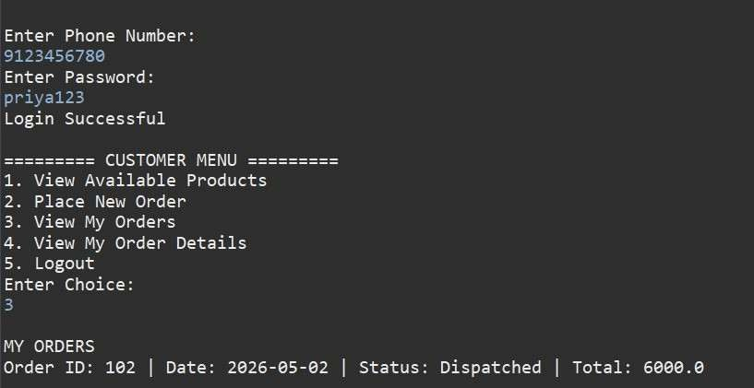

Product Display
This screen displays all available products stored in the system. It shows details such as product ID, product name, brand, price, and available quantity.
Both admin and customers can view this list. It helps users understand what products are available before performing any operations such as ordering.
Figure: Product Display Screen

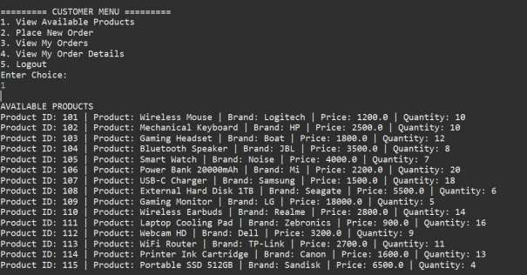

Order Placement
The order placement screen allows customers to place a new order. The user is required to enter the product ID and quantity.
The system checks whether the requested quantity is available. If sufficient stock exists, the order is processed successfully. Otherwise, an error message is shown.
This module also calculates the total cost of the order automatically. Figure: Order Placement Screen

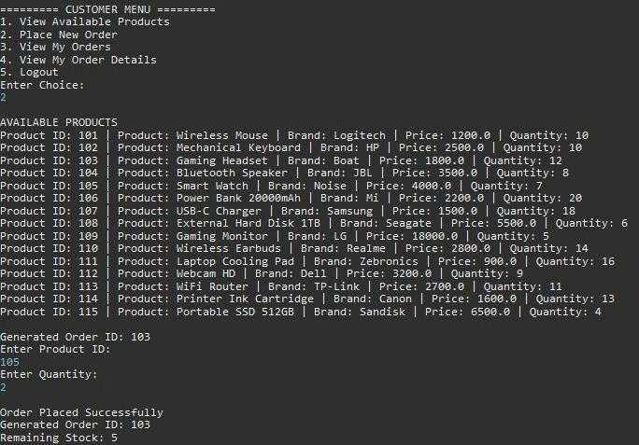

Order Details
This screen displays detailed information about the orders placed by the customer. It includes order ID, product name, quantity ordered, and subtotal.
It helps customers track their purchases and verify order information. This feature improves transparency and user satisfaction.
Figure: Order Details Screen

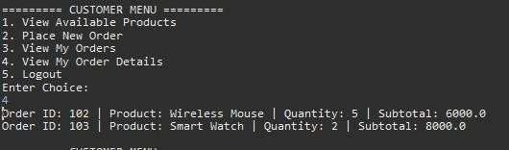

Conclusion
The Product Inventory System developed in this project successfully demonstrates how modern software technologies can be utilized to manage inventory and order processing efficiently. By integrating Java for application logic
and MySQL for database management, the system provides a reliable and structured platform for handling product data, customer information, and transactional records.
The system effectively automates key operations such as product management, customer registration, and order
placement. One of the major advantages of this system is the automatic stock update mechanism, which ensures that
product quantities are accurately maintained after every transaction. This reduces dependency on manual record-keeping and minimizes the chances of human errors.
The implementation of separate modules for admin and customer functionalities improves usability and ensures that different users can interact with the system according to their roles. The admin module enables efficient control over inventory, products, and customers, while the customer

module provides a smooth experience for browsing products and placing orders.
Furthermore, the use of structured database design with proper relationships between tables enhances data consistency and integrity. The system also uses secure database operations through JDBC, ensuring reliable
communication between the application and the database.
Overall, the Product Inventory System achieves its objective of providing an efficient, scalable, and easy-to-use solution for inventory management. The modular and extensible
design ensures that future improvements can be
incorporated with minimal changes, making the system suitable for real-world applications.

Future Enhancements
Although the current system provides essential functionalities for inventory and order management, several enhancements can be implemented to improve performance, security, and usability.
One important improvement is the implementation of password encryption. Currently, passwords are stored in plain text, which poses a security risk. By using encryption techniques such as hashing, user credentials can be securely stored and protected from unauthorized access.
Another enhancement is the addition of OTP-based authentication. This would provide an extra layer of security

during login by verifying users through a one-time password sent to their registered phone number or email. This helps prevent unauthorized access even if login credentials are
compromised.
The system can also be upgraded from a console-based application to a graphical user interface (GUI) or a web-based application. A GUI using frameworks like JavaFX or a web application using modern technologies would significantly
improve user experience and accessibility.
Implementing role-based access control is another valuable enhancement. This would allow different levels of access for different users, such as admin, manager, and customer, ensuring better control over system functionalities and
improving security.
Additionally, a reporting and analytics dashboard can be
introduced to provide insights into sales, inventory levels, and customer activity. This would help in decision-making and business analysis.
Finally, the system can be redesigned using a layered architecture approach, including DAO (Data Access Object),
Service, and Model layers. This would improve code
organization, maintainability, and scalability, making the system more robust and aligned with industry standards.
With these enhancements, the Product Inventory System can evolve into a fully functional enterprise-level application capable of handling complex business requirements
efficiently

