**Graph-RAG Powered Academic Assistant**

**Combining Citation Graphs and Research Papers for Explainable Generative AI**

1. **Problem Statement**

How can we enable users to query complex research papers, especially those with dense citations, and provide **context-aware, explainable answers** using **graph-augmented retrieval** and **LLMs**?

1. **Objective**

To develop an AI-powered assistant that allows students and researchers to read, query, and understand academic papers using **Retrieval-Augmented Generation (RAG)** combined with **Citation Knowledge Graphs**. The system enhances answer accuracy and explainability by integrating structured references from a citation graph (e.g., Microsoft Academic Graph) with unstructured paper text.

1. **Background & Motivation**

* Research papers often contain **dense content and complex references**.
* Readers struggle to **understand cited works and contextual links** between papers.
* Existing RAG systems **retrieve flat documents** without understanding inter-paper relationships.
* Combining **Knowledge Graphs (KG)** and LLMs can provide **structured and explainable insights**.
* This project aims to create an assistant that can:
  + Retrieve papers + referenced works.
  + Use **citation graphs** for contextual expansion.
  + Explain how answers were derived (XAI).

1. **Proposed Methodology**

**Architecture & Pipeline Overview**

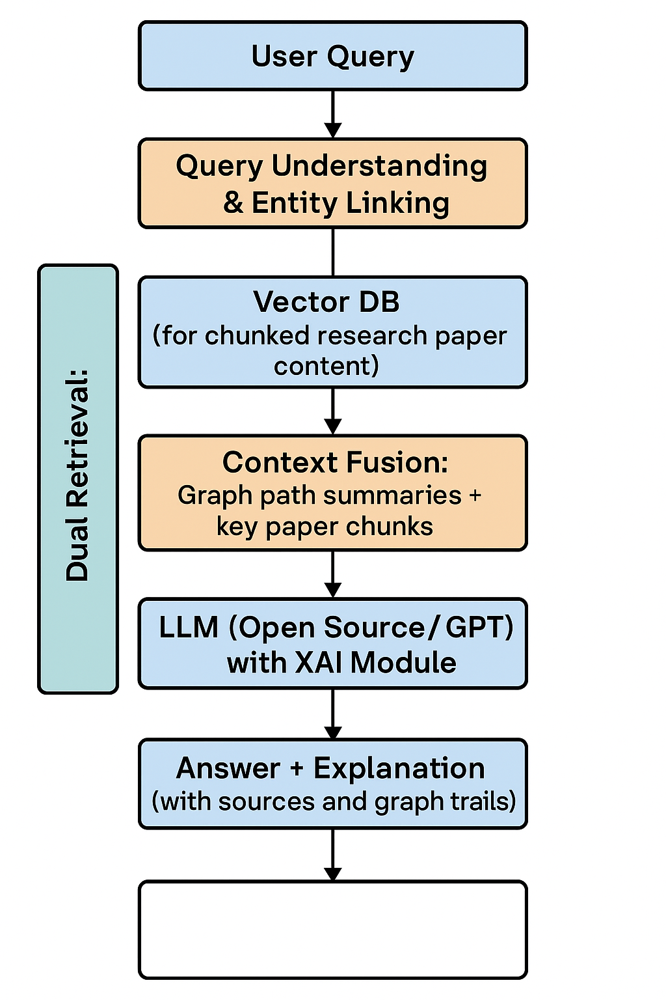

**Modules in Detail**

1. **Paper/Document Parsing and Chunking**

* Extract paragraphs, sections, and metadata from uploaded PDFs (e.g., using PyMuPDF, GROBID).
* Chunk content into semantically meaningful parts.

1. **Citation Graph Builder**

* Construct a directed graph using Microsoft Academic Graph / OpenAlex API.
* Nodes = papers, Edges = citations.

1. **Dual Retrieval Engine**

* Semantic search from paper vector DB (e.g., FAISS or Pinecone or Chroma).
* Graph traversal via top K relevant citations (e.g., shortest path, co-citation).

1. **Context Fusion**

* Merge results: Text chunks + path summaries from citation graph.

1. **LLM with an Explainable Wrapper**

* Use LLM to generate answers.
* Add explanation layer (e.g., show retrieved path, citations used, confidence).
* Use techniques like **attention visualization**, **source tagging**, or **token attributions**.

1. **Frontend (Optional)**

* Query UI with paper viewer.
* Answer pane + citation trail.

1. **Example Use Case Flow**

**📘 Uploaded Paper:**

*"Attention Is All You Need" (Vaswani et al., 2017)*

**🧑‍🎓 User Asks:**

*"How is attention different from previous sequence models?"*

**🧠 System Response (Summary):**

“Unlike RNNs or CNNs, attention mechanisms allow models to focus on all tokens at once, enabling parallelization. The concept builds on Bahdanau et al. (2015) and is further refined in Luong et al. (2015), both cited in this paper.”

**🔎 Explanation:**

* Pulled Section: “3.2 Scaled Dot-Product Attention”
* Graph Context: Path — [Vaswani → Bahdanau → Luong]
* Confidence: 94% (based on semantic overlap and citation relevance)

1. **Technologies & Tools**

|  |  |
| --- | --- |
| Component | Tool/Library |
| LLM | GPT-4, LLaMA, Mistral |
| Vector Store | FAISS, PineCone, ChromaDB |
| Citation Graph | Neo4j, NetworkX, OpenAlex |
| PDF Parsing | PyMuPDF, GROBID |
| Explainability | LIME, AttentionViz, LangChain |
| Backend/Frontend | Streamlit, Flask, React |

1. **Evaluation Plan**

|  |  |
| --- | --- |
| Metric | Description |
| Answer Relevance | BLEU, ROUGE, or BERTScore vs human answer |
| Hallucination Rate | Manual scoring of factual correctness |
| Citation Accuracy | % of responses with correct citation linkage |
| User Study (Optional) | Qualitative feedback from 5–10 peers |
| Explainability Score | User rating of clarity of source trace |

1. **Timeline (12–14 days)**

|  |  |
| --- | --- |
| Days | Milestone |
| 1–2 | Literature Review + Paper Corpus Collection |
| 3–4 | Citation Graph Construction |
| 5–6 | Vector Store Setup + Document Chunking |
| 7–8 | Dual Retrieval System (Vector + Graph) |
| 9–10 | LLM Integration + Response Generator |
| 11–12 | XAI Module + UI (optional) |
| 13 | Testing, Evaluation |
| 14 | Final Report + Demo |

1. **Expected Outcome**

* A working academic assistant that:
  + Ingests papers and citation links.
  + Accepts natural questions.
  + Returns accurate, source-aware, explainable answers.
* Optional UI for demos and usability testing.
* Can be extended to other domains (law, medicine, tech specs).

1. **References**

* Lewis et al. (2020). “Retrieval-Augmented Generation for Knowledge-Intensive NLP Tasks”
* Microsoft Academic Graph Dataset (MAG)
* OpenAlex API - <https://openalex.org>
* Ribeiro et al. (2016). “Why Should I Trust You?”: Explaining the Predictions of Any Classifier
* Vaswani et al. (2017). “Attention Is All You Need”