**Chapter 1: Introduction**

The documentation deals with the analysis of requirements of the system and differentiated in terms of functional and non-functional requirements. This is then prioritized using MoSCoW prioritization method.

It also encompasses several models to describe and manifest how the system looks like and how it functions. This includes use-case diagram, initial class diagram, and ER diagram followed by UI design.

**Justification of Project**

**Background of Project**

Woodcraft Store Management System is a web-based application software that focuses on providing its customers with best web-services. Moreover, e-commerce facilities and also other services that facilitates stock management and information gathering, etc.

**Chapter 2: Analysis**

Analysis is the process of identification and documentation of requirement of the proposed system. In the analysis phrase, first step is to feasibility study after that we model system in use case diagram and class diagram which is also called system modelling.

**Functional and Non-Functional Requirements:**

Functional requirements states what the system should door provide for users. It includes description of the required functions and details of data to be held in the system. E.g. business rules, administrative functions, authentication, adjustment and cancellation, certification requirements, etc.

Non-Functional requirements states how the system performs a certain function. It specifies the system quality attributes or characteristics. E.g. scalability, capacity, availability, usability, etc.

.

**Requirement Analysis:**

|  |  |  |  |
| --- | --- | --- | --- |
| **S. No** | **Requirements** | **Functional or Non-Functional** | **MoSCoW** |
|  | Registration | F | M |
|  | Login | F | M |
|  | Search and select items | F | M |
|  | Order items | F | M |
|  | Retrieve bill | F | M |
|  | Rate and review items | F | C |
|  | Post queries | F | S |
|  | Post comment | F | S |
|  | Delete posts | F | C |
|  | Update account details | F | S |
|  | Add items | F | M |
|  | Update item details | F | M |
|  | Delete items | F | M |
|  | Control user account | F | C |
|  | Create bill | F | S |
|  | Retrieve sales record | F | S |
|  | Generate Bill | F | S |
|  | Logout | F | M |
|  | Visitor counter | F | C |
|  | Authentication | F | M |
|  | Security | NF | S |
|  | Performance | NF | S |
|  | Availability | NF | S |
|  | Reliability | NF | S |
|  | Maintainability | NF | S |
|  | Usability | NF | S |
|  | Data Integrity | NF | S |
|  | Supportability | NF | S |

**Feasibility Study**

A feasibility study includes an estimate of the level of expertise required for a project and who can provide it, quantitative and qualitative assessments of other essential resources, identification of critical points, a general timetable, and a general cost estimate.

Advantages of feasibility study:

* It can provide valuable information for the project.
* By evaluating multiple factor, it has enhanced success rates.

Disadvantages of feasibility study:

* Costly
* Wrong information

**Use Case Diagram:**

A Use-case is a software and system engineering term that describe how user can interact with system to perform a particular operation. A use case acts as a software modelling technique that implies function to be implemented.

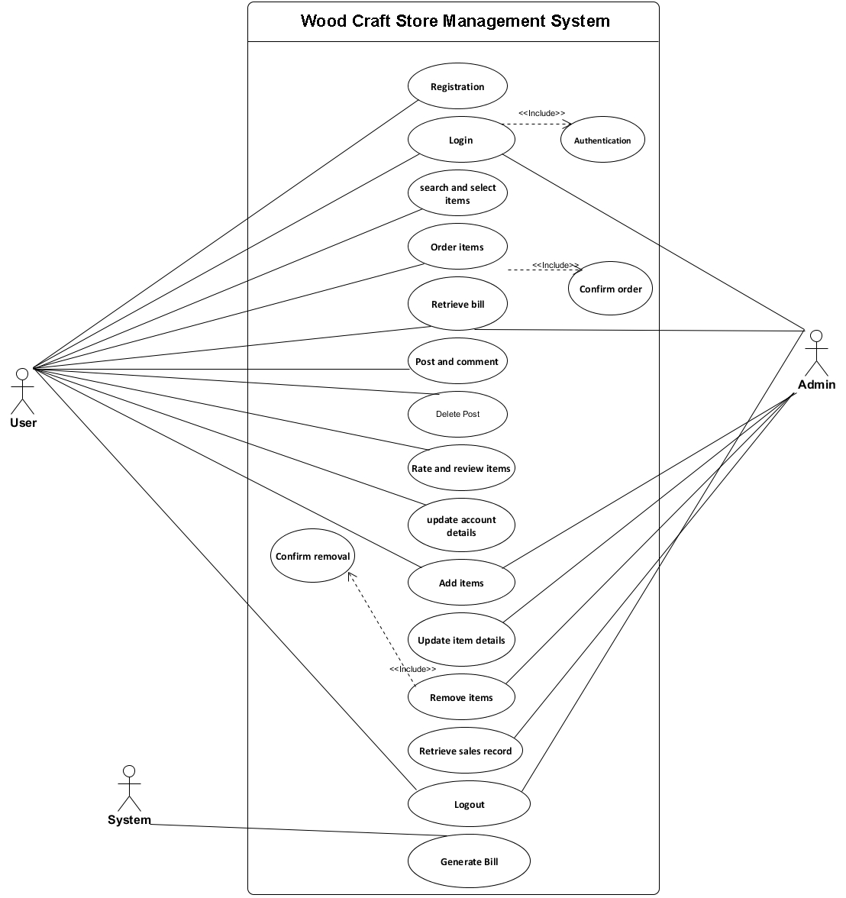**Justification**

The Usecase diagram, shown above, is consist of three different actors; Admin, User and System.

Admin manages Inventory and Users and also controls content writing.

User can register themselves and log into the site and use its functionalities.

The system does automated functions such as generating bill.

**Initial Class Diagram**

A class diagram is a description of relationship between different classes. It is a static diagram which represent static view of system. It describes the attributes and operations of class. It also shows a collection of classes, interface, and association.

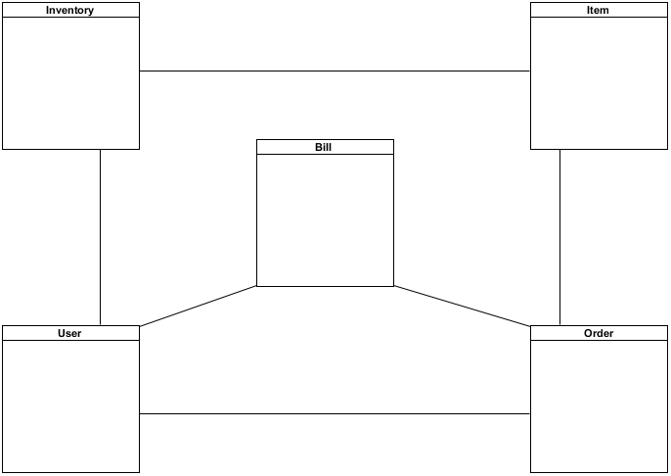

**Chapter 3: Design**

A design phase is detailed document providing information about a going to developed product of process. Its main aims to ensure that development product should meet users’ requirements. There are three different design phases i.e. structural design, behavioral design and database design.

**Structural Design**

It is architectural of the system which emphasis on the class, object and method of the system.

**Class Diagram:**

Class Diagram is UML, a type of static view of the system that describes the whole structure of the system by show classes, attributes, operation or method and relationship between classes.

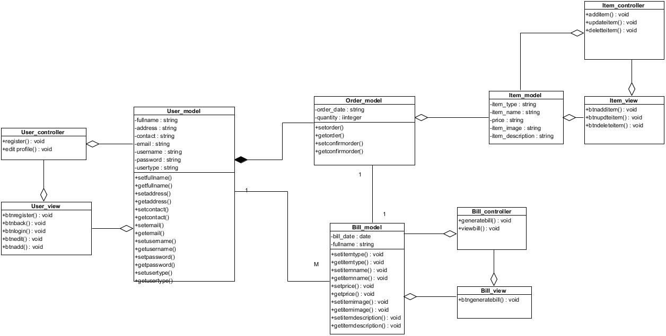

**Justification**

The above class diagram illustrated that each class has each controller and controller are direct associated with Database. Here, Order class is dependent to Bill Class and Item Class and User class which means when the user makes order, the Order class collects information from Item class and creates order whose details is now send to Bill class and the system generates the bill.

**Behavioral Design**

**Activity Diagram**

Activity diagram is UML diagram which describes the dynamic aspect of the system. It is advanced version of flow chart which show logic of flow of one activity to another activity.

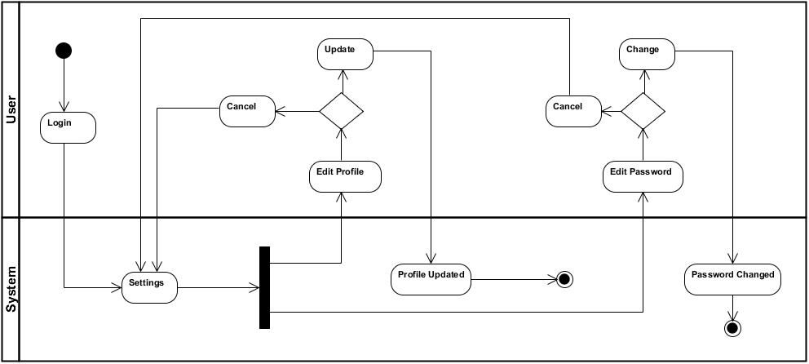

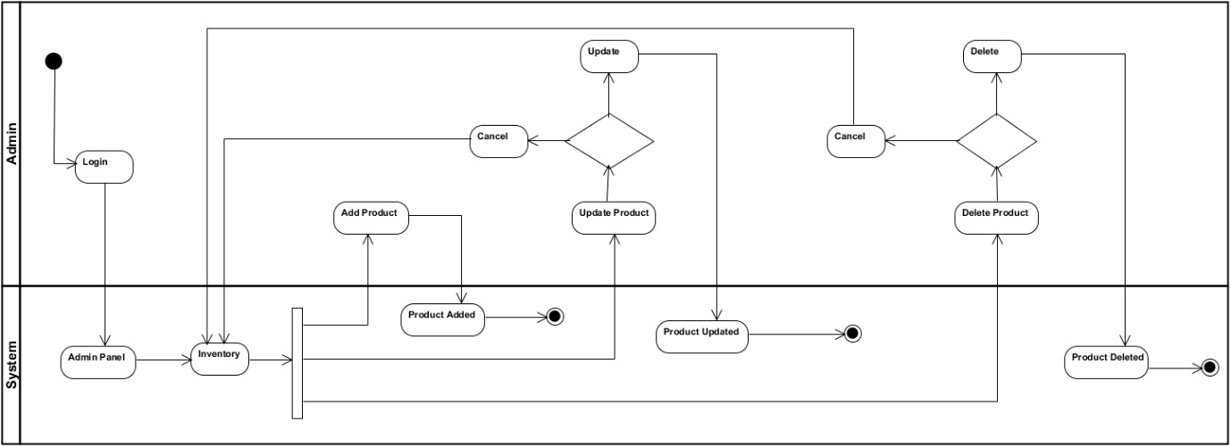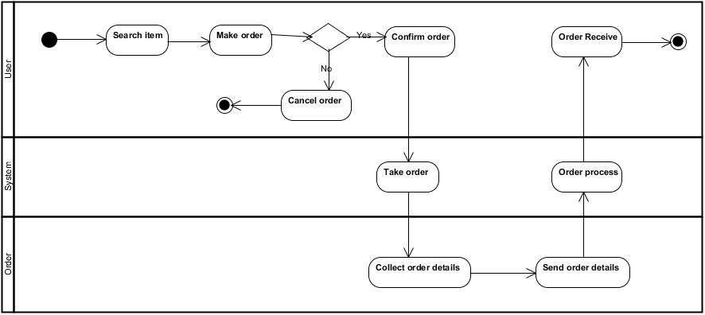

**Justification**

A user/customer searches for products and makes order which, if is confirmed, is processed and a bill is generated by the system as accordingly.

**Database Design**

Database design is the process of designing, development and implementation of data for proposed system. The main aims of database design are to produce logical and physical model for any system.

**ER Diagram:**

An Entity Relationship Diagram also called as ERD is a type of flowchart that illustrates how entities relate with each other within system.

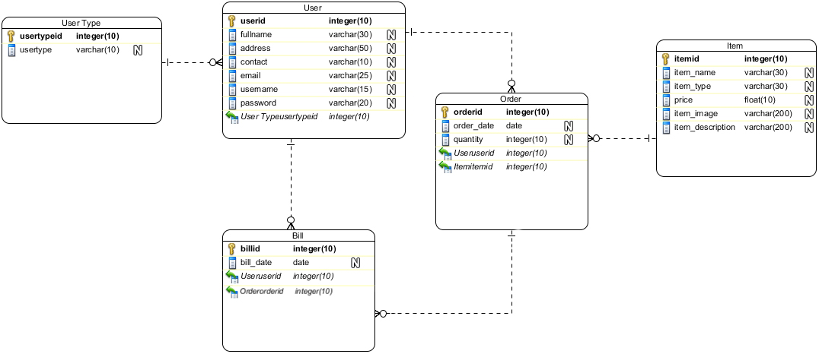

**Data Dictionary**

|  |  |  |  |  |  |
| --- | --- | --- | --- | --- | --- |
| **User Type** | | | | | |
| **Column Type** | **Type** | **Length** | **Nullable** | **PK/FK** | **Description** |
| Usertypeid | integer | 10 | No | PK | Unique Identification |
| Usertype | varchar | 10 | Yes |  | Types of User |

|  |  |  |  |  |  |
| --- | --- | --- | --- | --- | --- |
| **User** | | | | | |
| **Column Type** | **Type** | **Length** | **Nullable** | **PK/FK** | **Description** |
| Userid | integer | 10 | No | PK | Unique Identification |
| Fullname | Varchar | 30 | Yes |  | Fullname of User |
| Address | Varchar | 50 | Yes |  | Address of User |
| Contact | Varchar | 10 | Yes |  | Contact of User |
| Email | Varchar | 25 | Yes |  | Email of User |
| Username | varchar | 15 | Yes |  | Username |
| Password | varchar | 20 | Yes |  | Password |
| Usertypeid | integer | 10 | Yes | FK | Unique Identification |

|  |  |  |  |  |  |
| --- | --- | --- | --- | --- | --- |
| **Order** | | | | | |
| **Column Type** | **Type** | **Length** | **Nullable** | **PK/FK** | **Description** |
| Orderid | Integer | 10 | No | PK | Unique Identification |
| Order_date | Date |  | Yes |  | Date of Order |
| Quantity | Integer | 10 | Yes |  | Quantity of Items |
| Userid | Integer | 10 | Yes | FK | Unique Identification |
| Itemid | Integer | 10 | Yes | FK | Unique Identification |
| Billid | Integer | 10 | Yes | FK | Unique Identification |

|  |  |  |  |  |  |
| --- | --- | --- | --- | --- | --- |
| **Item** | | | | | |
| **Column Type** | **Type** | **Length** | **Nullable** | **PK/FK** | **Description** |
| Itemid | Integer | 10 | No | PK | Unique Identification |
| Item_name | Varchar | 30 | Yes |  | Name of Item |
| Item_type | Varchar | 30 | Yes |  | Type of Item |
| Price | Float | 10 | Yes |  | Price of Item |
| Item_image | varchar | 200 | Yes |  | Image of Item |
| Item_description | varchar | 200 | Yes |  | Description of Item |

|  |  |  |  |  |  |
| --- | --- | --- | --- | --- | --- |
| **Bill** | | | | | |
| **Column Type** | **Type** | **Length** | **Null** | **PK/FK** | **Description** |
| Billid | Integer | 10 | No | PK | Unique Identification |
| Bill_date | Date |  | Yes |  | Date of Bill Created |
| Orderid | Integer | 10 | Yes | FK | Unique Identification |
| Userid | Integer | 10 | Yes | FK | Unique Identification |