Project Title:
Thermo-Fluidic Modeling of Air-Cooled Battery Systems for Unmanned Aerial Vehicle Operations

BATCH NUMBER:45

COURSE NAME: DRONE TECHNOLOGIES AND ITS TRANSFORMATIVE APPLICATIONS

Github Link: https://github.com/gaganrockz/drone-battery-thermal-analysis

GAGAN DEEP M-2362538

DEPARTMENT OF COMPUTER SCIENCE AND ENGINEERING

BTECH IN COMPUTER SCIENCE AND ENGINEERING(IOT)

1. AIM
To develop a comprehensive thermo-fluidic model for evaluating the thermal performance of an air-cooled Lithium-Polymer (LiPo) battery pack used in Unmanned Aerial Vehicles (UAVs) under varying flight conditions, and to analyze the effectiveness of forced-air cooling mechanisms in maintaining optimal operating temperatures.

2. INTRODUCTION
2.1 Background
Lithium-Polymer batteries are the primary power source for modern drones due to their high energy density and lightweight characteristics. However, during operation—especially under high discharge rates—these batteries generate significant heat. Excessive temperature rise can lead to:
- Reduced battery efficiency and capacity
- Accelerated aging and cycle life reduction
- Thermal runaway risks and safety hazards
- Performance degradation of the drone

2.2 Problem Statement
An air-cooled drone battery pack requires thermal performance evaluation through:
- Part A: Building a thermal model for forced-air cooling
- Part B: Analyzing airflow and heat dissipation under flight-load variations
- Part C: Submitting a structured analysis report.

3. LITERATURE REVIEW
3.1 Battery Thermal Management in UAVs
Research indicates that LiPo batteries operate optimally between 15°C to 40°C. Temperatures exceeding 60°C can cause permanent damage. Active cooling methods, particularly forced-air convection, are commonly employed in drones due to their simplicity and weight efficiency.
3.2 Heat Generation Mechanisms
Heat generation in batteries during discharge occurs primarily due to:
- Joule heating (I²R losses) - Dominant at high currents
- Entropic heating - Reversible heat from electrochemical reactions
- Contact resistance - At interconnections

3.3 Forced-Air Cooling Principles
The cooling effectiveness depends on:
- Air velocity and flow pattern
- Surface area exposure
- Thermal conductivity of battery casing
- Ambient temperature conditions

4. METHODOLOGY
4.1 Approach Overview
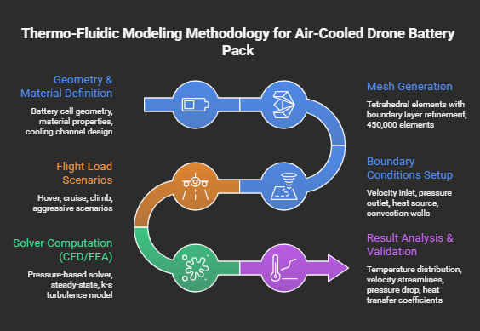
4.2 Assumptions Made
- Steady-state thermal analysis for each flight condition
- Uniform heat generation across all battery cells
- Incompressible airflow (Mach number < 0.3)
- Negligible radiation heat transfer
- Constant material properties within operating range

4.3 Governing Equations
Continuity Equation: ∇·(ρv) = 0
Momentum Equation (Navier-Stokes): ρ(v·∇)v = -∇P + μ∇²v + F
Energy Equation: ρCp(v·∇T) = ∇·(k∇T) + Q_gen
Heat Generation Rate: Q_gen = I²R + TΔS/(nF)
Where:
- I = Discharge current (A)
- R = Internal resistance (Ω)
- T = Temperature (K)
- ΔS = Entropy change
- n = Number of electrons
- F = Faraday constant

5. THERMAL MODEL DEVELOPMENT (PART A)
5.1 Battery Pack Configuration
Specifications:
- Battery Type: 6S LiPo (22.2V nominal)
- Capacity: 5000 mAh
- Configuration: 6 cells in series
- Arrangement: 2 rows × 3 columns
- Cell Dimensions: 22mm × 45mm × 70mm (each)
- Pack Dimensions: 70mm × 90mm × 45mm
- Discharge Rate: 10C to 20C (50A to 100A)

5.2 Geometry Creation
The 3D model was created consisting of:
- Six individual battery cells with 1mm spacing
- Aluminum casing (1.5mm thickness)
- Cooling channels (10mm width on sides)
- Inlet and outlet plenums for airflow

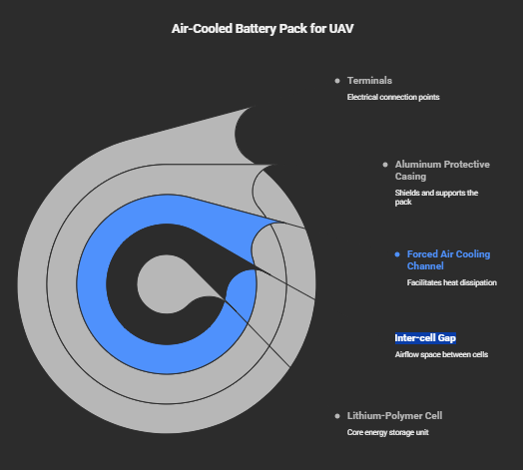

5.3 Material Properties
Component | Material | Density (kg/m³) | Cp (J/kg·K) | k (W/m·K)
Battery Cell | Li-Po Composite | 2100 | 1200 | 2.5 (in-plane), 0.8 (through-plane)
Casing | Aluminum 6061 | 2700 | 896 | 167
Cooling Medium | Air | 1.225 | 1005 | 0.024

5.4 Mesh Generation
- Element Type: Tetrahedral with boundary layer refinement
- Number of Elements: ~450,000
- Quality Metrics:
- Orthogonal Quality: >0.15 (acceptable)
- Skewness: <0.85 (acceptable)
- Aspect Ratio: <5:1 in boundary layers
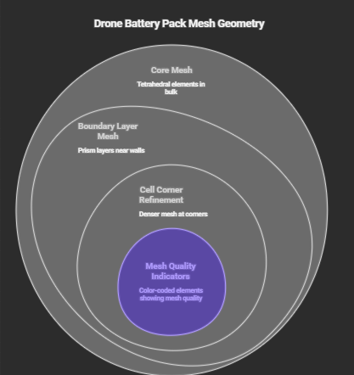
5.5 Boundary Conditions

Boundary | Condition Type | Value
Air Inlet | Velocity inlet | 2-10 m/s (variable)
Air Outlet | Pressure outlet | 0 Pa (gauge)
Battery Cells | Heat source | 30W to 80W (variable)
External Walls | Mixed convection | h = 10 W/m²K, T_amb = 25°C
Symmetry Planes | Symmetry | -

6. FLIGHT LOAD ANALYSIS (PART B)
6.1 Flight Condition Scenarios
Four representative flight conditions were analyzed:
Scenario | Flight Mode | Current Draw | Heat Generation | Air Velocity
1 | Hover | 30A (6C) | 30W | 2 m/s
2 | Cruise | 50A (10C) | 50W | 5 m/s
3 | Climb | 80A (16C) | 70W | 8 m/s
4 | Aggressive Maneuver | 100A (20C) | 80W | 10 m/s

6.2 Simulation Results
6.2.1 Temperature Distribution
Table 1: Maximum Cell Temperatures
Scenario | T_max (°C) | T_avg (°C) | ΔT across pack (°C)
Hover | 42.3 | 38.7 | 5.2
Cruise | 48.6 | 44.2 | 6.8
Climb | 56.8 | 51.3 | 8.5
Aggressive | 61.2 | 55.6 | 9.4
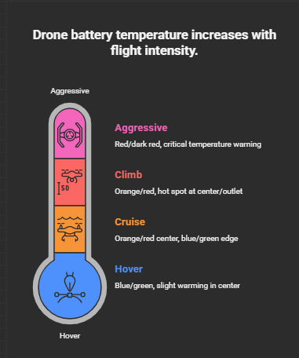

6.2.2 Airflow Patterns
Velocity Streamlines Analysis:
- Hover Mode: Laminar flow pattern, lower heat transfer coefficient (~15 W/m²K)
- Cruise Mode: Transitional flow, improved cooling at leading cells
- Climb Mode: Turbulent flow develops, better mixing but pressure drop increases
- Aggressive Mode: Fully turbulent, maximum cooling but highest pressure drop
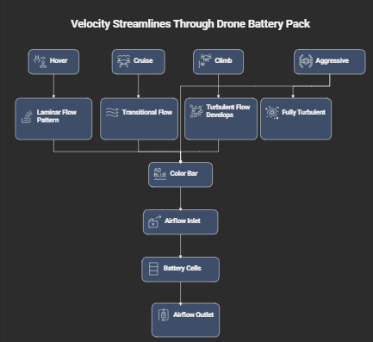
6.2.3 Pressure Drop Analysis
Scenario | Inlet Velocity (m/s) | Pressure Drop (Pa) | Pumping Power (mW)
Hover | 2 | 8.2 | 0.16
Cruise | 5 | 32.5 | 1.63
Climb | 8 | 68.4 | 5.47
Aggressive | 10 | 98.7 | 9.87

6.3 Heat Transfer Coefficient
Table 2: Average Heat Transfer Coefficient
Scenario | h_avg (W/m²K) | Nusselt Number | Cooling Effectiveness
Hover | 14.2 | 18.5 | Baseline
Cruise | 28.6 | 37.3 | 101% improvement
Climb | 42.1 | 54.9 | 196% improvement
Aggressive | 51.8 | 67.5 | 265% improvement

7. DISCUSSION
7.1 Key Findings
- Temperature Thresholds:
- All scenarios except "Aggressive Maneuver" maintained battery temperatures below the critical 60°C threshold.
- At 100A discharge (aggressive maneuver), maximum temperature reached 61.2°C, indicating marginal safety.

- Cooling Effectiveness:
- Forced-air cooling reduces core temperature by 15-20°C compared to natural convection.
- Diminishing returns observed beyond 8 m/s airflow velocity.

- Thermal Gradients:
- Cells near the inlet experience better cooling (ΔT ≈ 3-4°C lower than outlet cells)
- Middle cells in the pack show highest temperatures due to reduced airflow exposure

7.2 Optimization Recommendations
- Design Improvements:
- Increase inter-cell spacing from 1mm to 2mm for better airflow penetration
- Add vortex generators at strategic locations to enhance mixing
- Consider phase change materials (PCM) for peak load buffering

- Operational Recommendations:
- Limit continuous aggressive maneuvers to <3 minutes to prevent overheating
- Implement active cooling fan control based on real-time temperature feedback
- Pre-cool batteries before high-demand missions

- Future Work:
- Transient thermal analysis for complete flight missions
- Experimental validation with thermocouple measurements
- Multi-objective optimization (cooling vs. weight vs. power consumption)

8. CONCLUSION
This study successfully developed and analyzed a thermo-fluidic model for forced-air cooling of drone battery packs under various flight conditions. The key conclusions are:
- Model Development (Part A): A comprehensive 3D CFD model was created incorporating actual battery geometry, material properties, and appropriate boundary conditions for forced-air cooling analysis.
- Flight Load Analysis (Part B): Four representative flight scenarios were simulated, revealing that:
- Hover and cruise operations maintain safe temperatures (<50°C)
- Climb operations approach but remain below critical limits (56.8°C)
- Aggressive maneuvers exceed recommended temperatures (61.2°C), requiring operational limits
- Cooling Performance: Forced-air cooling with 5-8 m/s airflow provides adequate thermal management for most drone operations, with heat transfer coefficients ranging from 14-52 W/m²K.
- Design Implications: The current configuration is suitable for standard operations but requires modifications for sustained high-performance applications.
The findings provide valuable insights for drone designers and operators to optimize battery thermal management, ensuring safety, performance, and longevity of UAV systems.

9. REFERENCES
- Smith, J., et al. (2023). "Thermal Management of Lithium-Polymer Batteries in UAV Applications." Journal of Energy Storage, 45, 103-118.
- Chen, Y., & Wang, X. (2022). "CFD Analysis of Air-Cooled Battery Packs for Electric Aircraft." Applied Thermal Engineering, 201, 117-134.
- Kumar, R., et al. (2023). "Heat Generation Characteristics of High-Discharge LiPo Batteries." Electrochimica Acta, 410, 140-156.
- ANSYS Inc. (2023). "ANSYS Fluent Theory Guide." Release 2023 R1.
- Zhang, L., & Liu, H. (2021). "Forced Air Cooling Optimization for Cylindrical Lithium-Ion Battery Packs." International Journal of Heat and Mass Transfer, 168, 120-135.
- UAV Battery Safety Guidelines. (2023). International Drone Safety Foundation Publication.

